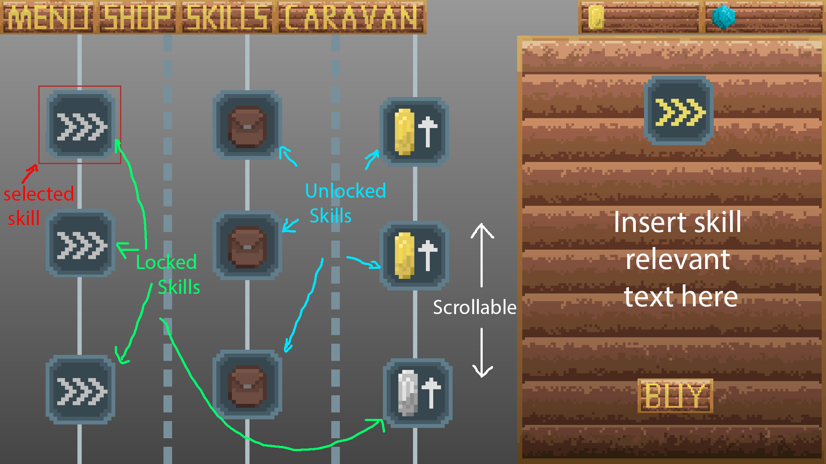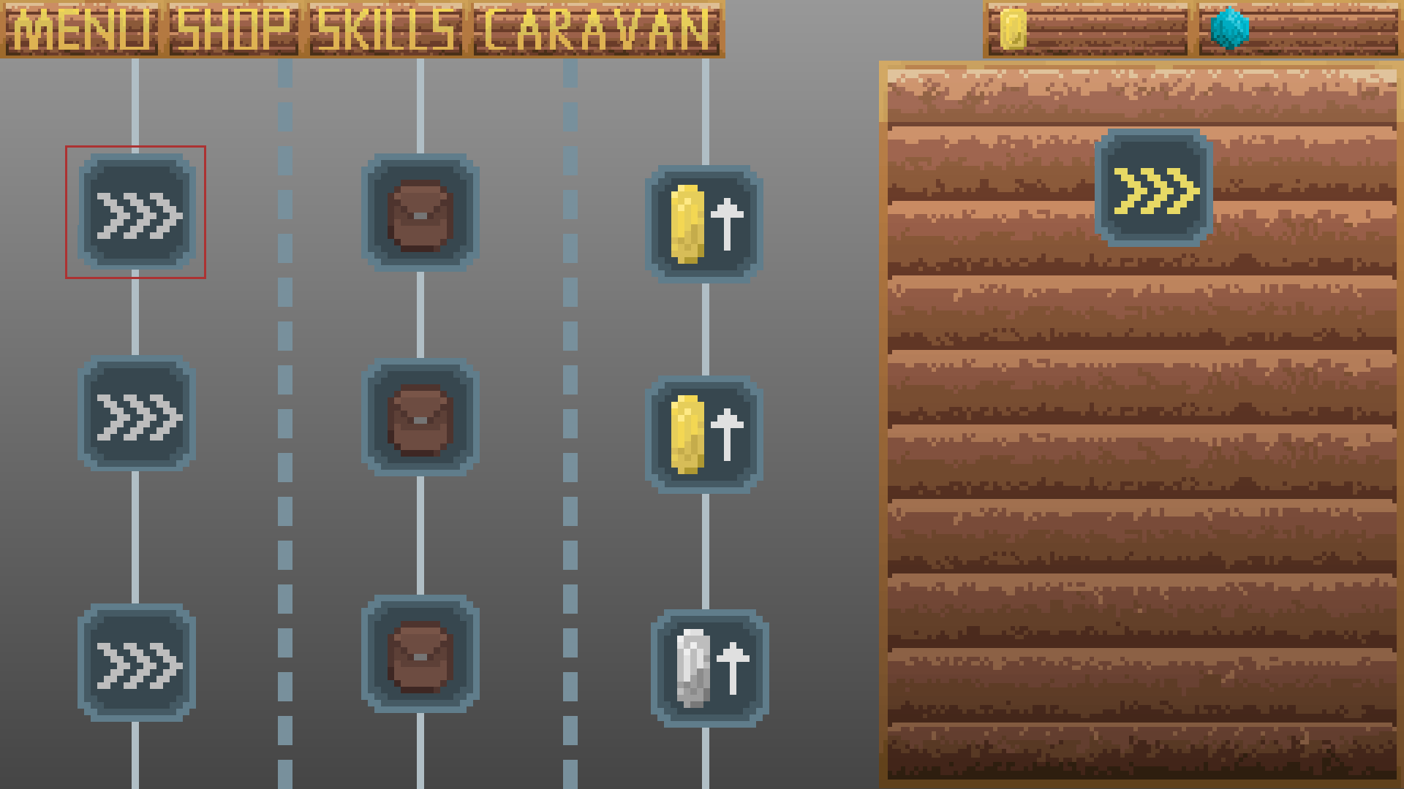

The mockup shows the main idea of skills. The second image is an annotated version with some notes on it. On the left, you have three columns of skills that you can interact with and unlock, with the information for the skills being shown on the right. Clicking on an icon should highlight it (something like the red box around the ‘speed’ skill here) and open the relevant page on the right (this involves getting the relevant icon and text as well as checking if it has been bought and, if so, adding the ‘Buy’ button at the bottom of the right side). When a skill has been purchased, it should use the coloured icon on the skill tree (left side), whereas if it hasn’t been purchased it should use the grey/locked icon. You also shouldn’t be able to get a skill in a vertical column until you have the one above it (i.e. all unlocked skills should be connected/in a vertical line). Additionally, the left side should be able to scroll down with 6 rows of skills at the moment but that will probably be extended further down the line (i.e. the mockup shows 3 rows, you should be able to scroll down/up for the other 3 rows). Keep in mind for the scrolling that this is for the phone so it should be more ‘dragging’ like you would with your finger.

For the lines, there should be an image that has the static lines. Hopefully it shouldn’t be too hard to align the skills on top of the lines image. That way, you don’t actually have to worry about creating lines and can just use the image instead. Skills should go centred on the full lines while the dashed lines separate columns.