# Sudoku Validator

Procedure

1. Setup jdk path in OS environment variable
2. Place **SudokuValidator.jar** and **validate.bat** in the same directory
3. Run below command in CMD for windows

.\validate.bat input-files\valid-puzzleName.txt

Note: **input-files\valid-puzzleName.txt** is input file path

Results

1. Valid Sudoku input: Return 0 for valid input

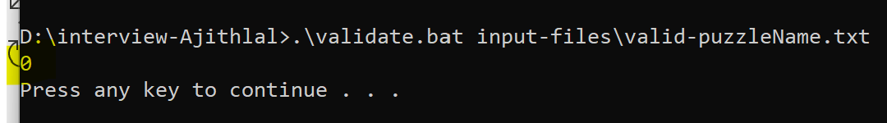

1. Invalid Sudoku (Duplicate entries) input: Return nonzero

3.Invalid Sudoku (Contains other than 1-9) input: Return nonzero

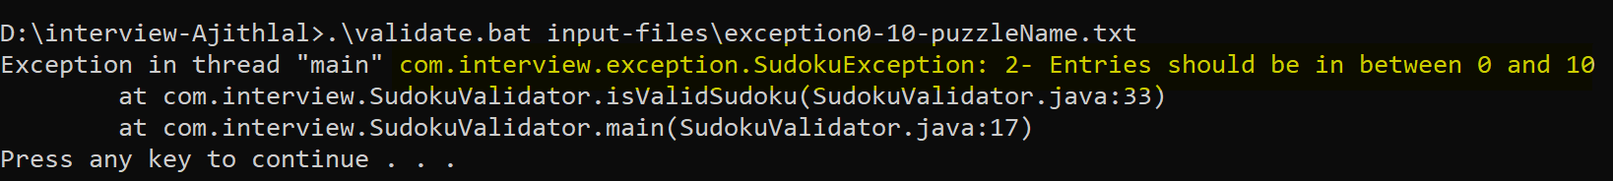

4.Invalid Sudoku (Invalid Sudoku size) input: Return nonzero

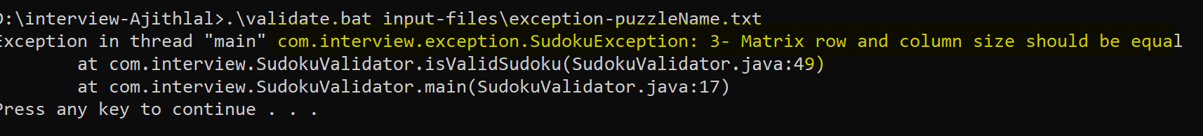

5.Invalid Sudoku (Empty file) input: Return non zero

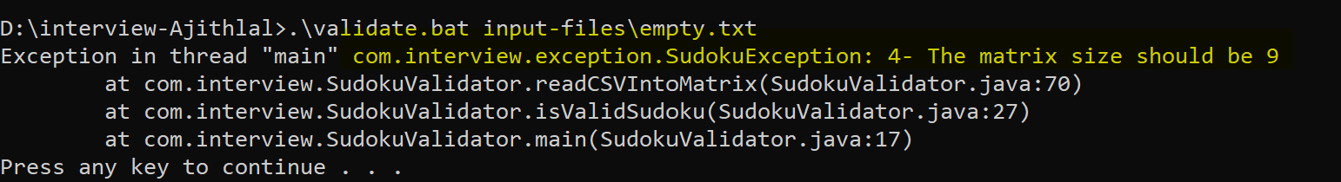

Junit and Coverage

