User Guide
For
WC External Variations

WordPress / WooCommerce Plugin

Version 1.0.10
Copyright © 2021 Impossible Dreams Network
11/25/2021
Table of Contents
1 Introduction 3
1.1 WordPress Plugin 3
1.2 WooCommerce Plugin 3
2 WC External Variations Plugin 3
2.1 Installation Instructions 4
2.2 Getting Started 4
3 WC External Variation Settings 5
4 Variable Product 6
4.1 Adding a Variable Product 6
4.1.1 Step 1: Set the Product Type 6
4.1.2 Step 2: Add Attributes to Use for Variations 7
4.1.3 Step 3: Add Variations 9
5 Bulk Editing 13
6 How to Use? 13
7 FAQ (Frequently Asked Questions) 16
7.1 Why “WC External Variations” plugin for WooCommerce? 16
7.2 How to use? 16
7.3 How do I change the settings of the "WC External Variations" plugin? 16
7.4 Is it suitable for any theme? 16
7.5 How do external links open in the same tab? 16
7.6 Advanced Use: Shortcodes. 17
8 Abbreviations 17
9 Revision History 17
10 References 17

Introduction
WordPress (WP, WordPress.org) is a free and open-source Content Management System (CMS). Features include a plugin architecture and a template system, referred to within WordPress as Themes. WordPress was originally created as a blog-publishing system but has evolved to support other web content types including more traditional mailing lists and forums, media galleries, membership sites, learning management systems (LMS) and online stores. WordPress is used by 41.4% of the top 10 million websites as of May 2021. WordPress is one of the most popular content management system solutions in use.

WordPress Plugin
A WordPress plugin architecture allows users to extend the features and functionality of a website or blog. It is essentially a bit of code that “plugs in” to your self-hosted WordPress site. In human terms, that means a WordPress plugin is something that adds new functionality to your WordPress site or extends existing functionality on your site.
Plugins can make everything from small tweaks to massive changes to your site. For example, some plugins can even turn your WordPress site into a fully functioning eCommerce store, social network, or forum or one can install plugins to improve your site’s performance or help it rank better in search engines like Google.

WooCommerce Plugin
WooCommerce is the world’s most popular open-source eCommerce solution. WooCommerce is a free WordPress plugin that adds e-commerce functionality to your WordPress website so you can have an online store. With just a few clicks, your WordPress website turns into a fully-functional e-commerce website.

WC External Variations Plugin
A WordPress plugin that adds basic support for external products to WooCommerce variations / variable products. This plugin also allows you to define an external URL on any variation and will then open that link when the user clicks on the “Add to Cart” button. This is a main feature of this plugin. The basic information of this plugin is shown below:
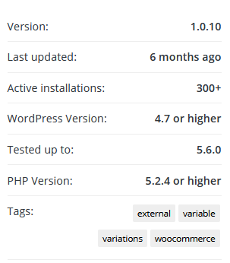

Installation Instructions
To install the “WC External Variations” plugin follow the below steps:
- Make sure you are running WooCommerce v4.0 or higher.
- In the left admin panel of WordPress, click Plugins > Add New.
- Search for “WC External Variations by Impossible Dreams Network” and click “Install”. When the installation is completed.
- “Activate Plugin” through the plugin’s menu in the WordPress.
- You will see a new plugin, ready to work in the admin menu.
We are now ready to use the “WC External Variations” plugin, but we have to perform the pre-requisite steps to finally use this plugin features.

Getting Started
What we need to know before using the basic features of this plugin?
- “WC External Variations” Plugin Settings
- How to Add a Variable Product?
  - Step 1: Set the Product Type
  - Step 2: Add Attributes to Use for Variations
  - Step 3: Add Variations
  - Editing Multiple Variations
  - Setting Defaults
  - Adding Variation Data
  - Add an Image to the Variation
- Bulk Editing

WC External Variation Settings
To use the “WC External Variations” plugin properly, it’s necessary to do the basic settings. In the settings tab, you are able to customize this plugin functions/features.
- In the left admin panel of WordPress, click WooCommerce > Settings.
- Select the “Products” tab from the available tabs list. The “Products” General setting displays.
- Select the “External Variations” link from the top menu available right under the tabs list. The “External Variations” plugin setting displays.
- Click “Save changes”.
The details are shown in the below screenshot:
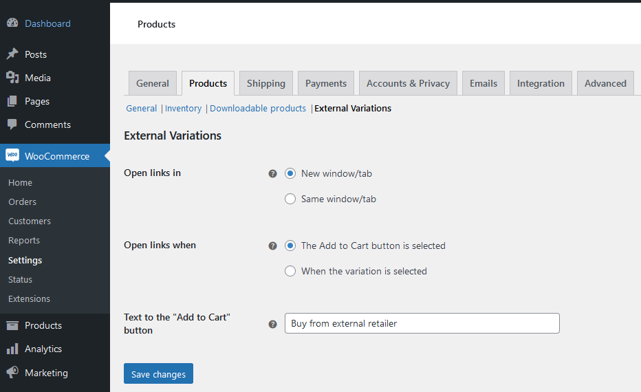
The “WC External Variations” plugin offers following settings to the user:
- Open links in
Configures whether external links open in new or existing window. The user has 2 possible options and can select one at a time. The options are:
  - New window/tab (Default option)
  - Same window/tab
- Open links when
Configures what action triggers the opening of external links. The user has 2 possible options and can select one at a time. The options are:
- The “Add to Cart” button is selected (Default option)
- When the variation is selected
- Text to the “Add to Cart” button
Configures custom text for the “Add to Cart” button, leave empty not to override. The user needs to provide a text for the “Add to Cart” button.

Variable Product
Variable products are a product type in WooCommerce that lets you offer a set of variations on a product, with control over prices, stock, image and more for each variation and external URL. They can be used to define options for a product like a T-shirt, where you can offer a large, medium and small and in different colors and prices. The “WC External Variations” plugin allows you to define an external URL on any variation and will then open that link when the user clicks on the “Add to Cart” button.

Adding a Variable Product
The user needs to perform the following three steps to add a variable product:

Step 1: Set the Product Type
To add a variable product, create a new product or edit an existing one.
- Go to: WooCommerce > Products.
- Select the Add Product button or Edit an existing product. The Product Data displays.
- Select Variable product from the Product Data dropdown.
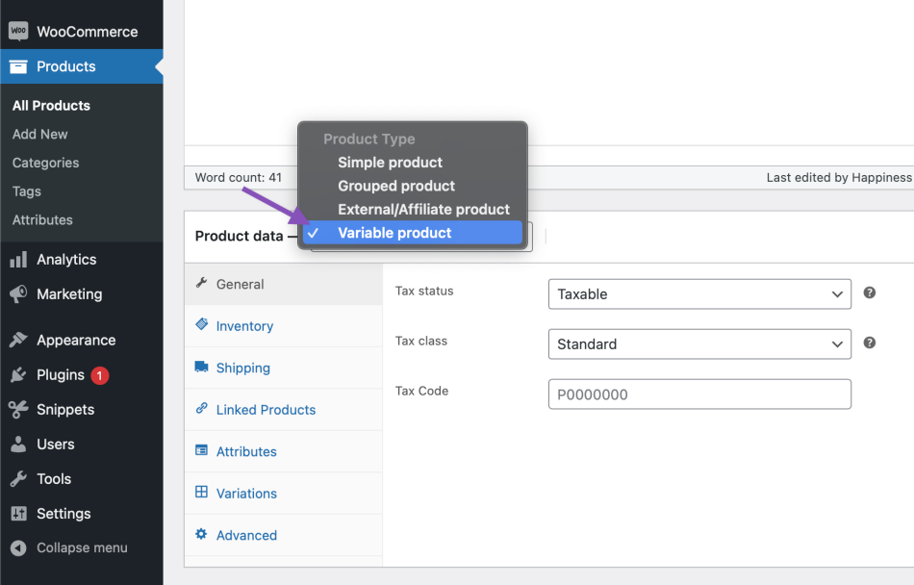

Step 2: Add Attributes to Use for Variations
In the Attributes section, add attributes before creating variations — use global attributes that are site-wide or define custom ones specific to a product.
Global Attributes
To use a global attribute:
- Create global attributes.
- Select one from the dropdown and click Add.
- Choose Select all to add all attributes to the variable product (if applicable).
- Enable the Used for variations checkbox to tell WooCommerce it’s for your variations.
- Click Save attributes.
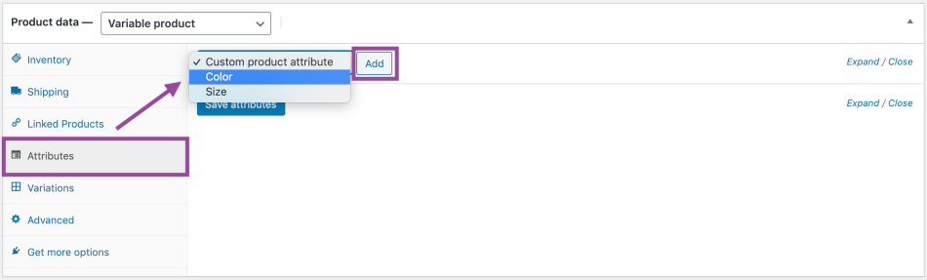
Adding a global attribute:
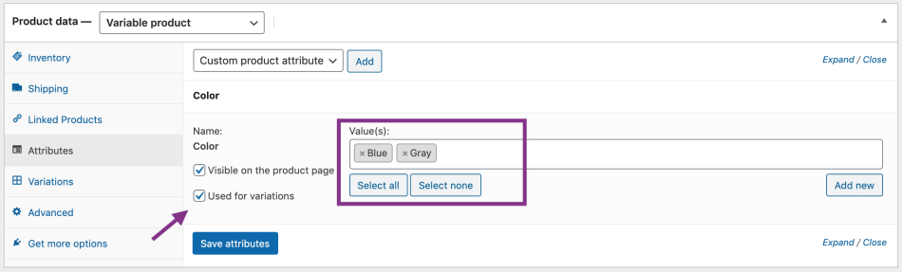
Custom Attributes
To add a new attribute specific to this product:
- Select Custom product attribute and click Add.
- Name the attribute (e.g., Size).
- Set values separated by a vertical pipe, | (e.g., Small | Medium | Large).
- Enable the Used for variations checkbox.
- Click Save attributes.
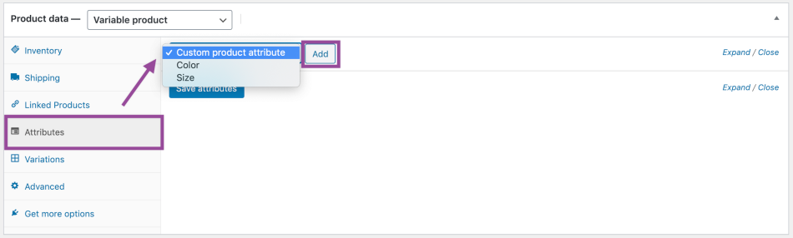
Adding a custom attribute and values:
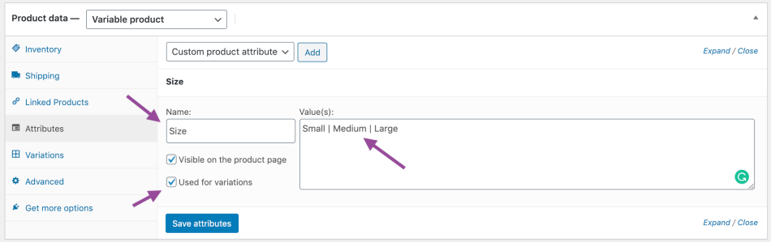

Step 3: Add Variations
To add a variation, go to the Variations section in the Product Data Meta box.
Manually Add a Variation
- Select Add variation from the dropdown menu, and select Go.
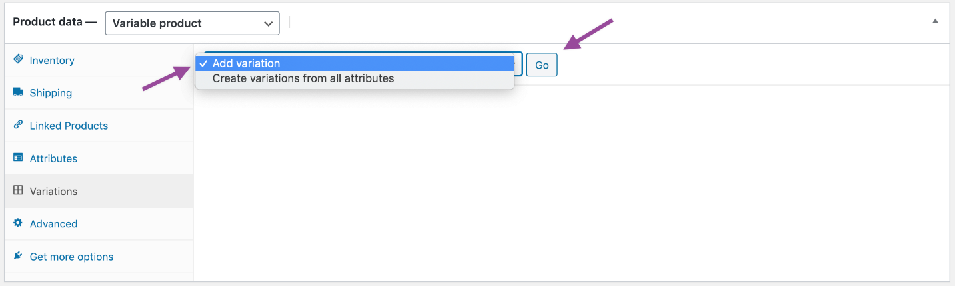
- Select attributes for your variation. To change additional data, click the triangle icon to expand the variation.
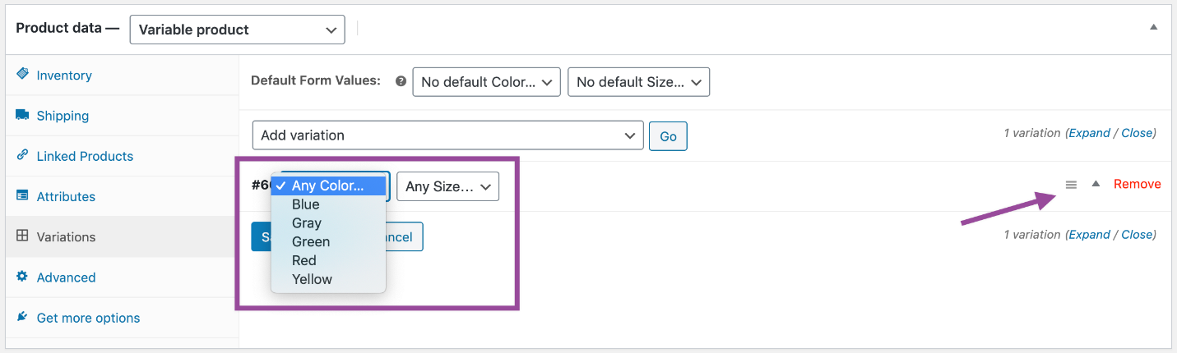
- Edit any available data. The only required field is Regular Price.
- Click Save changes.
Creating All Possible Variations
Select Create variations from all attributes to have WooCommerce create every possible combination of variations and click Go:
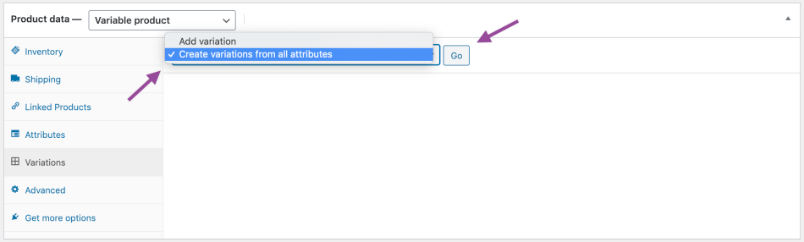
It will create a new variation for each and every possible combination of variation attributes (max 50 per run). If you have more possible combinations you can run it again.
If you have two attributes – color (with values blue and green) and size (with values large and small) it creates the following variations:
- Large Blue
- Large Green
- Small Blue
- Small Green
The user can also have the following customization options available for the variable products:
- Editing Many Variations
If you have more than 15 variations, use the buttons to navigate forward and backward through the list. Each time you navigate to a new set of variations, the previous set is saved. This ensures that all data is saved.
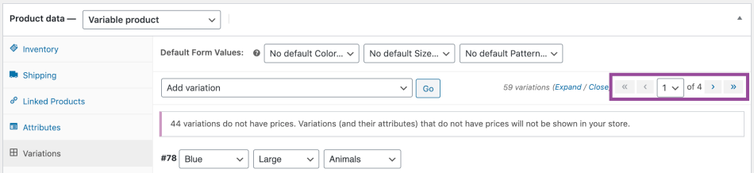

- Setting Defaults
Set defaults you prefer on variations. In the example, no default form values were set, so users can pick any color and size right away from the product page.
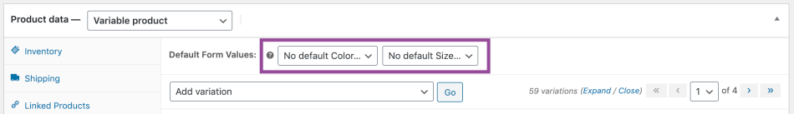

If you want a certain variation already selected when a user visits the product page, choose the default form values. This also enables the Add to Cart button to appear automatically on variable product pages.
You can only set defaults after at least one variation has been created.

- Adding Variation Data
Each variation can have the following properties.
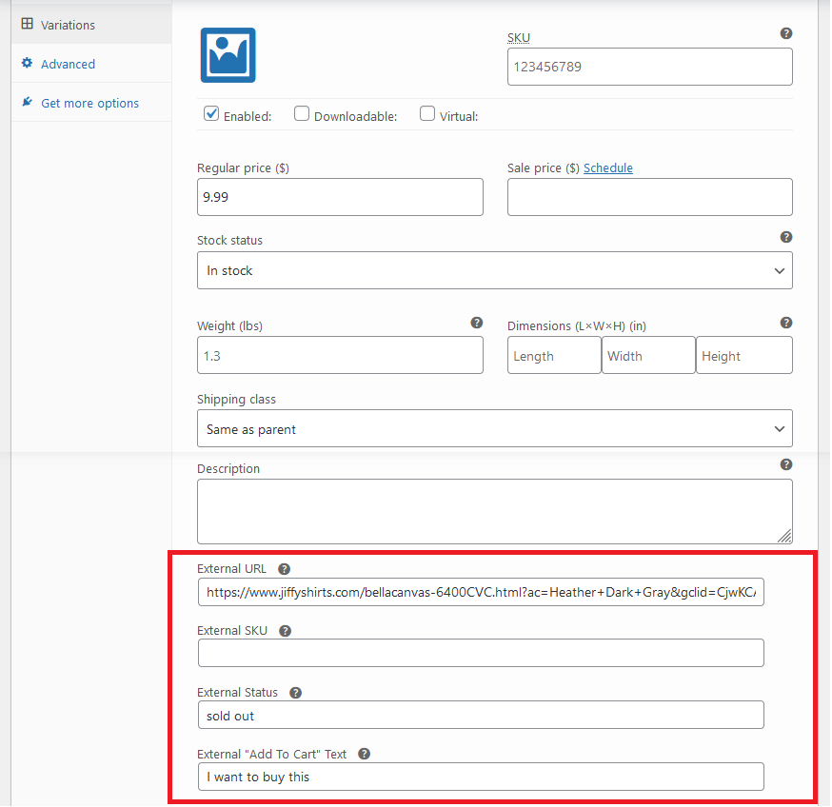

The red highlighted section shows the main properties which are related to this plugin to provide “External URL” features which can be defined on any variation. The external URL then open that link when the user clicks on the “Add to Cart” button.
In addition to the external URL field, a second field called “External SKU” is provided for each variation. The user can set this field and then use the provided “shortcode” to display it. The purpose is to track the external SKU separately from the internal one.

There is now ability to specify the ‘Add to Cart’ button text in a specific variation. If the global setting is set, the variation-specific field will override it.

Bulk Editing
You can bulk-edit variations by selecting the specific piece of data you want from the dropdown. In this example, I want to edit prices for all variations:
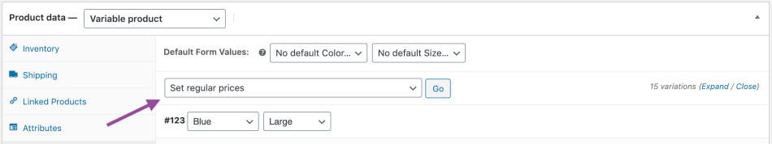

How to Use?
The WooCommerce variable product type lets you offer different options on a product like price, stock, image and related variations like color and size etc. Let’s take an example of a T-Shirt where a user can have choices for sizes and colors like small, medium and large with different colors as shown below:
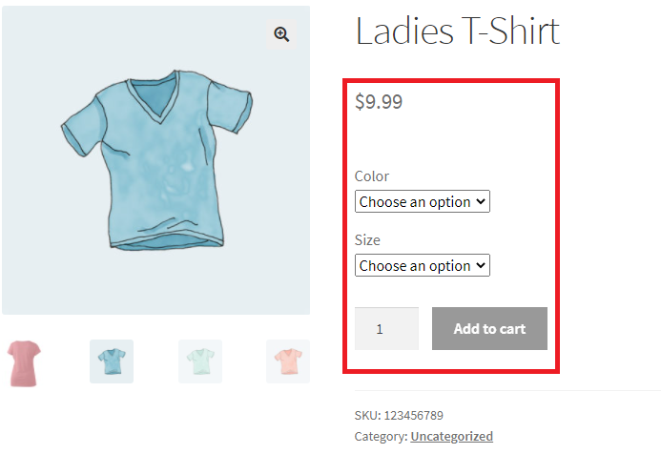
The user can view the images attached with the product along with available product variations / options. When the user selects color and size, the “Add to Cart” button’s text will be changed to “I want to buy this” as this is defined in the product variation settings.
This plugin offers some extra features to the user which are originally not available in the WooCommerce variable product variations settings. The additional variations settings are shown below:
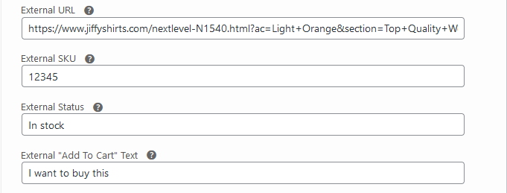
The plugin name “WC External Variations” also gives an idea that this plugin add some features related to external sources. All the variation settings prefixed with “External” keyword are those options which are offered by this plugin.
The user can set the following options:
- External URL
Allows the user to define an external URL on any variation and will then open that link when the user clicks on the “Add to Cart” button.
- External SKU
The user can set this field to track the external SKU separately from the internal one.
- External Status
Shows status of an external product.
- External “Add to Cart” Text
Allows the user to enter a text for the “Add to Cart” button. This text will be displayed, when a user select product variations.

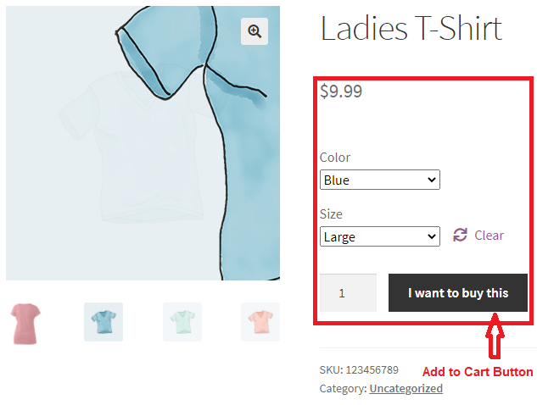
The “WC External Variations” plugin will open “External URL” link, when the user clicks on the “Add to Cart” button as shown below:
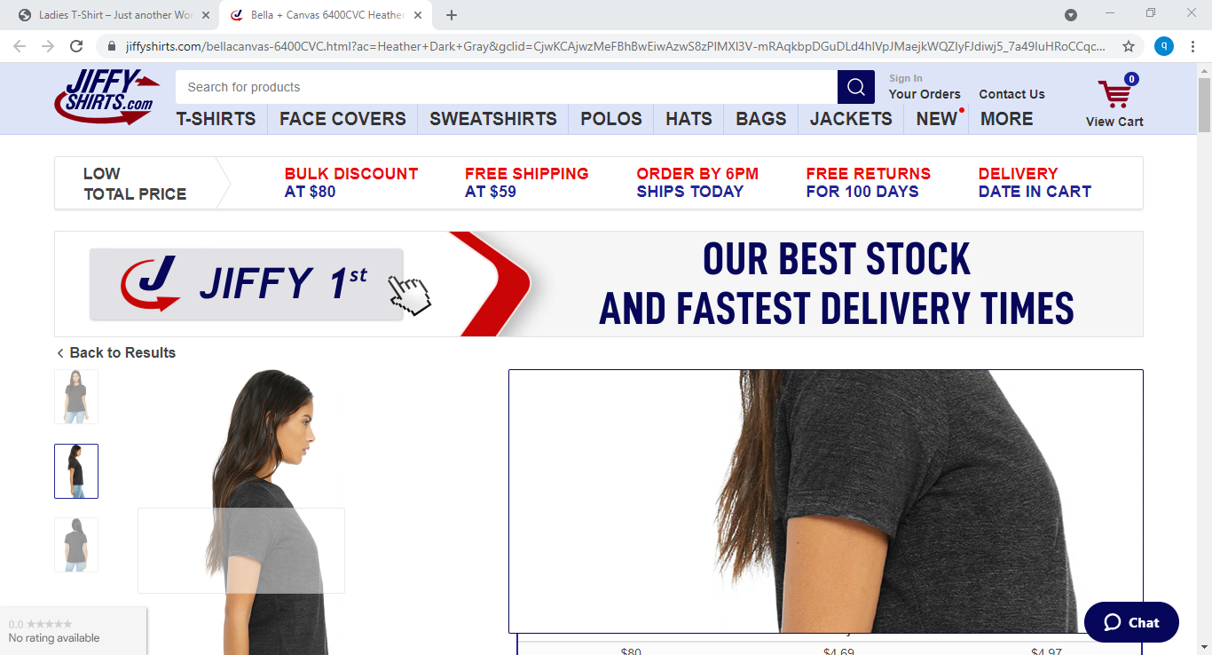
That’s it. The user can easily integrate and use the additional functionality provided by this plugin. The plugin’s user interface and its workflow is very easy and it offers very useful extra features which can added to any variable product variations in the WooCommerce.

FAQ (Frequently Asked Questions)
Do you still have questions and need assistance? Our FAQ section will help you to use the “WC External Variations” plugin.

Why “WC External Variations” plugin for WooCommerce?
To define an external URL on any variation and will then open that link when the user clicks on the “Add to Cart” button. User friendly interface with easy options. If you want to increase user engagement in your site then it’s the best solution.

How to use?
Install and activate. Then go to (Dashboard → WooCommerce → Settings → Products → External Variations) for the plugin settings. Then add a variable product, add product’s attributes and variations. Finally, define the external URL on any variation. That link will be opened when the user clicks on the “Add to Cart” button. That’s it. So easy, Right!!!!!

How do I change the settings of the "WC External Variations" plugin?
To change the settings, go to WooCommerce Settings -> Products -> External Variations.
The following options are available:
- Ability to change if links open in new or same window
- Ability to change if links open when the ‘Add to Cart’ button is clicked or when the variation is selected
- Ability to override the ‘Add to Cart’ button text for all external variations

Is it suitable for any theme?
Yes, “WC External Variations” for WooCommerce will adapt with your theme design.

How do external links open in the same tab?
The plugin was originally coded to open links in a new window. This setting has been added to v1.0.6. The details are available on the “Support” page here: https://wordpress.org/support/topic/how-to-external-links-open-in-same-tab/
All the related details of “WC External Variations” plugin are available on “Support” page here: https://wordpress.org/support/plugin/wc-external-variations/

Advanced Use: Shortcodes.
There are several shortcodes available for advanced users. For more information about what shortcodes are in WordPress and how to use them, see here:
https://codex.wordpress.org/Shortcode
The shortcodes provided by this plugin can be used within the description or other fields for a specific variations. Details can be found on our main plugin page under “Shortcode Support”:
https://wordpress.org/plugins/wc-external-variations/

Abbreviations
Abbreviations used in this document.
Abbreviation | Description
CMS | Content Management System
FAQ | Frequently Asked Questions
LMS | Learning Management System
UI | User Interface
WP | WordPress

Revision History
Identify changes to this document.
Version | Date | Name | Description
1.0.10 | 11/25/2021 | IDN | Initial version created

References
This section contains information about all the references / resources used in this document.
- WordPress:
https://en.wikipedia.org/wiki/WordPress
- WC External Variations
https://wordpress.org/plugins/wc-external-variations/
- Variable Products
https://docs.woocommerce.com/document/variable-product/#prettyPhoto

