**WEB DESIGN**

*Mid Term*

|  |  |
| --- | --- |
| **Course** | Web Design |
| **Exam Type** | **Mid Term** |
| **Duration** | 2 hours |
| **Generation** | GEN-10 |
| **Date** | NOV 20th 2024 |
| **Exam Rules** | * All documents allowed * The following actions are forbidden and will conduct to a 0 score:   + Talking or exchanging information with another student   + Using Internet or any Network |

Evaluation

|  |  |
| --- | --- |
| **Exercise 1** | 20 points |
| **Exercise 2** | 30 points |
| **Exercise 3** | 50 points |

To start

* Read this **document** AND the start **code** (ZIP) from MS TEAM

To submit

* Submit this **document** AND your **code** (ZIP) on MS TEAM

**EXERCISE 1 (20 pts)** *CRITICAL THINKING*

**Q1 – 6 pts**

You need to apply a style to 5 elements on a page.

*Would you* ***use a class, an ID, or a type selector?*** *Justify your choice and explain the potential risks of each method.*

If I need to apply a style to 5 elements on the page and they’re all related and can be put in one class then I’d use class to make the styling more efficient. On the other hand, I would use ID if I had to set a different styling to one element in particular to the others. But I’d rather not use type selector as it would not be efficient to type the style out one by one if not needed.

**Q2 – 3 pts**

You are tasked to design a button with an exact width of 100px, including padding and borders.

*Which* ***box-sizing mode*** *should you use,* ***and why****?*

If tasked to design a button with an exact width of 100px, including padding and borders, I’d choose border-box as border-box takes the size of padding, border and the content.

**Q3 – 3 pts**

You are creating a photo gallery.

*Would you use* ***Flexbox or Grid for the layout****? Explain your decision, considering alignment, responsiveness, and maintenance.*

If I were to create a photo gallery, I would use grid for the layout as grid is used to make 2 dimensions layout, both horizontal and vertical. With grid, we can efficiently align all the items inside the grid, putting gaps so it is pleasing to look. Grid can also made responsive so it can be viewed by devices with different screen sizes. We can also easily make changes to the items inside the grid.

**Q4 – 3 pts**

You need to add space between a button and the text above it.

*Should you use margin or padding on the button? Justify your choice.*

If I need to add space between a button and the text above the button, I would use margin as it adds space the border of the button therefore creating space between the button and the text above it.

**Q4 – 5 pts**

Here is a website folder structure.

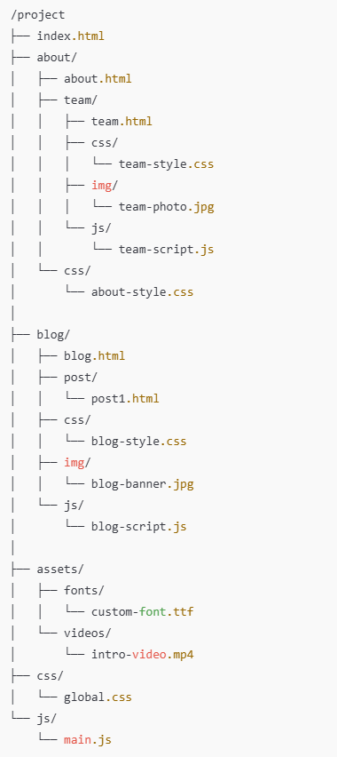

Fill up the table with the **hyperlink**, so that we **can create an anchor link** from the **source folder** to the **destination file**.

|  |  |  |  |
| --- | --- | --- | --- |
| ***PATH TYPE*** | ***SOURCE FOLDER*** | ***DESTINATION FILE*** | ***HYPERLINK LINK*** |
| ABSOLUTE |  | team-style.css | href= “team-style.css” |
| RELATIVE | project/about/team | blog.html | href= “project/blog/blog.html” |
| RELATIVE | project/ blog/css / | team-style.css | href= “project/team/css/team-style.css” |
| RELATIVE | project/ blog/js / | Global.css | href= “project/css/global.css” |
| ABSOLUTE |  | intro-video.mp4 | href= “intro-video.mp4” |

**EXERCISE 2 (30 pts)**

Design the bellow mock up using a **GRID layout**.

**PART 1** *– Main components – 25 pts*

Design the bellow mock up.

* Your need to change both CSS and HTML
* Use the color as the bellow mockup

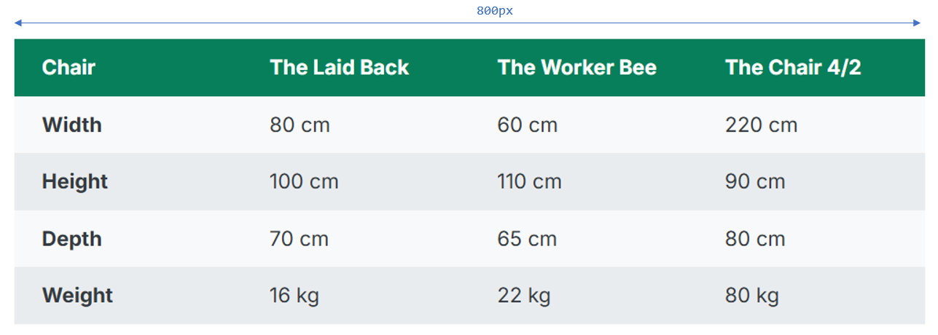

* Each cell should have the same paddings:

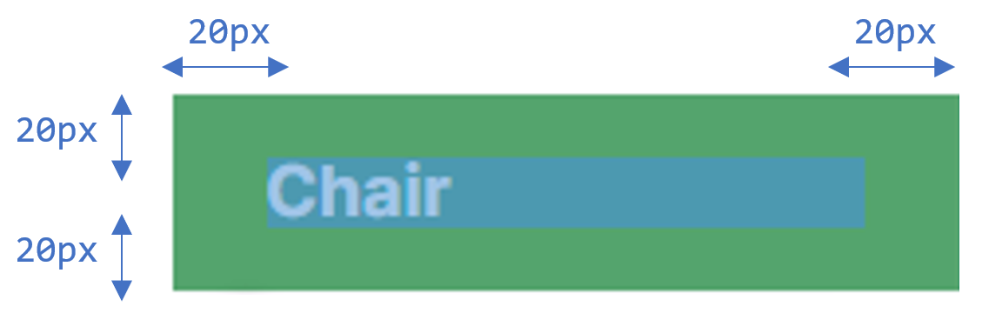

**EXERCISE 3 (50 pts)**

**PART 1** *– Main components – 20 pts*

Design the below mock up using a **GRID layout**. *(No grid layout = no points!)*

* The HTML is provided and **cannot change**.
* *Remaining* means the related row or column **shall stretch** on the available space.

Colors:

* Menu #343a40
* Left Section #7048e8
* Nav #e9ecef

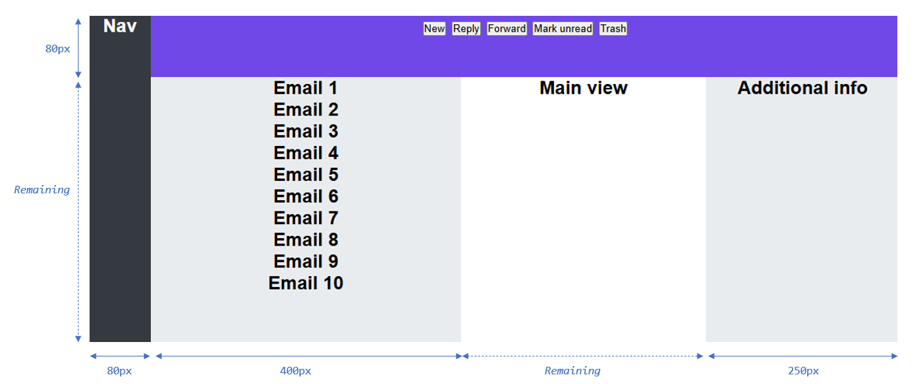

**PART 2** *– Inner elements – 30 pts*

Continue the work by designing the **menu buttons** and **email items**

* Use the types of layouts you want
* Note: the **email section has a scrollbar**: are you able to display it?

Colors:

* Menu button: # 5F3DC4
* Last menu button # d6336c
* Email # adb5bd

