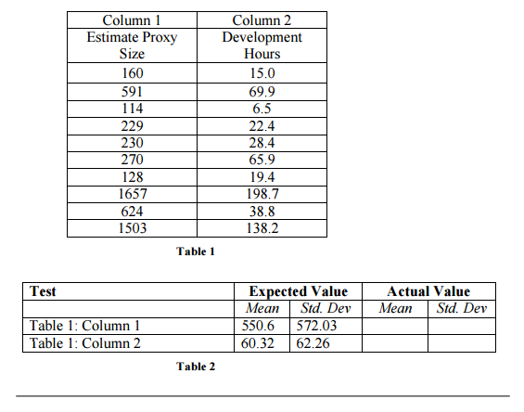

|  |
| --- |
| **Actual Value** |

|  |  |
| --- | --- |
| *Mean* | *Std. Dev* |
| 550.6 | 572.0268 |
| 60.32 | 62.2558 |