PSP Estimating Worksheet

1. Conceptual Design

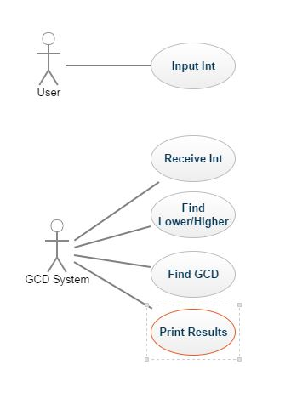

2. Module Estimates

Module Description | Estimated Size
Get Input | 15
Arrange Input | 2
Method to find GCD | 15
Print Results | 8

TOTAL ESTIMATED SIZE: ___40_________

