PROJECT OVERVIEW
Mutual funds have become one of the most preferred investment options in India due to their ability to provide diversified portfolios and long-term wealth creation opportunities. However, investors often face difficulties in comparing schemes, analyzing performance, and understanding risk because financial data is available from multiple sources and in different formats. The Mutual Fund Analytics Platform was developed to solve this problem by integrating publicly available datasets into a centralized analytical platform. The project collects, cleans, transforms, and stores mutual fund data using Python and SQLite before presenting meaningful insights through interactive dashboards and analytical reports. The platform enables users to analyze Net Asset Value (NAV) trends, Assets under Management (AUM), SIP inflows, investor transactions, benchmark performance, and various financial risk metrics. The complete workflow follows a modern ETL (Extract, Transform, and Load) pipeline and demonstrates practical data engineering and business intelligence techniques used in the fintech industry. This project was completed as part of the Data Analyst Internship at Bluestock Fintech and focuses on applying Python, SQL, Power BI, and data analytics techniques to solve real-world financial problems using publicly available datasets. The implementation follows the objectives outlined in the internship capstone project guide.

- PROJECT OBJECTIVE
The primary objective of this project is to build a complete data analytics solution for mutual fund performance analysis by integrating data engineering, business intelligence, and advanced analytical techniques. The project aims to transform raw financial data into meaningful insights that support informed investment decisions.
The key objectives of this project are:
- Develop an end-to-end ETL pipeline to collect, clean, transform, and store mutual fund datasets.
- Perform Exploratory Data Analysis (EDA) to understand investment patterns, fund performance, and investor behavior.
- Calculate important financial performance and risk metrics including CAGR, Sharpe Ratio, Sortino Ratio, Maximum Drawdown, VaR (95%), and CVaR.
- Build interactive Power BI dashboards with KPIs, filters, slicers, and visualizations for business users.
- Implement advanced analytics modules such as Investor Cohort Analysis, SIP Continuity Analysis, Rolling Sharpe Ratio, Sector HHI Concentration Analysis, and Fund Recommendation System.
- Generate business insights that help investors compare mutual funds and evaluate portfolio performance.
- Demonstrate practical applications of Python, SQL, SQLite, Power BI, and GitHub in solving real-world financial analytics problems.
Requirements | Description
ETL Pipeline | Collect, clean, transform and load mutual fund datasets.
EDA | Analyze investment trends and fund performance
Performance Analysis | Calculate financial performance and risk metrics
Dashboard | Develop interactive Power BI dashboards of dashboards and portal interface.
Advance Analysis | Cohort Analysis, VaR, CVaR, Recommender, HHI
Reporting | Generate business reports and actionable insights

PROBLEM STATEMENT
The Indian mutual fund industry generates a large volume of financial data from multiple sources such as AMFI, MFAPI, benchmark indices, and investor transactions. Since these datasets are available in different formats, investors often find it difficult to compare fund performance, evaluate investment risk, and make informed financial decisions. Traditional reporting methods require significant manual effort to collect, clean, and analyze data, making the process time-consuming and error-prone. Moreover, important financial metrics such as Sharpe Ratio, Sortino Ratio, Maximum Drawdown, Value at Risk (VaR), and Conditional Value at Risk (CVaR) are not readily available for comprehensive comparison. Therefore, this project aims to build an automated Mutual Fund Analytics Platform that integrates multiple datasets into a centralized analytical system. The platform enables investors to analyze fund performance, visualize investment trends, measure financial risk, and generate business insights through interactive dashboards and advanced analytics modules. This directly addresses the business challenges outlined in the internship project specification.

- DATA SOURCE AND DATA SET
4.1 Introduction

The Mutual Fund Analytics project uses multiple publicly available datasets collected from trusted financial sources. These datasets were integrated into a centralized analytics pipeline to support performance evaluation, investor behavior analysis, dashboard development, and advanced financial analytics. Before loading into the analytical database, all datasets were cleaned, validated, and transformed using Python-based ETL processes.

4.2 Data Sources
Source | Description | Usage
AMFI | Mutual Fund scheme information | Fund details & AUM
MFAPI | Historical NAV data | NAV analysis & return calculation
NSE/BSE Benchmark Data | Market benchmark indices | Benchmark comparison
Investor Transactions | SIP & investment records | Investor behaviour analysis
Portfolio Holdings | Sector-wise fund allocation | HHI concentration analysis

4.3 Project Dataset
Dataset | Records | Purpose | Status
01_fund_master.csv | 40 | Scheme information | Cleaned
02_nav_history.csv | 46,000+ | Historical NAV | Cleaned
03_aum_by_fund_house.csv | 25+ | AUM analysis | Cleaned
04_monthly_sip_inflows.csv | Monthly | SIP trends | Cleaned
05_category_inflows.csv | Category-wise | Category analysis | Cleaned
06_industry_folio_count.csv | Industry data | Investor analysis | Cleaned
07_scheme_performance.csv | 40 | Performance metrics | Cleaned
08_investor_transactions.csv | 10,000+ | Investor transactions | Cleaned
09_portfolio_holdings.csv | 1000+ | Portfolio allocation | Cleaned
10_benchmark_indices.csv | Historical | Benchmark comparison | Cleaned

4.4 Project Processing Workflow
The datasets were processed using a structured ETL (Extract, Transform, Load) pipeline. Raw CSV files were collected from multiple financial sources, cleaned using Python libraries such as Pandas and NumPy, validated for missing values and inconsistencies, transformed into analysis-ready datasets, and finally loaded into an SQLite database for further analytics. The processed data was then used for Exploratory Data Analysis (EDA), financial performance analysis, advanced analytics, and interactive Power BI dashboard development.

4.5 Technology Stack
Technology | Purpose
Python | Data Cleaning & Analytics
Pandas | Data Manipulation
NumPy | Numerical Computation
Matplotlib | Data Visualization
SQL | Data Querying
SQLite | Database Management
Power BI | Dashboard Development
Git & GitHub | Version Control

Fig 4.1 GitHub Repository Showing Project Structure.

- SYSTEM ARCHITECTURE & ETL PIPELINE
  - Introduction
The Mutual Fund Analytics project follows a structured ETL (Extract, Transform, and Load) architecture to process financial datasets efficiently. The pipeline automates the process of collecting raw data, cleaning and validating records, transforming the datasets into an analysis-ready format, loading the processed data into a SQLite database, and finally generating business insights through Python analytics and Power BI dashboards. The modular architecture improves data quality, minimizes manual effort, and provides a scalable workflow for financial data analysis. Each stage of the pipeline performs a specific task, ensuring reliable and accurate analytical outputs.

  - System Architecture
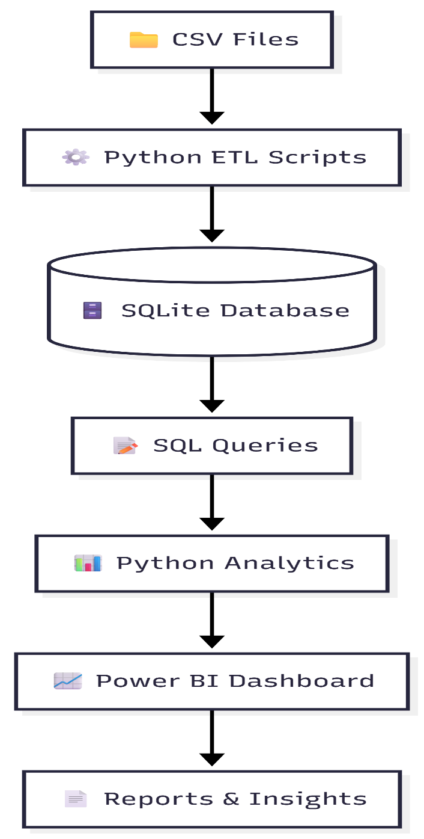

Fig 5.1: Overall ETL System Architecture

- DATABASE DESIGN

6.1 Introduction
The Mutual Fund Analytics project uses SQLite as the backend relational database for storing processed financial data. After the ETL process, all cleaned datasets are loaded into the database, allowing efficient querying, aggregation, and analytics. A structured database design improves data integrity, reduces redundancy, and supports Power BI dashboards and advanced financial analysis.

6.2 Database Architecture
The database follows a star-schema inspired design where dimension tables store descriptive information and fact tables store transactional and performance data. This structure enables efficient SQL queries, faster reporting, and scalable analytics.

6.3 Database Tables
Table Name | Type | Purpose | Key
dim_fund | Dimension | Mutual Fund Information | fund_id
dim_date | Dimension | Date Information | date_id
fact_nav | Fact | Historical NAV Records | fund_id
fact_transactions | Fact | Investor Transactions | investor_id
fact_performance | Fact | Performance Metrics | fund_id

6.4 Database Schema
The database schema was designed to efficiently manage mutual fund data by separating descriptive information from transactional records. Primary keys uniquely identify each record, while foreign keys establish relationships between dimension and fact tables. This design minimizes redundancy and improves query performance.

6.5 SQL Operations
SQL was used extensively throughout the project for querying, filtering, aggregation, and analytical reporting. Queries were written to calculate fund performance, investor statistics, benchmark comparison, sector allocation, and financial risk metrics.

6.6 SQL Features Used
SQL Feature | Purpose
SELECT | Retrieve records
WHERE | Filter data
GROUP BY | Aggregate records
ORDER BY | Sorting
JOIN | Combine multiple tables
Aggregate Functions | SUM(), AVG(), COUNT()
Views | Reporting
Indexing | Faster query execution

6.7 Database Benefits
The database design significantly improves the overall efficiency and reliability of the Mutual Fund Analytics platform by eliminating duplicate records through normalization and ensuring data consistency. It enables faster data retrieval and supports complex SQL queries required for financial analysis and reporting. The structured database also serves as a reliable backend for Power BI dashboards, facilitating real-time visualization and business insights. Furthermore, its scalable architecture allows efficient processing of large financial datasets and supports advanced analytics for informed investment decision-making.

- EXPLORATORY DATA ANALYSIS
7.1 Introduction
Exploratory Data Analysis (EDA) was performed to understand the characteristics of the mutual fund datasets before conducting performance and risk analysis. The objective was to identify trends, detect anomalies, validate data quality, and gain meaningful insights into investor behavior, fund performance, and portfolio distribution. Python libraries such as Pandas, NumPy, and Matplotlib were used to preprocess the data and generate visualizations.
7.2 Data Quality Assessment
Before analysis, the datasets were examined for missing values, duplicate records, inconsistent formats, and invalid entries. Data cleaning techniques such as duplicate removal, missing value handling, datatype conversion, and validation checks were applied to ensure the datasets were accurate and analysis-ready.
7.3 EDA Visualizations
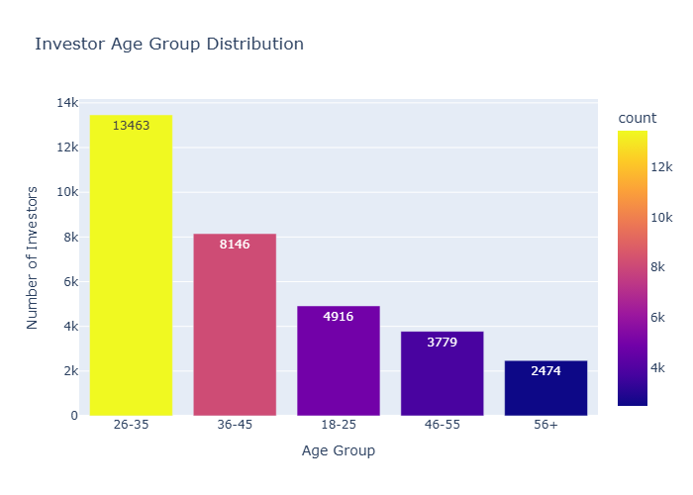
- Age Distribution
Fig 7.1: Age Distribution of Investors

The age distribution analysis indicates that the majority of investors belong to the working-age population, highlighting strong participation from individuals seeking long-term wealth creation through mutual fund investments.
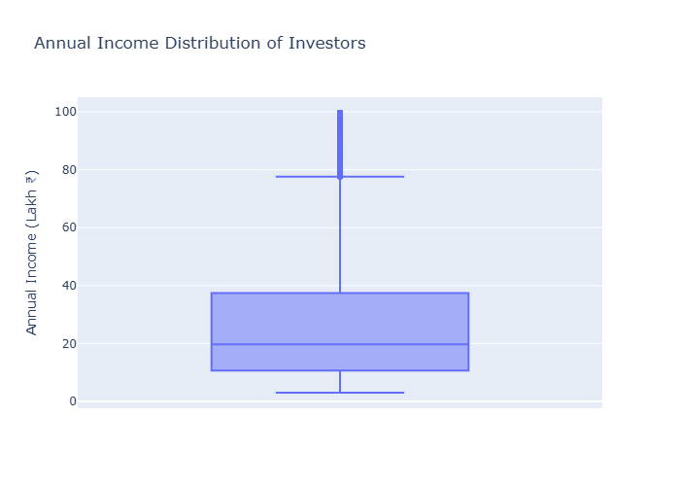
- Income Distribution
Fig 7.2: Income Distribution of Investors
Income distribution analysis shows that investors from different income groups actively participate in mutual fund investments, indicating broad market adoption across various financial segments.

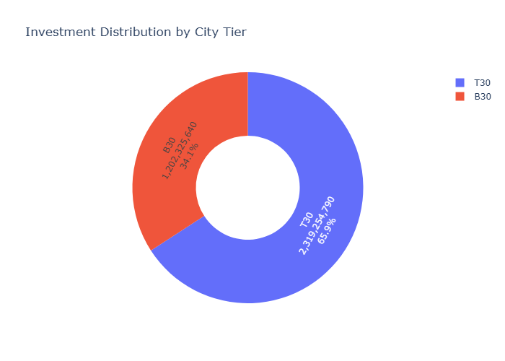
- City Tier Distribution

Fig 7.3: Investor Distribution Across City Tiers
This visualization illustrates the geographical distribution of investors across Tier-1, Tier 2, and Tier-3 cities, helping identify regions with higher investment activity.
- KYC Status
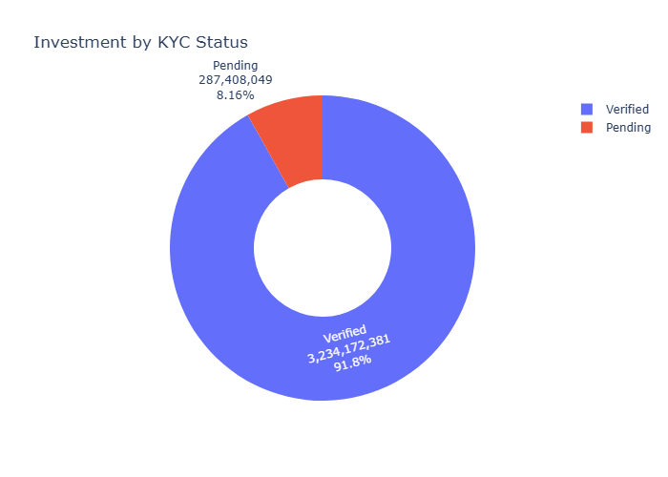

Fig 7.4: KYC Verification Status
The analysis shows that the majority of investors have completed KYC verification, ensuring regulatory compliance and enabling uninterrupted investment transactions.

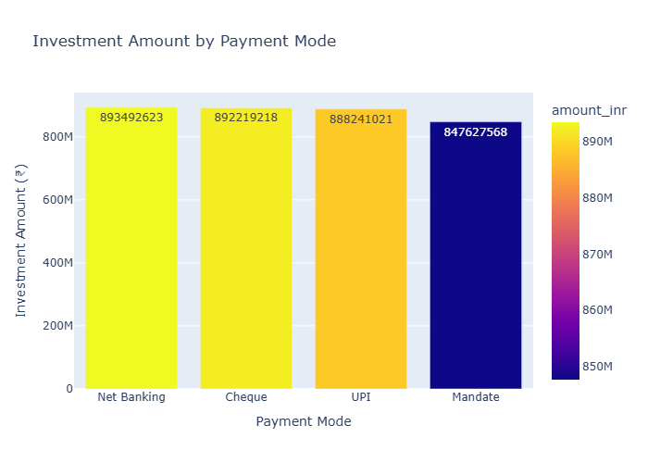
- Payment Mode

Fig 7.5: Payment Mode Distribution
The payment mode analysis highlights the preferred transaction methods used by investors, providing insights into customer payment behaviour.
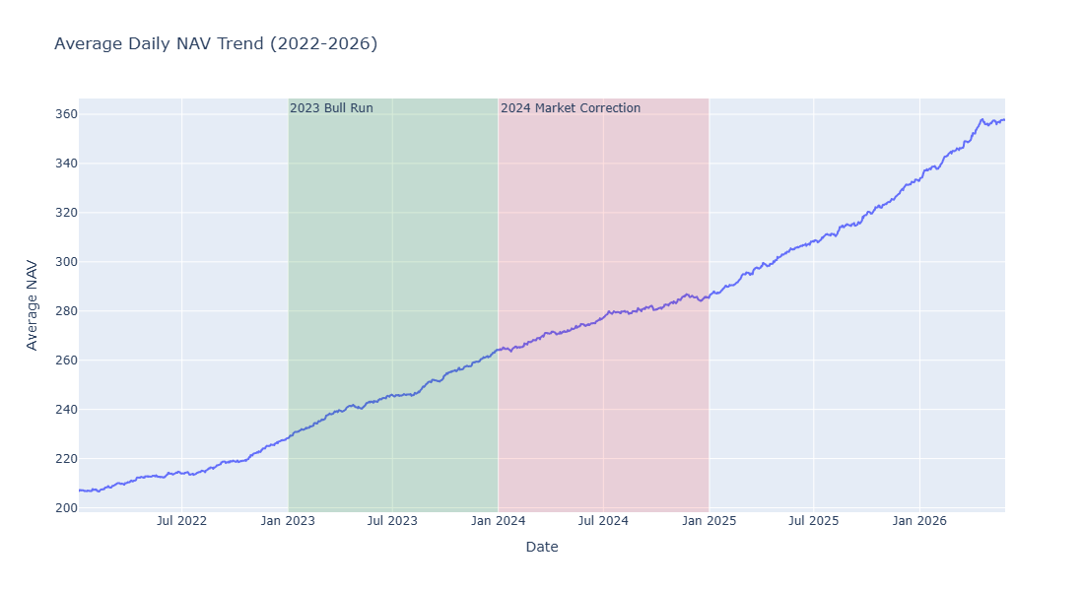
- NAV Trend

Fig 7.6: Historical NAV Trend
Historical NAV analysis demonstrates the long-term growth patterns of selected mutual fund schemes and helps evaluate investment performance over time.

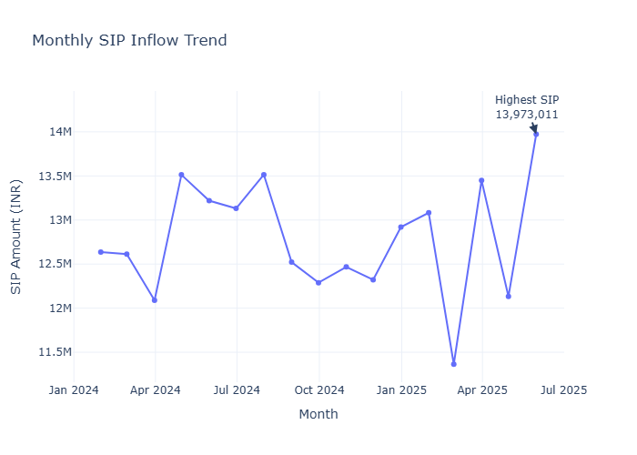
- SIP Trend

Fig 7.7: Monthly SIP Trend
The SIP trend visualization shows monthly investment behavior and indicates the consistency of systematic investment plans among investors.
7.4 Key Insights
- Most investors belong to the working-age population.
- KYC compliance is high across the investor base.
- SIP investments show consistent long-term participation.
- NAV values indicate steady growth for several equity schemes.
- Investor participation is higher in metropolitan and Tier-1 cities.
- Data quality improved significantly after ETL pre-processing.

- PERFORMANCE ANALYSIS
8.1 Introduction
Performance Analytics plays a vital role in evaluating the financial performance, risk, and overall efficiency of mutual fund investment schemes. Unlike simple return analysis, performance analytics considers both returns and the level of risk taken to achieve those returns, providing a more comprehensive assessment of investment quality. In this project, historical Net Asset Value (NAV) data was analyzed using Python to calculate daily returns and several key financial performance indicators. Metrics such as Compound Annual Growth Rate (CAGR), Sharpe Ratio, Sortino Ratio, Maximum Drawdown, Value at Risk (VaR), Conditional Value at Risk (CVaR), and Rolling 90-Day Sharpe Ratio were computed to measure profitability, volatility, downside risk, and consistency of fund performance. These metrics enable objective comparison of multiple mutual fund schemes and help investors understand the balance between return and risk. The insights generated through performance analytics support data-driven investment decisions and provide a strong foundation for financial reporting, risk assessment, and business intelligence dashboards.
8.2 Financial Metrics Used
Metric | Description
CAGR | Measures annualized growth rate of investment
Daily Return | Percentage change in NAV
Sharpe Ratio | Risk-adjusted return
Sortino Ratio | Downside risk-adjusted return
Maximum Drawdown | Maximum portfolio decline
VaR (95%) | Maximum expected loss at 95% confidence
CVaR | Average loss beyond VaR
Rolling Sharpe Ratio | Performance consistency over time

8.3 Performance Analysis
Historical NAV data was processed to calculate daily returns and evaluate long-term fund performance. Risk-adjusted metrics such as Sharpe Ratio and Sortino Ratio were computed to compare returns relative to investment risk. Maximum Drawdown was used to measure downside exposure, while Value at Risk (VaR) and Conditional Value at Risk (CVaR) estimated potential losses under adverse market conditions. Rolling Sharpe Ratio was calculated over a 90-day window to analyze the consistency of fund performance over time.
8.4 Visualizations
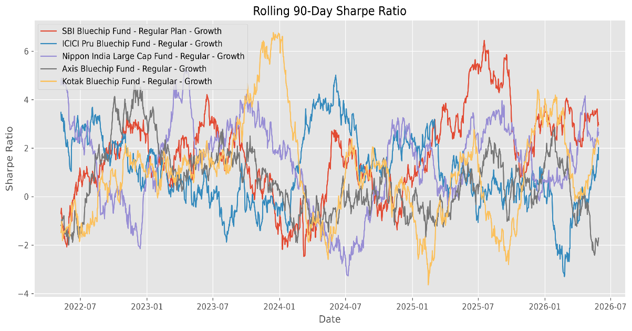
- Rolling Sharpe Chart
Figure 8.1: Rolling 90-Day Sharpe Ratio of Selected Mutual Funds
The rolling Sharpe ratio illustrates how the risk-adjusted performance of selected mutual funds changes over time. Higher values indicate better return generation relative to investment risk.

- VaR / CVaR Report
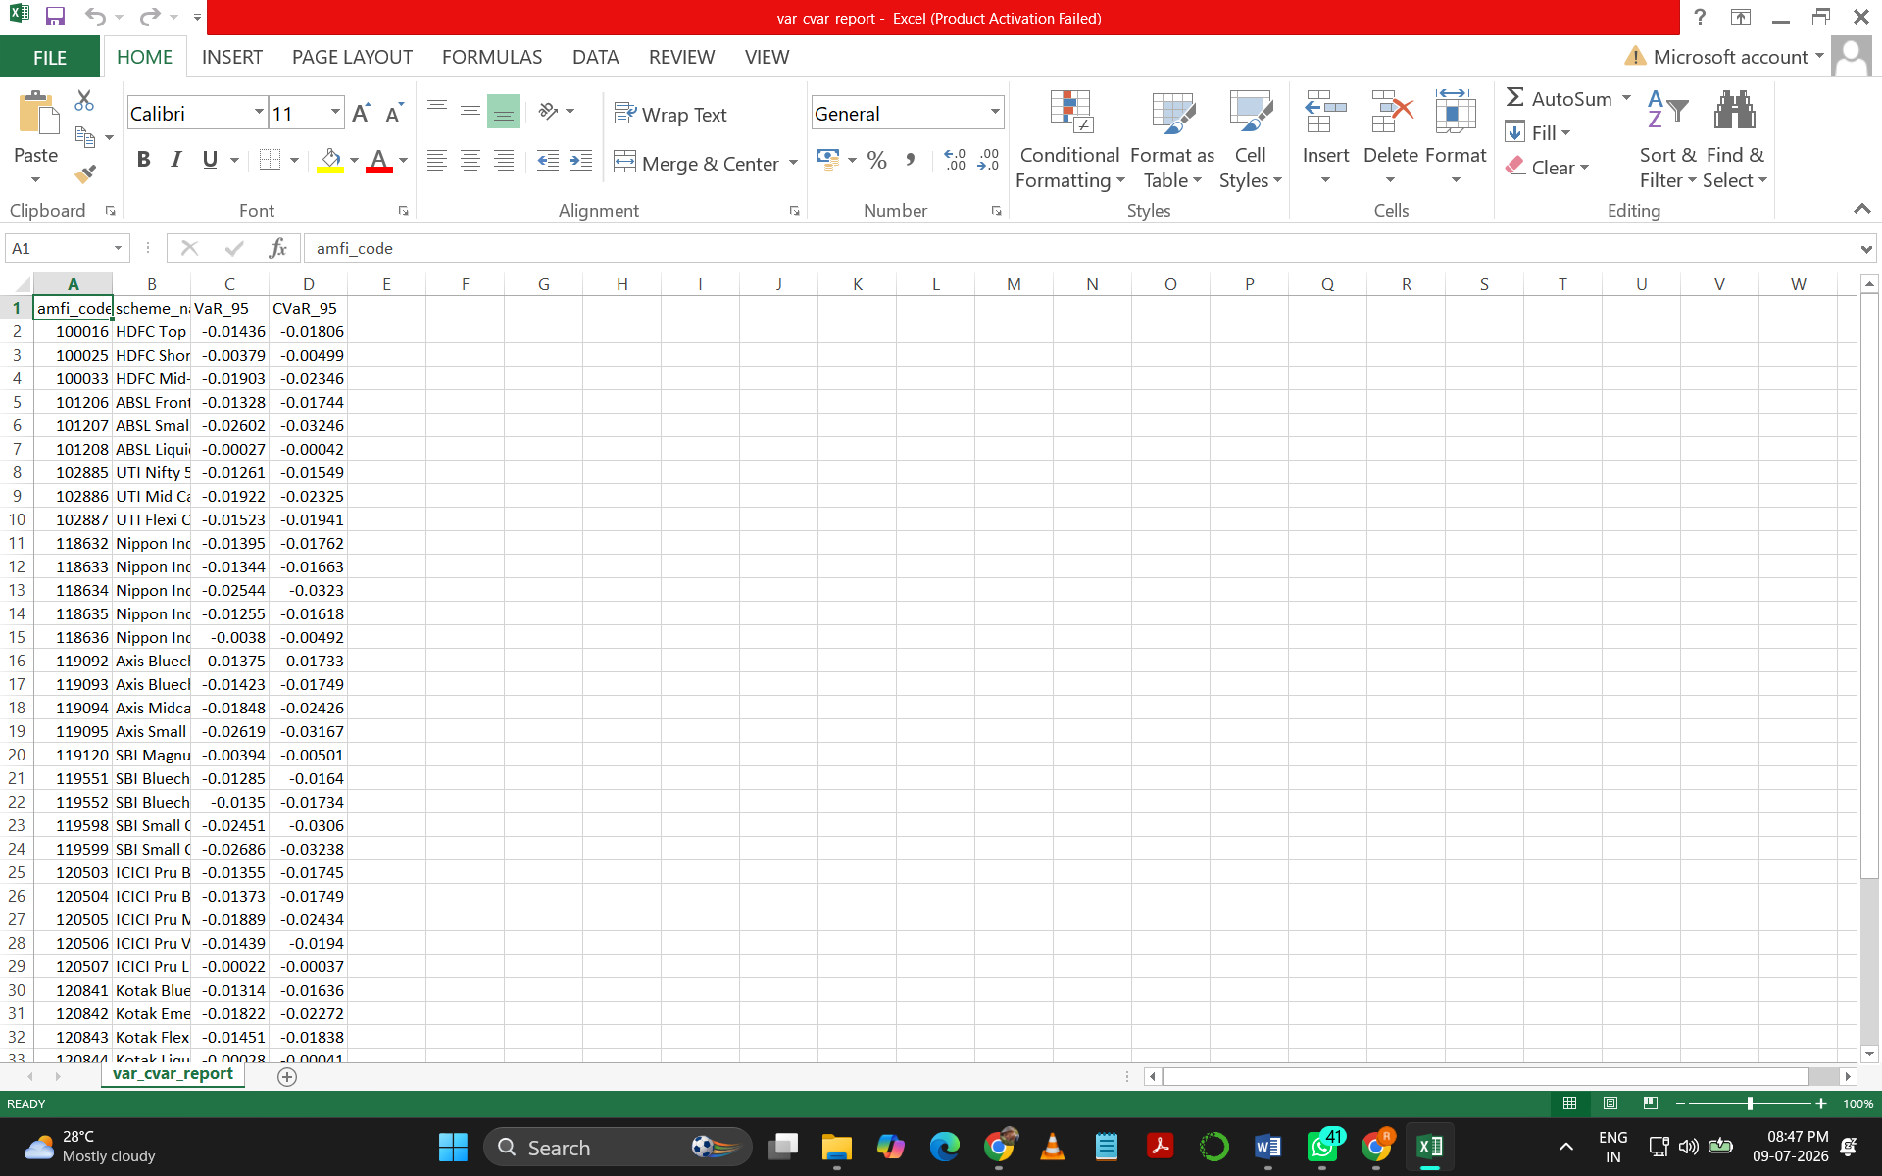

Fig 8.2: Historical VaR (95%) and CVaR Analysis
Value at Risk (VaR) and Conditional Value at Risk (CVaR) estimate potential portfolio losses during unfavorable market conditions, helping investors understand downside risk.

- Fund Performance Table
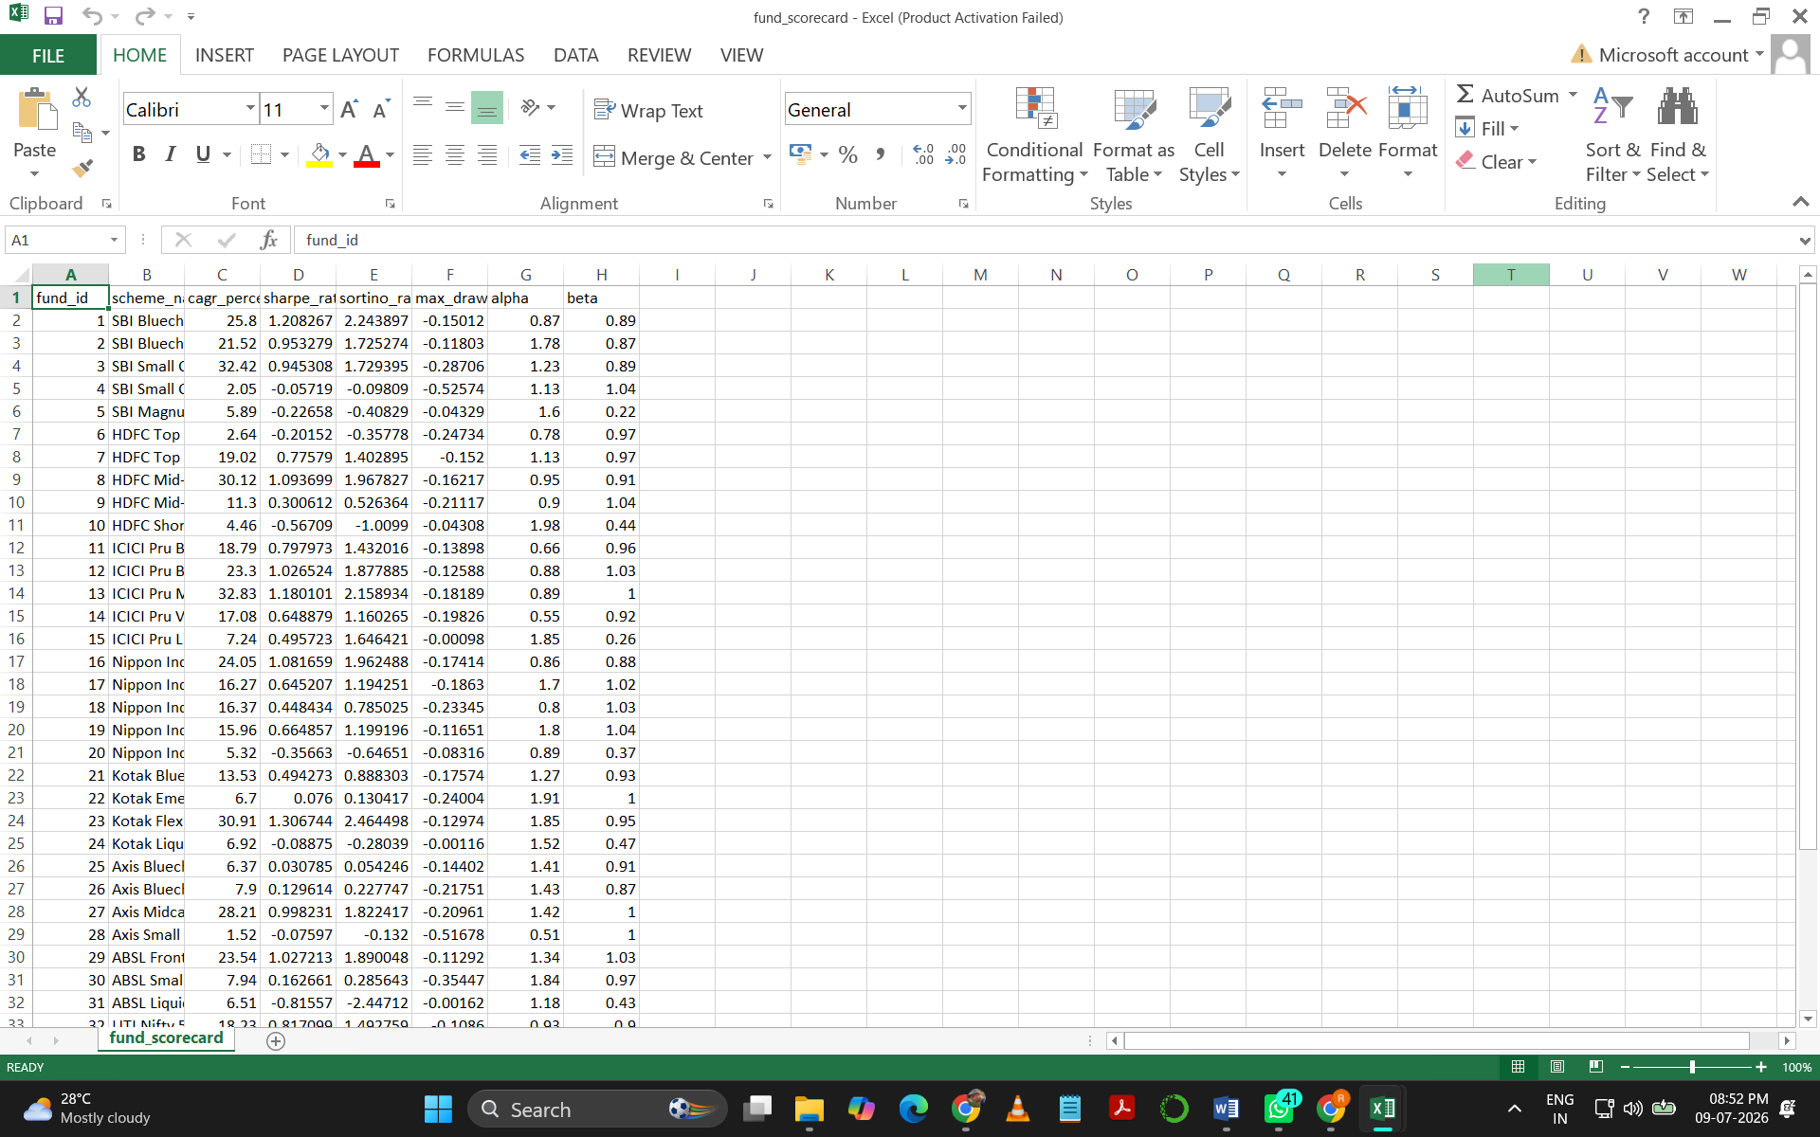

Figure 8.3: Mutual Fund Performance Metrics
This table summarizes important performance indicators including returns, Sharpe Ratio, Sortino Ratio, Maximum Drawdown, and risk classification for selected mutual funds.
8.5 Key Findings
- Risk-adjusted performance varied significantly across mutual fund schemes.
- Rolling Sharpe Ratio highlighted periods of consistent and volatile performance.
- VaR and CVaR effectively quantified downside investment risk.
- Funds with higher Sharpe Ratios generally delivered better returns relative to risk.
- Performance analytics enabled objective comparison of multiple mutual fund schemes.

- DASHBOARD DEVELOPMENT
9.1 Introduction
The final phase of the Mutual Fund Analytics project focused on designing and developing an interactive Power BI dashboard to convert processed financial data into meaningful, easy-to-understand business insights. After completing the ETL pipeline, database design, exploratory data analysis, and performance analytics, the cleaned and structured datasets were integrated into Power BI to create a centralized reporting platform. The dashboard was designed to provide a comprehensive view of mutual fund performance, investor behaviour, portfolio composition, and industry trends through interactive visualizations. The dashboard incorporates multiple visual elements such as KPI cards, line charts, bar charts, pie charts, tables, slicers, and filters, enabling users to analyse data from different perspectives. Users can compare mutual fund schemes across various fund houses, investment categories, and time periods while monitoring key financial metrics such as returns, risk measures, Assets under Management (AUM), and Systematic Investment Plan (SIP) trends. Interactive filters and drill-down capabilities allow users to explore detailed information without requiring technical knowledge of SQL or Python. The primary objective of the dashboard is to support data-driven decision-making by presenting complex financial information in a simple, interactive, and visually appealing format. It enables investors, analysts, and business stakeholders to identify investment trends, evaluate fund performance, assess financial risk, and compare benchmark indices efficiently. The dashboard also serves as the final business intelligence layer of the project, demonstrating how data engineering, analytics, and visualization techniques can be integrated to build a complete end-to-end financial analytics solution.
9.2 Dashboard Objectives
The primary objectives of the dashboard are:
- Present key financial metrics through interactive visualizations.
- Enable comparison of mutual fund performance across different fund houses and categories.
- Analyse investor demographics and transaction behaviour.
- Monitor industry trends using KPIs and time-series charts.
- Provide business users with a centralized analytics platform for investment insights.
9.3 Dashboard Features
Feature | Description
KPI Cards | Display key financial indicators
Interactive Slicers | Filter dashboard by fund, category, state, and date
Charts & Graphs | Visualize trends and comparisons
Tables | Display detailed financial metrics
Drill-down Analysis | Explore data at multiple levels
Business Insights | Support investment decision-making

9.4 Dashboard Pages
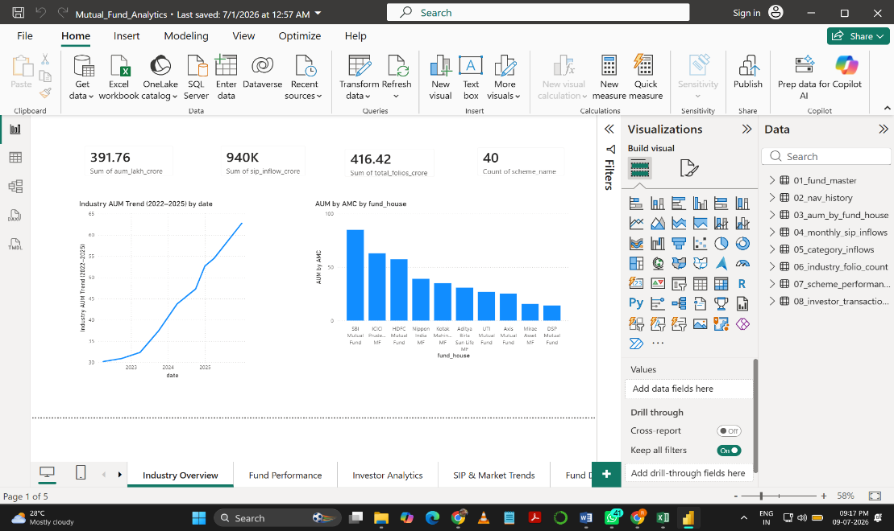
- Executive Overview

Fig 9.1: Executive Dashboard Overview
This page provides a high-level overview of the mutual fund industry using KPI cards, fund performance summaries, and key investment statistics. Interactive filters enable users to analyze different fund houses and investment categories.

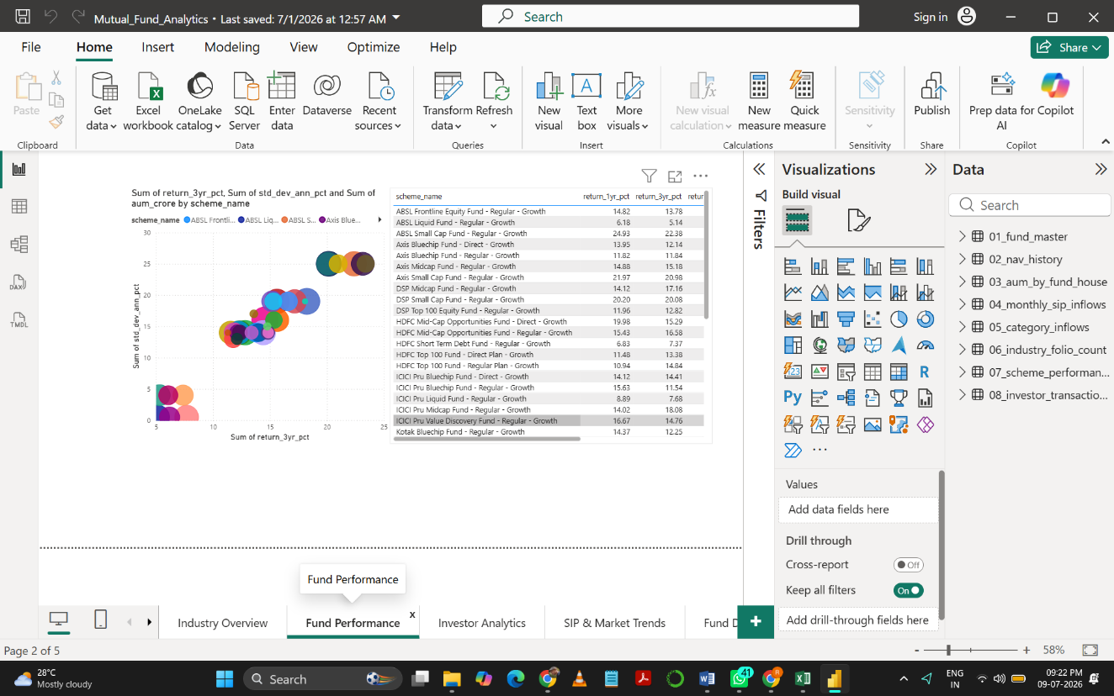
- Fund Performance Analysis
Fig 9.2: Fund Performance Dashboard

This page compares mutual fund schemes using return, risk, and performance indicators. Interactive charts allow users to evaluate fund performance across different categories and benchmark selected schemes.

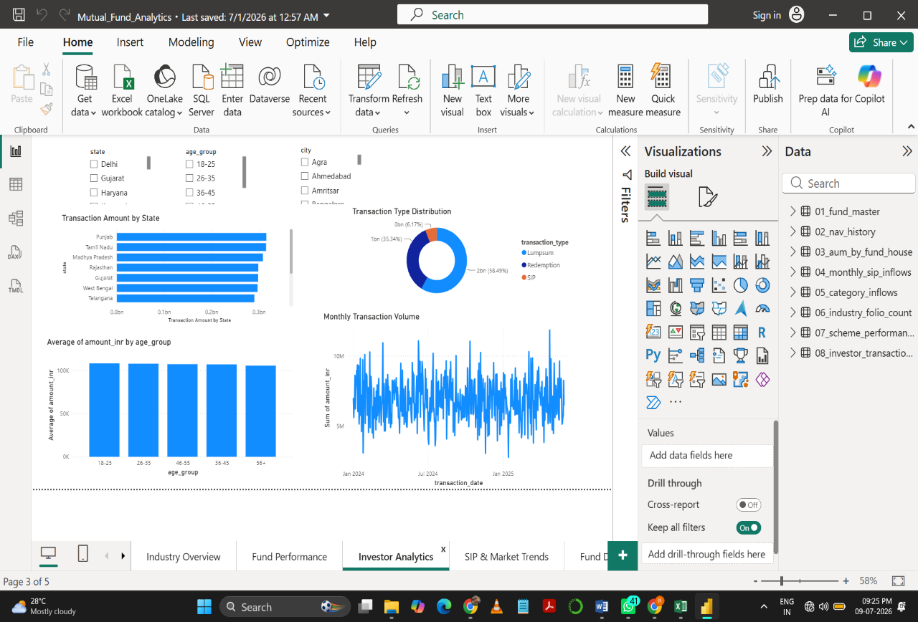
- Investor Analytics
Fig 9.3: Investor Analytics Dashboard
The dashboard visualizes investor demographics, transaction patterns, geographical distribution, and SIP investment behaviour, helping identify customer trends and investment preferences.

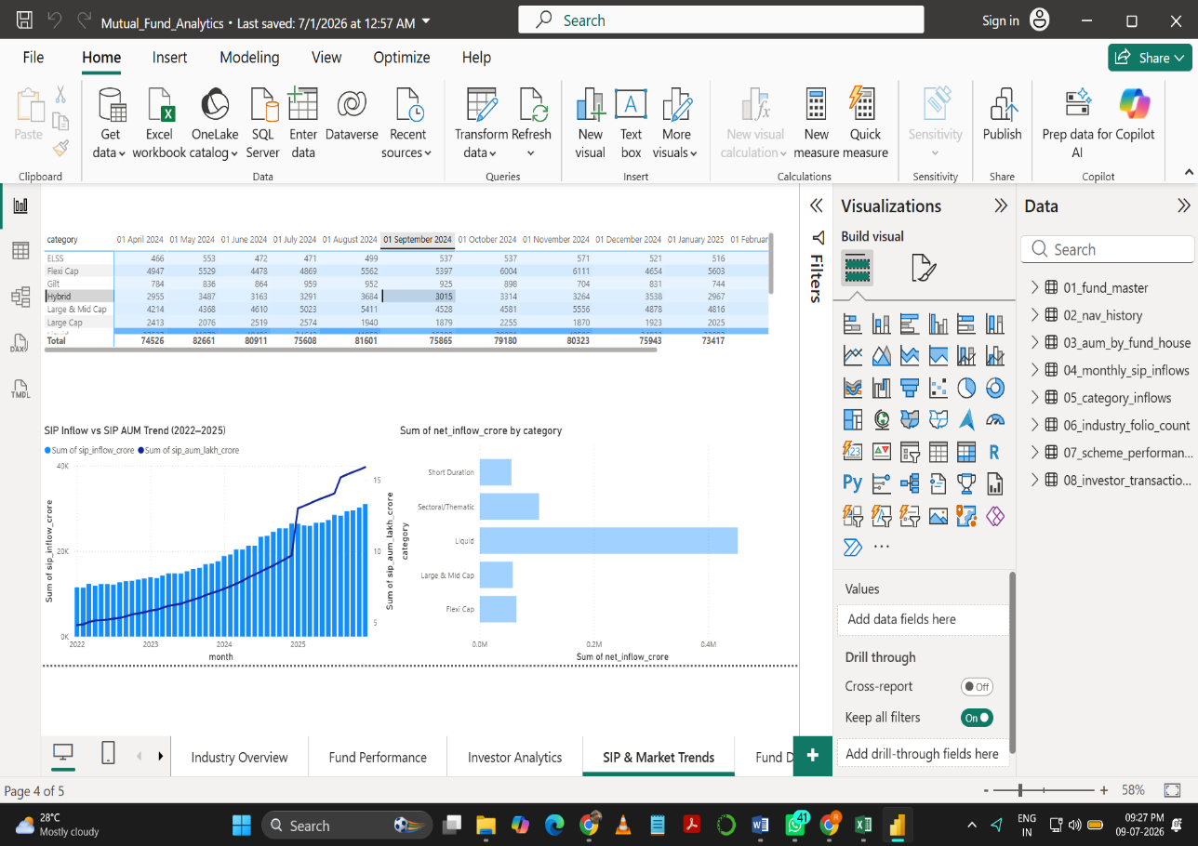
- Industry & Market Trends
Fig 9.4: Industry Trends Dashboard
This page presents industry-level insights including SIP inflows, category-wise investment trends, AUM growth, and benchmark comparisons through interactive visualizations.

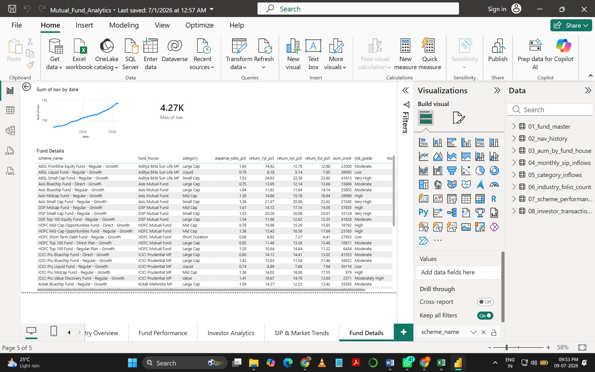
- Fund Details Dashboard
Fig 9.5: Fund Details Dashboard displaying scheme-wise performance, returns, expense ratio, AUM, and risk grade.

The Fund Details dashboard provides detailed information about individual mutual fund schemes, including fund house, investment category, expense ratio, historical returns (1-Year, 3-Year, and 5-Year), Assets Under Management (AUM), and risk grade. It enables users to compare multiple schemes and evaluate their performance using a single interactive interface.

9.5 Key Dashboard Insights
- Interactive filters enable quick comparison across fund houses and investment categories.
- KPI cards provide an overview of important financial indicators.
- Investor analytics reveal demographic and geographic investment trends.
- Industry trend analysis highlights changes in SIP inflows and mutual fund growth.
- Dashboard visualizations simplify complex financial data and improve decision-making.

- ADVANCED ANALYTICS
10.1 Introduction
Advanced Analytics extends traditional data analysis by applying statistical and financial models to extract deeper insights from historical mutual fund data. In this project, advanced techniques such as Value at Risk (VaR), Conditional Value at Risk (CVaR), Rolling Sharpe Ratio, Investor Cohort Analysis, SIP Continuity Analysis, Fund Recommendation System, and Sector HHI Concentration Analysis were implemented to evaluate investment risk, investor behaviour, and portfolio diversification.
10.2 Advanced Analytics Modules
Module | Purpose
Historical VaR (95%) | Estimate maximum expected loss
Conditional VaR (CVaR) | Measure average loss beyond VaR
Rolling Sharpe Ratio | Evaluate risk-adjusted performance over time
Investor Cohort Analysis | Study investor retention
SIP Continuity Analysis | Analyze SIP continuation patterns
Fund Recommendation | Recommend funds based on performance
Sector HHI Analysis | Measure portfolio concentration

10.3 Key Findings
The advanced analytics module provides deeper financial insights beyond traditional return analysis. Risk metrics such as VaR and CVaR help estimate potential investment losses under adverse market conditions, while the Rolling Sharpe Ratio evaluates the consistency of risk-adjusted returns over time. Investor Cohort and SIP Continuity analyses reveal long-term investment behavior and customer retention trends. Additionally, the Fund Recommendation System identifies suitable investment options based on historical performance, and the Sector HHI Analysis measures portfolio diversification by identifying concentration across sectors. These analytics improve investment evaluation and support informed financial decision-making.
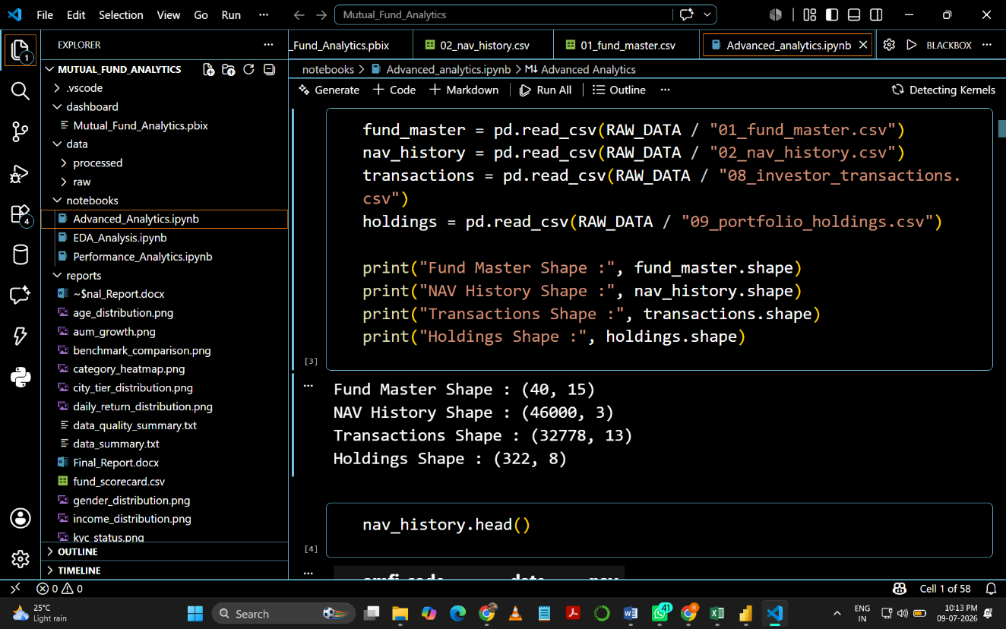
Fig 10.1: Advanced Analytics Module

- Challenges
During the development of the Mutual Fund Analytics project, several technical and analytical challenges were encountered. One of the primary challenges was cleaning and validating multiple financial datasets containing missing values, duplicate records, inconsistent formats, and data quality issues before loading them into the database. Designing a robust ETL pipeline to automate data extraction, transformation, and loading while ensuring data integrity was another significant task. Calculating advanced financial metrics such as Sharpe Ratio, Sortino Ratio, Maximum Drawdown, Value at Risk (VaR), Conditional Value at Risk (CVaR), and Rolling Sharpe Ratio required careful implementation of financial formulas and validation of results. Managing relationships between multiple datasets in SQLite and integrating them seamlessly with Power BI for interactive reporting also required considerable effort. Additionally, optimizing dashboard performance, implementing interactive filters and slicers, and ensuring consistent results across Python, SQL, SQLite, and Power BI were important challenges throughout the project. Overcoming these challenges strengthened the overall quality, reliability, and analytical capabilities of the solution while providing valuable practical experience in building an end-to-end data analytics project.

- Conclusion
The Mutual Fund Analytics project successfully demonstrates the complete end-to-end data analytics lifecycle, beginning with data collection, pre-processing, and transformation, followed by database management, exploratory data analysis, advanced financial analytics, and interactive dashboard development. Throughout the project, multiple financial datasets were cleaned, validated, and integrated using a structured ETL pipeline to ensure data accuracy and consistency. Python was extensively used for data pre-processing, statistical analysis, and financial calculations, while SQLite served as the backend database for efficient data storage and retrieval. SQL was utilized for querying and managing relational data, and Power BI was employed to develop interactive dashboards that effectively present business insights through dynamic visualizations and KPI monitoring. The project implemented several advanced analytical techniques, including Compound Annual Growth Rate (CAGR), Sharpe Ratio, Sortino Ratio, Maximum Drawdown, Value at Risk (VaR), and Conditional Value at Risk (CVaR), Rolling 90-Day Sharpe Ratio, Investor Cohort Analysis, SIP Continuity Analysis, Fund Recommendation System, and Sector HHI Concentration Analysis. These analytics provided a comprehensive evaluation of mutual fund performance, investment risk, investor behavior, and portfolio diversification. The interactive dashboards further enabled users to compare fund performance, analyze investment trends, and make informed financial decisions using real-time business intelligence concepts. Overall, this project enhanced practical knowledge of Data Analytics, ETL development, SQL, Database Management, Financial Analytics, Data Visualization, and Business Intelligence while providing valuable hands-on experience in building a real-world analytics solution. The final system demonstrates how modern data analytics tools and techniques can be integrated to transform raw financial data into meaningful insights, supporting effective decision-making for investors, financial analysts, and business stakeholders.

- Future Scope
The Mutual Fund Analytics project can be further enhanced by integrating live mutual fund APIs to automatically fetch real-time NAV data, eliminating the need for manual data updates and ensuring that the dashboard always reflects the latest market information. Advanced Artificial Intelligence (AI) and Machine Learning (ML) models can be incorporated to predict future mutual fund returns, identify investment patterns, and provide personalized fund recommendations based on historical performance and investor preferences. The solution can also be extended by developing a mobile-friendly dashboard or a responsive web interface, enabling users to monitor investments from smartphones and tablets. Future versions of the project may include an automated email reporting system that periodically sends portfolio summaries, performance reports, and market insights to investors. Portfolio optimization techniques such as the Markowitz Efficient Frontier can be implemented to recommend an optimal asset allocation by balancing expected returns and investment risk. Additionally, Monte Carlo Simulation can be used to forecast future NAV movements under different market scenarios, helping investors evaluate potential outcomes and uncertainties. Finally, the entire analytics solution can be deployed as a Streamlit-based web application, allowing users to access interactive dashboards, financial analytics, and investment recommendations through any web browser without requiring Power BI Desktop.

- References
• https://www.amfiindia.com
• https://www.mfapi.in
• https://learn.microsoft.com/power-bi
• https://pandas.pydata.org
• https://numpy.org
• https://matplotlib.org
• https://plotly.com
• https://docs.python.org
• https://www.sqlite.org
• https://git-scm.com

