Machine Learning
Midterm Assignment Report
Student Name: Mehmet Akif Çetinkaya
Student ID: 23040202006
Course: Machine Learning
1. Loading the Datasets
Two datasets were used for this assignment: the Breast Cancer Wisconsin dataset (binary classification) and the Wine Classification dataset (multi-class classification). The Breast Cancer dataset contains 569 samples with 30 features, classified into 0 (malignant, 212 samples) and 1 (benign, 357 samples). The Wine dataset contains 178 samples with 13 features, classified into three cultivars: Class 0 (59 samples), Class 1 (71 samples), and Class 2 (48 samples). Original scikit-learn labels were strictly preserved.
2. Dataset Quality Checks
For both datasets, missing-value and duplicate-row checks were performed; neither dataset contained missing values or duplicate rows. All feature types were numerical (float64). Using the IQR method, potential outliers were detected. For example, in the Breast Cancer dataset, "mean area" showed extreme values, and in the Wine dataset, "proline" and "magnesium" had outliers. These outliers were not deleted because they represent genuine natural or medical variations, but their presence underscored the absolute necessity of feature scaling, particularly for distance-based algorithms like KNN.
3. Exploratory Data Analysis (EDA)
Descriptive statistics (mean, median, min, max, std, Q1, Q3) were computed for all features. For the Breast Cancer dataset, the correlation heatmap revealed strong relationships between size-based features. The top three most correlated unique pairs were "mean radius" & "mean perimeter", "mean radius" & "mean area", and "mean perimeter" & "mean area". Boxplots confirmed vastly different feature ranges, with "mean area" ranging up to 2500 while "mean smoothness" remained close to 0.

For the Wine dataset, similar varying scales were observed in boxplots (e.g., "proline" values over 1600 vs. "nonflavanoid_phenols" below 1), further emphasizing the need for standardisation prior to distance calculations.
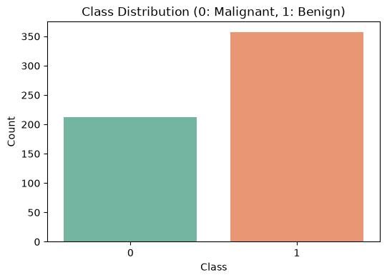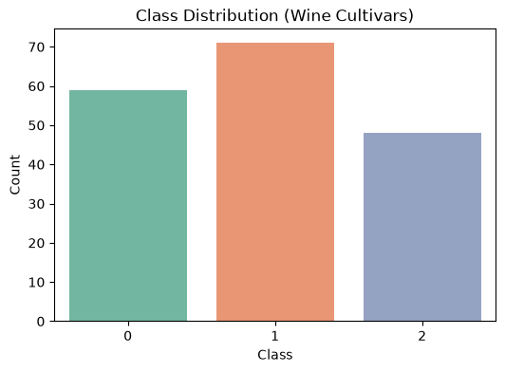
Figure 3.1:Class Distrubution Breast Figure 3.2: Class Distrubution Wine
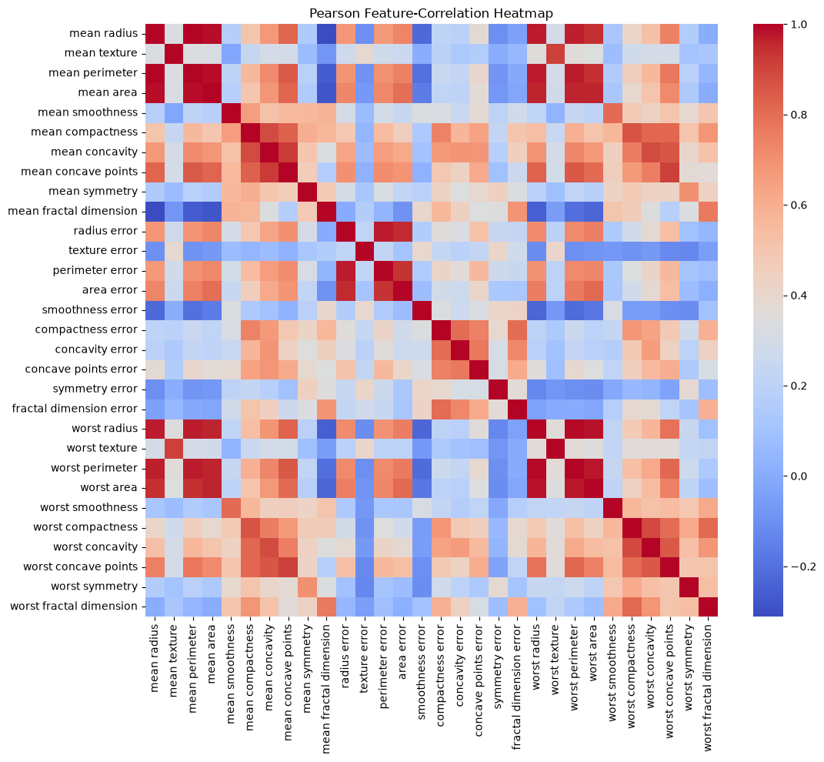
Figure 3.3: Correlation Heatmap Breast
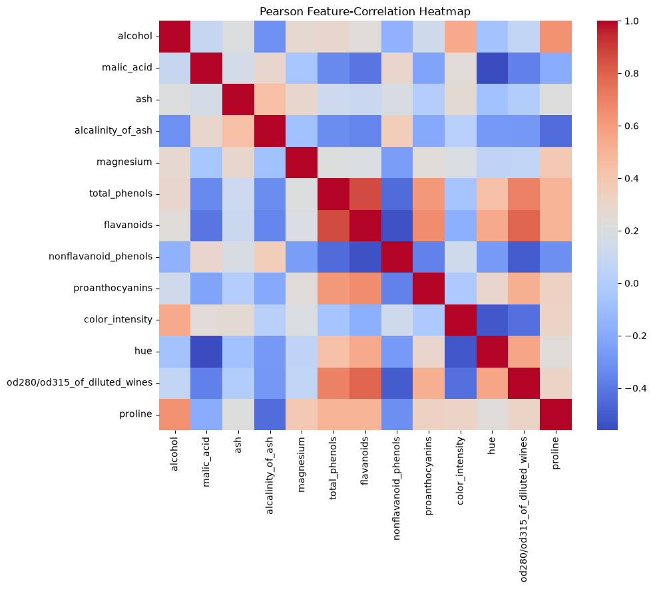
Figure 3.4: Correlation Heatmap Wine
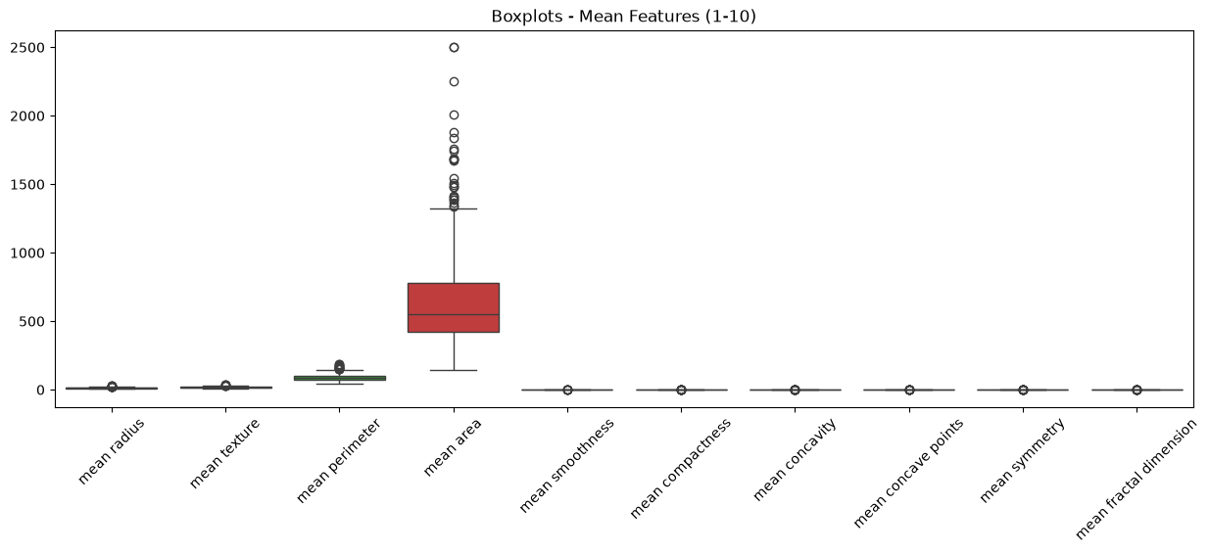
Figure 3.5: Boxplot Mean Breast
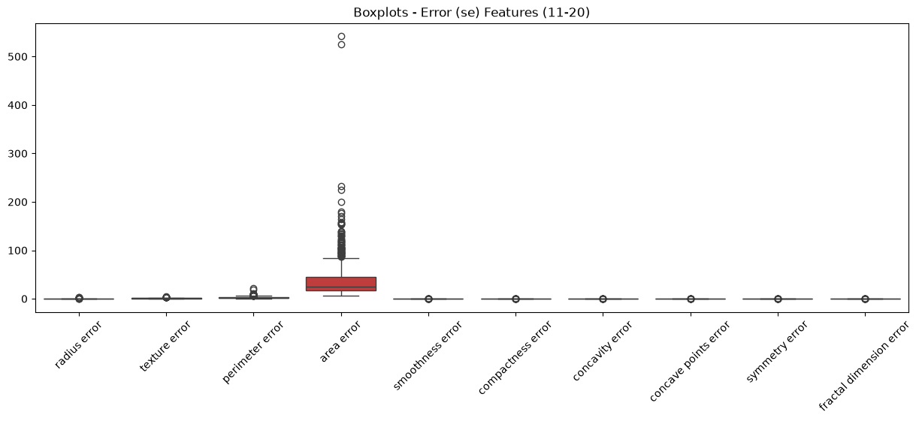
Figure 3.6: Boxplot Error Breast
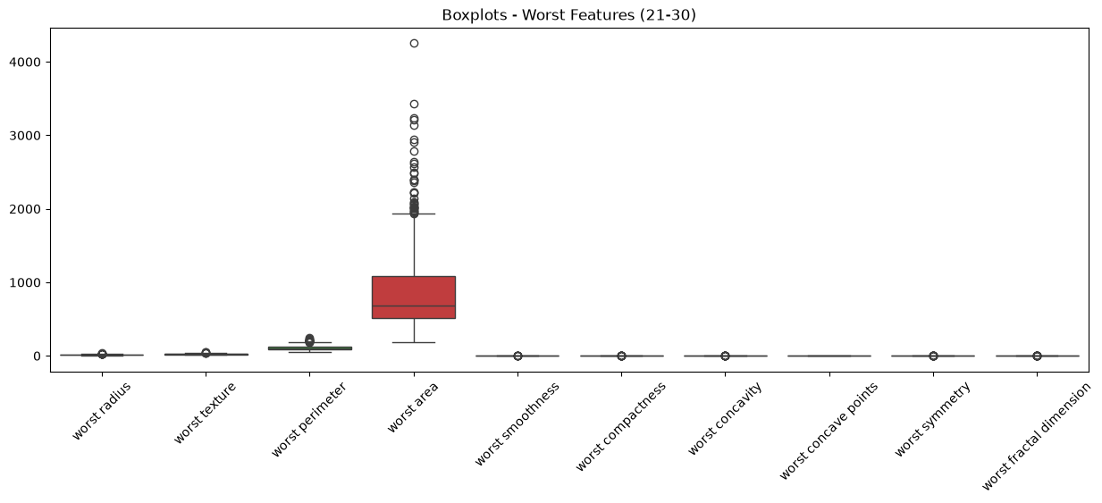
Figure 3.7: Boxplot Worst Breast
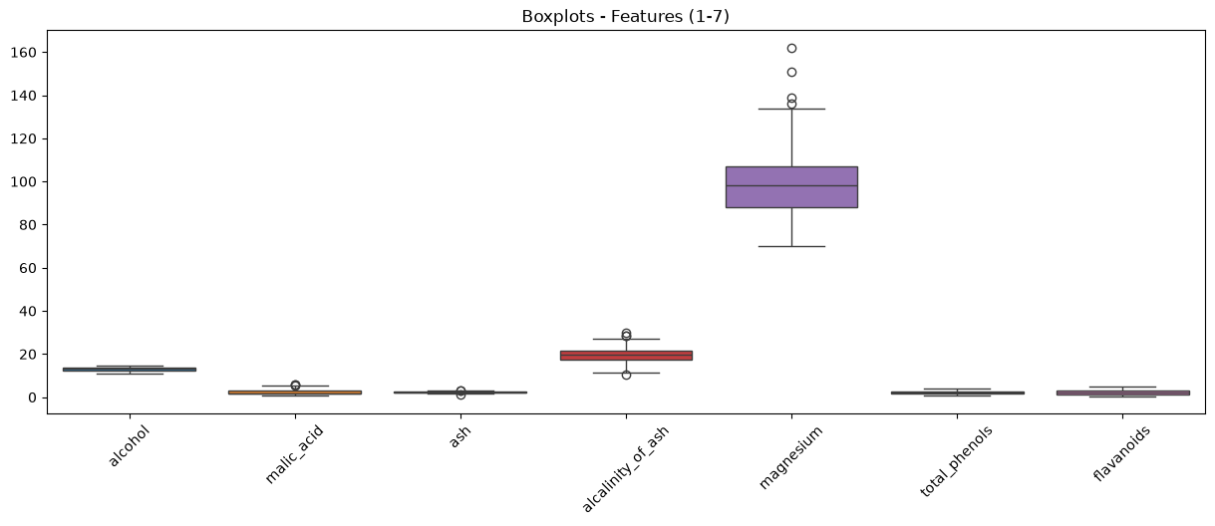
Figure 3.8: Boxplot Features 1-7 Wine
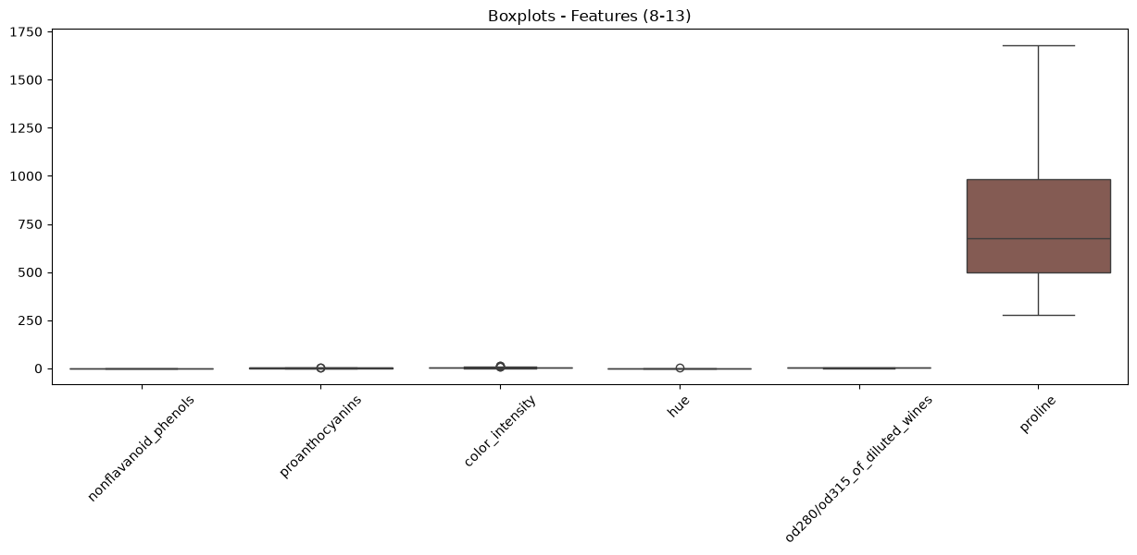
Figure 3.9: Boxplot Features 8-13 Wine
4. Splitting the Datasets
To ensure reliable evaluation, a fixed 20% test set was reserved initially using train_test_split with random_state=42 and stratification. This fixed test set remained untouched during training. The remaining 80% was repeatedly split into a 70% training subset and a 10% validation subset using three specific seeds (42, 52, 62). Verification confirmed that the fixed test indices remained identical across all three repetitions, and no overlap occurred between the training and validation subsets within any specific seed run.
5. Data Preprocessing and Scaling
Since no missing values were present, imputation was bypassed. StandardScaler was chosen as the preprocessing method for both datasets and all seeds because distance-based classifiers (like KNN) are highly sensitive to unscaled features with large ranges (e.g., mean area, proline). To rigorously prevent data leakage, six separate scaler instances were fitted exclusively on their respective training features (one for each dataset-seed combination). The fitted scalers were then used to transform the corresponding training, validation, and test subsets.
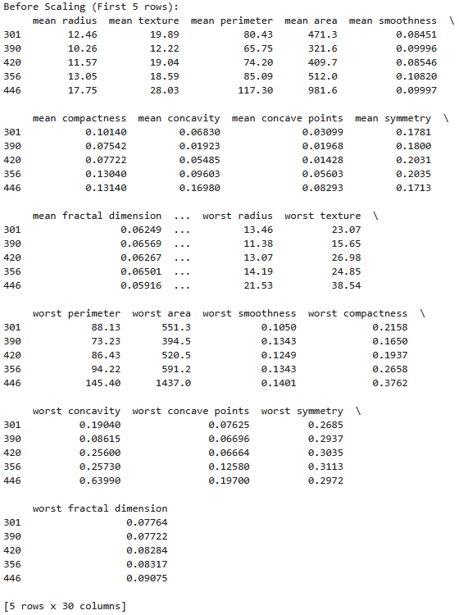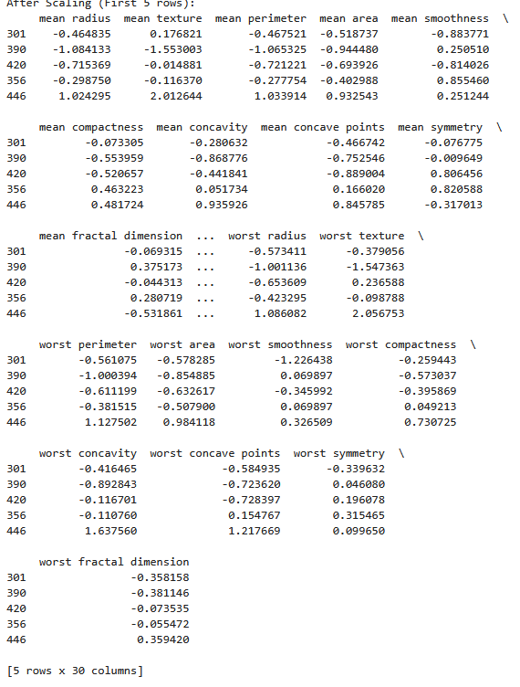
Figure 5.1: Before Scaling Breast Figure 5.2: After Scaling Breast
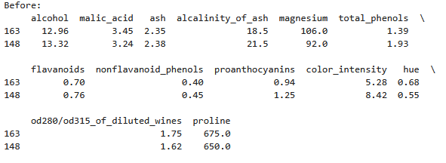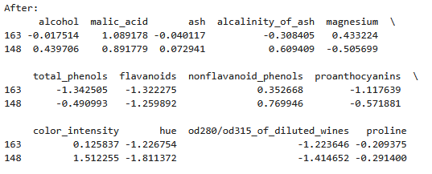
Figure 5.3: Before Scaling Wine Figure 5.4: After Scaling Wine
6. Preparing the Two Data Representations
For every dataset and seed combination, two data representations were maintained with identical sample indices:
Unscaled: The original features.
Scaled: The features transformed by the StandardScaler fitted on the training data. All subsequent model experiments were conducted on both representations to comparatively evaluate the effect of standardisation.
7. Training the Classification Models
Three algorithms were trained: Decision Tree (max_depth = 2, 3, 5, 10, None), KNN (n_neighbors = 1, 3, 5, 7, 11), and Gaussian Naive Bayes (default). Every configuration was trained on both representations across all three seeds. This resulted in exactly 66 model fits for the Breast Cancer dataset and 66 model fits for the Wine dataset, totaling 132 classifier runs. Fits were strictly performed on the training subsets.
8. Measuring Validation Performance
For all 132 runs, validation performance was measured using Accuracy, macro-Precision, macro-Recall, macro-F1, and ROC-AUC. For Breast Cancer, malignant (Class 0) was designated as the positive class for ROC-AUC. For Wine, a multi-class One-vs-Rest (ovr) macro-averaged ROC-AUC approach was implemented.
8.2 Classifier Summaries (22 Configurations per Dataset)
The mean and sample standard deviation (ddof=1) of the validation metrics across the three seeds were calculated for the 22 configurations.
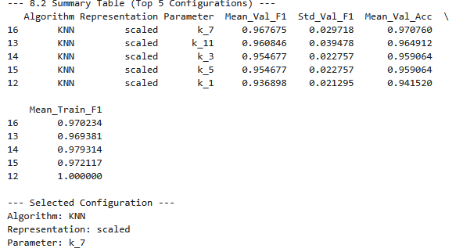
Figure 8.1: Classifier Summary Table Breast
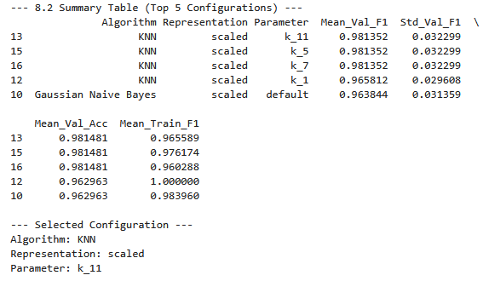
Figure 8.2: Classifier Summary Table Wine
Selection & Parameter Comparison: Based strictly on the highest mean validation macro-F1 score (using accuracy and standard deviation as tie-breakers), the selected configuration for both datasets was KNN on Scaled Representation with 7 Neighbors (k=7).
The parameter comparison figures reveal that Decision Trees suffered from severe overfitting on the unscaled data; as depth increased beyond 3 or 5, training macro-F1 approached 1.0 while validation stalled or declined. Scaling had minimal impact on tree performance. Conversely, KNN exhibited extreme sensitivity to scaling. Unscaled KNN failed to generalise effectively across all neighbor counts, whereas scaled KNN demonstrated a balanced bias-variance trade-off, peaking at k=7 for both datasets.
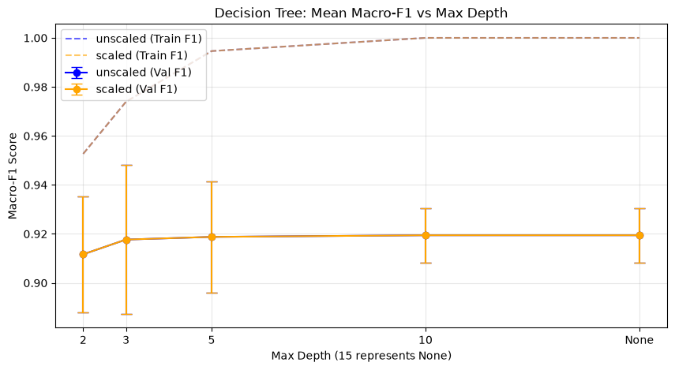
Figure 8.3: Tree Depth Breast
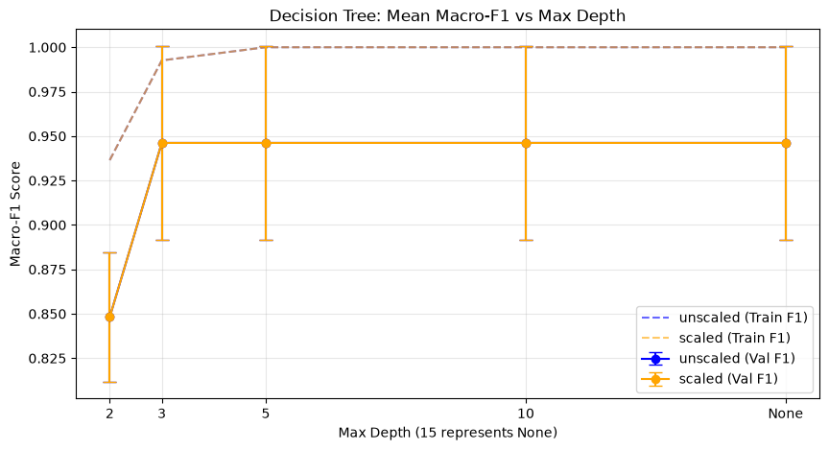
Figure 8.4: Tree Depth Wine
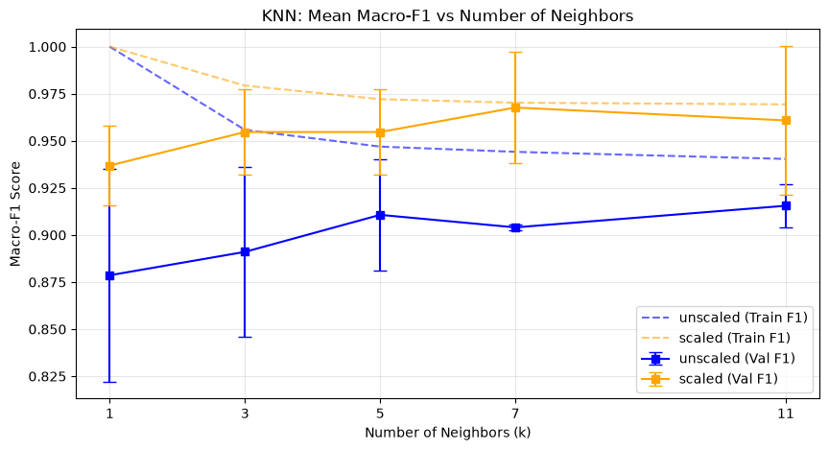
Figure 8.5: Neighbor Count Breast
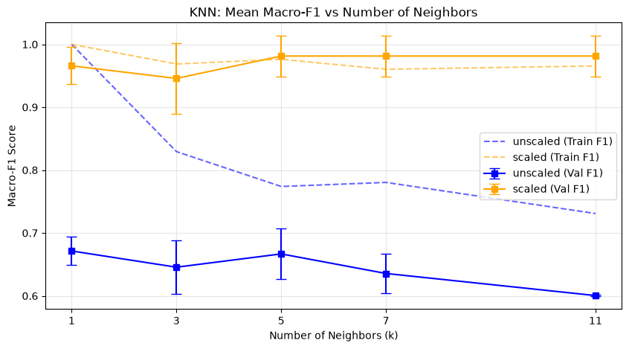
Figure 8.6: Neighbor Count Wine
9. Evaluating the Selected Models on the Test Sets
The single, pre-declared Seed 42 instance of the chosen configuration (KNN, Scaled, k=7) was evaluated on the strictly isolated test sets.
9.1 Final Performance Metrics & Confusion Matrices
Breast Cancer Test Evaluation (Seed 42):
The classification report showed strong predictive capability.
Manual Check (Malignant/Class 0): True Positives = 39, False Negatives = 3, False Positives = 0, True Negatives = 72.
Manual Precision: 39 / (39 + 0) = 1.000
Manual Recall: 39 / (39 + 3) = 0.9286
Manual F1: 0.9630. These matched the software report.
Wine Test Evaluation (Seed 42):
The confusion matrix displayed a perfect diagonal (Class 0: 12, Class 1: 14, Class 2: 10) with exactly zero misclassifications.
Manual Check (Class 0): TP = 12, FN = 0, FP = 0, TN = 24.
Manual Precision: 12 / 12 = 1.000
Manual Recall: 12 / 12 = 1.000
Manual F1: 1.000.
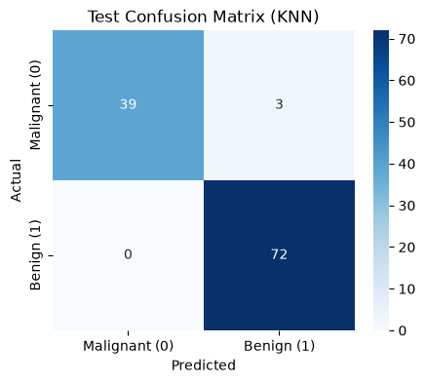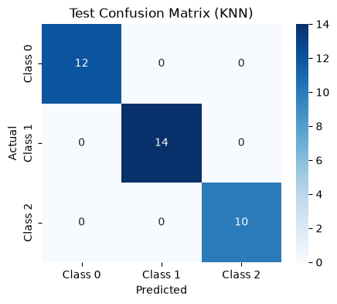
Figure 9.1: Test Confusion Matrix Breast Figure 9.2: Test Confusion Matrix Wine
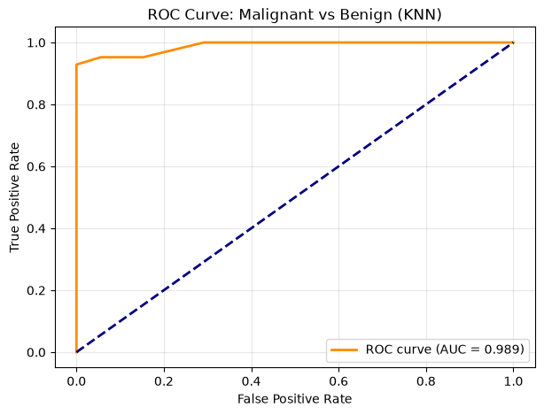
Figure 9.3: ROC Curve Breast
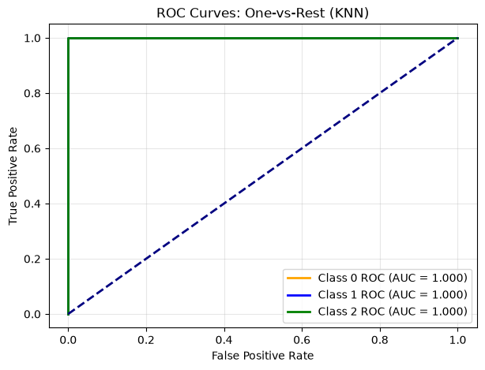
Figure 9.4: ROC Curve Wine
9.4 Error Interpretation
For the Breast Cancer dataset, the confusion matrix revealed 3 False Negatives (malignant cases predicted as benign). In a medical context, this is the most perilous error, as an untreated malignant tumor poses a severe health risk. Lowering the decision threshold on the ROC curve could capture these cases at the expense of higher False Positives. For the Wine dataset, the model produced zero test errors. However, this single error-free result on a small 36-sample test subset does not establish perfect generalisation. It implies that the chemical properties in this specific sample are highly separable when scaled, but noisy, real-world data would inevitably induce errors.
10. K-Means Clustering
A total of 12 K-Means fits (2 datasets × 2 representations × 3 seeds) were conducted strictly on the training features (without labels) using n_init=10. Breast Cancer used 2 clusters; Wine used 3 clusters.
10.2 & 10.3 Final Cluster Evaluation & Interpretation
The Seed 42 K-Means models were evaluated on the fixed test sets. Scaling had a profound effect on clustering. For both datasets, the unscaled contingency tables demonstrated highly mixed clusters because features with massive scales (e.g., 'mean area' or 'proline') monopolized the Euclidean distance calculations. In the scaled representations, all features contributed equally, drastically improving the Adjusted Rand Index (ARI) score. However, because K-Means is entirely unsupervised and seeks geometrical structures rather than semantic labels, it could not perfectly recreate the exact true classes, especially in the 3-class Wine dataset.
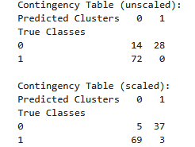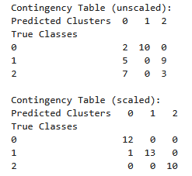
Figure 10.1: Contingecy Table Breast Figure 10.2: Contingency Table Wine
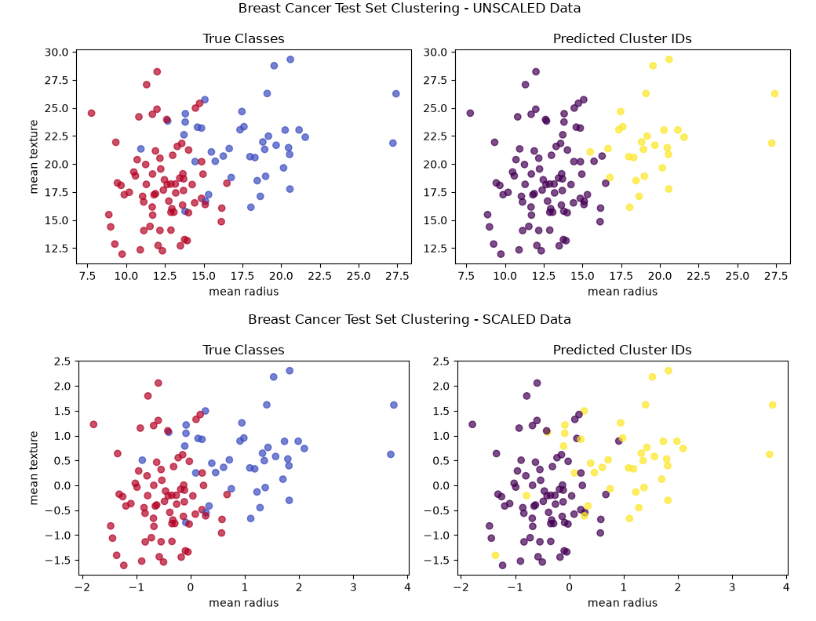
Figure 10.3: 4 Paired Visulations Breast
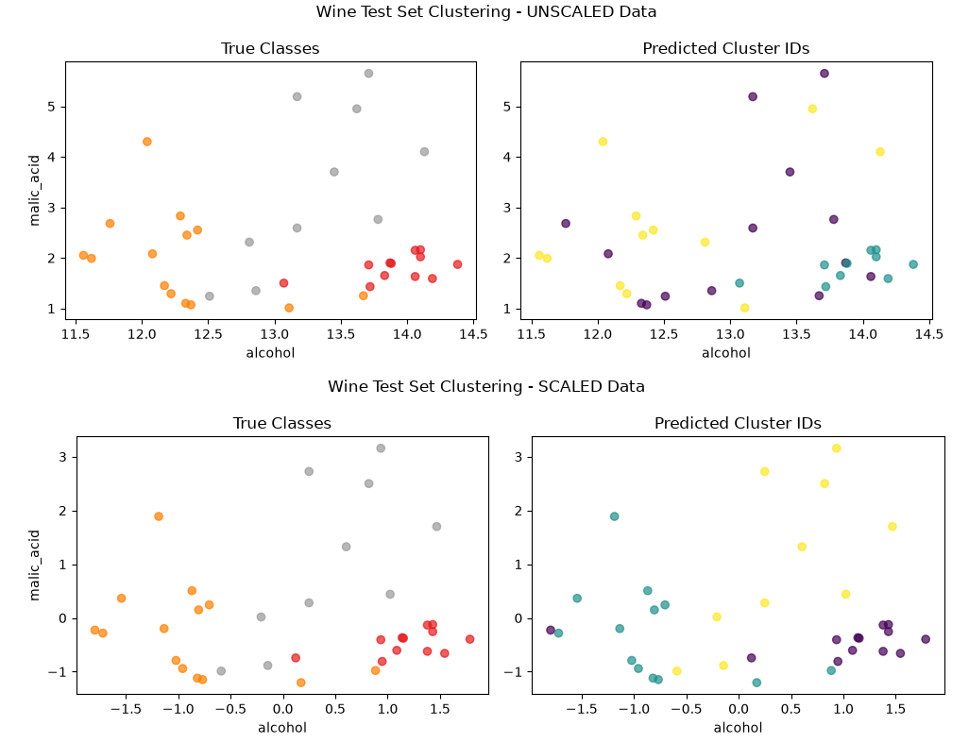
Figure 10.4: Paired Visulations Wine
11. Comparing the Two Datasets
Did the same classifier and representation perform best on both datasets? Yes, the KNN algorithm using the scaled representation with k=7 achieved the highest mean validation macro-F1 score for both the Breast Cancer and Wine datasets.
Which algorithm was most affected by scaling in your experiments? KNN was the most severely affected algorithm. For example, in the Wine dataset, unscaled KNN produced a mean validation macro-F1 of ~0.63 at k=7, whereas the scaled representation boosted the mean validation macro-F1 to ~0.98.
Did deeper trees or larger neighbour counts always improve mean validation performance? How much did results vary across seeds? No. Deeper Decision Trees (e.g., max_depth=None) consistently overfit the training data (reaching 1.0 training macro-F1) without improving the mean validation performance, which stalled or declined. Results varied noticeably across seeds, reflected by the standard deviation bars in the parameter-comparison figures.
How did the main classification errors differ between the two datasets? In the Breast Cancer dataset, the model's only errors were False Negatives (predicting malignant as benign). In contrast, the Wine dataset resulted in an entirely error-free confusion matrix on the test subset.
How did K-Means agreement with the true classes differ between datasets? K-Means achieved a much stronger agreement (higher ARI) with the true classes on the Breast Cancer dataset when scaled, as the two biological classes naturally form more distinct structural clusters. The Wine dataset's three classes exhibited more overlap in the unsupervised feature space, leading to a slightly lower ARI despite scaling.
What one change would you investigate next, and why? As future work, I would investigate applying dimensionality reduction (such as Principal Component Analysis - PCA) prior to training. Reducing the 30 features of the Breast Cancer dataset to fewer, uncorrelated principal components could eliminate noise, potentially resolving the remaining False Negatives in the KNN classifier.

