*ImpressPages New/Blog widget*

Contents

Setup multiple blogs aka Streams 1

Creating entries in the Blogs 2

Add the widget on the page 3

Troubleshooting 4

Editing a blog entry, the occasional error 4

## Setup multiple blogs aka Streams

Assuming you have rights to Administrator privileges. You would navigate the menu bar:  Standard>>News/Blog.  Here you are able to select from the available languages.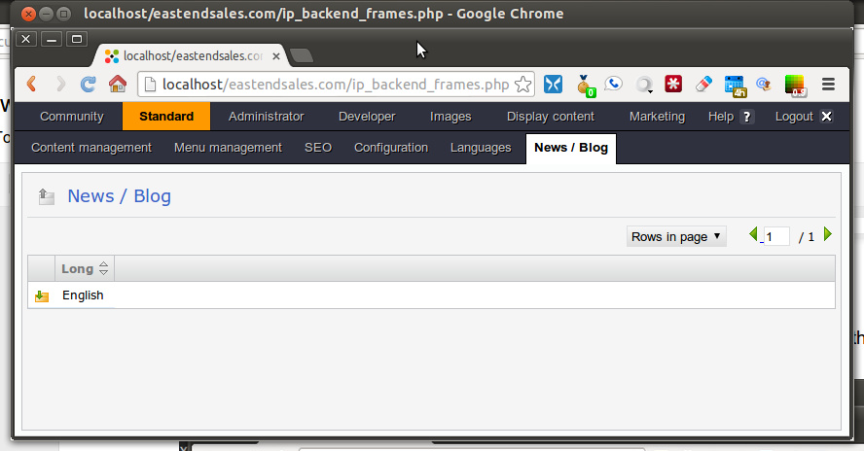

You then click on the Yellow with the green arrow.

You arrive at News / Blog -> English (the only language available for this demo).  
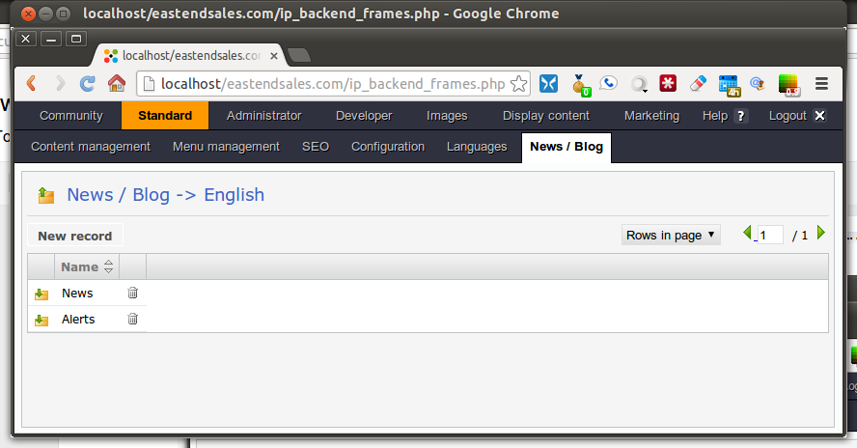  
Then using the “New record” button (the button border is visible when you mouse over it) you create the different blogs you require e.g. News and Alerts.

## Creating entries in the Blogs

Click the down arrow at the Yellow entry e.g. in the blog either “News” or “Alerts”, 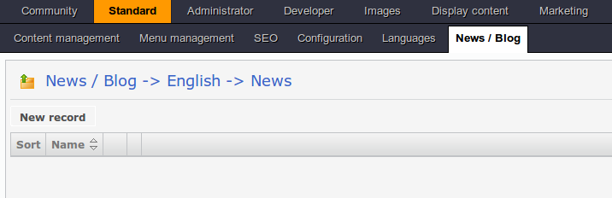  
now you are able to create new blog entries in the English language blog named “News”.  Click the “New Record” button (the button border is visible when you mouse over it).  
  
You can then use the Name field to give the Blog entry a title; I entitled my blog entry: “Fire erupts at local charity Bar-B-Que.  The titles appear on the page when you place the appropriately configured News / Blog widget.

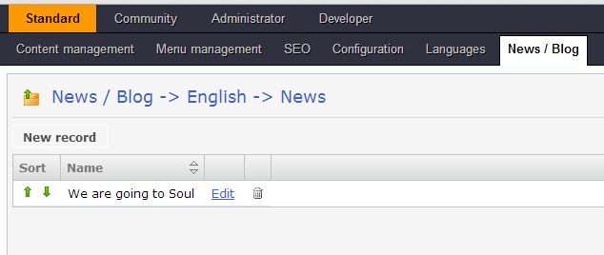  
Notice the underlined Edit in the above example?  When you click the link, you open a standard page with all the edit capabilities; the breadcrumb will clearly show it is under the Home/Welcome page. The page you create here is the page the users will see when they click on the title in the blog.

## Add the widget on the page

The approach i took was to create menu entries with separate pages, you do not have to do this.  You just need to place the New / Blog widget on a page.   
  
Drop the widget and choose the correct blog aka Stream.  Streams are equivalent to the blogs created previously.   
  
Then the blog titles will appear when you press confirm. The blog entries i.e. the titles, are each a link to a page with the blog entry.  
  
When you click on the blog title, a page will appear with the details (the details you entered when you pressed the edit link).

## Troubleshooting

### Editing a blog entry, the occasional error

Occasionally when you create a News / Blog widget with the Stream and you press Edit, it might popup an error message.

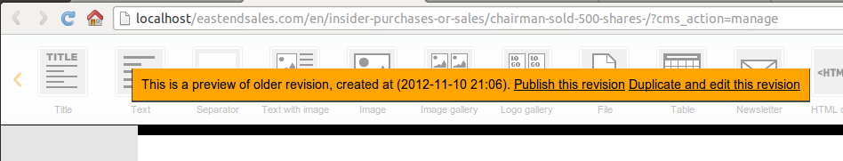

Closing the window seems to get rid of the error.  