**15SE401M MULTI DISCIPLINARY DESIGN**



**The Bluebox Device (final report)**

**Team members :**

**Prithish ghosh (RA1711020010165)**

**Harsh J shah (RA1711020010131)**

**Jash Thakkar (RA1711020010109)**

**Table of Contents**

1. Abstract
2. Introduction
   1. Purpose
   2. DocumentConventions
   3. Definitions, Acronyms andAbbreviations
   4. References
   5. Technologies to beused
   6. Scope
3. OverallDescription
   1. ProductPerspective
   2. ProductFunctions
   3. User Classes andCharacteristics
   4. Operatingenvironment
   5. Design and Implementation Constraints

4. External InterfaceRequirements

* 1. UserInterfaces
  2. HardwareInterfaces
  3. SoftwareInterfaces

1. SystemFeatures
   1. GasDetection
   2. Alarm Activation
   3. Notification
2. FunctionalRequirements
   1. Gas Sensors
   2. Data Transmitter
   3. Microcontroller Arduino
3. Non-FunctionalRequirements
   1. Modifiability
   2. Availability
   3. Performance
   4. Testability
   5. Interoperability
   6. Security
4. Software Design Document
   1. Use Case Diagram
   2. Activity Diagram
   3. State diagram
   4. Interaction diagram
   5. ER Diagram
   6. Component Diagram
   7. Deployment Diagram
   8. Collaboration Diagram
   9. Package diagram
5. Block Diagram
6. Conclusion
7. References
8. Plagiarism Report

**The Bluebox Device**

**Abstract**

The purpose of the "Bluebox" is to effectively operate the whole emergency system so that any incident or accident can be dealt with in a quick response and limited delay. The system is a computer-based system so that we can achieve speed as well as accuracy.

To override the problems occurring due to a manual system a computer based system will be designed that will overcome the manual delay as well as making the whole system efficient. The device will get the signals from sensors installed and send medical details (stored in IT Website) and location to nearby hospital, blood bank and police station respectively.

**Software Requirements Specification**

**Introduction**

The purpose of the "Bluebox" is to effectively operate the whole emergency system so that any incident or accident can be dealt with in a quick response and limited delay.

* To curb the accident rate, the driver must be self-aware and be in a normal condition to contact for medical emergency.
* But, post-accident, to investigate the crash of the vehicle, at present the processes in the emergency system are manual, also there is no method or device to locate the accident spot and reach immediately.
* Whenever an incident occurs involving only an informer, information about the incident goes to police stations and hospital.

This novel innovation would be very useful in decimating the death numbers on roads and it basically focuses on crash response system. Installation of this module would be a great measure towards road safety. This device would be a pioneering innovation in the domain.

**Purpose**

* The main objective for development of the project is to save lives claimed by accidents by implementing a quicker crash response system.
* We are to develop a device that would get the signals from sensors and send medical details and location to nearby hospital, blood bank and police station.

**Product Scope:**

* The Bluebox device is a device that people can use to save lives claimed by accidents by implementing a quicker crash response system.
* The device will get the signals from sensors installed and send medical details (stored in IT Website) and location to nearby hospital, blood bank and police station respectively.

**Overall Description**

**Product Perspective:**

* Bluebox device is developed to effectively operate the whole emergency system so that any incident or accident can be dealt with in a quick response and limited delay.
* The system is a computer based system so that we can achieve speed as well as accuracy.
* A device that would get the signals from sensors and send medical details and location to nearby hospital, blood bank and police station.

**Product Functions:**

1. **Website/android app:**

User:

* + User Registration.
  + Store personal details of user(Name, age, Blood group, etc…)
  + Store vehicle details(Number, Model, etc…)

Responder:

* + Register([Hospital, Blood bank]: name, address, contact, etc…)
  + Provide details of vehicle and service details.

2. **Bluebox device:**

* Accelerometer sensor – connected with vehicle’s speedometer to detect if accident occurred.
* Mechanical sensor – connected with vehicle’s upright position to detect if the vehicle has rolled over.
* Vibration sensor – connected with vehicle’s outer component to detect if collision has occurred.
* GPS tracker – connected with vehicle’s GPS, within registered phone as well as the inbuilt GPS in blue box.

**User Classes and Characteristics**

* **Police Authorities**: nearby police station from the spot will get alert about the accident and its details(like location, vehicle, intensity of the collision, etc…). This will help them to reach the spot quickly.
* **Ambulance:** nearby ambulance will get the alert about the incident and will help it to reach their soon.
* **Hospitals**: nearby hospitals will be informed about this to accelerate the process for preparation.
* **Blood Bank**: they will receive the information about victims details to arrange the blood as soon as possible.
* **Family/Friends**: they will receive the details of the accident, which would help them to reach faster.

**Operating Environment**

* Android devices/website.
* Vehicle’s core component.
* Speedometer.
* Physically stable state(Vehicle in upright case).
* Bluebox device consisting of different sensors and chipset.

**External Interface Requirements**

**Hardware Interfaces**

* The blue box would be having an accelerometer sensor so that dangerous driving can be detected.
* Also when a vehicle meets with an accident immediately Vibration sensor will detect the signal or if a car rolls over.
* An Micro electro mechanical system sensor will detect the signal.

**Software Interface**

* The signals from the sensors will trigger the user’s personal information stored in the website/android app.
* The victims detail are then forwarded to respected classes from the IT website/ android app.

**Communications Interfaces**

* Bluebox requires to have a proper installation on the vehicles hardware, so it can sense the state of it.
* Bluebox needs to have active sim to trigger and send signal to the website/android app.

**System Requirements**

**Functional Requirements**

* User:
  + User Registration – verify and validate the details.
  + Store personal details of user(Name, age, Blood group, etc…)
  + Store vehicle details(Number, Model, etc…) – verify by providing necessary documents.
* Responder:
  + Register([Hospital, Blood bank]: name, address, contact, etc…) – verify and validate the details.
  + Provide details of vehicle and service details – check proper availability and proper registered license.

**Non-Functional Requirements**

* **Performance:**
  + Once the device sends signal within 2minutes the details are shared to respected authorities.
  + Also there is a built in switch to revoke the details or cancel the alert sent to the concern authorities.
  + **Safety:**
  + To save the loss of data due to the damage caused by breaking the device, it keeps backing up data.
  + Even if the complete GPS is damaged the previous fetched location is sent across.
  + **Security:**
  + User’s personal information is shared to the hospitals and police authorities only when the alert signal needs to be sent to them.
  + The revoke/cancelling of the alert will only be done by the pin been known by the registered user.

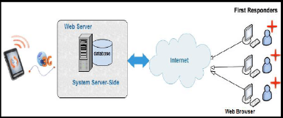

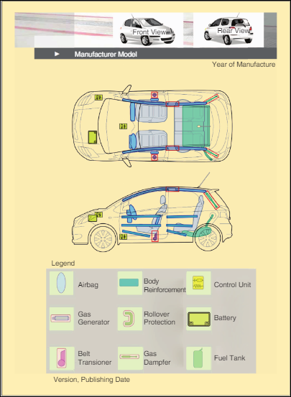

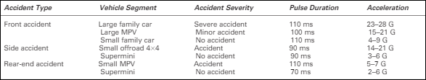

**Software Design Document**

**Use Case Diagram**

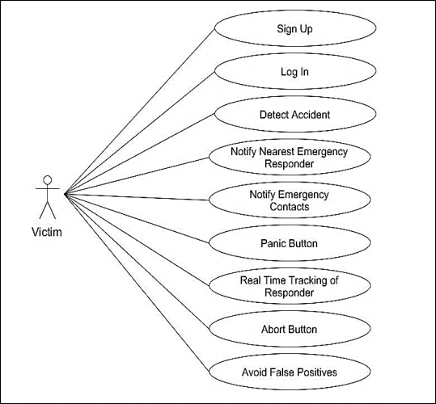

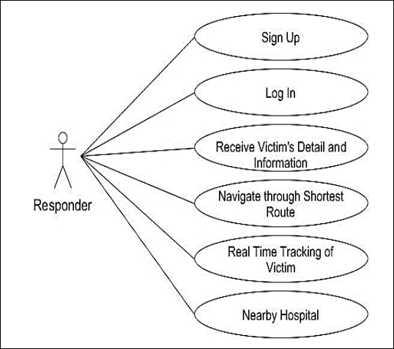

**Activity Diagram**

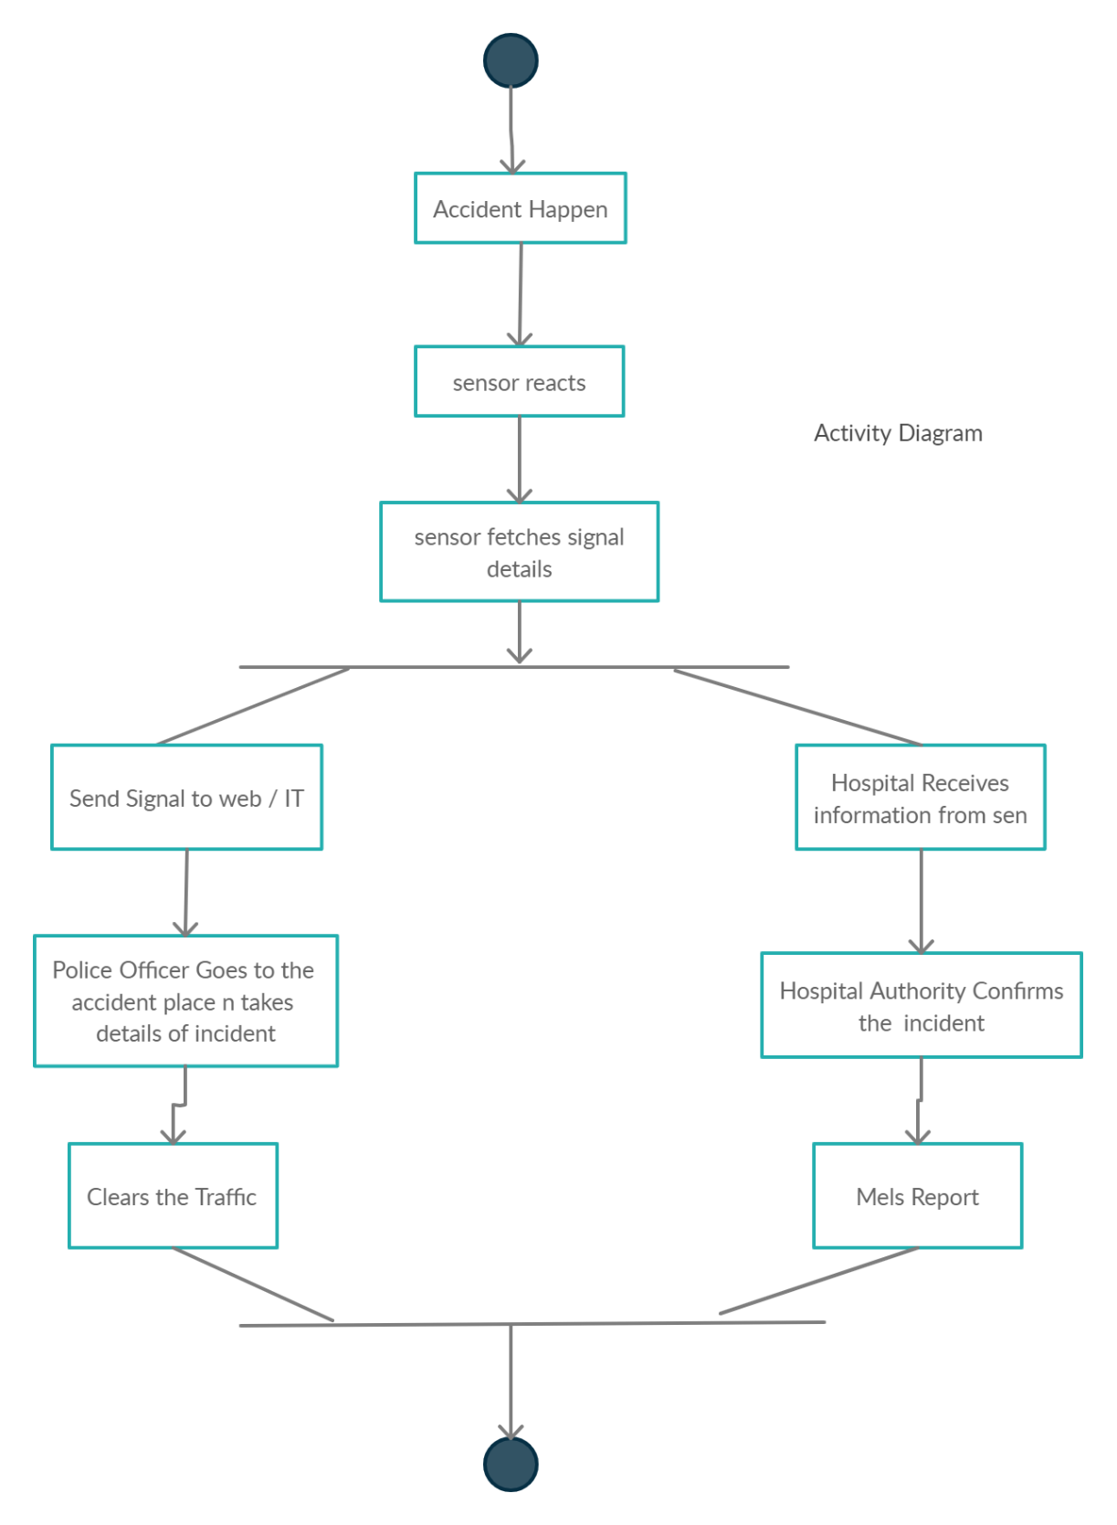



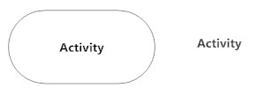



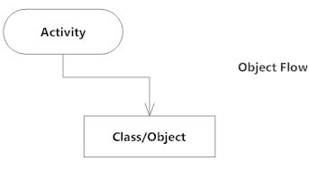

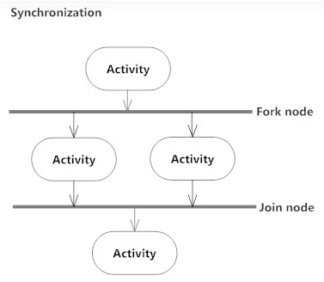

**Sequence Diagram**

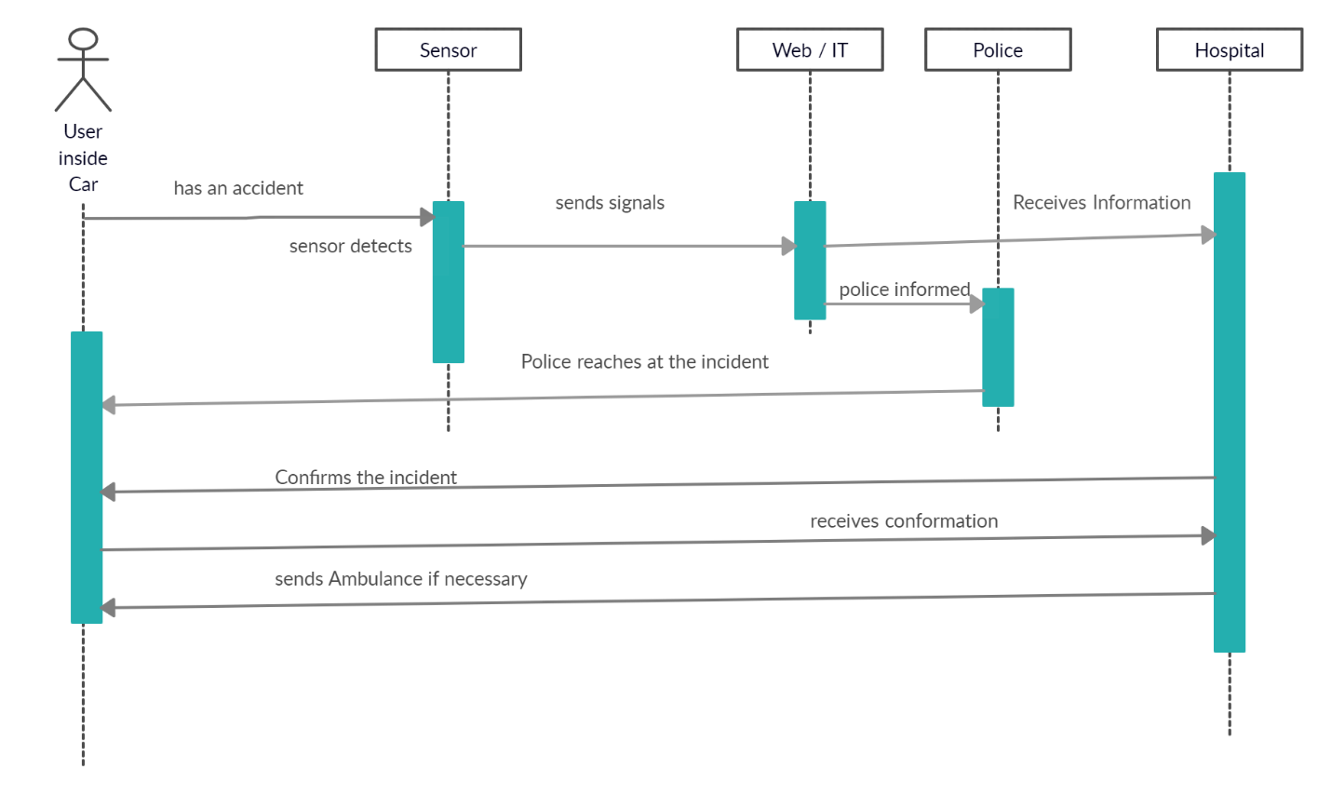

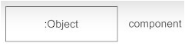

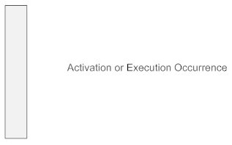

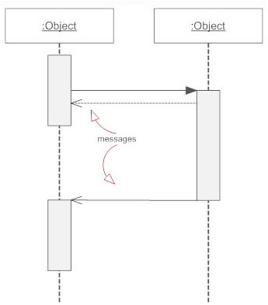





**Class Diagram**

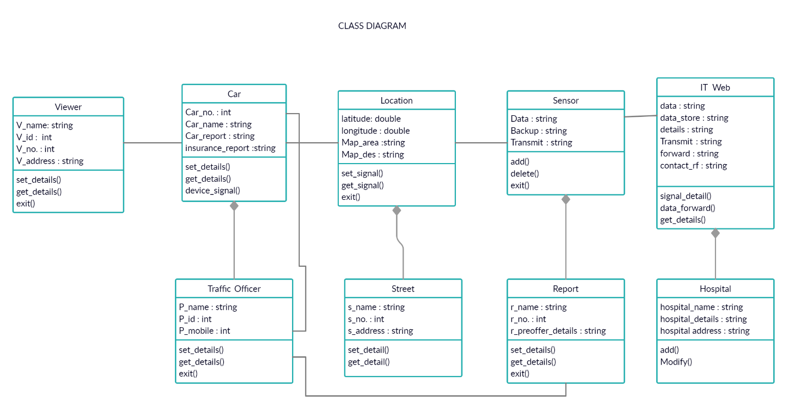

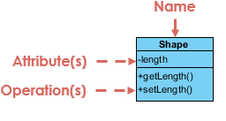

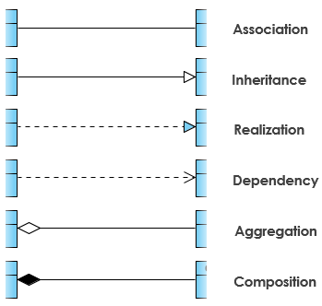

**Conclusion**

With the proposed architecture, if constructed with at most accuracy, the lives of many people can be secured when exposed to any accident situation be it in a small area or at a factory. IOT based crash investigation and alert system shall be developed efficiently and accurately. The detector shall be useful in reducing the risk of such accidents which may prove to be extremely hazardous for the environment as it will keep alarming the user, the nearest fire department and the gas agency until the rescue action has been taken. The developed prototype gives good results in detecting all kinds of quick accident response. This shall prove to be a boon for the world.