DATA BASE MANAGEMENT PROJECT



**Entity-Relationship Diagram**

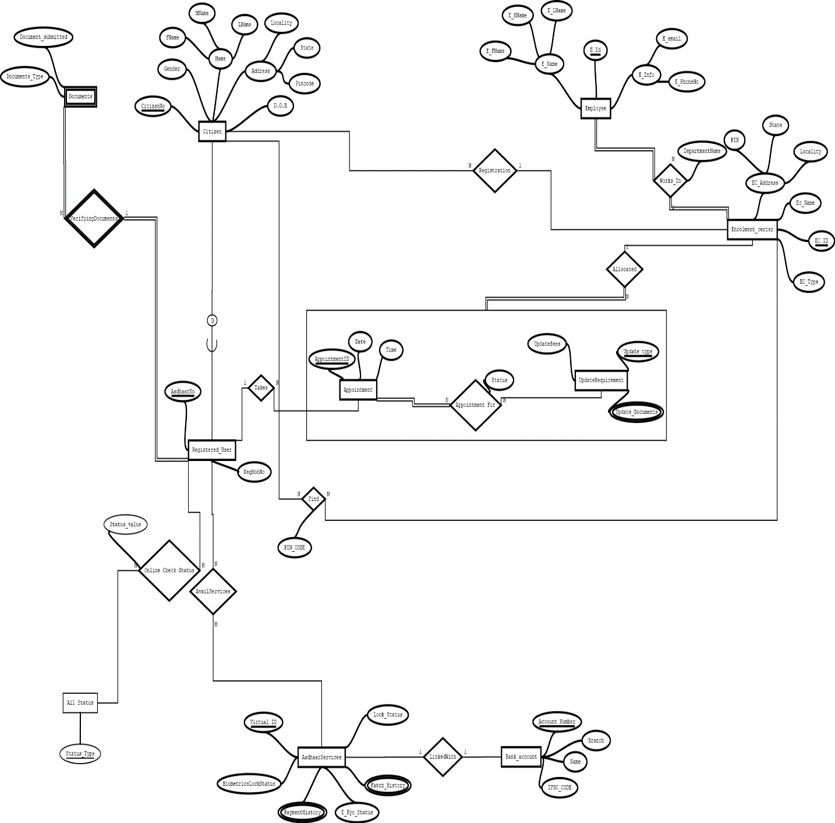

**Relational Diagram**

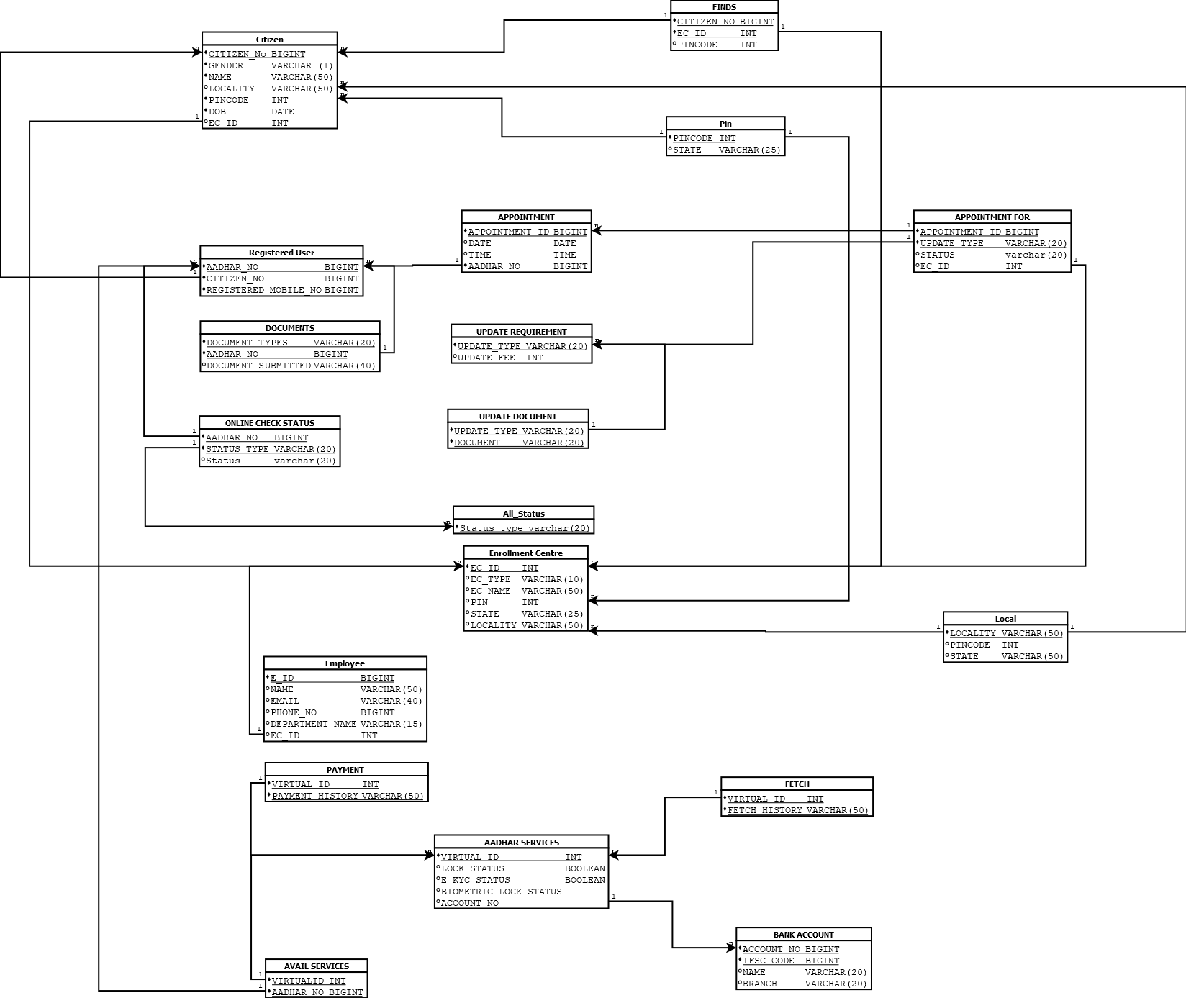

**FUNCTIONAL DEPENDENCIES AND NORMALIZATION**

* **Citizen**

Attributes – Citizen (CitizenNo, Gender, Fname, Mname, Lname, Locality, State, Pincode, Dob,EC_ID)

* **Minimal Functional Dependencies Set**

CitizenNo ->Fname

CitizenNo -> Gender

CitizenNo ->Mname

CitizenNo ->Lname

CitizenNo -> Locality

CitizenNo -> State

CitizenNo -> Pincode

CitizenNo -> DOB

CitizenNo -> EC_ID

Pincode -> State

Locality -> Pincode

Locality -> State

Let find closure of CitizenNo

CitizenNo+ = {CitizenNo,Gender,Fname ,Mname,Lname,Locality,State,Pincode,DOB,EC_ID}

Since its closure include all attribute of Citizen relation , therefor CitizenNo is Primary Key.

Last 3 functional dependencies does not have super-key on left side of FD hence the given relation is not in BCNF, it is 2NF. We can decompose it into BCNF by having 3 relation as following

R1( CitizenNo,Gender,Fname ,Mname,Lname, DOB,EC_ID)

R2(Pincode,State)

R3(Locality,Pincode,State)

* **Enrollment Centre**

Attributes – Enrollment Centre (EC_ID,EC_Type,EC_Name,Pincode,State,Locality)

* **Minimal Functional Dependencies Set**

EC_ID -> EC_Name

EC_ID -> EC_Type

EC_ID -> Pincode

EC_ID -> State

EC_ID -> Locality

Pincode -> State

Locality -> Pincode

Locality -> State

Let find closure set of EC_ID

EC_ID+ = {EC_ID , EC_Name ,EC_Type,Pincode,State,Locality}

Since it involves all attributes of Enrollment Centre relation it is Primary Key.

Last 3 functional dependencies does not have super-key on left side of FD hence the given relation is not in BCNF, it is 2NF. We can decompose it into BCNF by having 3 relation as following

R1( EC_ID , EC_Name ,EC_Type)

R2(Pincode,State)

R3(Locality,Pincode,State)

* **Finds**

Attribute – Finds(CitizenNo ,EC_ID, Pincode)

* **Minimal Functional Dependencies Set**

{CitizenNo, EC_ID} - > Pincode

Primary Key is {CitizenNo , EC_ID}.

Relation is in BCNF as super-key is present on left side of FD.

* **Appointment For**

Attributes – Appointment For (AppointmentID , UpdateType, Status , EC_ID)

* **Minimal Functional Dependencies Set**

{AppointmentID , UpdateType} - > Status

{AppointmentID , UpdateType} - > EC_ID

Primary Key is {AppointmentID , UpdateType} as it determines all attribute of given relation

Since primary key is present on left side of all FDs of relation we can say “Appointment For” relation to be in BCNF.

* **Appointment**

Attribute – Appointment (AppointmentID , Date , Time, AadharNo)

* **Minimal Functional Dependencies Set**

AppointmentID -> AadharNo

AppointmentID -> Date

AppointmentID -> Time

Primary Key is AppointmentID as it determines all other attribute of relation. Relation is in BCNF as all FD has AppointmentID on left side of its FD’s.

* **Registered User**

Attribute – Registered User (AadharNo , CitizenNo , RegisteredMobileNo)

* **Minimal Functional Dependencies Set**

AadharNo - > CitizenNo

AadharNo -> RegisteredMobileNo

Primary Key is AadharNo as it determines all other attribute of relation. Relation is in BCNF as all FD has AadharNo on left side of its FD’s.

* **Documents**

Attributes – Documents (DocumentType , AadharNo , DocumentSubmitted)

* **Minimal Functional Dependencies Set**

{DocumentType , AadharNo} -> DocumentSubmitted

Primary Key is {DocumentType , AadharNo} as it determines all other attribute of relation. Relation is in BCNF as all FD has {DocumentType , AadharNo} on left side of its FD’s.

* **Employee**

Attribute – Employee (E_ID,Name,Email,PhoneNo,DepartmentName,EC_ID)

* **Minimal Functional Dependencies Set**

E_ID->Name

E_ID -> Email

E_ID->PhoneNo

E_ID ->DepartmentName

E_ID - >EC_ID

Primary Key is E_ID as it determines all other attribute of relation. Relation is in BCNF as all FD has E_ID on left side of its FD’s.

* **Aadhar Services**

Attribute – Aadhar Services(VirtualID, LockStatus, EKYCStatus,BiometricLockStatus,AccountNo,FetchHistory(multivalue),PaymentHistory(multivalue))

* **Minimal Functional Dependencies Set**

VirtualID -> LockStatus

VirtualID -> EKYCStatus

VirtualID -> BiometricLockStatus

VirtualID -> AccountNo

VirtualID- >> FetchHistory

VirtualID ->> PaymentHistory

Primary Key is VirtualID as its closure include all attribute of relation. However the relation is not in BCNF due to presence of multivalue dependencies such as FetchHistory and PaymentHistory.Since this multivalue dependencies are independent of each other we can so we decompose the given relation into 3 new relation as following

R1 (VirtualID, LockStatus, EKYCStatus,BiometricLockStatus,AccountNo)

R2 (VirtualID , PaymentHistory)

R3 (VirtualID , FetchHistory)

Now relation is in 4NF.

* **BankAccount**

Attribute – BankAccount (AccountNo , IFSCCode , Name,Branch)

* **Minimal Functional Dependencies Set**

IFSCCode - >Name

IFSCCode -> Branch

Primary Key is {AccountNo ,IFSCCode} as its closure include all attributes of relation. Relation is in BCNF.

* **Online Check Status**

Attribute – Online Check Status (AadharNo , StatusType,Status)

* **Minimal Functional Dependencies Set**

{AadharNo,StatusType} -> Status

{AadharNo , StatusType} together form composite primary key as it closure include all attribute of relation. The relation above is in BCNF as primary key is present on left of above FD.

* **Update Requirement**

Attribute – Update Requirement(Update Type , Update Fee)

* **Minimal Functional Dependencies Set**

Update Type -> Update Fee

Update Type is primary key as it closure include all attribute. The relation is in BCNF as primary key is present on left of above FD

* **Update Document**

Attribute – Update Document(Update Type , Document)

Update Type and Document together form composite primary key hence there is no FD and table is in BCNF

* **All Status**

Attribute – All Status(StatusType)

All status have Status Type as it primary key hence no FD is present and thus table is BCNF.

* **Avail Services**

Attribute – Avail Services(VirtualID , AadharNo)

Both (VirtualID , AadharNo) form composite primary key and hence relation is in BCNF.