1.GitHub repository URL
https://github.com/improperboy/github-skills-challenge
2. Pull request URL used to validate the workflows
https://github.com/DebbieAUG/github-skills-challenge/compare/main...improperboy:github-skills-challenge:test-ci-setup?expand=1
3. Screenshot showing the GitHub Actions workflows
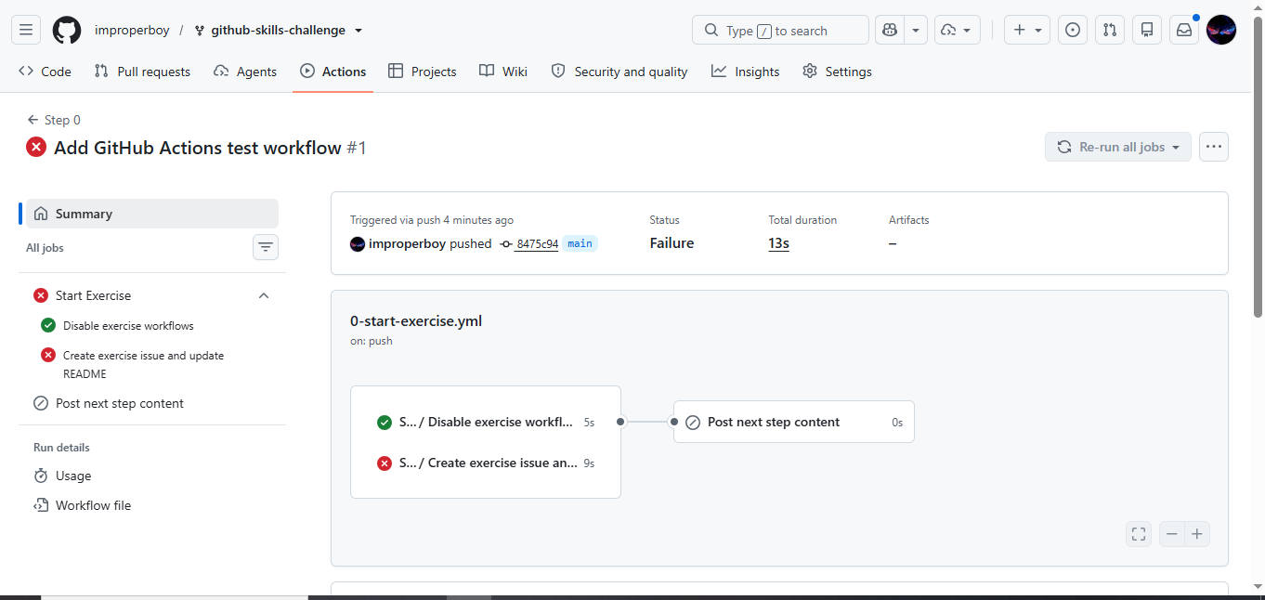
4. Screenshot showing a successful test workflow execution
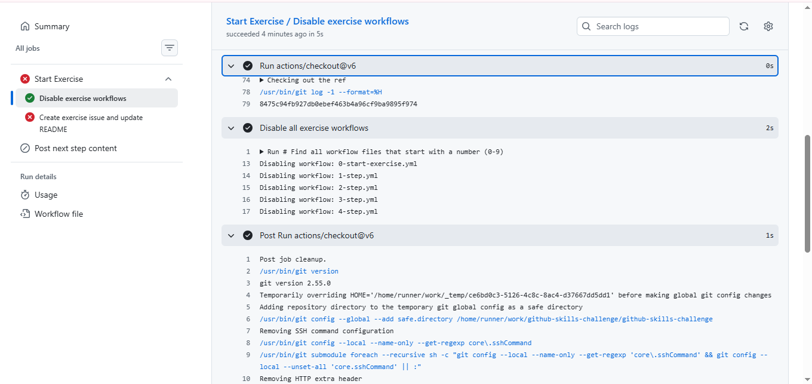
5. Screenshot showing the coverage result/comment on the pull request
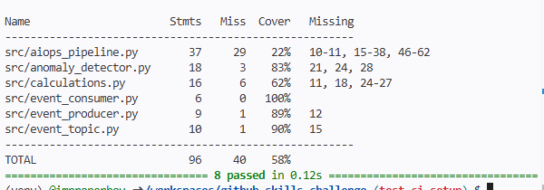
6. Screenshot showing the final repository/workflow files
