Lab report 1 (variant 13)

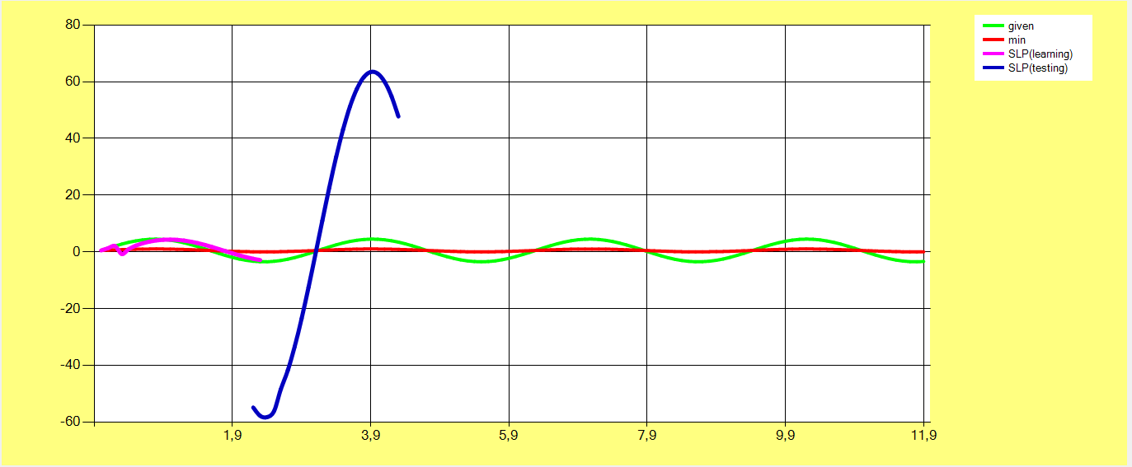

**Learning rate:** 0.7

**Desired error:** 0.001

**Function: $4*\sin\left(2x\right)+0.5$**

**Inputs:** 3

The values in *Table 1* were randomly selected within the range (-1; 1)

|  |  |  |  |
| --- | --- | --- | --- |
| w1 | w2 | w3 | T |
| -0.69173 | -0.64322 | -0.15587 | 0.44494 |

*Table 1*

## Learning outcomes.



## Prediction results.

