**Lab report 2 (variant 13)**

## Task

Develop MLP with one hidden layer using any programming language for prediction of the following function:

$$y=α\sin\left(bx\right)+d$$

|  |  |  |  |
| --- | --- | --- | --- |
| α | b | d | number of inputs |
| 4 | 2 | 0,5 | 3 |

Chosen values: α=0.22; Em=0.0001.

**Learning outcomes**

1. **Training 30 points.**

|  |  |
| --- | --- |
|  | y |
| 1 | 1,294677 |
| 2 | 2,057673 |
| 3 | 2,75857 |
| 4 | 3,369424 |
| 5 | 3,865884 |
| 6 | 4,228156 |
| 7 | 4,441799 |
| 8 | 4,498294 |
| 9 | 4,395391 |
| 10 | 4,13719 |
| 11 | 3,733986 |
| 12 | 3,201853 |
| 13 | 2,562005 |
| 14 | 1,839953 |
| 15 | 1,06448 |
| 16 | 0,266503 |
| 17 | -0,522164 |
| 18 | -1,270082 |
| 19 | -1,947432 |
| 20 | -2,52721 |
| 21 | -2,986303 |
| 22 | -3,306408 |
| 23 | -3,474764 |
| 24 | -3,484658 |
| 25 | -3,335697 |
| 26 | -3,033819 |
| 27 | -2,591058 |
| 28 | -2,025067 |
| 29 | -1,358409 |
| 30 | -0,617662 |
| 31 | 0,167642 |
| 32 | 0,966197 |
| 33 | 1,746165 |
| 34 | 2,476453 |
| 35 | 3,127946 |
| 36 | 3,674671 |
| 37 | 4,094832 |
| 38 | 4,371679 |
| 39 | 4,494173 |
| 40 | 4,457433 |
| 41 | 4,262922 |
| 42 | 3,918396 |
| 43 | 3,437588 |
| 44 | 2,839669 |
| 45 | 2,148474 |
| 46 | 1,39156 |
| 47 | 0,599102 |
| 48 | -0,197307 |
| 49 | -0,965917 |
| 50 | -1,676084 |

*Tab1. Theoretical and training outputs*

|  |  |
| --- | --- |
| w(11) | 0,070503 |
| w(12) | 0,034894 |
| w(13) | 0,083057 |
| v(1) | -0,0943 |
| w(21) | -0,05264 |
| w(22) | 0,040307 |
| w(23) | -0,07595 |
| v(2) | 0,065748 |
| w(31) | -0,03678 |
| w(32) | 0,006104 |
| w(33) | 0,014303 |
| v(3) | -0,09044 |

*Tab2. The weights of input and hidden neurons*

Initial thresholds are taken as 0.

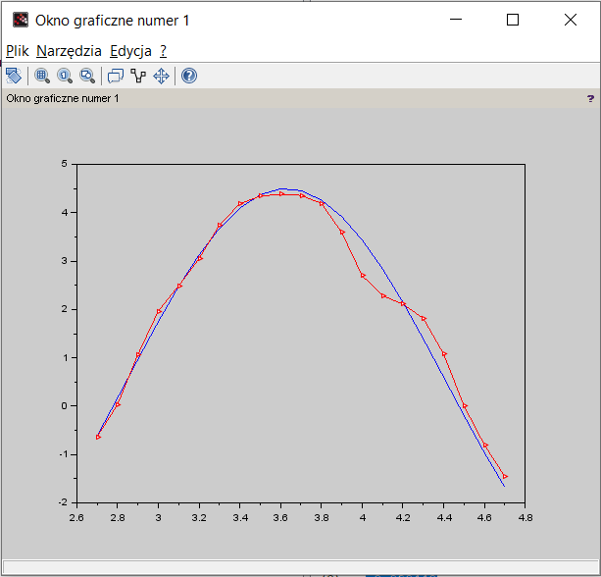

*Graph1.Theoretical and real values*

In the *Graph1* blue line — theoretical values, red line — real values.

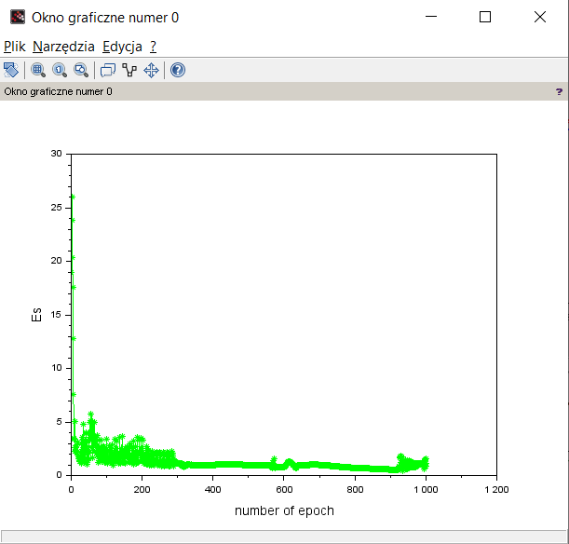

*Graph2. Error depending on the epoch*

Testing 20 points.

|  |  |  |
| --- | --- | --- |
|  | e | output |
| 1 | -0,61766 | -0,63095 |
| 2 | 0,167642 | 0,03244 |
| 3 | 0,966197 | 1,064853 |
| 4 | 1,746165 | 1,964094 |
| 5 | 2,476453 | 2,489546 |
| 6 | 3,127946 | 3,048792 |
| 7 | 3,674671 | 3,747135 |
| 8 | 4,094832 | 4,186971 |
| 9 | 4,371679 | 4,343712 |
| 10 | 4,494173 | 4,382405 |
| 11 | 4,457433 | 4,358629 |
| 12 | 4,262922 | 4,19308 |
| 13 | 3,918396 | 3,590962 |
| 14 | 3,437588 | 2,698309 |
| 15 | 2,839669 | 2,282251 |
| 16 | 2,148474 | 2,11213 |
| 17 | 1,39156 | 1,814846 |
| 18 | 0,599102 | 1,076227 |
| 19 | -0,19731 | 0,002291 |
| 20 | -0,96592 | -0,80348 |

*Tab3. Theoretical and testing outputs*

1. **Training 50 points.**

|  |  |
| --- | --- |
|  | Y |
| 1 | 1,294677 |
| 2 | 2,057673 |
| 3 | 2,75857 |
| 4 | 3,369424 |
| 5 | 3,865884 |
| 6 | 4,228156 |
| 7 | 4,441799 |
| 8 | 4,498294 |
| 9 | 4,395391 |
| 10 | 4,13719 |
| 11 | 3,733986 |
| 12 | 3,201853 |
| 13 | 2,562005 |
| 14 | 1,839953 |
| 15 | 1,06448 |
| 16 | 0,266503 |
| 17 | -0,52216 |
| 18 | -1,27008 |
| 19 | -1,94743 |
| 20 | -2,52721 |
| 21 | -2,9863 |
| 22 | -3,30641 |
| 23 | -3,47476 |
| 24 | -3,48466 |
| 25 | -3,3357 |
| 26 | -3,03382 |
| 27 | -2,59106 |
| 28 | -2,02507 |
| 29 | -1,35841 |
| 30 | -0,61766 |
| 31 | 0,167642 |
| 32 | 0,966197 |
| 33 | 1,746165 |
| 34 | 2,476453 |
| 35 | 3,127946 |
| 36 | 3,674671 |
| 37 | 4,094832 |
| 38 | 4,371679 |
| 39 | 4,494173 |
| 40 | 4,457433 |
| 41 | 4,262922 |
| 42 | 3,918396 |
| 43 | 3,437588 |
| 44 | 2,839669 |
| 45 | 2,148474 |
| 46 | 1,39156 |
| 47 | 0,599102 |
| 48 | -0,19731 |
| 49 | -0,96592 |
| 50 | -1,67608 |
| 51 | -2,2995 |
| 52 | -2,81131 |
| 53 | -3,1911 |
| 54 | -3,42375 |
| 55 | -3,49996 |
| 56 | -3,41671 |
| 57 | -3,17731 |
| 58 | -2,79131 |
| 59 | -2,2741 |
| 60 | -1,64629 |
| 61 | -0,93292 |
| 62 | -0,16242 |
| 63 | 0,634492 |
| 64 | 1,426039 |
| 65 | 2,180668 |
| 66 | 2,868294 |
| 67 | 3,461504 |
| 68 | 3,936647 |
| 69 | 4,274783 |
| 70 | 4,462429 |

*Tab4. Theoretical and training outputs*

|  |  |
| --- | --- |
| w(11) | 0,04123 |
| w(12) | 0,035757 |
| w(13) | -0,01734 |
| v(1) | -0,07195 |
| w(21) | -0,00095 |
| w(22) | -0,0161 |
| w(23) | 0,072524 |
| v(2) | -0,04285 |
| w(31) | -0,04976 |
| w(32) | -0,03222 |
| w(33) | -0,02156 |
| v(3) | -0,00637 |

*Tab3. Testing outputs*

Initial thresholds are taken as 0.

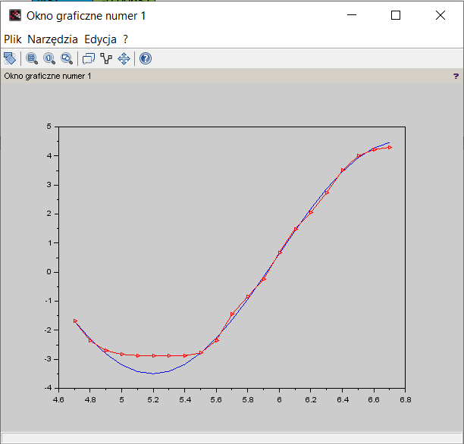

*Graph3. Theoretical and real values*

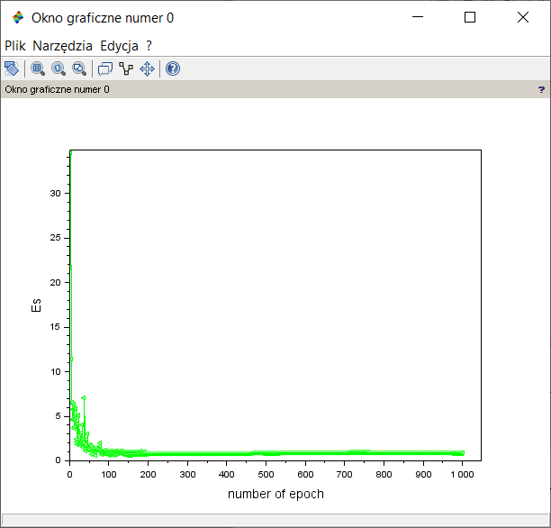

*Graph4. Error depending on the epoch*

Testing 20 points.

|  |  |  |
| --- | --- | --- |
|  | E | output |
| 1 | -1.676084 | -1.683831 |
| 2 | -2.299499 | -2.362015 |
| 3 | -2.811306 | -2.703443 |
| 4 | -3.191102 | -2.829766 |
| 5 | -3.423745 | -2.872717 |
| 6 | -3.499961 | -2.887127 |
| 7 | -3.416711 | -2.889514 |
| 8 | -3.177314 | -2.875400 |
| 9 | -2.791314 | -2.785656 |
| 10 | -2.274100 | -2.354320 |
| 11 | -1.646292 | -1.452881 |
| 12 | -0.932917 | -0.835271 |
| 13 | -0.162417 | -0.248593 |
| 14 | 0.634492 | 0.672552 |
| 15 | 1.426039 | 1.486200 |
| 16 | 2.180668 | 2.053313 |
| 17 | 2.868294 | 2.732079 |
| 18 | 3.461504 | 3.501087 |
| 19 | 3.936647 | 4.003146 |
| 20 | 4.274783 | 4.218023 |
| 21 | 4.462429 | 4.295651 |

*Tab6. Theoretical and testing outputs*

1. **Training 100 points.**

|  |  |
| --- | --- |
|  | y |
| 1 | 1,294677 |
| 2 | 2,057673 |
| 3 | 2,75857 |
| 4 | 3,369424 |
| 5 | 3,865884 |
| 6 | 4,228156 |
| 7 | 4,441799 |
| 8 | 4,498294 |
| 9 | 4,395391 |
| 10 | 4,13719 |
| 11 | 3,733986 |
| 12 | 3,201853 |
| 13 | 2,562005 |
| 14 | 1,839953 |
| 15 | 1,06448 |
| 16 | 0,266503 |
| 17 | -0,52216 |
| 18 | -1,27008 |
| 19 | -1,94743 |
| 20 | -2,52721 |
| 21 | -2,9863 |
| 22 | -3,30641 |
| 23 | -3,47476 |
| 24 | -3,48466 |
| 25 | -3,3357 |
| 26 | -3,03382 |
| 27 | -2,59106 |
| 28 | -2,02507 |
| 29 | -1,35841 |
| 30 | -0,61766 |
| 31 | 0,167642 |
| 32 | 0,966197 |
| 33 | 1,746165 |
| 34 | 2,476453 |
| 35 | 3,127946 |
| 36 | 3,674671 |
| 37 | 4,094832 |
| 38 | 4,371679 |
| 39 | 4,494173 |
| 40 | 4,457433 |
| 41 | 4,262922 |
| 42 | 3,918396 |
| 43 | 3,437588 |
| 44 | 2,839669 |
| 45 | 2,148474 |
| 46 | 1,39156 |
| 47 | 0,599102 |
| 48 | -0,19731 |
| 49 | -0,96592 |
| 50 | -1,67608 |
| 51 | -2,2995 |
| 52 | -2,81131 |
| 53 | -3,1911 |
| 54 | -3,42375 |
| 55 | -3,49996 |
| 56 | -3,41671 |
| 57 | -3,17731 |
| 58 | -2,79131 |
| 59 | -2,2741 |
| 60 | -1,64629 |
| 61 | -0,93292 |
| 62 | -0,16242 |
| 63 | 0,634492 |
| 64 | 1,426039 |
| 65 | 2,180668 |
| 66 | 2,868294 |
| 67 | 3,461504 |
| 68 | 3,936647 |
| 69 | 4,274783 |
| 70 | 4,462429 |
| 71 | 4,492107 |
| 72 | 4,362631 |
| 73 | 4,079165 |
| 74 | 3,653008 |
| 75 | 3,101151 |
| 76 | 2,445595 |
| 77 | 1,712473 |
| 78 | 0,931015 |
| 79 | 0,132373 |
| 80 | -0,65161 |
| 81 | -1,38969 |
| 82 | -2,05243 |
| 83 | -2,61341 |
| 84 | -3,05027 |
| 85 | -3,34559 |
| 86 | -3,4876 |
| 87 | -3,47064 |
| 88 | -3,29538 |
| 89 | -2,96881 |
| 90 | -2,50395 |
| 91 | -1,91933 |
| 92 | -1,23826 |
| 93 | -0,4879 |
| 94 | 0,301857 |
| 95 | 1,099509 |
| 96 | 1,87326 |
| 97 | 2,592263 |
| 98 | 3,227854 |
| 99 | 3,754695 |
| 100 | 4,151781 |
| 101 | 4,403282 |
| 102 | 4,499172 |
| 103 | 4,435627 |
| 104 | 4,215181 |
| 105 | 3,846623 |
| 106 | 3,344645 |
| 107 | 2,72926 |
| 108 | 2,025002 |
| 109 | 1,259947 |
| 110 | 0,464595 |
| 111 | -0,32935 |
| 112 | -1,09022 |
| 113 | -1,7877 |
| 114 | -2,39398 |
| 115 | -2,88488 |
| 116 | -3,24084 |
| 117 | -3,44766 |
| 118 | -3,4971 |
| 119 | -3,38719 |
| 120 | -3,12231 |

*Tab7. Theoretical and training outputs*

|  |  |
| --- | --- |
| w(11) | -0,03277 |
| w(12) | 0,006738 |
| w(13) | -0,05922 |
| v(1) | -0,0682 |
| w(21) | -0,09636 |
| w(22) | -0,01803 |
| w(23) | -0,09788 |
| v(2) | -0,06069 |
| w(31) | -0,04549 |
| w(32) | -0,03125 |
| w(33) | -0,05933 |
| v(3) | -0,03976 |

*Tab8. Testing outputs*

Initial thresholds are taken as 0.

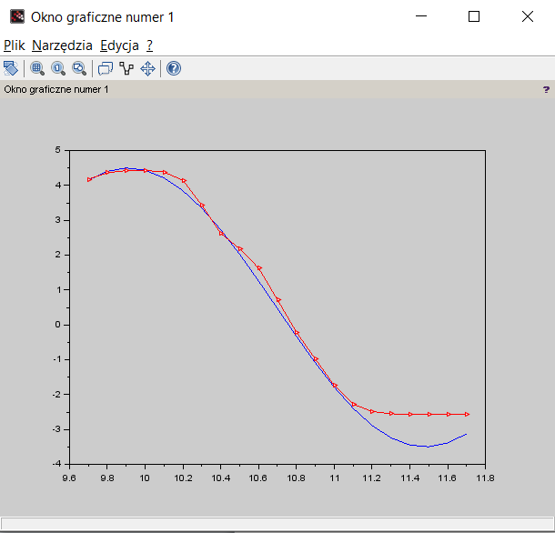

*Graph5. Theoretical and real values*

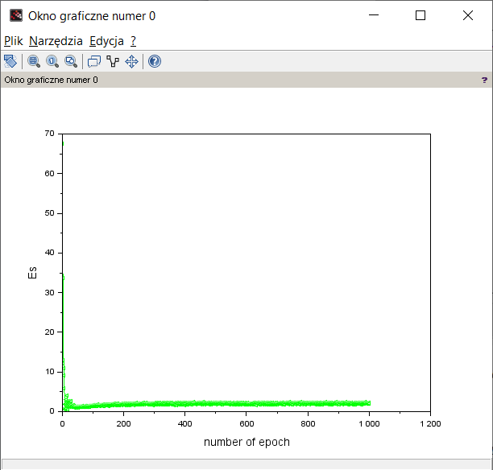

*Graph6. Error depending on the epoch*

Testing 20 points.

|  |  |  |
| --- | --- | --- |
|  | e | output |
| 1 | 4.151781 | 4.173398 |
| 2 | 4.403282 | 4.363091 |
| 3 | 4.499172 | 4.422759 |
| 4 | 4.435627 | 4.430638 |
| 5 | 4.215181 | 4.383051 |
| 6 | 3.846623 | 4.147478 |
| 7 | 3.344645 | 3.429592 |
| 8 | 2.729260 | 2.627197 |
| 9 | 2.025002 | 2.180973 |
| 10 | 1.259947 | 1.627699 |
| 11 | 0.464595 | 0.720590 |
| 12 | -0.329346 | -0.211326 |
| 13 | -1.090223 | -0.977430 |
| 14 | -1.787703 | -1.739928 |
| 15 | -2.393979 | -2.273937 |
| 16 | -2.884882 | -2.485719 |
| 17 | -3.240840 | -2.549531 |
| 18 | -3.447662 | -2.568046 |
| 19 | -3.497104 | -2.573257 |
| 20 | -3.387194 | -2.573070 |
| 21 | -3.122313 | -2.565640 |

*Tab9. Theoretical and testing outputs*

**Comparison of results**

When training the neural network for 30, 50 and 100 points, it was concluded that the test points that are closest to zero (along the Oy axis) are the closest to the theoretical values. With an increase in the number of training points the mean square error becomes more predictable, which means that the range of its variation becomes smaller.

**Code of the program:** <https://pastebin.com/ZsPTrrEj>