**CHAPTER 1**

**1. INTRODUCTION**

* 1. **COMPUTER GRAPHICS**

Computer Graphics become a powerful tool for the rapid and economical production of pictures. There is virtually no area in which Graphical displays cannot be used to some advantage so it is not surprising to find the use of CG so widespread.

Although early application in engineering & science had to rely on expensive & cumbersome equipment’s, advances in computer technology have made interactive computer graphics a practical tool. Today Computer Graphics is found in a diverse area such as science, engineering, medicine, business, industry, government, art, entertainment, education and training.

Now you are able to answer about computer graphics as generalized tool for drawing and creating pictures and simulate the real world situations within a small computer window.

## HISTORY

William fetter was credited with coning the term Computer Graphics in 1960, to describe his work at Boeng. One of the first displays of computer animation was future world (1976), which included an animation of a human face and hand-produced by Carmull and Fred Parkle at the University of Utah.

There are several international conferences and journals where the most significant results in computer-graphics are published. Among them are the SIGGRAPH and Euro graphics conferences and the association for computing machinery (ACM) transaction on Graphics journals.

## APPLICATIONS OF COMPUTER GRAPHICS

Nowadays Computer Graphics is used in almost all the areas ranging from science, engineering, medicine, business, industry, government, art, entertainment, education and training.

* + 1. **CG in presentation Graphics**

Another major application area is presentation graphics used to produce illustrations for reports or generate slides. Presentation graphics is commonly used to summarize financial, statistical, mathematical, scientific data for research reports and other types of reports.2D and 3D bar chart to illustrate some mathematical or statistical report.

### CG in computer Art

CG methods are widely used in both fine art and commercial art applications. Artists use a variety of computer methods including special purpose hardware, artist’s paintbrush program (lumena), other pain packages, desktop packages, and maths packages, animation packages that provide facility for designing object motion. Ex: cartoons decision is an example of computer art, which uses CG.

### Entertainment

Computer graphics methods are now commonly used in making motion pictures, music, videos, games and sounds. Sometimes graphics objects are combined with the actors and live scenes.

### Education and Training

Computer generated models of physical financial, economic system is often as education aids. For some training application special systems are designed. Ex: specialized system is simulator for practice sessions or training of ship captain, aircraft pilots and traffic control.

### Image Processing

Although the methods used in CG image processing overlap, the 2 areas are concerned with fundamentally different operations. In CG a computer is used to create picture. Image processing, on the other hand applies techniques to modify existing pictures such as photo scans, TV scans.

### User Interface

It is common for software packages to provide a graphical interface. A major component of a graphical interface is a window manager that allows a user to display multiple window area. Interface also displays menus, icons for fast selection and processing.

## INTRODUCTION TO OPENGL

Most of our application will be designed to access OpenGL directly through functions in three libraries. Functions in the main GL (or OpenGL in windows) library have names that begin with the letters gl and are stored in a library usually referred to as GL (or OpenGL in windows). The second is the **OpenGL Utility Library** (GLU). This library uses only GL functions but contains code for creating common objects and simplifying viewing. All functions in GLU can be created from the core GL library but application programmers prefer not to write the code repeatedly. The GLU library is available in all OpenGL implementations; functions in the GLU library begin with letters glu.

To interface with the window system and to get input from external devices into our programs, there is a need of at least one more system-specific library that provides the “glue” between the window system and OpenGL. For the X window system, this library is functionality that should be expected in any modern windowing system.

Fig 1.1 shows the organization of the libraries for an X Window System environment. For this window system, GLUT will use GLX and the X libraries.

The application program, however, can use only GLUT functions and thus can be recompiled with the GLUT library for other window systems.

OpenGL application Program

GLU

GLX

GLUT

Xlib, Xtk

GL

Frame Buffer

##### Fig 1.1 Library organization of OpenGL

**CHAPTER 2**

**2. PROBLEM STATEMENT**

To implement the three transmission modes namely Simplex mode, Duplex mode, Half Duplex mode using computer graphics and OpenGL programming.

**2.1 OBJECTIVES OF THE PROJECT**

1. To implement the concepts of Computer Graphics.
2. To understand the functionality of OpenGL programming.
3. To design an interactive demo of various transmission modes.

**CHAPTER 3**

**3. WORKING PRINCIPLE**

### 3.1 MOTIVATION

Transmission mode refers to the mechanism of transferring of data between two devices connected over a network. It is also called Communication Mode. For user’s purpose of understanding the concept better, we have shown the visual representation using computer graphics. Using open graphics library as cross-platform application programming interface for rendering 2D or 3D vector graphics.

### 3.2 AIM

The main aim of the transmission modes is to show the different modes of data transmission applied depending on the application which has to be performed.

### 3.3 WORKING PRINCIPLE

##### SIMPLEX

##### Simplex is one direction. A good example would be your keyboard to your CPU.



Fig 3.1 An example of simplex mode

The CPU never needs to send characters to the keyboard but the keyboard always sends characters to the CPU. In many cases, Computers almost always send characters to printers, but printers usually never send characters to computers (there are exceptions, some printers do talk back). Simplex requires only one lane (in the case of serial).

##### HALF DUPLEX

Half-Duplex is like the dreaded "one lane" road you may have run into at construction sites. Only one direction will be allowed through at a time

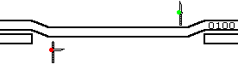

Fig 3.2 An example of Half Duplex mode

Railroads have to deal with this scenario more often since it's cheaper to lay a single track. A dispatcher will hold a train up at one end of the single track until a train going the other direction goes through. The only example I could think of for Half-Duplex is actually a Parallel interface. Even though parallel is eight lanes, data travels through the lanes in the same direction at the same time but never in both directions at the same time. The IEEE-1284 allows printers to send messages to the computer. The printer cannot send these messages while the computer is sending characters but when the computer stops sending characters, then the printer can send messages back. It's kind of like some roads that head into downtown. In the morning, they're one way roads, allowing traffic to go into downtown. In the evening their one way roads, allowing traffic to head out of downtown. The only advantage that Half-Duplex would have is the single lane or single track is cheaper then the double lane or double track.

##### FULL DUPLEX

Full-Duplex is like the ordinary two-lane highway. In some cases, where traffic is heavy enough, a railroad will decide to lay a double track to allow trains to pass in both directions. In communications, this is most common with networking.



Fig 3.3 An example of Full Duplex mode

Our fiber optic hubs have two connectors on each port, one for each lane of a two-lane roadway. Full-Duplex fiber is two cables bundled or tied together to form the two- lane roadway. In 100Base-TX, the two lanes are housed in the same jacket. RS232 was also designed to handle Full-Duplex but some of our short haul modems and converters give the user the option to go Half-Duplex or Simplex to reduce the number of conductors needed to connect between them.

**CHAPTER 4**

**4. IMPLEMENTATION**

**4.1 HEADER FILES**

The Header files used in OpenGL are

* + 1. **GL**, for which the commands begin with GL;
    2. **GLUT**, the GL Utility Toolkit, opens windows, develops menus, and manages events.
    3. **STDLIB,** the header of the general purpose standard library of C programming language.
    4. **STDIO,** provides many standard library functions for file input and output.
    5. **MATH,** defines various mathematical functions and one macro.
    6. **STRING,** defines one variable type, one macro, and various functions for manipulating arrays of characters.

## GRAPHIC FUNCTIONS

##### The Graphic Function used in OpenGL are

##### glRaster2f(x,y)

* 1. Specifies the raster position for pixel operation.

1. **glutBitmapCharacter(GLUT_BITMAP_TIMES_ROMAN_24,st[i])** Renders a bitmap character using OpenGL from the specified array of characters and in the specified font style.

##### glutPostRedisplay()

* 1. Marks the current window as needing to be redisplayed.

##### glutSwapBuffers()

* 1. Swaps the buffers of the current window if double buffered.

##### glViewport()

* 1. Sets the viewport.

##### glutInitDisplayMode(GLUT_DOUBLE|GLUT_RGB)

* 1. Sets the initial display mode.

##### glutInitWindowSize(500,500)

* 1. Sets the initial window size.

##### glutInitWindowPosition(50,100)

* 1. Sets the initial window position.

##### glutCreateWindow()

* 1. Creates a top level window width the window name as specified.

##### glPushMatrix()

* 1. Push the current matrix.

##### glPopMatrix()

* 1. Pops the current matrix.

##### glMatrixMode(GL_PROJECTION)

* 1. Specifies which matrix is the current matrix.

##### glLoadIdentity()

* 1. Replaces current matrix with identity matrix.

##### glutDisplayFunc(display)

* 1. Sets the display callback for the current window.

##### glutReshapeFunc(reshape)

* 1. Sets the reshape callback for the current window.

##### glutMainLoop()

* 1. Enters the GLUT event processing loop. This routine should be called at main once in a GLUT program. Once called, this routine will never return. It will call necessary any callbacks that have been registered.

### 4.3 FLOWCHART

The flowchart of the model is as below



START

INITIALIZE CALLBACK FUNCTIONS

MAIN



MAIN SCREEN DISPLAYED

READING INPUT [ENTER]

STOP

MODE 3

MODE 2

MODE 1

Fig 4.1 The flowchart of the model

**CHAPTER 5**

**RESULTS**

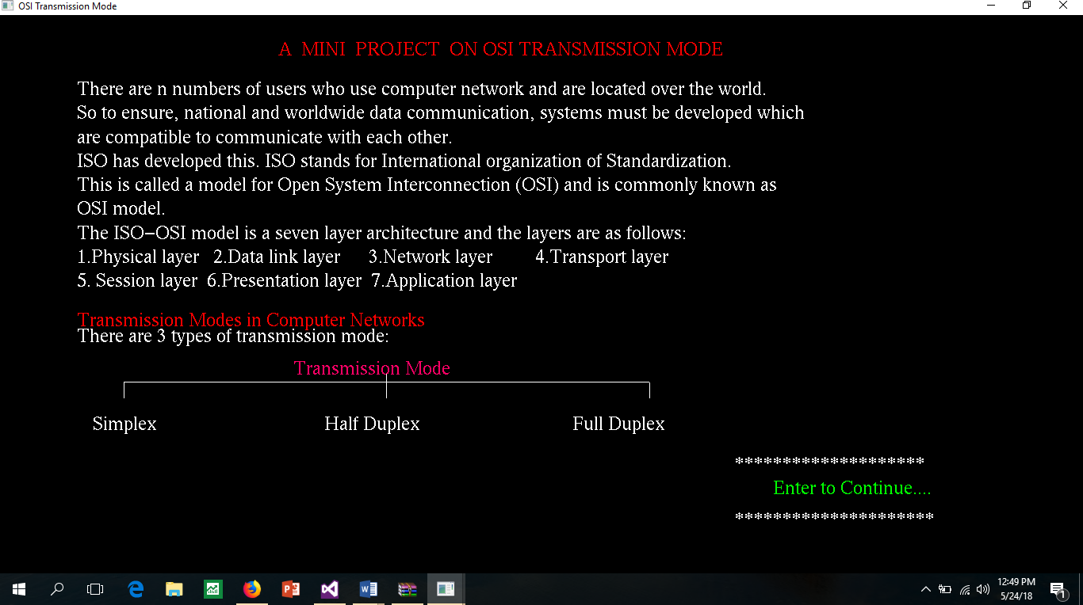The first window shows the title of mini project with the definition of transmission modes and the types of transmission modes. Clicking on enter from the home page will take to the simulation of all three modes.

Fig 5.1 The first window

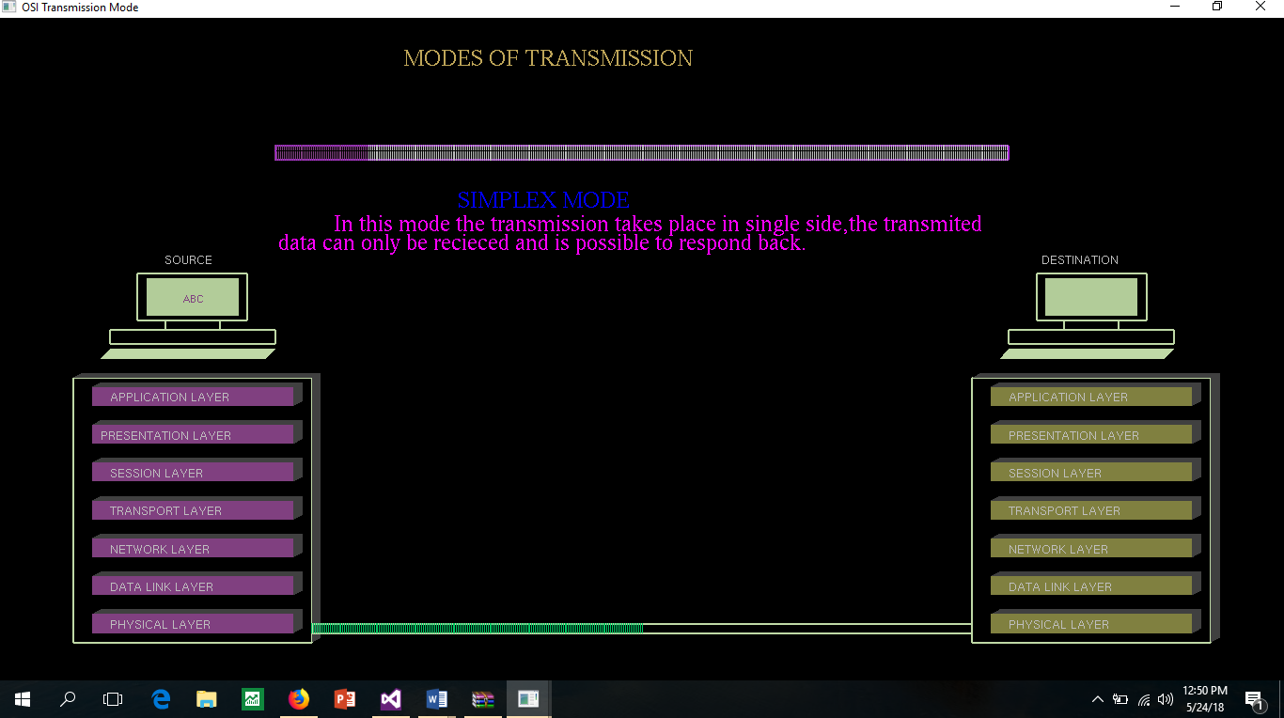The second window starts with the simplex mode where one can observe the data being passed on the 7 layers from source to destination only.

Fig 5.2 The simplex mode

The third window shows up the half duplex mode, similar to the simplex data moves in one direction and after reaching it starts from the destination to the source.

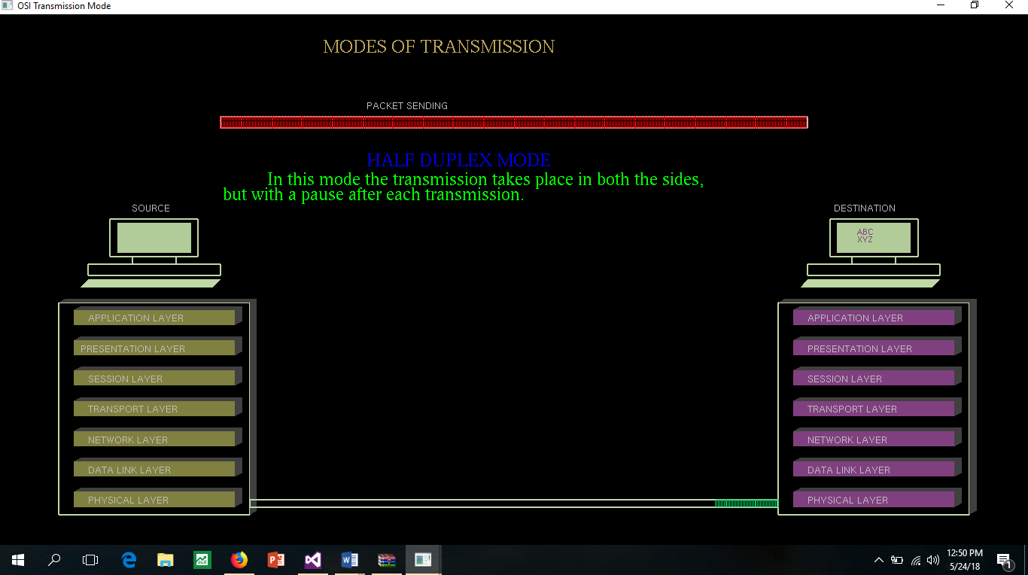

Fig 5.3 The Half Duplex Mode

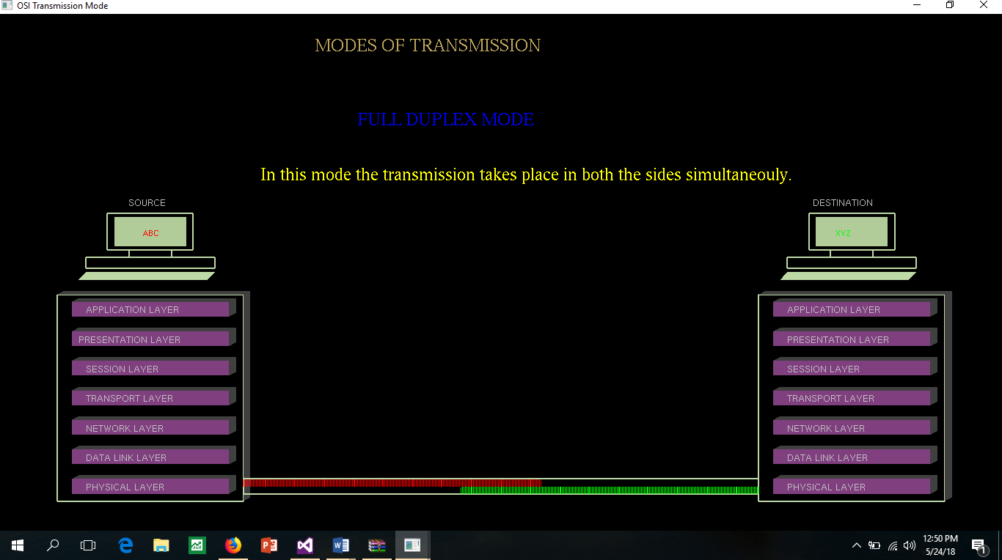The fourth window shows up the last mode that is duplex mode where the data moves simultaneously from source to destination and destination to source.

Fig 5.4 The Full Duplex

# CONCLUSION

OpenGL API helps in the easy implementation of computer graphics and is useful in many cases for visualization and explanatory methods for understanding the working of algorithm. This library helps in the implementation of many useful visualizations and animations. The projects exploits the power of OpenGL for demonstrating the different types of Transmission modes.

Transmission modes are necessary for the transfer of data from source to destination, as this includes processing of different models in OSI, it may be made simpler and power of understandability can be increased using computer graphics which is shown above in the implementation.

**REFERENCES**

1. The OSI Reference Mode J.D. Day and H. Zimmermann.. Retrieved on Dec 1983
2. Research based on OSI Model Yadong Li ; Danlan Li ; Wenqiang Cui ; Rui Zhang . Retrieved on May 2011.
3. https://en.wikipedia.org/wiki/Data_transmission
4. https://en.wikipedia.org/wiki/OpenGL
5. https://[www.khronos.org/opengl/wiki/Code_Resources](http://www.khronos.org/opengl/wiki/Code_Resources)
6. https://en.wikipedia.org/wiki/OpenGL_Utility_Library
7. vle.du.ac.in/mod/book/view.php?id=5697&chapterid=2486
8. vle.du.ac.in/mod/book/view.php?id=5697&chapterid=2486
9. https://en.wikipedia.org/wiki/Open