**CHAPTER 1**

**1. INTRODUCTION**

**1.1 OVERVIEW**

Blood bank is a place where blood bag that is collected from blood donation events is stored in one place. Blood Bank Management System (BBMS) is a browser-based system that is designed to store, process, retrieve and analyze information concerned with the administrative and inventory management within a blood bank. This project aims at maintaining all the information pertaining to blood donors, different blood groups available in each blood bank and help them manage in a better way. Aim is to provide transparency in this field, make the process of obtaining blood from a blood bank hassle free and corruption free and make the system of blood bank management effective.

**1.2 PROBLEM STATEMENT**

Entering the details about the blood groups, members, addresses etc. and tracking the database is complicated when the details are maintained manually. It is time consuming and it leads to error prone results. It consumes lot of men power to better results and it lacks data security. Retrieval of data takes lots of time. So, the main aim of this application is to automate the complete operations of the blood bank. The purpose of the project is to build an application program to reduce the manual work for managing the blood bank, blood group, record and donor.

**1.3 OBJECTIVES**

The main objective of this application is to automate the complete operations of the blood bank. They need maintain hundreds of thousands of records. Also searching should be very faster so they can find required details instantly.

To develop a web-based portal to facilitate the co-ordination between supply and demand of blood. This system makes conveniently available good quality, safe blood and other blood components, which can be provided in a sound, ethical and acceptable manner, consistent with the long-term well-being of the community.

It actively encourages voluntary blood donation, motivate and maintain a well-indexed record of blood donors and educate the community on the benefits of blood donation. This will also serve as the site for interaction of best practices in reducing unnecessary utilization of blood and help the state work more efficiently towards self-sufficiency in blood.

The system will provide the user the option to look at the details of the existing Donor List, Blood Group and to add a new Donor. It also allows the user to modify the record. The administrator can alter all the system data.

**1.4 ADVANTAGES**

There are three beneficiaries which can get benefits from the management information system of blood bank which are: 1. Donors: person who wants to donate the blood voluntarily at the blood donation camp. Information system also keeps the record of the donors who wants to register online. 2. Seekers: person who wants the blood from the blood bank due to various reasons like accidents, surgeries, delivery and many more. 3. Blood bank: staff people which are working in the blood bank which includes staff member, operator, blood bank in charge, head of pathological department.

Benefits of blood bank management information system to donors:

1. It provides the unique identification number at the time of blood donation camp which helps him for the future correspondence. MIS gives the unique user id and password for those donors who are applying online. They can edit their information time to time. This feature helps administrator to collect the information of all the donor’s area wise and blood group wise.
2. Donors can view the blood donation camp organizing at the different places. 3. As it is a web-based application, its index page encourages the donor to donate the blood. 4. Donor can also check his blood group medical status whether it is healthy or unhealthy. 5. Donor can check the status of the particular blood group just on one click sitting at home.

Benefits of blood bank management information system to seekers:

1. Seeker can get the information of the desired blood group from the central inventory

2. Seeker can get the list of donors’ areas wise, blood group wise if the desired blood group is not available in the central inventory.

3. Seeker can get the information of the particular blood group available in the blood bank.

4. Seeker can get the information of that blood group which is not fit for blood transfusion

.5. Seeker can get the blood units according to his requirement from the blood bank.

Benefits of blood bank management information system to blood bank:

1. Blood bank in charge is getting rid from manual procedure. Now they to do the entries in the information system.

2. The probability of error should be minimal.

3. Information retrieval should be precise and effective.

4. Inventory control can be properly controlled and managed as researcher is using the FIFO (First in First Out) concept.

5. Report can be generated of donors, seekers, total consumption of the blood units and overall report monthly, bi-monthly, quarterly, half yearly, annually

**CHAPTER 2**

**2. REQUIREMENT ANALYSIS**

System requirement specification provides the details like hardware and software necessary to carry out this project. Analysis is the phase where actual expectations from the software are set. The requirements desired from the software are set in analysis phase which are carried on to design phase where the software is designed to fulfill these requirements.

**2.1 SOFTWARE REQUIREMENTS**

1. Operating System : Windows 10
2. Language : PHP
3. Back End : MYSQL Server
4. Browser : Any of Mozilla, Opera, Chrome etc.
5. Software Tool Kit : XAMP

**2.2 HARDWARE REQUIREMENTS**

1. Desktop or Laptop
2. Minimum 25GB HDD
3. Minimum 2GB RAM

**CHAPTER 3**

**3. SYSTEM DESIGN**

System analysis and design sets an ultimate frame work or selection for actual cause of building a software system. Whenever the requirements document say an SRS for the software system to be built is finalized, the system design in terms of an architectural design would commence.

The basic design activities of a software being developed is a two-level process comprising system design or top-level design at the first level and logic design or detailed design as its second level. In essence the design of a software system is a plan or a mindful blueprint of the solution for a system to be developed.

**3.1 MODULES**

1. **ADMIN**
2. **USER**

**3.1.1 ADMIN LOGIN:**

After entering to the home page of the website, admin can choose the ADMIN LOGIN option where they are asked to enter username & password, and if he/she is a valid user then admin login page will be displayed.

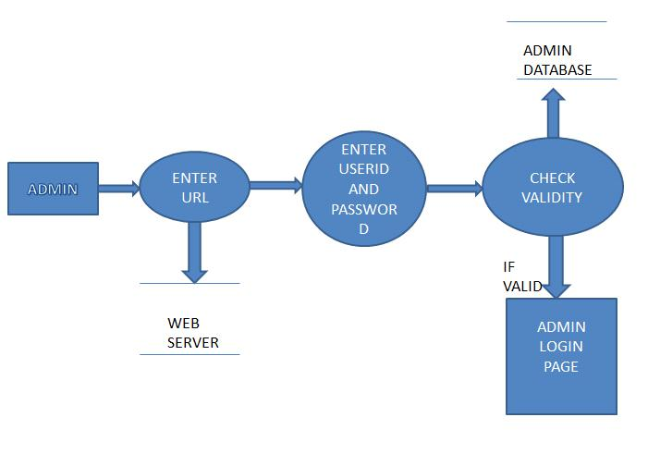

**Figure 3.1 Admin login design**

The user can do the following

1. View Feedback
2. Search for donors
3. See activate donors
4. Activate or deactivate donors
5. Update the status if any donor has donated blood
6. Change the status of blood is provided or not

**3.1.2 USER**

The user can make a new register to be a donor, request for blood by giving the valid details, and write a feedback to the admin

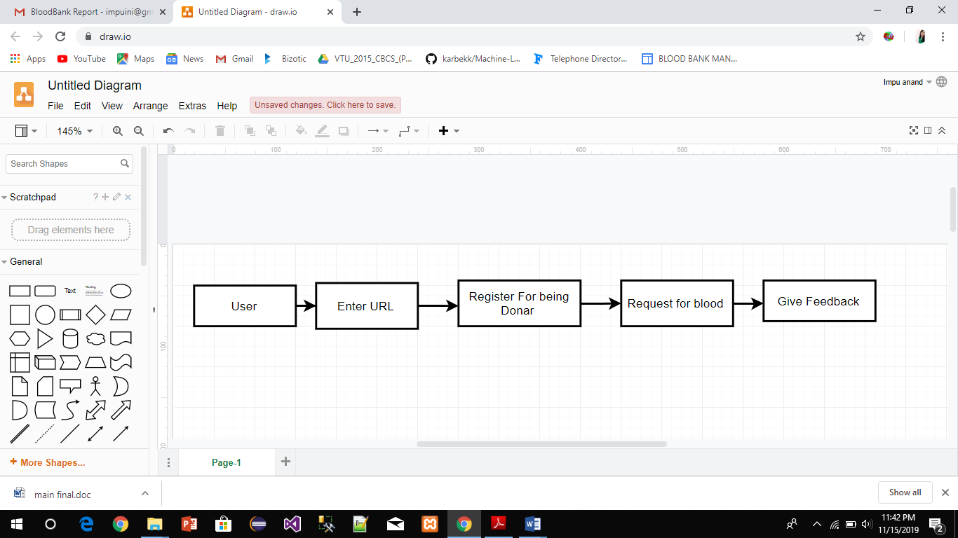

**Figure 3.2 User module design**

**CHAPTER 4**

**4. IMPLEMENTATION**

System implementation is the important stage of project when the theoretical design is tuned into practical system. The main stages in the implementation are as follows:

1. Planning

2. Training

3. System Testing and

4. Changeover Planning

Planning is the first task in the system implementation. At the time of implementation of any system people from different departments and system analysis involve. They are confirmed to practical problem of controlling various activities of people outside their own data processing departments. The line managers controlled through an implementation coordinating committee. The committee considers ideas, problems and complaints of user department, it must also consider:

1. The implication of system environment

2. Self-selection and allocation for implementation tasks

3. Consultation with unions and resources available

4. Standby facilities and channel communication

**4.1 TOOLS AND TECHNOLOGY**

**4.1.1 PHP**

PHP is a server-side scripting language designed for web development but also used as a general-purpose programming language. Originally created by Rasmus Lerdorf in 1994, the PHP reference implementation is now produced by The PHP Group. PHP originally stood for Personal Home Page, but it now stands for the recursive acronym PHP: Hypertext Preprocessor.PHP code may be embedded into HTML code, or it can be used in combination with various web template systems. PHP code is usually processed by a PHP interpreter implemented as a module in the web server or as a Common Gateway Interface (CGI) executable.

**4.1.2 APACHE**

The Apache HTTP Server, colloquially called Apache, is free and open-source cross platform web server software, released under the terms of Apache License 2.0. Apache is developed and maintained by an open community of developers under the auspices of the Apache Software Foundation. The Apache HTTP server is a software (or program) that runs in the background under an appropriate operating system, which supports multi-tasking, and provides services to other applications that connect to it, such as client web browsers. It was first developed to work with Linux/Unix operating systems, but was later adapted to work under other systems, including Windows and Mac. The Apache binary running under UNIX is called HTTPd (short for HTTP daemon), and under win32 is called Apache.exe.

**4.1.3 MySQL**

MySQL is a freely available open source Relational Database Management System (RDBMS) that uses Structured Query Language (SQL). Its name is a combination of "My", the name of co-founder Michael Widenius's daughter, and "SQL", the abbreviation for Structured Query Language. SQL is the most popular language for adding, accessing and managing content in a database. It is most noted for its quick processing, proven reliability, ease and flexibility of use. MySQL is an essential part of almost every open source PHP application. Good examples for PHP & MySQLbased scripts are WordPress, Joomla, Magento and Drupal.

**4.1.4 XAMPP SERVER**

XAMPP is a [free and open-source](https://en.wikipedia.org/wiki/Free_and_open-source) [cross-platform](https://en.wikipedia.org/wiki/Cross-platform) [web server](https://en.wikipedia.org/wiki/Web_server) [solution stack](https://en.wikipedia.org/wiki/Solution_stack) package developed by Apache Friends,[]](https://en.wikipedia.org/wiki/XAMPP#cite_note-kaiseidlerinterview-2) consisting mainly of the [Apache HTTP Server,](https://en.wikipedia.org/wiki/Apache_HTTP_Server) [MariaDB](https://en.wikipedia.org/wiki/MariaDB) [database,](https://en.wikipedia.org/wiki/Database) and [interpreters](https://en.wikipedia.org/wiki/Interpreter_(computing)) for scripts written in the [PHP](https://en.wikipedia.org/wiki/PHP) and [Perl](https://en.wikipedia.org/wiki/Perl) [programming languages.](https://en.wikipedia.org/wiki/Programming_language) Since most actual web server deployments use the same components as XAMPP, it makes transitioning from a local test server to a live server possible.

**CHAPTER 5**

**5. TESTING**

The purpose of testing is to discover errors. Testing is the process of trying to discover every conceivable fault or weakness in a work product. It provides a way to check the functionality of components, sub-assemblies, assemblies and/or a finished product It is the process of exercising software with the intent of ensuring that the

Software system meets its requirements and user expectations and does not fail in an unacceptable manner. There are various types of test. Each test type addresses a specific testing requirement.

**5.1 UNIT TESTING:**

Unit testing involves the design of test cases that validate that the internal program logic is functioning properly, and that program inputs produce valid outputs. All decision branches and internal code flow should be validated. It is the testing of individual software units of the application .it is done after the completion of an individual unit before integration. This is a structural testing, that relies on knowledge of its construction and is invasive. Unit tests perform basic tests at component level and test a specific business process, application, and/or system configuration. Unit tests ensure that each unique path of a business process performs accurately to the documented specifications and contains clearly defined inputs and expected results.

**5.2 INTEGRATION TESTING:**

Integration tests are designed to test integrated software components to determine if they actually run as one program. Testing is event driven and is more concerned with the basic outcome of screens or fields. Integration tests demonstrate that although the components were individually satisfaction, as shown by successfully unit testing, the combination of components is correct and consistent. Integration testing is specifically aimed at exposing the problems that arise from the combination of components.

The following table shows the test conditions:

|  |  |  |  |  |
| --- | --- | --- | --- | --- |
| **Test cases** | **Description** | **Expected Result** | **Actual Result** | **Result** |
| TC01 | Execute/run the application. | Application should run without any interrupts | Application is executing properly | Pass |
| TC02 | Verification of Admin login with valid user Id and  Password. | User ID and password should be verified with database. If it is valid navigate to respective page or else intimate the error message like Access denied | Admin user ID & password is checked in the database and is navigating to respective dashboard page. Invalid details if invalid input is given | Pass |
| TC03 | Registering for being a Donor with valid details | Registration successful if valid details or else display to provide valid details | Adding new donor registration otherwise showing to provide valid details | Pass |
| TC04 | Requesting for blood  With valid details of blood group and location | If found should show the results of the donors or else should show no donors. | Showing results otherwise no result found. | Pass |
| TC05 | Feedback system | Admin viewing and deleting them. | Admin is able to view the feedback and delete them. | Pass |
| TC06 | Activate donor and deactivate donor | Admin must be able to active donors and deactivate the registered donors | Admin is able to activate and deactivate donors | Pass |

**Table 5.1 Test cases**

**CHAPTER 6**

**6. RESULTS**

Here we discuss about the snapshots and results based on our project. Based on certain inputs here are some of the snapshots.

**6.1 SNAPSHOTS**

The below picture will show the login page for the website 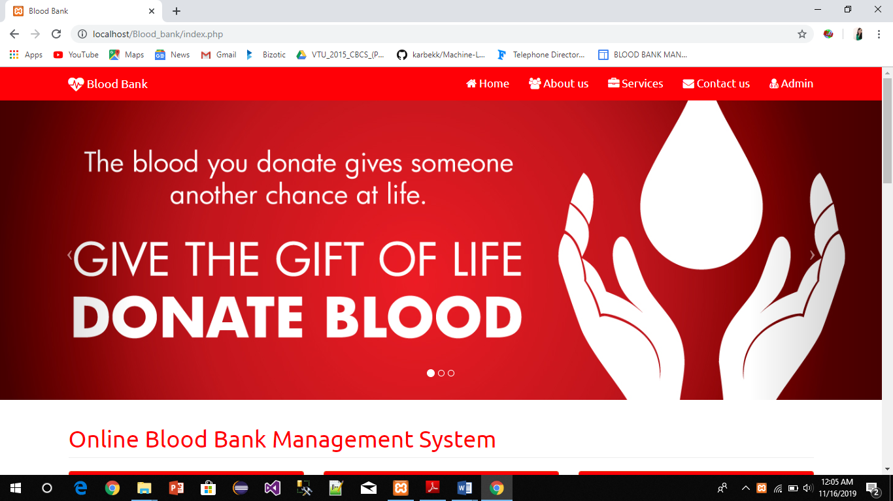

**Figure 6.1: Home page**

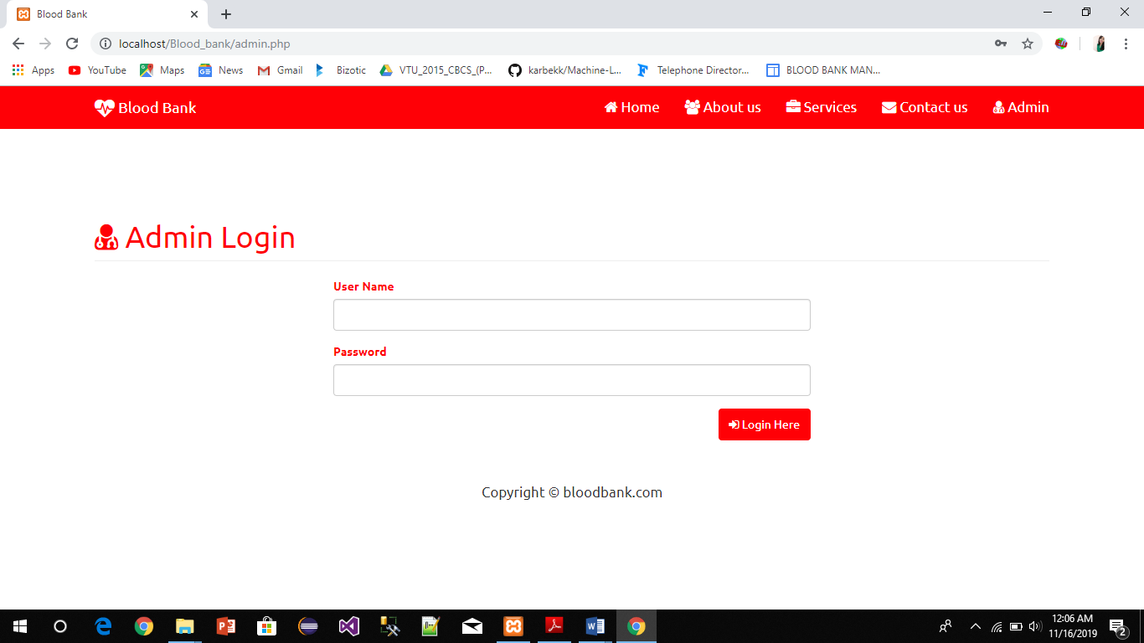After going to the home page if you are the admin you can login as admin user.

**Figure 6.2: The Admin login page**

The user can register to become a donor in this form

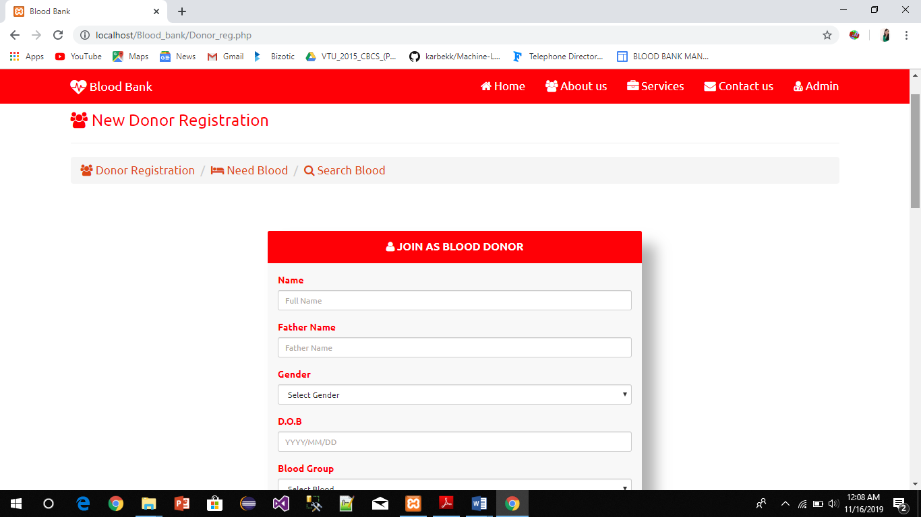

**Figure 6.3: Adding new donor by user**

The user can also request for blood.

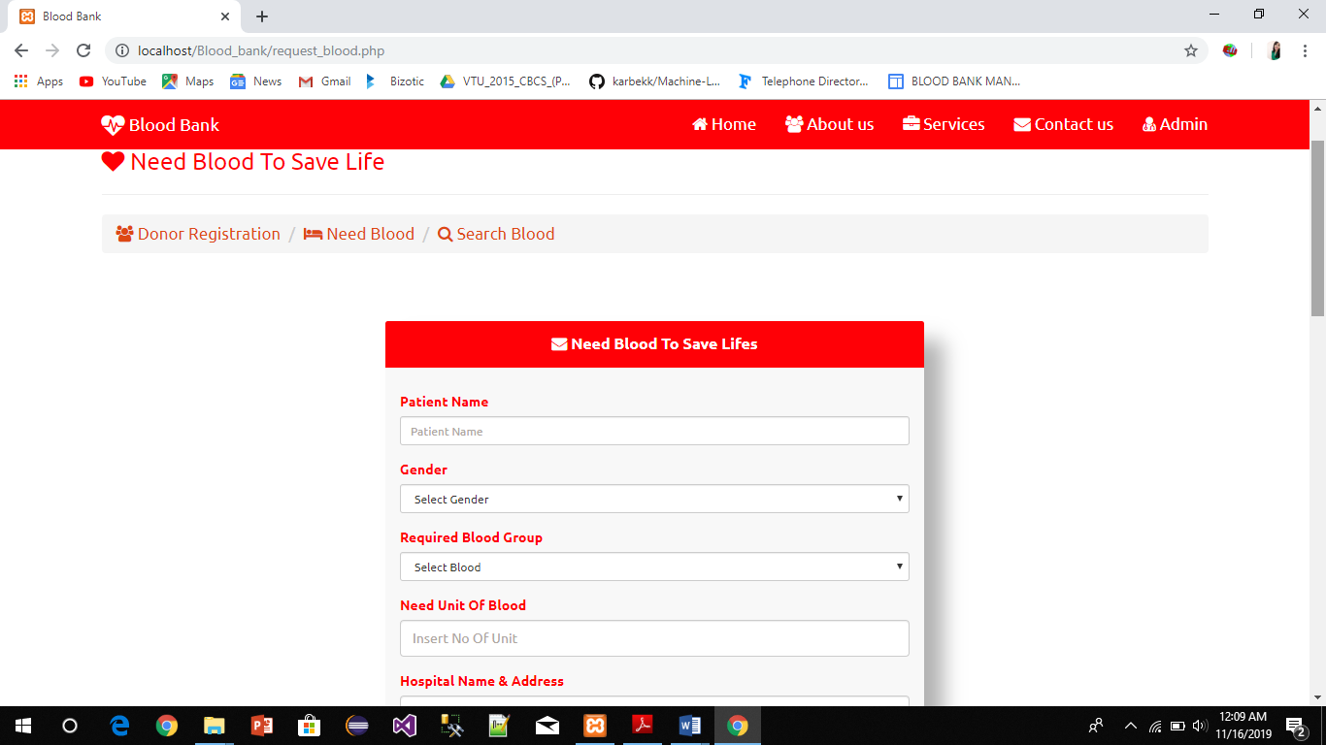

**Figure 6.4: Requesting blood page**

The user can also search blood availability

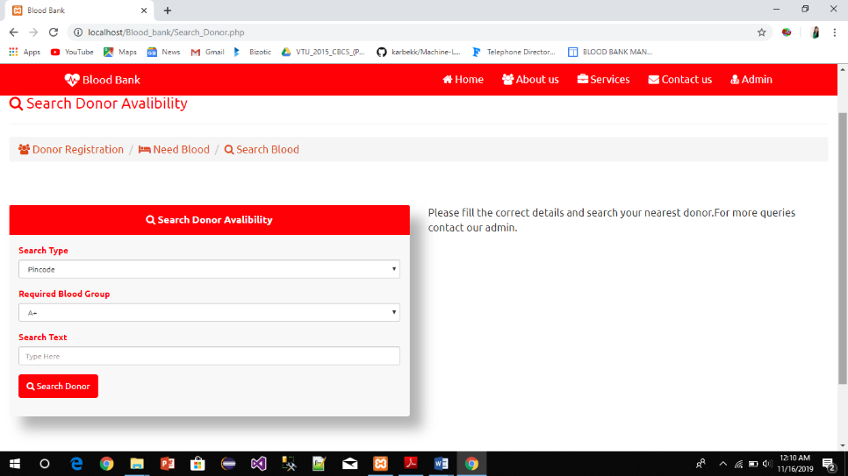

**Figure 6.5 Searching blood page**

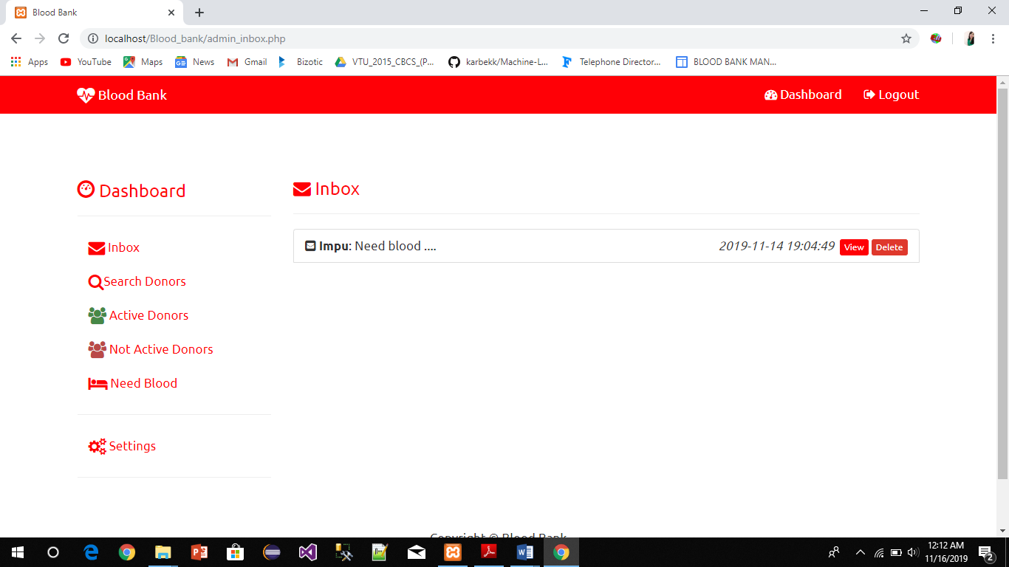The admin can view inbox messages from the users

**Figure 6.6: Admin page**

**CONCLUSION**

With the theoretical inclination of our syllabus it becomes very essential to take the at most advantage of any opportunity of gaining practical experience that comes along. The building blocks of this Major Project” BLOOD BANK Management System” was one of these opportunities. It gave us the requisite practical knowledge to supplement the already taught theoretical concepts thus making us more competent as a computer engineer. The project from a personal point of view also helped us in understanding the following aspects of project development:

1. The planning that goes into implementing a project.
2. The importance of proper planning and an organized methodology.
3. The key element of team spirit and co-ordination in a successful project.

**REFERENCES**

1. <https://www.w3schools.com/>asp/webpages.asp
2. <https://www.comentum.com/>guide-to-web-application-development.html
3. <https://www.myssqltutorial.com/>php
4. https://www.html.com/[#The_HTMLcom_Guide_to_Web_Hosting](https://html.com/#The_HTMLcom_Guide_to_Web_Hosting)
5. www.php.net/phpmanual
6. <https://www.w3schools.com/php/default.asp>