Car Service Operations Management System
Software Requirements Specification (SRS) & System Architecture Specification
Document Version | 2.0 (Production Master)
Technology Stack | Java 21, Spring Boot 3.3.1, Spring Cloud, Kafka, JJWT, MySQL 8
Architecture Pattern | Microservices Architecture (6 Services + Gateway + Eureka)
Security Standard | Dual-Layer Defense (Edge Gateway + Service-Level Security Filters)

1. Executive Summary & Project Objectives
The Car Service Operations Management System is a resilient, enterprise-grade microservice application designed to streamline vehicle maintenance operations, fleet tracking, role-based workflows, and audit logging. The system comprises 6 standalone microservices communicating synchronously via REST (Spring Cloud OpenFeign) and asynchronously via event messaging (Apache Kafka), monitored in real-time through Spring Boot Actuator health endpoints.
AUTHORITATIVE SPECIFICATION: This document serves as the authoritative Software Requirements Specification (SRS) defining all functional requirements, non-functional requirements, security models, data contracts, and operational execution steps.

2. System Architecture & Microservices Topology
The system architecture follows a clean 6-service microservices pattern operating behind an Edge API Gateway and registered with a central Netflix Eureka Discovery Server.
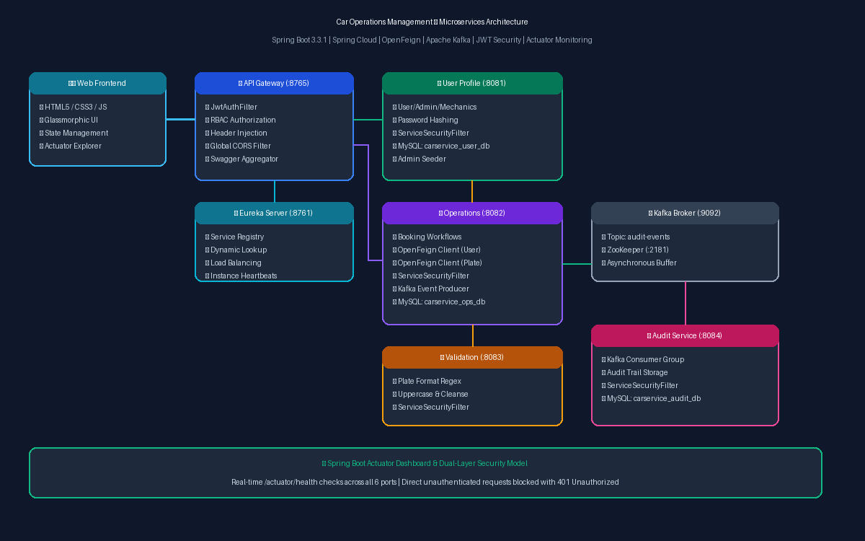
Figure 2.1: Microservices Architecture & Network Topology Diagram

2.1 Microservices Inventory
Service Name | Port | Tech / Database | Core Responsibilities
eureka-discovery-server | 8761 | Spring Cloud Eureka | Central service registry, cluster node tracking, instance heartbeats
api-gateway | 8765 | Spring Cloud Gateway, JJWT | Edge routing, JWT verification, RBAC enforcement, CORS, Swagger UI aggregator
user-profile-service | 8081 | MySQL (carservice_user_db) | User registration, Admin/Mechanic profiles, SHA-256 salted auth, Admin seeder
car-service-operations | 8082 | MySQL (carservice_ops_db), Feign, Kafka | Core service bookings, vehicle status workflows, OpenFeign client, Kafka event publisher
car-details-validation-service | 8083 | Spring Boot (Regex Engine) | Enforces national license plate syntax rules (^[A-Z]{2}[0-9]{1,2}[A-Z]{1,2}[0-9]{4}$)
audit-service | 8084 | MySQL (carservice_audit_db), Kafka Consumer | Asynchronously consumes audit events from Kafka topic car-service-audit-events into DB

3. Functional Requirements Specification

FR-1: User Management & Authentication
The system shall provide registration and authentication endpoints for three distinct user roles (ADMIN, MECHANIC, CUSTOMER). Passwords must be hashed using SHA-256 with salt and pepper. On initial startup, the User Profile Service must auto-seed a default Admin user (username: admin, password: adminpassword).

FR-2: Vehicle Service Registration & Status Lifecycle
Authorized Admin users shall be able to register vehicle service logs. The lifecycle transitions sequentially from PENDING -> IN_PROGRESS -> COMPLETED. Operations Service must verify customer existence via User Profile Service and license plate syntax via Validation Service before creation.

FR-3: Terminal COMPLETED State Lock & Admin Override
When a service status reaches COMPLETED, Mechanics are permanently locked out from modifying the record. The UI hides the status dropdown and replaces it with a lock icon. Direct API calls from Mechanics return 403 Forbidden. Admins retain override authority to revert COMPLETED status back to active states.

FR-4: National License Plate Validation
Car Details Validation Service shall validate license plate numbers against national regex format ^[A-Z]{2}[0-9]{1,2}[A-Z]{1,2}[0-9]{4}$. Spacing must be stripped and text converted to uppercase prior to evaluation.

FR-5: Real-Time Event-Driven Auditing
Every service log creation, status update, or deletion in Car Service Operations must publish a JSON audit event to Kafka topic car-service-audit-events. Audit Service consumers must parse and persist these events into MySQL audit DB.

FR-6: Admin Actuator Health Dashboard
The frontend web dashboard shall provide a dedicated Health & Actuator Panel displaying live status cards (UP / DOWN) for all 6 microservices and an interactive JSON explorer for health, metrics, env, beans, and mappings.

4. Non-Functional Requirements & Security Architecture

4.1 Dual-Layer Security Defense Model
To satisfy high-security standards, the system implements a Dual-Layer Defense Architecture:
• Layer 1 (Edge Gateway Security): The API Gateway intercepts incoming public traffic, validates JWT signatures and expiration, enforces Role-Based Access Control (RBAC), and injects verified identity headers (X-Authenticated-User, X-Authenticated-Role, X-Authenticated-Id) downstream.
• Layer 2 (Service-Level Security): Downstream microservices (User Profile, Operations, Audit, Validation) enforce a custom ServiceSecurityFilter. Direct unauthenticated requests bypassing the Gateway without a valid JWT token or Gateway header are rejected with HTTP 401 Unauthorized.
• CORS Preflight Support: ServiceSecurityFilter explicitly intercept HTTP OPTIONS preflight requests and respond with HTTP 200 OK and Access-Control-Allow-Origin: * to prevent browser fetch blocking.

4.2 Database Isolation & ID Prefix Architecture
To prevent auto-increment identifier collisions across user roles, users are partitioned into dedicated MySQL tables with distinct prefix formatting:
• admin_profiles: ID Prefix: ADM- (Auto-increment sequence starts at 1, e.g., ADM-1)
• mechanic_profiles: ID Prefix: MCH- (Auto-increment sequence starts at 1, e.g., MCH-1)
• customer_profiles: ID Prefix: USR- (Auto-increment sequence starts at 1, e.g., USR-1)

5. REST API Endpoint Reference Matrix
HTTP Method | Endpoint URI | Microservice | Access Permission
POST | /auth/login | api-gateway | Public
POST | /users/userprofile | user-profile-service | Public / Registration
GET | /users/userprofile/all | user-profile-service | ADMIN, MECHANIC
POST | /carservice/book | car-service-operations | ADMIN
GET | /carservice/all | car-service-operations | ADMIN, MECHANIC
GET | /carservice/customer/{id} | car-service-operations | CUSTOMER (Filtered), ADMIN
PUT | /carservice/status/{id} | car-service-operations | ADMIN (Any), MECHANIC (Active)
DELETE | /carservice/delete/{id} | car-service-operations | ADMIN
GET | /audits/all | audit-service | ADMIN
GET | /actuator/health | All Microservices | Public / Dashboard Monitor

6. Deployment & Operational Execution Guide
Follow this strict execution sequence to launch the environment:
Step 1: Start MySQL Database Server — Ensure MySQL is running on port 3306 with credentials root / root.
Step 2: Start Apache Kafka & ZooKeeper — Terminal 1: zookeeper-server-start.bat config/zookeeper.properties
Terminal 2: kafka-server-start.bat config/server.properties
Step 3: Launch Eureka Discovery Server — Run eureka-discovery-server Spring Boot application and verify dashboard at http://localhost:8761.
Step 4: Launch Core Microservices — Start user-profile-service, api-gateway, car-details-validation-service, car-service-operations, and audit-service in STS/Eclipse.
Step 5: Open Web Dashboard — Open car-service-frontend/index.html in browser and log in with admin / adminpassword.

