INTERNSHIP TRAINING REPORT
January – June, 2018

Project Name – SELENA TOOL DEVELOPMENT
Organization – Robert Bosch Engineering and Business Solutions (BOSCH)

Submitted by –
Rahul Chandravanshi
Reg. No – 11403420
Course code - CSE441J

Under the guidance of Mr. Pramod Srivatsa K (senior software engineer, BOSCH).

School of Computer Science and Engineering

Company Mentor End Term Evaluation Form
DECLARATION

I hereby declare that I am doing an internship at Robert Bosch Engineering and Business Solutions (RBEI) from 18th January 2018 under the guidance of Pramod Srivatsa Krishna Murthy (senior developer).
I declare that I have been working with full dedication during these 4 months of internship.
I have successfully completed tasks given to me during this period which includes demo on Github, presentation of SAFe and addition of extra option to python script which is core to our current project Selena.

Name of student: Rahul Chandravanshi
Registration Number: 11403420

CERTIFICATE
This is to certify that the declaration statement made by this student is correct to the best of my knowledge and belief. He has completed this Internship Project under my guidance and supervision. The present work is the result of their original investigation, effort and study. No part of the work has ever been submitted for any other degree at any University. The Internship Project is fit for the submission and partial fulfillment of the conditions for the award of B.Tech degree in _____________ (Program Name) from Lovely Professional University, Phagwara.

Signature and Name of the Mentor

Designation

School of Computer Science and Engineering,
Lovely Professional University,
Phagwara, Punjab.

Date :
ACKNOWLEDGEMENT

In completing this internship I have been fortunate to have help, support and encouragement from many people. I would like to acknowledge them for their cooperation.
Pramod Srivatsa K, my mentor at BOSCH, for guiding me through each and every step of the process with knowledge and support.
I would also like to thank Akash Babu Suresh, guide for new recruits and Abdul Rahim P A, project manager for their support in my transition from college to corporate world.
A special thanks to my team Selena for helping understand the bits of such a big project.

INTERNSHIP TIMELINE

JANUARY | FEBRUARY | MARCH | APRIL | MAY
Getting to organization structure
 | Presentation on SAFe
 |  | Demo on Github
 |  |  | Task on Project SELENA
 |  |  |  | Task on Project SELENA continued..

TABLE OF CONTENTS

Inner first page ………………………………………………………………………(i)
Company mentor end term evaluation form ………………………………………...(ii)
Declaration...………………………………………………………………………..(iii)
Certificate …………………………………………………………………………..(iv)
Acknowledgement…………………………………………………………………..(v)
Internship Timeline ………………………………………………………………...(vi)
Table of contents ………………………………………………………………..…(vii)
- INTRODUCTION
  - DACore
  - SELENA
- PROBLEM
- EXISTING SYSTEM
  - INTRODUCTION
  - WHAT’S NEW IN THE SYSTEM TO BE DEVELOPED

1. INTRODUCTION
SELENA is a simulation tool. It simulates the DACore functionality. The idea is to feed data to selena so that it can simulate real test scenario. It helps by not requiring to test with a real car in a real test site again and again. To understand how exactly SELENA works, we need to consider looking into DACore.

1.1. DACore
DACore is BOSCH operating system for all future Driver Assistance System including HAD. It runs customer specific Apps on various sensor and computing platforms, abstracting from E/E architecture and includes mainstream reference implementation.
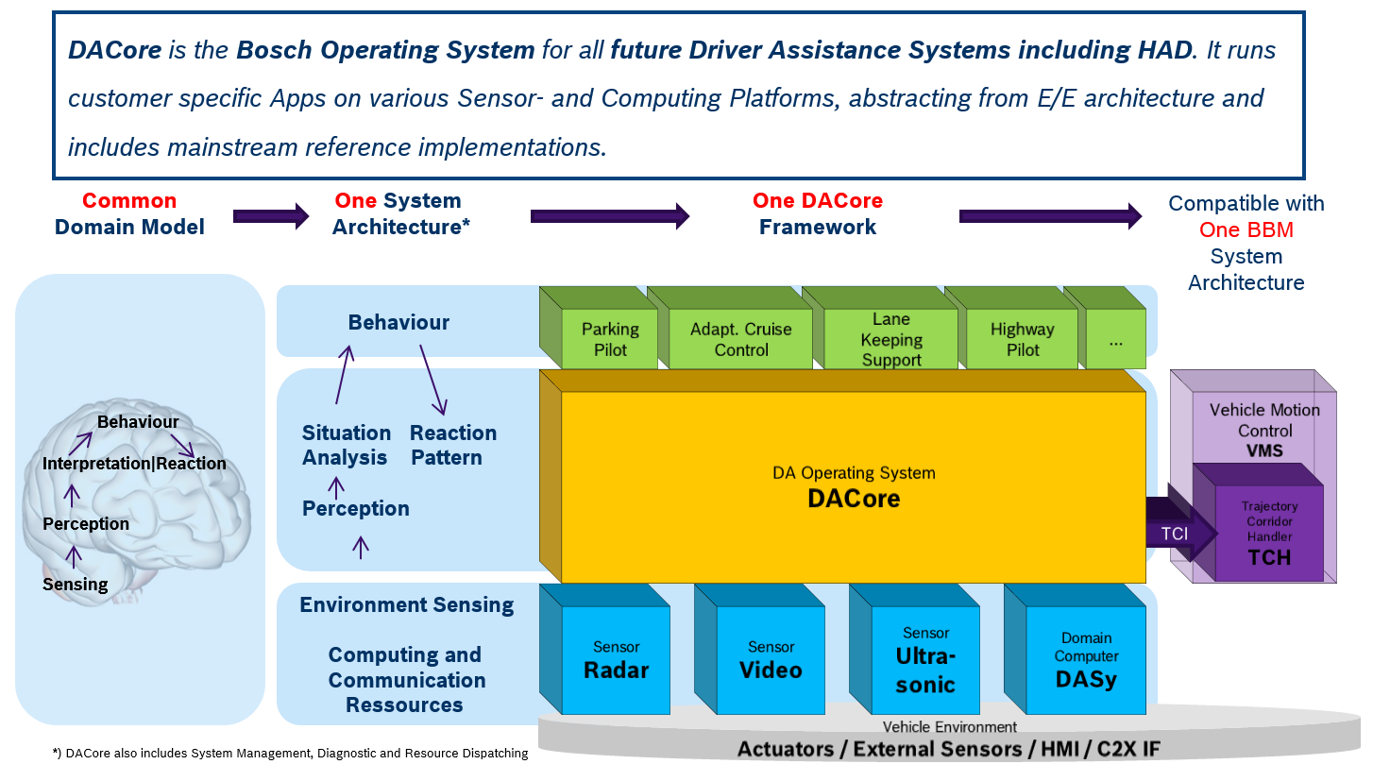
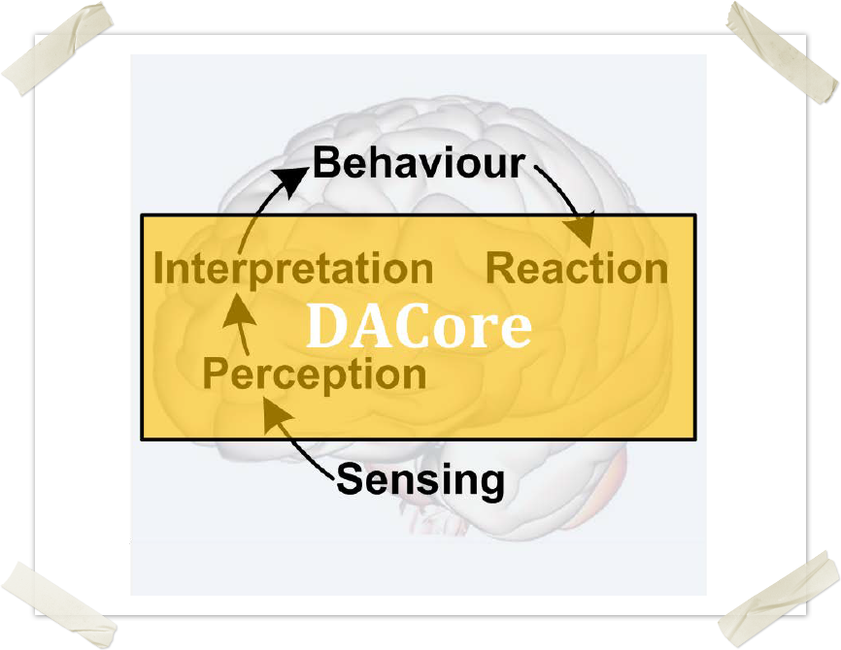

1.2. SELENA
Now, to realize all of these, a car needs to be tested on site, which is not feasible and cost friendly all the time. Here comes Selena, the simulation environment. It can take different configurations into consideration and simulate accordingly.
Before using Selena, it needs to be build first. It can be run on both Windows and Linux platforms. Windows being the standard BOSCH operating system supports direct installation of Selena, on the other hand for Linux it can be installed on a custom BOSCH made Ubuntu based Linux OS on top of a virtual machine.
This is how you build SELENA
Step 1. cd into the project directory
Step 2. Run the following command with appropriate configuration file
python R2D2.py –m path_to_config_file

2. PROBLEM
The Selena simulation tool can be built with different-different configurations. The python script that builds Selena is called R2D2. It creates a build directory, inside which we have Selena build with different configurations. The problem is with cleaning (deleting) a particular build. What R2D2 does is, it deletes the entire build directory irrespective of number of builds inside that directory. So, the objective is to give out a warning to the developer if he tries to clean the build directory with more than one builds.

3. EXISTING SOFTWARE
3.1. INTRODUCTION
The current R2D2 python script builds SELENA based on configuration files passed to it. It has many options to interface with tools required in building SELENA. The screenshot below shows all the options.
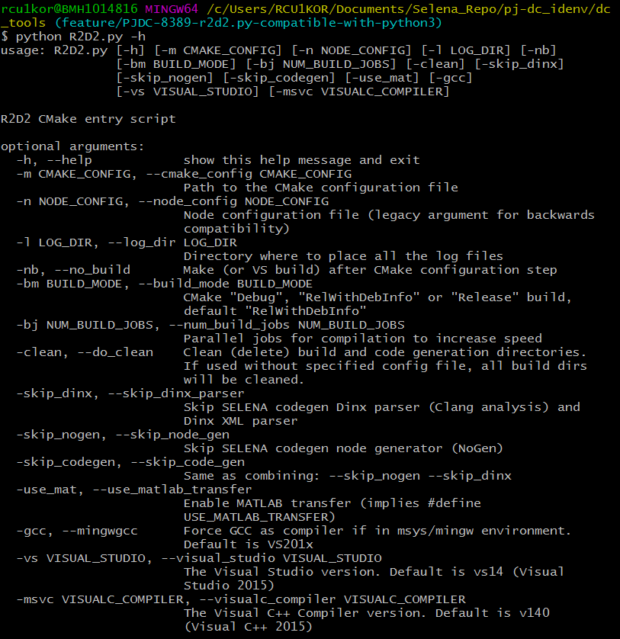
3.2. WHAT’S NEW IN THE SYSTEM TO BE DEVELOPED?
The current R2D2 script takes care of cleaning the build directory but the current system deletes the entire build directory irrespective of number of builds inside the directory. So, the objective is to check for the other builds in the build directory and if there are more than one builds found, show a warning to the developer and let the developer decide what to keep and what to remove.

4. PROBLEM ANALYSIS
4.1. PRODUCT DEFINITION
The R2D2 python script builds SELENA from given configuration and all the builds are located inside the build directory. The problem is when user tries to remove a build by specifying option ‘-c’ in the command, the script removes the entire build directory. The solution is to check whether there are more than one builds inside the build directory and take action accordingly.
4.2. FEASIBILITY ANALYSIS
The task at hand is completely feasible with only 1 developer required to edit and modify the python script. The man hours required is just a week, but for me, being an intern it took a month. The reason being, I had to learn python and entire process of building SELENA.

5. IMPLEMENTATION & TESTING
The script was successfully modified using the python module named ‘os’. Here all I had to do is check for existing builds and if the number is more than one display a warning message to developer else delete the entire build directory.
The pictures below depict the exact working.
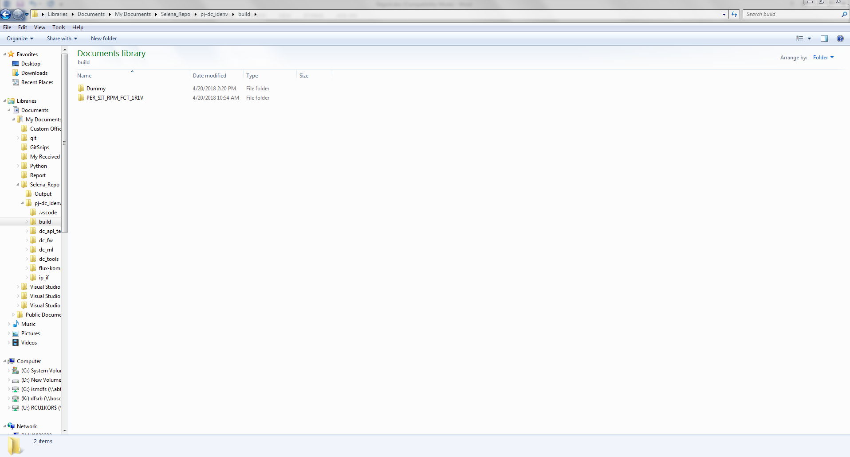
As you can see above there is one build and one dummy folder to test the working of R2D2 script.
Objective is to get a warning when trying to clean.
The below image shows the output from git bash where we run R2D2 with option ‘-c’.
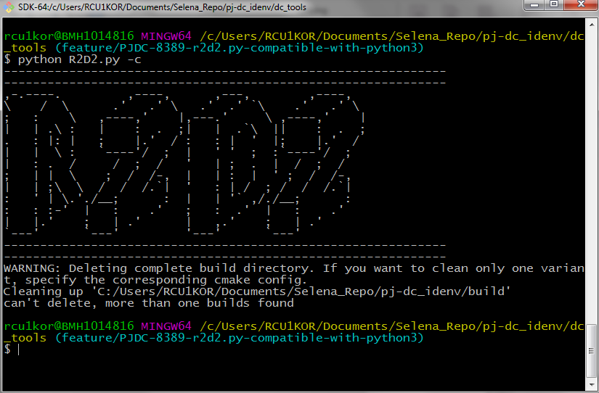
Have a look at the last line of the output. It clearly says “can’t delete, more than one build found”.
Now, it’s time to check whether it works for just one build.
Image below shows, we have just one build now.
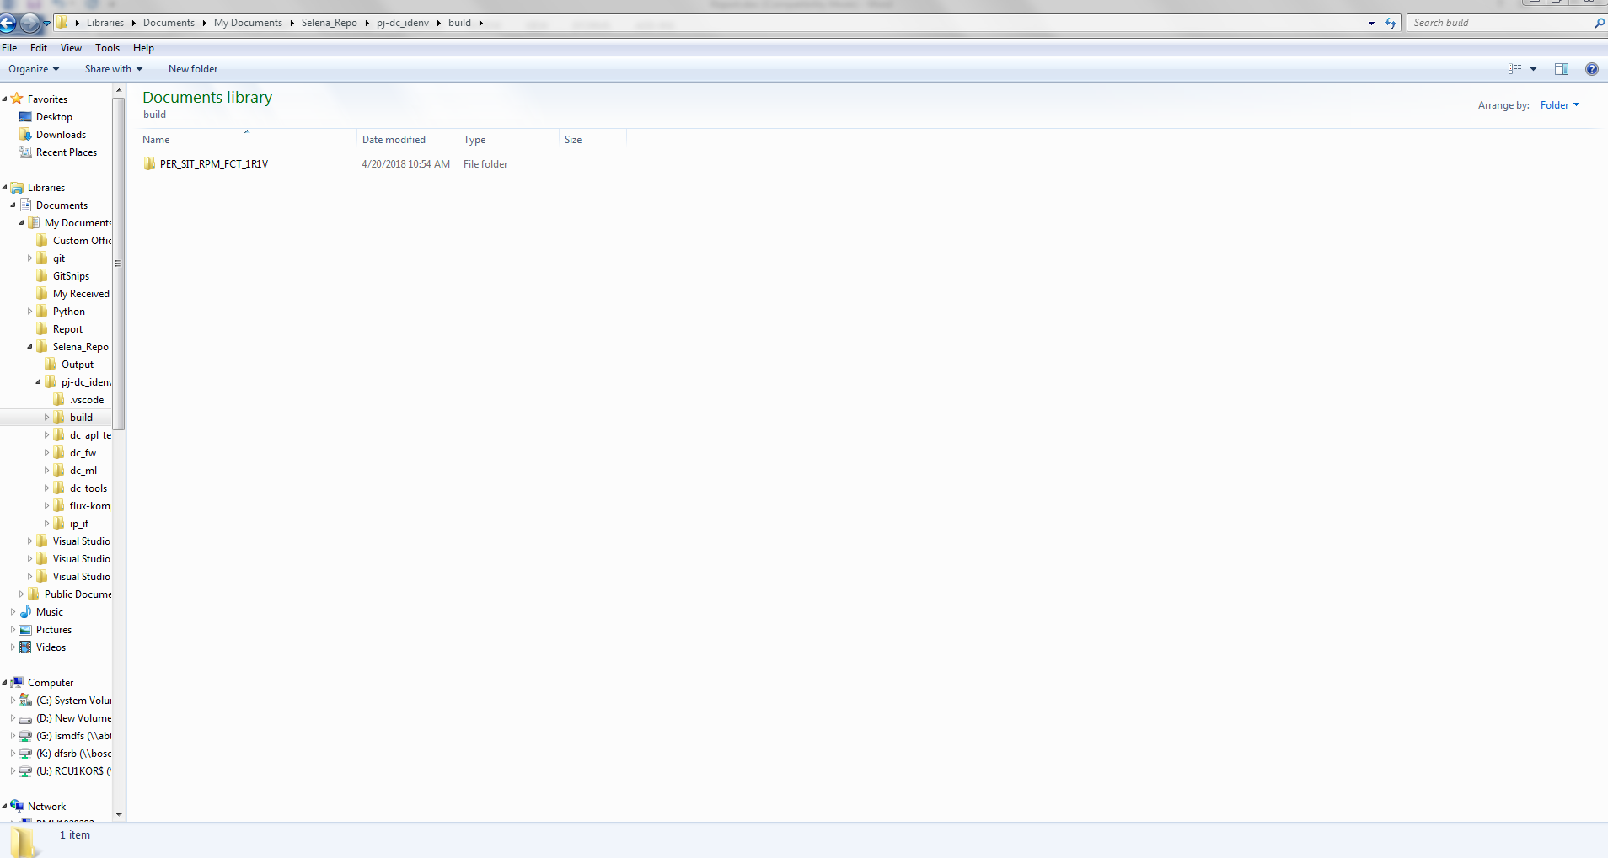
Here we run the R2D2 script again with option ‘-c’.
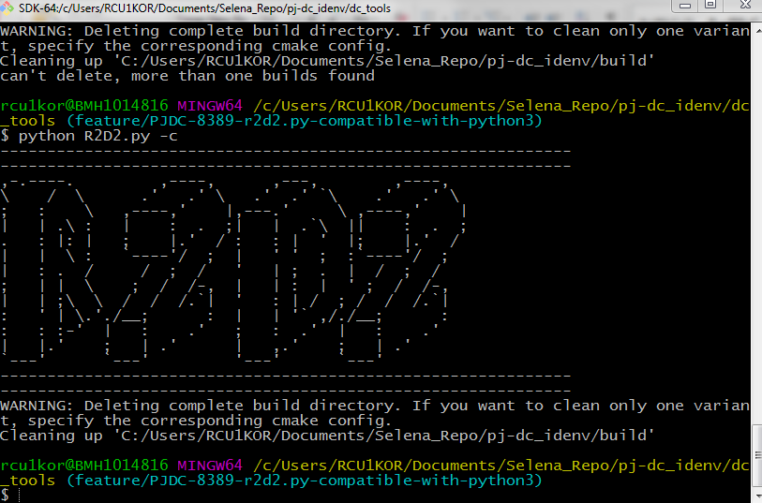
The image below confirms that build directory has been removed from the project folder.
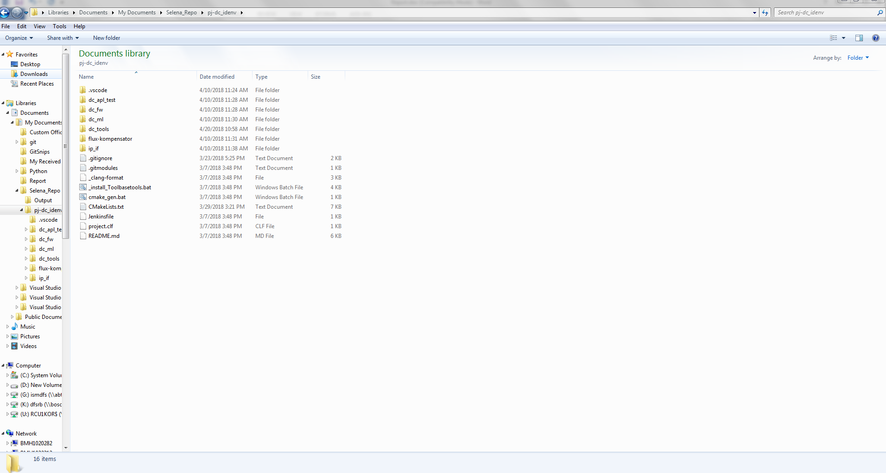
The script is working as expected.
6. REFERENCES
Inside Docupedia page, not accessible outside.

