INTERNSHIP TRAINING REPORT
January – June, 2018

Project Name – SELENA TOOL DEVELOPMENT
Organization – Robert Bosch Engineering and Business Solutions (BOSCH)

Submitted by –
Rahul Chandravanshi
Reg. No – 11403420
Course code - CSE441J

Under the guidance of Mr. Pramod Srivatsa K (senior software engineer, BOSCH).

Robert Bosch Engineering and Business Solutions India

Company Mentor End Term Evaluation Form
DECLARATION

I hereby declare that I am doing an internship at Robert Bosch Engineering and Business Solutions (RBEI) from 18th January 2018 under the guidance of Pramod Srivatsa Krishna Murthy (senior developer).
I declare that I have been working with full dedication during these 4 months of internship.
I have successfully completed tasks given to me during this period which includes demo on Github, presentation of SAFe and addition of extra option to python script which is core to our current project Selena.

Name of student: Rahul Chandravanshi
Registration Number: 11403420

CERTIFICATE
This is to certify that the declaration statement made by this student is correct to the best of my knowledge and belief. He has completed this Internship Project under my guidance and supervision. The present work is the result of their original investigation, effort and study. No part of the work has ever been submitted for any other degree at any University. The Internship Project is fit for the submission and partial fulfillment of the conditions for the award of B.Tech degree in CSE(Program Name) from Lovely Professional University, Phagwara.

Signature and Name of the Mentor

Designation

School of Computer Science and Engineering,
Lovely Professional University,
Phagwara, Punjab.

Date :
ACKNOWLEDGEMENT

In completing this internship I have been fortunate to have help, support and encouragement from many people. I would like to acknowledge them for their cooperation.
Pramod Srivatsa K, my mentor at BOSCH, for guiding me through each and every step of the process with knowledge and support.
I would also like to thank Akash Babu Suresh, guide for new recruits and Abdul Rahim P A, project manager, for their support in my transition from college to corporate world.
A special thanks to my team Selena for helping understand the bits of such a big project.

INTERNSHIP TIMELINE

JANUARY | FEBRUARY | MARCH | APRIL | MAY
Getting to organization structure
 | Presentation on SAFe
 |  | Demo on Git
 |  |  | Task on Project SELENA
 |  |  |  | Task on Project SELENA continued..

TABLE OF CONTENTS
Inner first page ………………………..……………………………………(i)
Company mentor end term evaluation form …………………..…………...(ii)
Declaration...………………………………………………………………..(iii)
Certificate …………..….…………………………………………………..(iv)
Acknowledgement…………………………………………………………..(v)
Internship Timeline ………………………………………………………...(vi)
Table of contents ………………………………………………………..…(vii)
PART I
- INTRODUCTION TO SAFe
1.1. SAFe RECOMMENDATIONS
1.2. LAST SPRINT
PART II
- INTRODUCTION TO GIT
PART III
- INTRODUCTION
  - DACore
  - SELENA
- PROBLEM
- EXISTING SYSTEM
  - INTRODUCTION
  - WHAT’S NEW IN THE SYSTEM TO BE DEVELOPED
4. PROBLEM ANALYSIS
4.1. PROBLEM DEFINITION
4.2. FEASIBILITY ANALYSIS
5. IMPLEMENTATION & TESTING
PART I
1. INTRODUCTION TO SAFe
- SAFe is an agile framework for software development. It provides simple, lightweight experience for the development team. The whole framework is divided into four segments Portfolio, Value stream, Program and Team.
- Version 1.0 was the first official release in 2011. The latest version 4.0, was released in January 2016.
- It’s based on lean and agile principles.
- It’s designed to meet the needs of all stakeholders within an organization.
- It is agile framework at its core, but can expand to fulfill the need of large system development.
Now, the question is isn’t simple agile enough? Why SAFe?
Well, let’s see what simple agile offers?
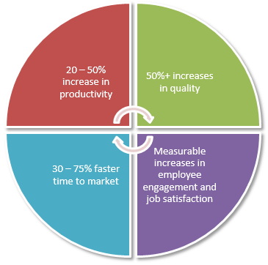
Agile is
- Incremental
- Customer feedback can be incorporated at any time.
- 1 - 4 weeks sprint.
- 5 – 9 team members including developers, testers, Scrum master, Product owner and Tech lead.
- Plan -> Do -> Check -> Adjust
- Works fine for 5 – 7 teams
But……
- When there are large number of teams running their own way of agile implementation but facing obstacles, delays and failures.
- When teams want to work independently.
- When you want to scale agile at organizational level but don’t know how?
Here comes SAFe to help us achieve the above objectives.
The team segregation looks like this
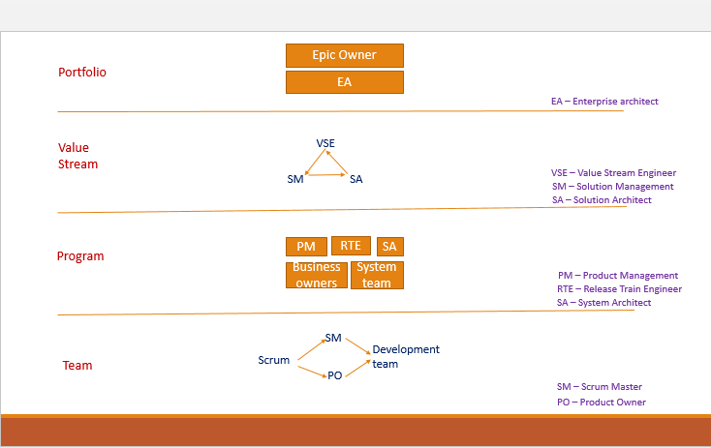

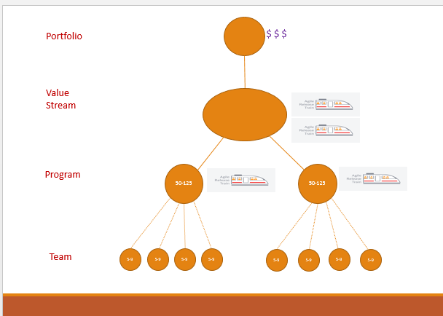
So, how do we exactly plan the work? The time allotment is done in the same way it was done for agile but just scaled.
Have a look at the time boxing
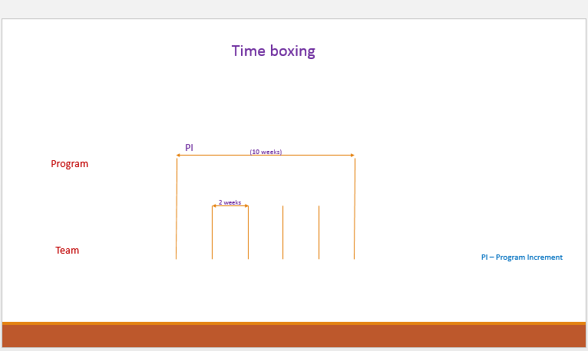
The task flows from top level to bottom into the team. At each stage the tasks are called different names. The flowchart below mentions them.
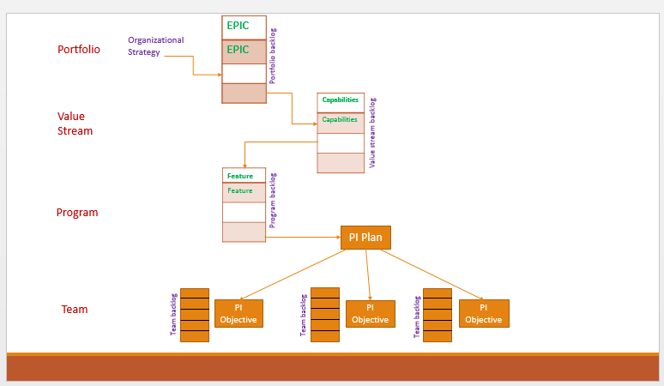
1.1. SAFe RECOMMENDATIONS
Here are a few SAFe recommended rules
- Continuous collaboration between Program management and Scrum masters (scrum of scrum) or product owners to remove any obstacles.
- At the end of every two week sprint, system integration will be done to make a demo-able working software.
- We keep doing this incremental development at team level until the last sprint.

1.2. LAST SPRINT
- In last sprint, we don’t do any development instead it is reserved for IP (Innovation and planning).
- It is kept to do innovations, hardening, hackathons etc.
- The most important is, we plan for next PI in the last sprint.
- An Inspect and adapt event is planned and all 50 – 125 members are required to attend the event to see where the system is headed.

PART II
1. INTRODUCTION TO GIT
Git is a version control system for tracking changes in a project. It allows one to have multiple version (snapshot) of a project, which is really helpful when you are working in large project.
Few Terminologies to remember-
- Version Control System (VCS) or Source Code Manager (SCM): A VCS allows you revert files back to a previous state, revert the entire project back to a previous state, review changes made over time, see who last modified something that might be causing a problem, who introduced an issue and when, and more.
- Commit (Snapshot): Git thinks of its data like a set of snapshots of a mini file system. Every time you commit, or save the state of your project in Git, it basically takes a picture of what your files look like at that moment and stores a reference to that snapshot.
- Repository (Repo): A directory that contains your project work, as well as a few files (hidden by default) which are used communicate with Git. Repositories can exist either locally on your computer or as a remote copy on another computer.
- Checkout: When content in the repository has been copied to the Working Directory. It is possible to checkout many things from a repository: a file, a commit, a branch, etc.
- Staging Area or Staging Index: A file in the Git directory that stores information about what will go into your next commit. You can think of Staging area as a prep table where Git will take the next commit. Files in the staging index are poised to be added to the repository.
- SHA (Secure Hash Algorithm): A SHA is basically an ID number for each commit. It is 40 character string composed of characters (0-9 and a-f) and calculated based on the contents of a file or a directory structure in Git. A SHA might look like this
e2adf8ae3e2e4ed40add75cc44cf9d0a869afeb6

- Branch: A branch is when a new line of development is created that diverges from the main line of development. This alternative line of development can continue without altering the main line.
Let’s dive into making commits, branching and merging. Before we make a commit, we need to have a repository. To do that, fire up git bash
cd into the directory you want your new project to be in. The prompt may look like this ( I have created a directory ‘git’ where I will put all the projects). 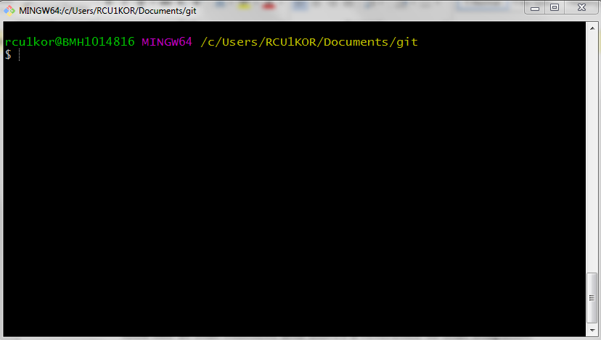
Create a new folder (i.e. project folder) and cd into newProject folder.
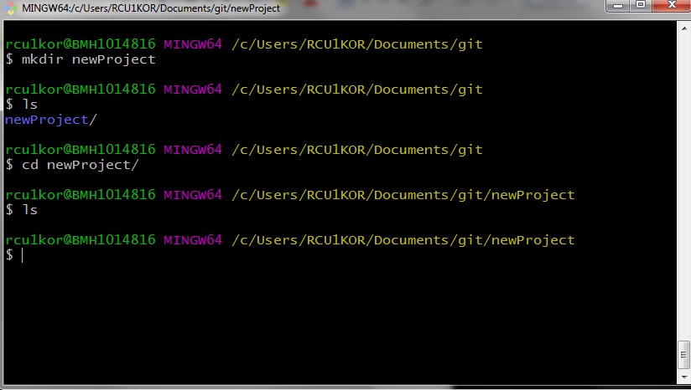
As you can see, we are inside the newly created ‘newProject’ folder and it is empty.
Now, let’s initialize it as a git repository. To do that simply type following command and hit enter.
git init
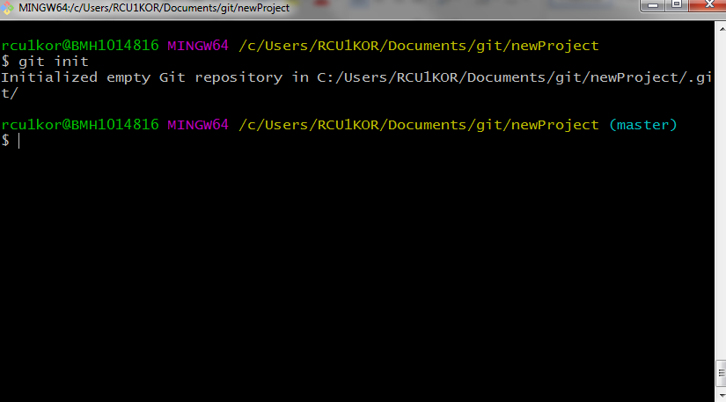
* Look at the output, it says “Initialized empty Git repository in ‘your working directory’ ”.
* Also look at the prompt, it has another field and it says ‘(master)’, it means we are in master branch. We will have a look at this later.
Now, let’s add some files to our project
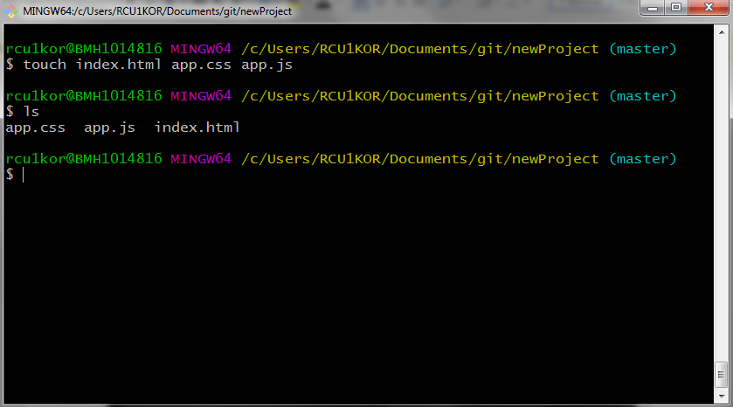
Here we have 3 files in project. Go ahead and run following command
git status
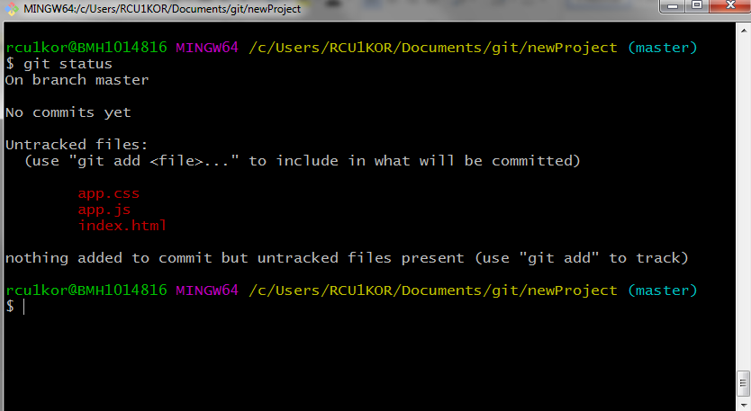
Notice, how git notifies that there are 3 untracked files. To make these files trackable by git we need to add them to staging area. Run the command –
git add .
This adds all the files in current working directory into the staging area.
No output means, command ran successfully.
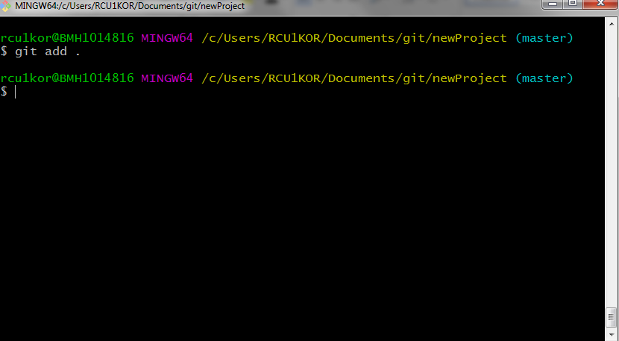
To see if it’s really been added to staging area run the git status command again.
git status
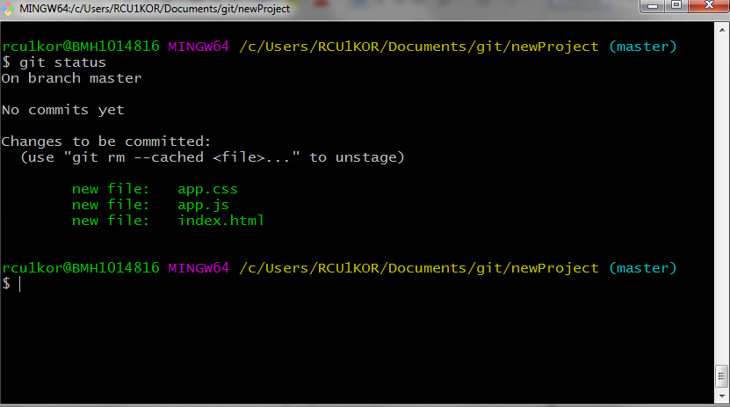
See, it’s being tracked by git now, but hasn’t been committed yet. To commit these files run following command
git commit
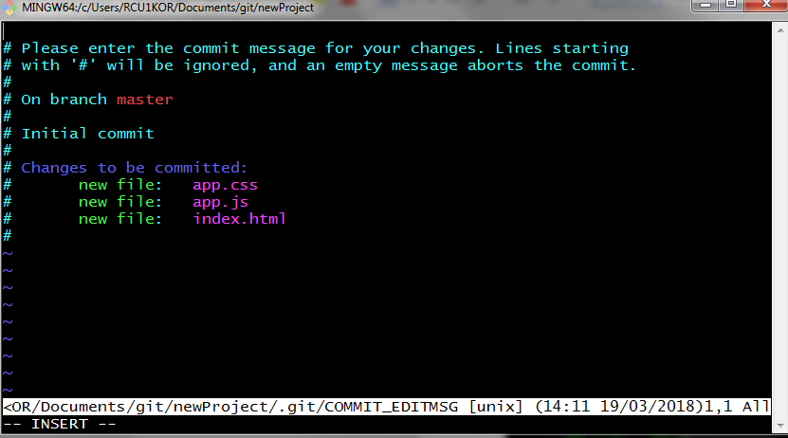
Running this command opens your default text editor and prompts for a commit message.
* A commit message is just a brief description of what you did.
* Lines starting with a ‘#’ are just comments (they are really helpful though).
Since, it’s our first commit and we haven’t really done anything, let’s pass a message saying “Initial commit”.
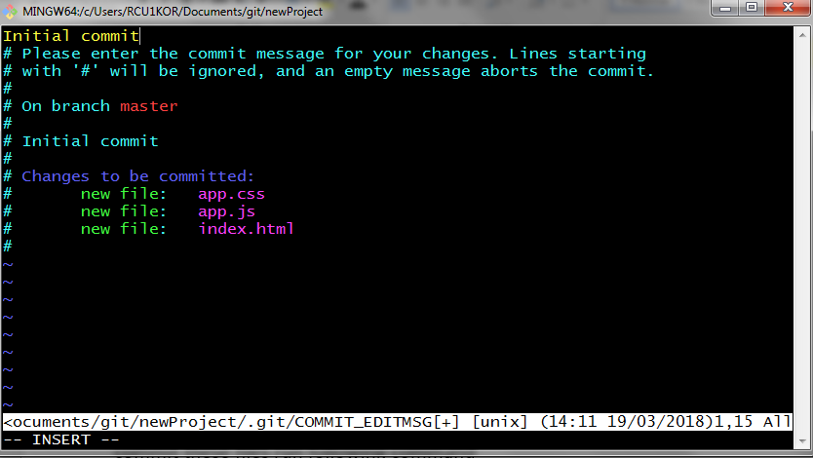
Save and exit, and you have just made your first commit.
* You can bypass the text editor by using option ‘m’ with git commit as following (use only one either the text editor or the command below).
git commit –m “Initial commit”
You will get output as below
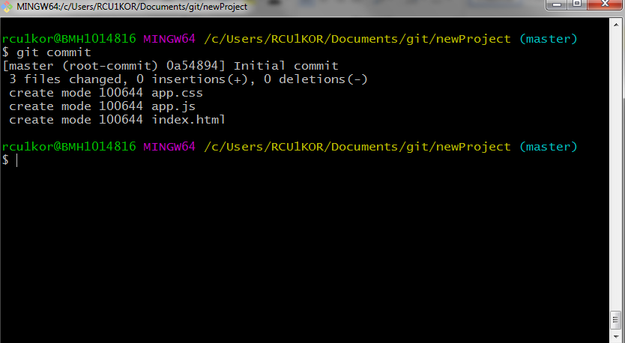

Now, to see the details of past commits we need another command. The ‘git log’ command shows details of all the past commits. Go ahead and try running it.
git log
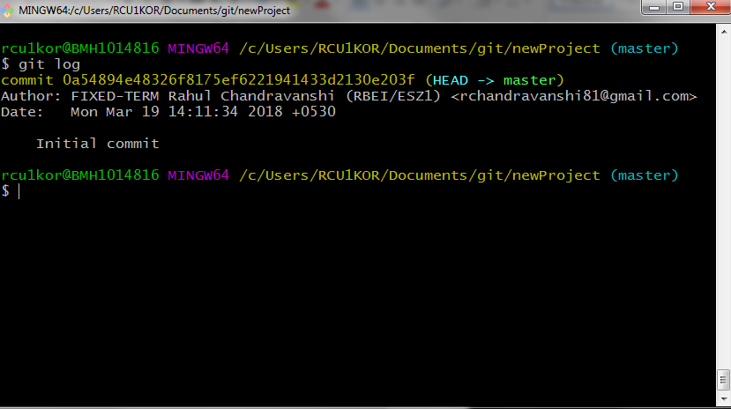
Let’s break down the output
Line no-
- It shows 40 character unique SHA value as well as HEAD pointer location (which is currently pointing to master branch)
- Name and email id of the person who did the commit.
- Date and time the commit was made.
- Commit message.
Now, let’s make changes to index.html file and make another commit.
Open index.html in your favorite text editor and add following.
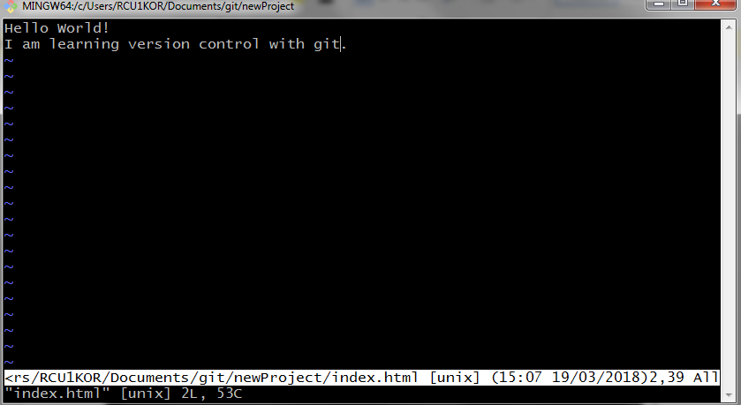
Save and exit. Now check git status
git status
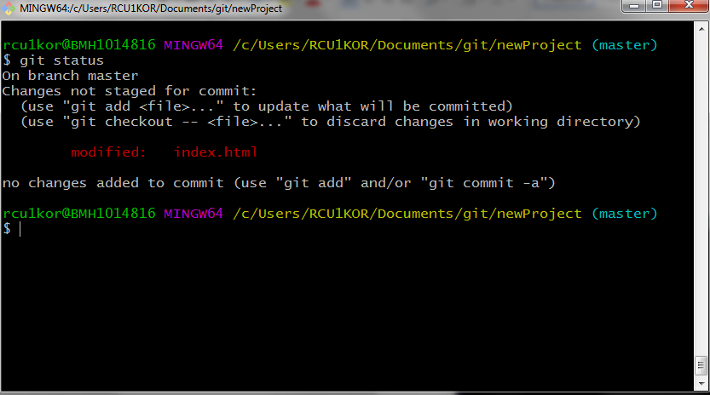
As you can see, the index.html file has been modified and git knows it. Go ahead and stage the index.html file and commit it.
git add index.html
git commit –m “Added text to index.html file”
git log
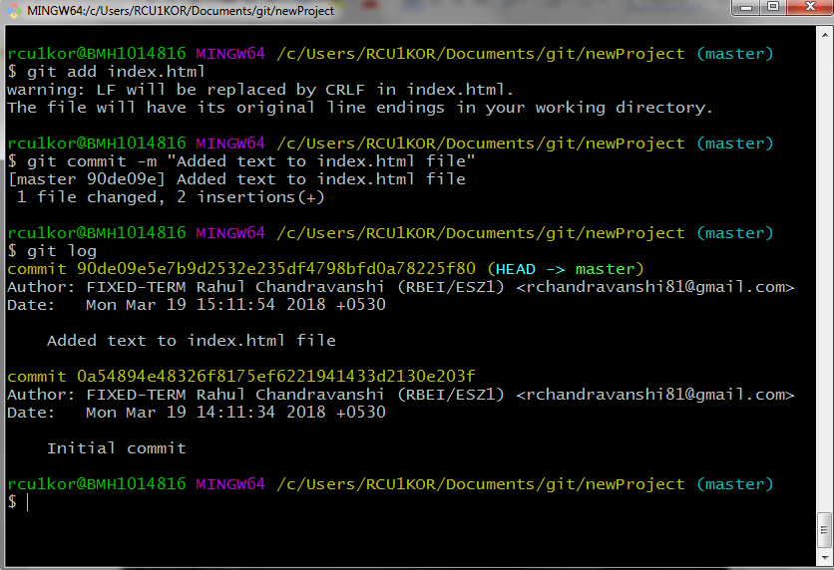
The git log shows 2 commits with respective commit messages.
Here are some variations to git log command
- git log --oneline - displays one line information with 7 characters of SHA and the commit message.
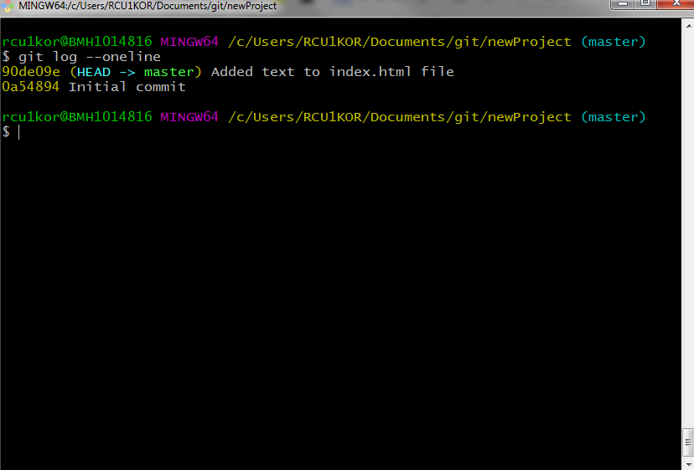
- git log --stat – Lists files that were changed as well as number of lines added and deleted.
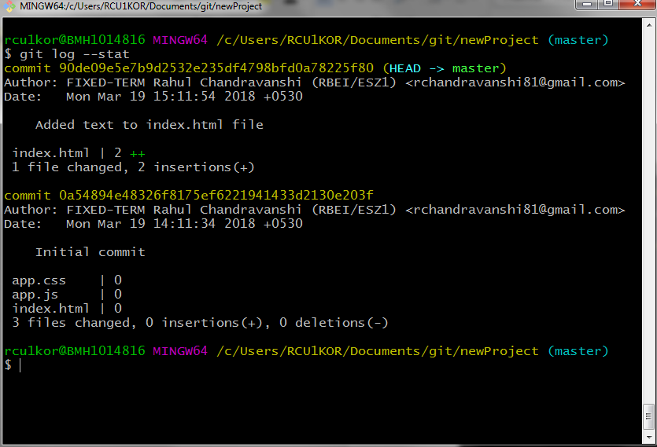
- git log -p - Allows us to actually see those changes.
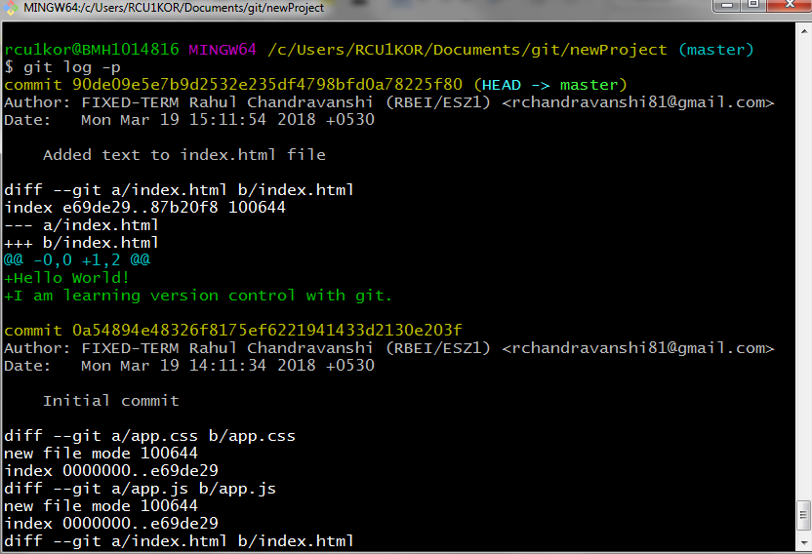

To see details of a specific commit. Use following
git show 0a54
(0a54 is first few characters of SHA of the commit I want details for, your SHA might be different.)
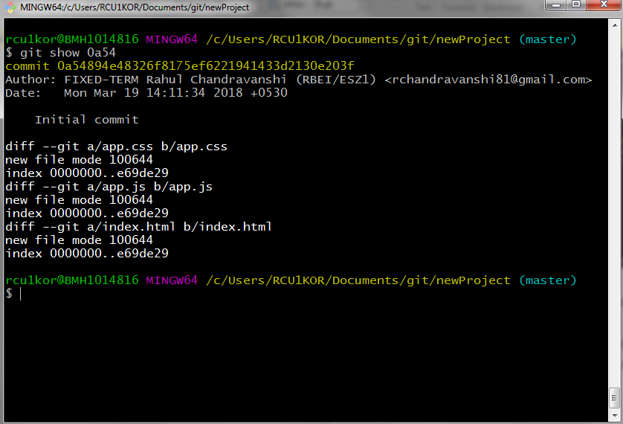

* Running “git show” without any argument will show the details of very recent commit.

Next command to master is “git diff”. What it does is, it compares the modified file with the recent commit. To see it in action, let’s modify index.html.
Open your favorite text editor and make changes as below
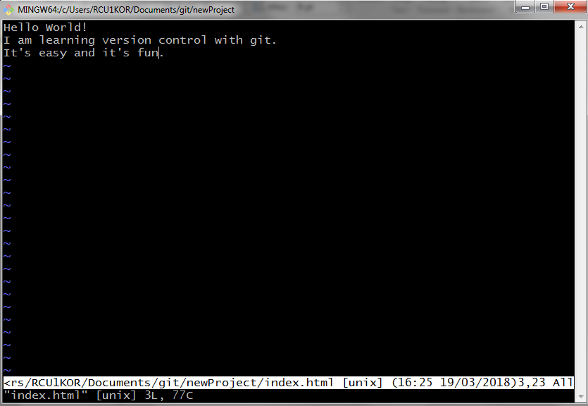
Now run the command
git diff
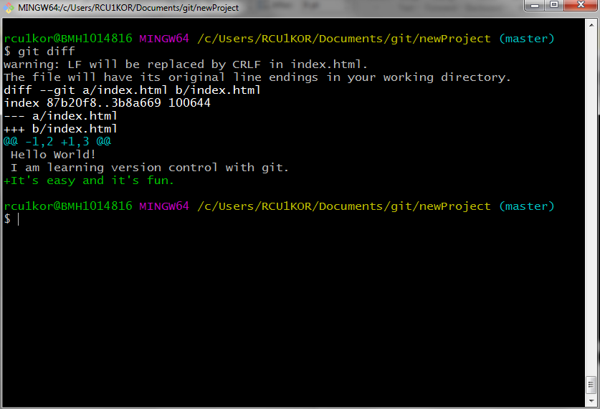

As you can notice, it tells us that a new line has been added (The lines in green and a ‘+’ in front).

So far we have learned quite a lot, from making commits to actually looking at the changes. We know how to add files to staging area, one by one or all at once by using ‘.’. What if, we don’t want certain file in our project directory to be tracked by git? We can do that too and its very easy. Just create a file called ‘.gitignore’ (The file has a ‘.’ In front of it, so it will be hidden) and add the name of the files, line by line in this file. Do that, and git will ignore those files while staging or committing. Use following commands –
Create a dummy file to ignore
touch project.docx

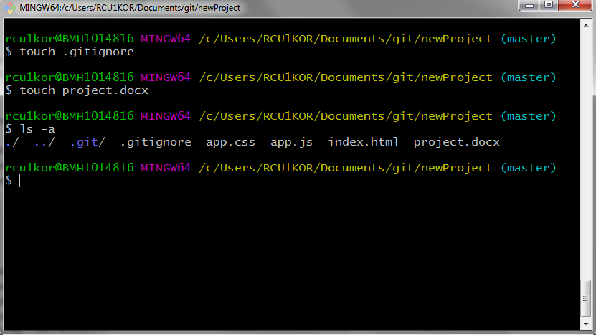
Open .gitignore in a text editor and add the name ‘project.docx’
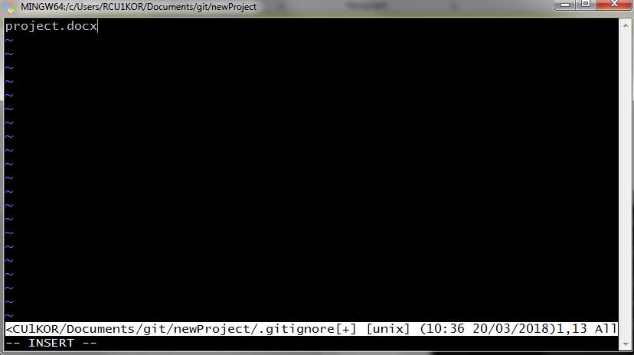

Save and exit. Now check git status to see if its working.
git status
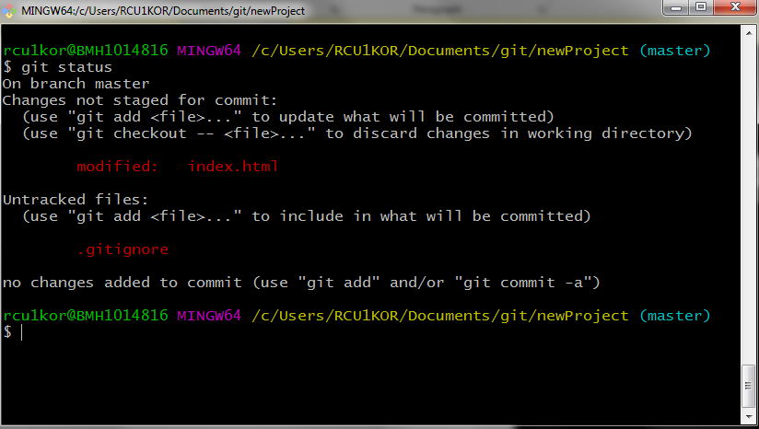

Yes, it is working. See, the only modified file git sees is the .gitignore file and not the ‘project.docx’ file. Go ahead and stage and commit this change to the repository. This is going to be our 3rd commit. Check the git log to see the commit history.
git add .gitignore
git commit –m “added the .gitignore file”
git log --oneline

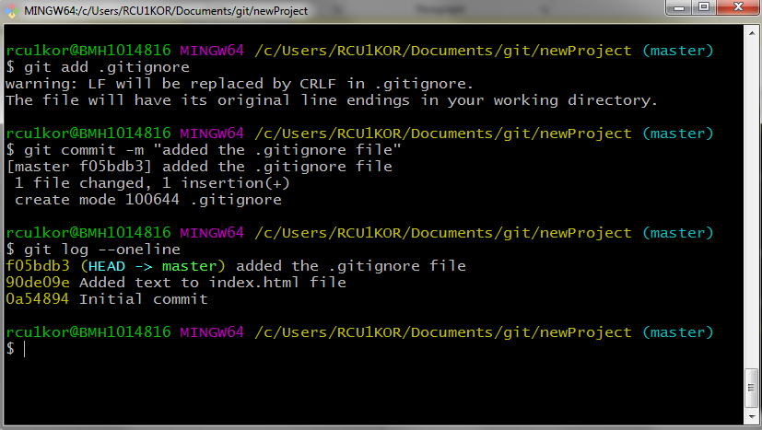

Tagging
Tags are extra piece of information, which is specific to a commit. Let’s say you have just completed a stable version of your project and you want to call it version 1.0. You can do that in commit message, but it’s not preferred. Here comes tag.
Let’s add a tag named ‘v1.0’ to our third commit. Run the command. Doing so will ask for a message. Pass a message and save and exit.
git tag –a v1.0
git log --oneline
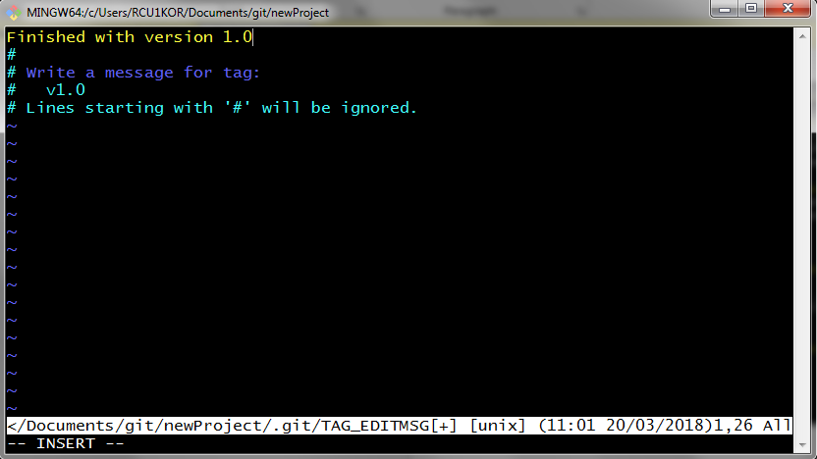
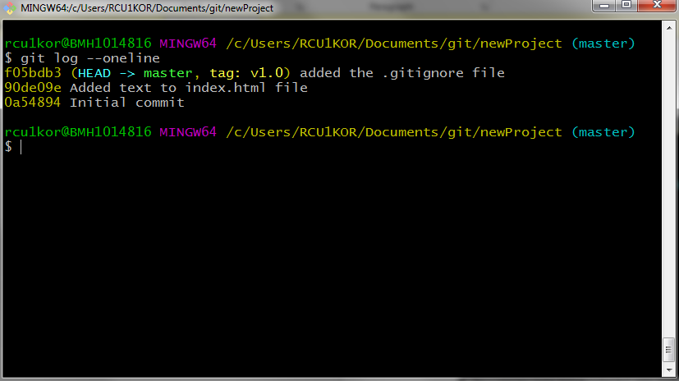

See the output, it has the tag: v1.0 for third commit.
Now, you can also add tag info to any past commit as well, all you need to do is, pass an extra argument, which is first few characters of SHA of the commit. Let’s add ‘v0.5’ tag to first commit.
git tag –a v0.5 0a54
git log --oneline
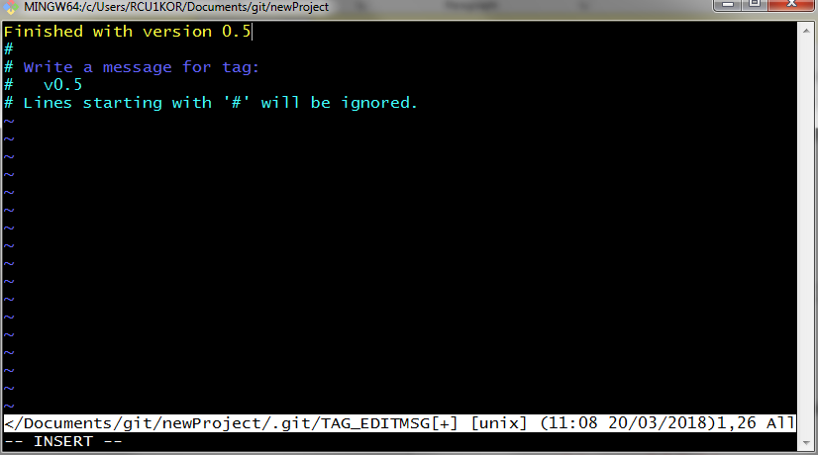
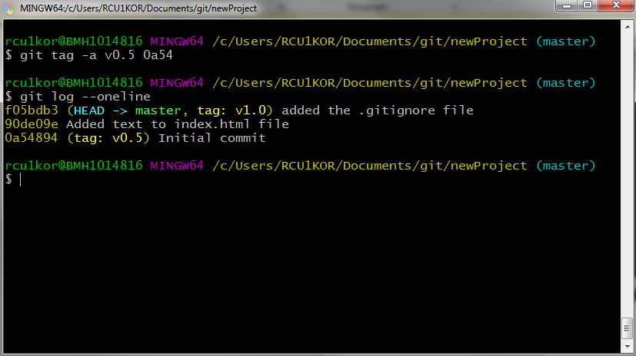

Now we have two version tags. You can also list all the tags by running ‘git tag’ command without any arguments.
git tag
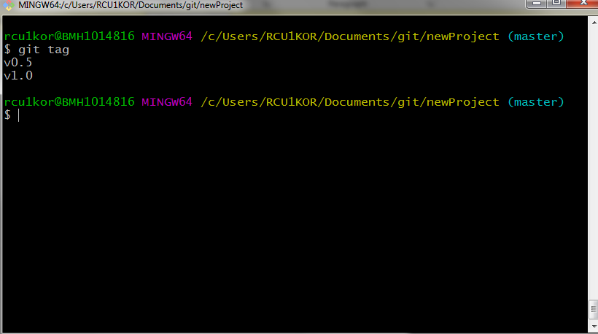

To delete a tag run following command. Here we delete the ‘v0.5’.
Remember it will delete the tag only, not the commit.
git tag –d v0.5
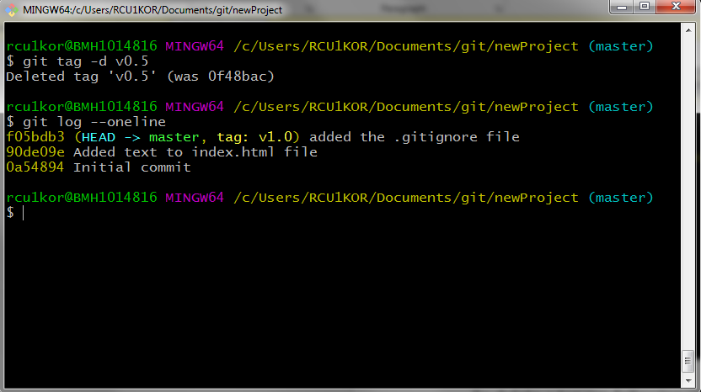

Branching
Branching lets us work in same project in different isolated environment. Changes to files in one branch doesn’t affect other. Once we are done with the development in a branch, we can merge it to master branch (we will see about merging later).

Suppose we want to add a sidebar to our current webpage. Adding this feature in master branch might break things. So, we create a new branch to work on new feature independently. To create a new branch run following
git branch sidebar
It’s time to move to our new branch. Run the command
git checkout sidebar
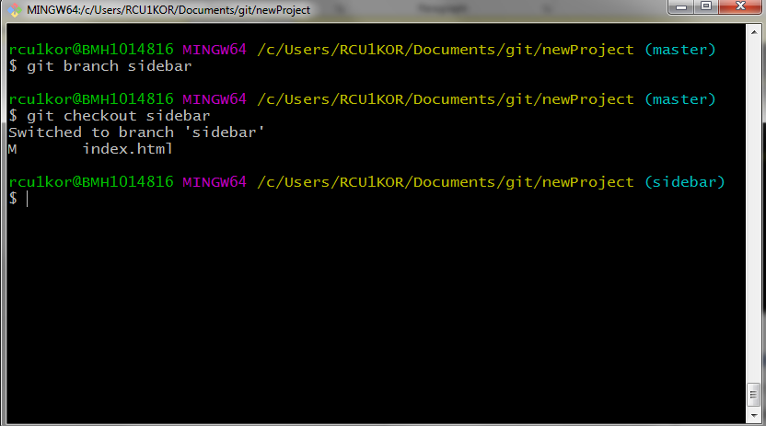
Notice the prompt. It now shows that we are in sidebar branch. Let’s make some changes to index.html file and commit it.
Open editor and make changes
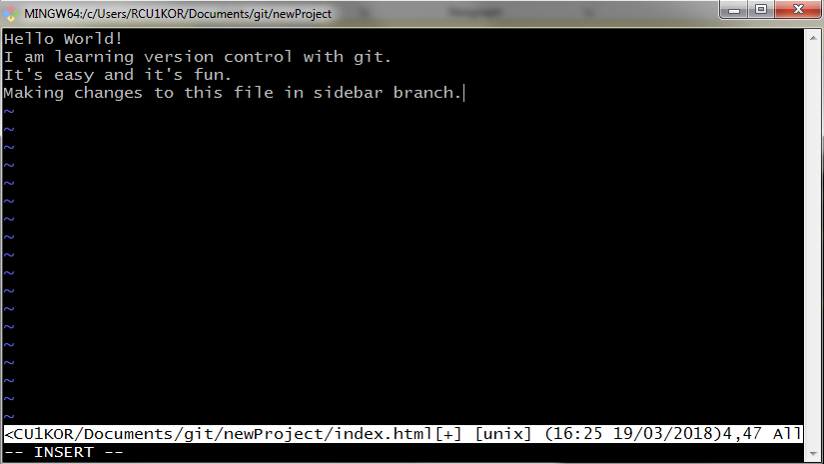
Save and exit.
Add to staging area and commit.
git add index.html
git commit –m “changed index file in sidebar branch”
git log --online
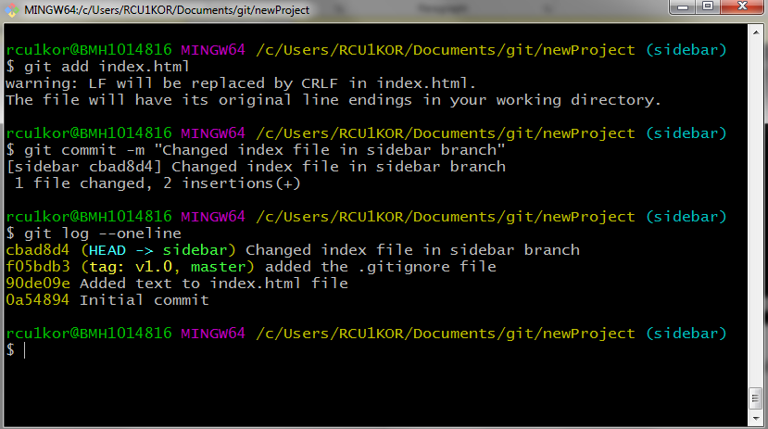

To list all the branches run
git branch
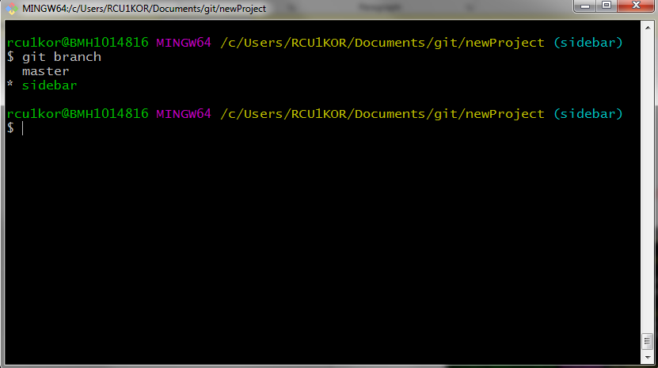
It shows a * in front of currently active branch.

* To delete a branch use command (Make sure you don’t need this branch anymore or you have already merged it to another branch)
git branch –d branch_name

Merging
Merging helps combine two branches. Git automatically figures out the difference between two files in two different branch and merges them line by line.
To merge a branch to master branch, switch to master branch
git checkout master
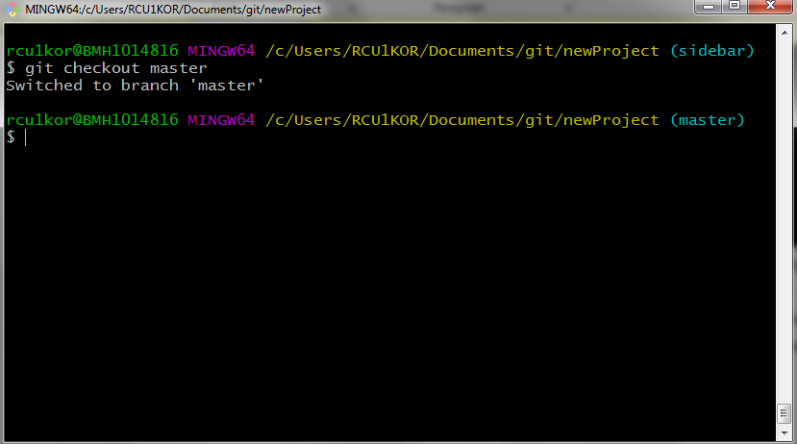
As you can see the prompt changed to master from sidebar.
Now run following to merge sidebar to master-
git merge sidebar
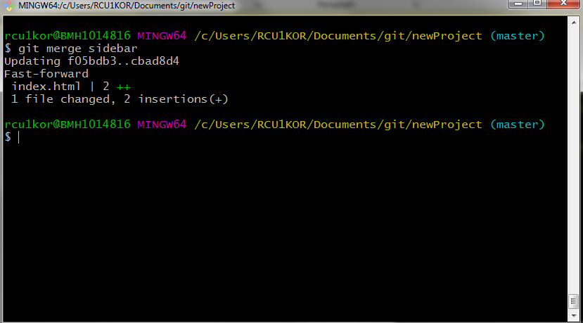
Now the master branch will have changes made in sidebar branch as well.
Here, since git tracks a file line by line, so modification in a file at same line in two different branches might cause a conflict known as merge conflict. The programmer has to resolve this manually, but don’t worry it’s easy. All we have to do is choose which lines we want from which branch. Git also adds some markers to make it easy to find which lines caused the conflict.
To demonstrate let’s create a conflict and then we will resolve them.
On master branch, change the first line of index.html to this
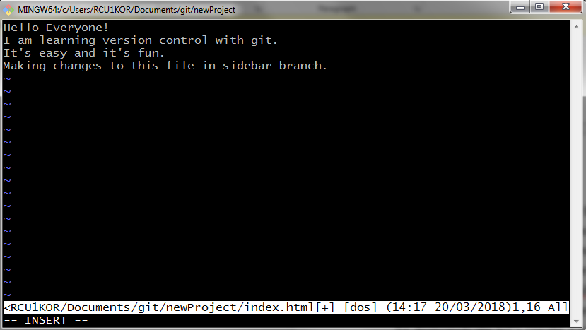
Stage and commit the change.
git add index.html
git commit –m “change first line of index file on master branch”

Now, move to sidebar branch using git checkout command
git checkout sidebar

On sidebar branch change the first line of index.html to this
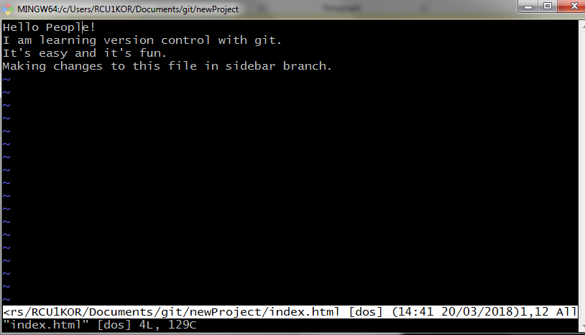
Stage and commit the changes
git add index.html
git commit –m “change first line of index file on sidebar branch”

It’s time to merge and see what happens.
Make sure to check out to master branch and run this
git merge sidebar
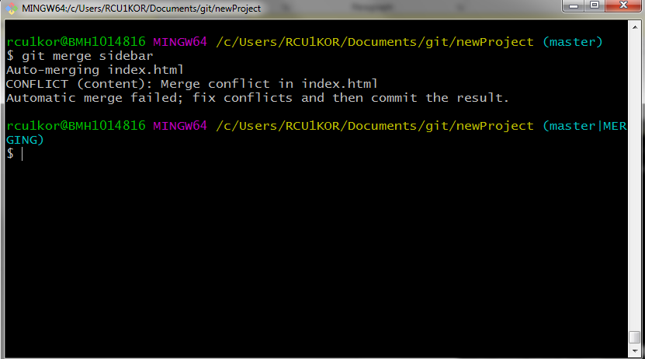
Look at that scary merge conflict. It says, ‘Automatic merging failed’. It also tells us that conflict occurred in index.html file. Also have a look at the prompt. It means we are in a merging process and we manually need to resolve the conflict.
To do that open the index.html file, which may look like this with some markers
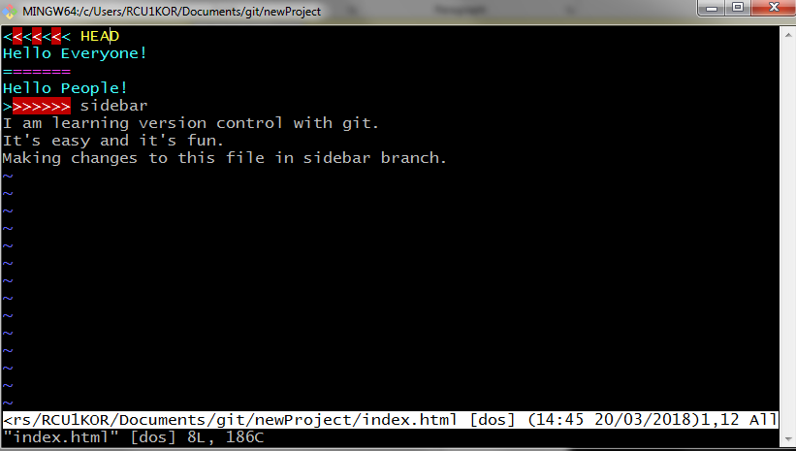
Text from
<<<<<<<
to
=======
Is in current branch and
text from
=======
to
>>>>>>>
Is in sidebar branch.

Here just choose what you want to keep and remove everything else (the markers too). It may now look like this,
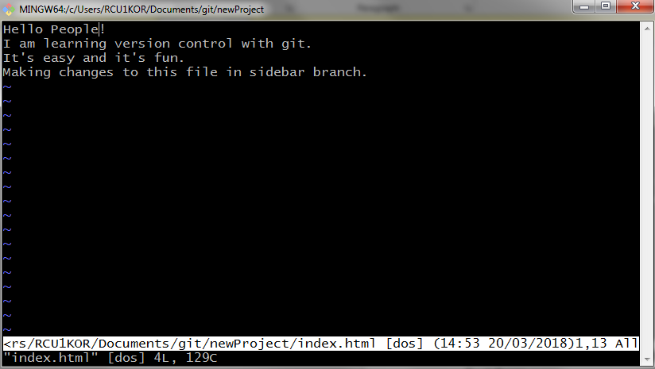
Save and exit, stage and commit and we are good.
The conflict will be gone.
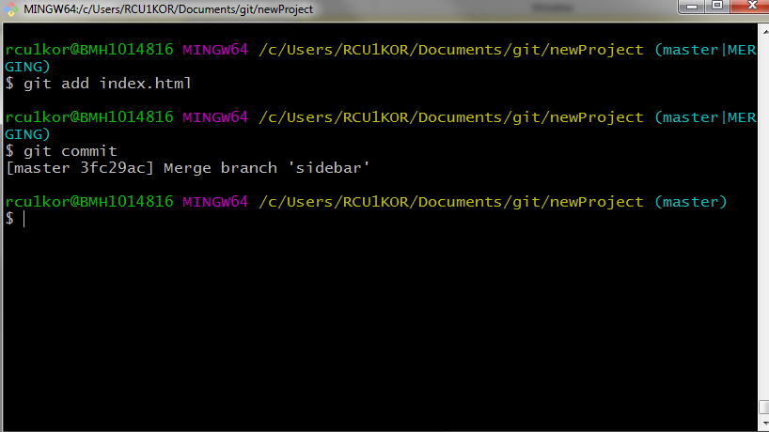
Use the following command to see the commit history with branches in much comprehensive way
git log --oneline --graph --all
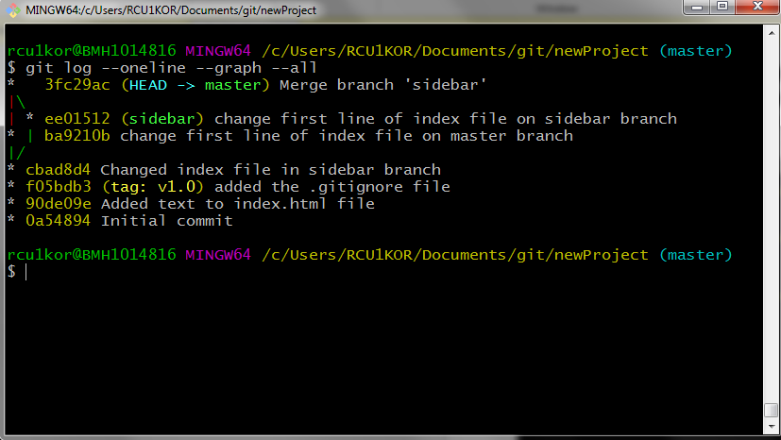

Undoing changes
One might make a mistake, be it a typo in commit message or forgetting to add a file into a commit. We can revert a commit and we will also look at how to delete a commit.
The first command is ‘git commit --amend'. It allows us make changes to a recent commit. This could be a simple typo in commit message or you just forgot to add a file. To see it in action lets edit our index file and stage it and commit it with a message that has an error.
Edit the index file as following.
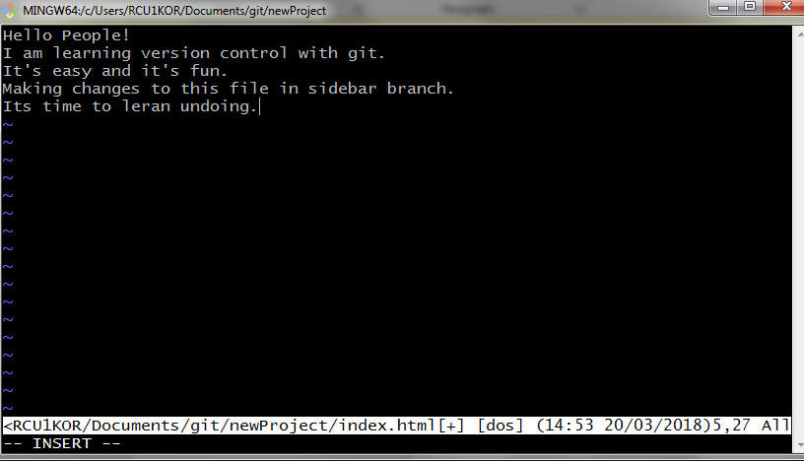

Save, exit, stage and commit
git add index.html
git commit –m “added another line to index file”

Now, what if I want to add a ‘.’ (full stop) at the end of commit message. To do just that run the command
git commit --amend
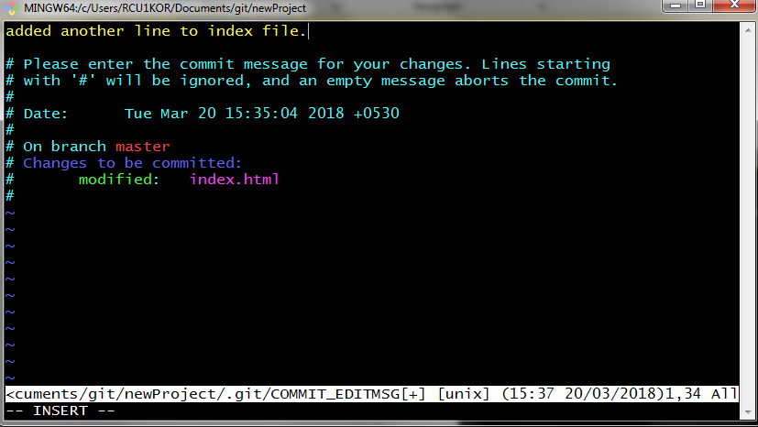
Make the changes, save and exit. There you go, commit message has been updated. You can check the new message (with a full stop) by running
git log --oneline 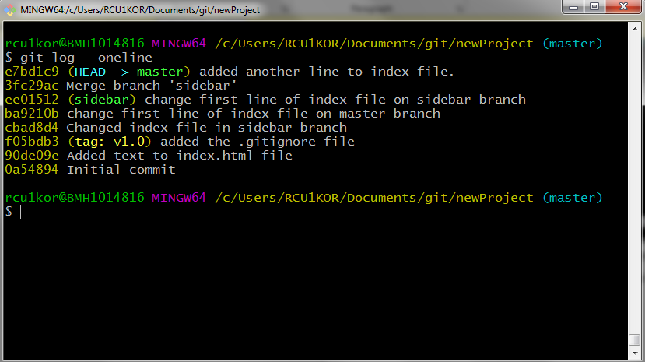

Forgot to add a file in last commit? Don’t worry!
To add a file, follow these steps
- Edit / create the file
- Add the file to staging area using git add command
- Now commit the file using git commit --amend

Next up, what if we want to revert an entire commit. We can do that too. Let’s see it in action.
Make some changes to index file, totally erase it and add something
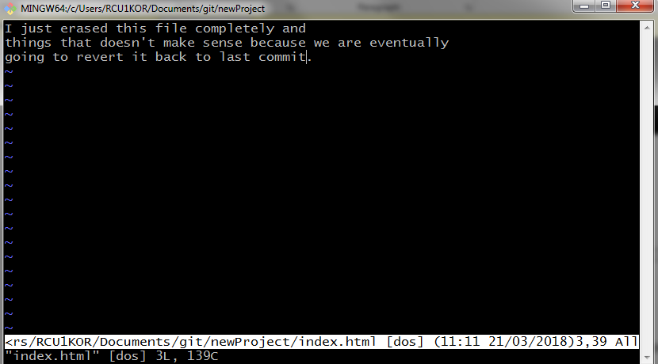

Save and exit, stage and commit.
git add index.html
git commit –m “senseless commit”
git log --oneline

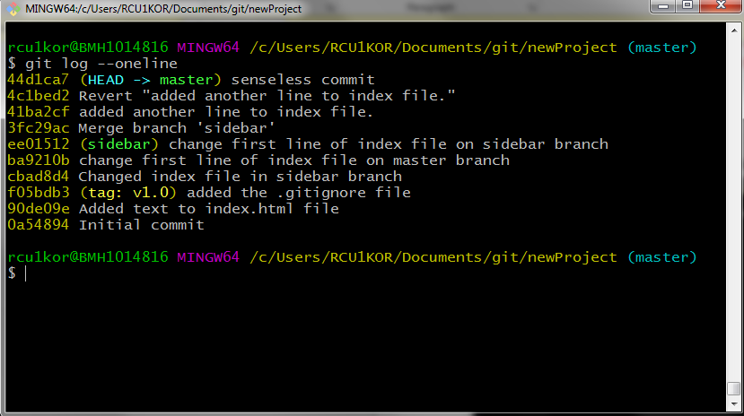

It’s time to reverse the commit.
Run the command with commit’s SHA
git revert 44d1ca7

This will perform a new commit with changes reversed. Just accept the default commit message (You can change the message if you want).
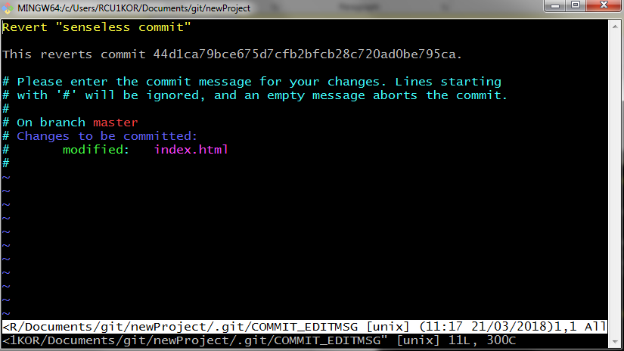
Save and exit.
Now you can open index.html file to see if the commit has been reversed?
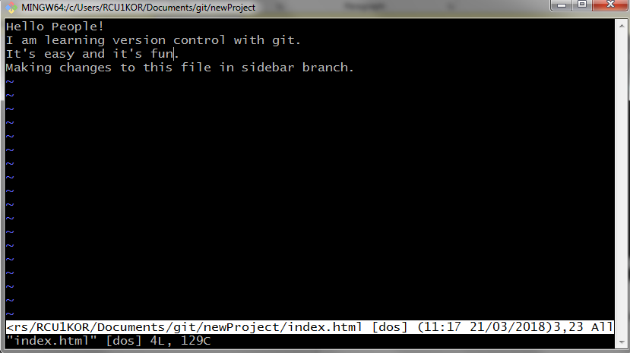
Yes, it has been.

Now, one last thing.
Can we delete commits?
Yes, we can but it could be pretty dangerous. So, make sure you don’t need that commit.
To start with resetting (deleting) commits, we need to know about
Relative Commit Reference
There are 2 symbols that represent a commit relative to HEAD.
- ^ – indicates the parent commit
- ~ – indicates the first parent commit
Here's how we can refer to previous commits:
- the parent commit – the following indicate the parent commit of the current commit
  - HEAD^
  - HEAD~
  - HEAD~1
- the grandparent commit – the following indicate the grandparent commit of the current commit
  - HEAD^^
  - HEAD~2
- the great-grandparent commit – the following indicate the great-grandparent commit of the current commit
  - HEAD^^^
  - HEAD~3
The git log looks like this
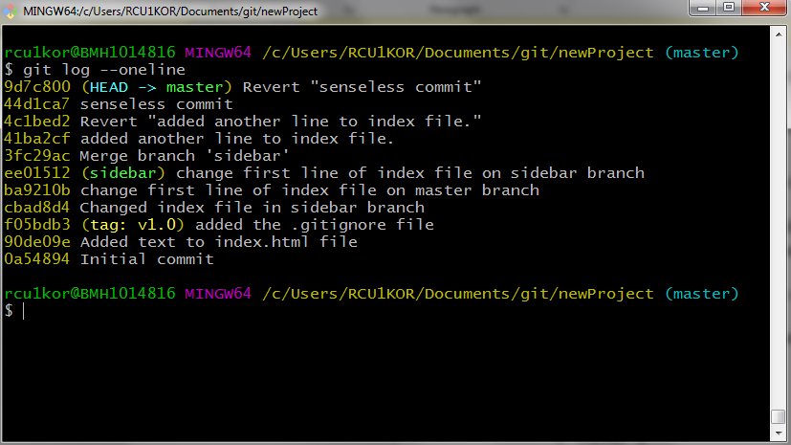
Run the command
git reset HEAD^^
and top two commits will be deleted (I lost my progress, so, can not show it here).

So, this is it. We have gone through a lot of git commands. I have tried to attach input commands and output screenshots as well.

PART III
1. INTRODUCTION (PROJECT SELENA)
SELENA is a simulation tool. It simulates the DACore functionality. The idea is to feed data to selena so that it can simulate real test scenario. It helps by not requiring to test with a real car in a real test site again and again. To understand how exactly SELENA works, we need to consider looking into DACore.

1.1. DACore
DACore is BOSCH operating system for all future Driver Assistance System including HAD. It runs customer specific Apps on various sensor and computing platforms, abstracting from E/E architecture and includes mainstream reference implementation.
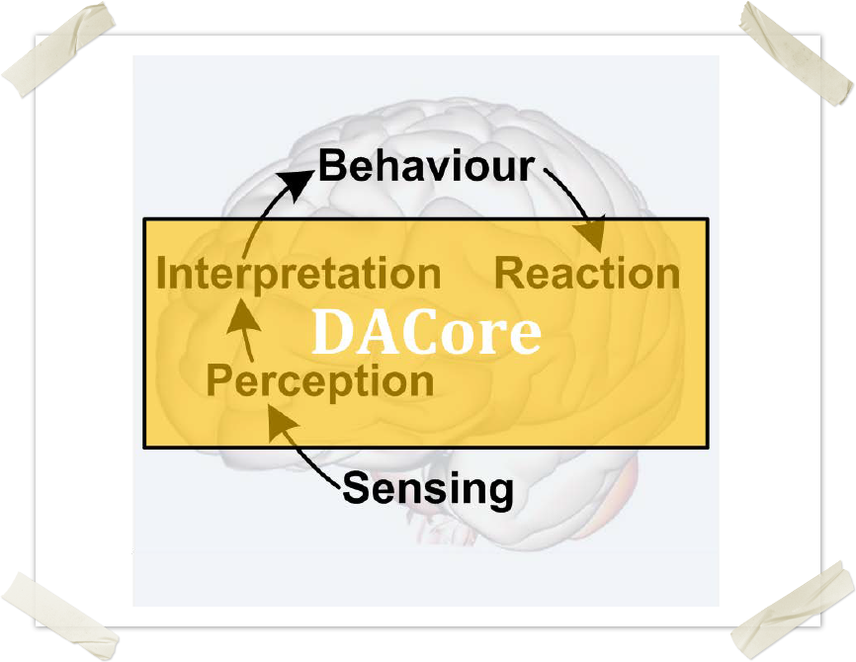

1.2. SELENA
Now, to realize all of these, a car needs to be tested on site, which is not feasible and cost friendly all the time. Here comes Selena, the simulation environment. It can take different configurations into consideration and simulate accordingly.
Before using Selena, it needs to be build first. It can be run on both Windows and Linux platforms. Windows being the standard BOSCH operating system supports direct installation of Selena, on the other hand for Linux it can be installed on a custom BOSCH made Ubuntu based Linux OS on top of a virtual machine.
This is how you build SELENA
Step 1. cd into the project directory
Step 2. Run the following command with appropriate configuration file
python R2D2.py –m path_to_config_file

2. PROBLEM
The Selena simulation tool can be built with different-different configurations. The python script that builds Selena is called R2D2. It creates a build directory, inside which we have Selena build with different configurations. The problem is with cleaning (deleting) a particular build. What R2D2 does is, it deletes the entire build directory irrespective of number of builds inside that directory. So, the objective is to give out a warning to the developer if he tries to clean the build directory with more than one builds.

3. EXISTING SOFTWARE
3.1. INTRODUCTION
The current R2D2 python script builds SELENA based on configuration files passed to it. It has many options to interface with tools required in building SELENA. The screenshot below shows all the options.
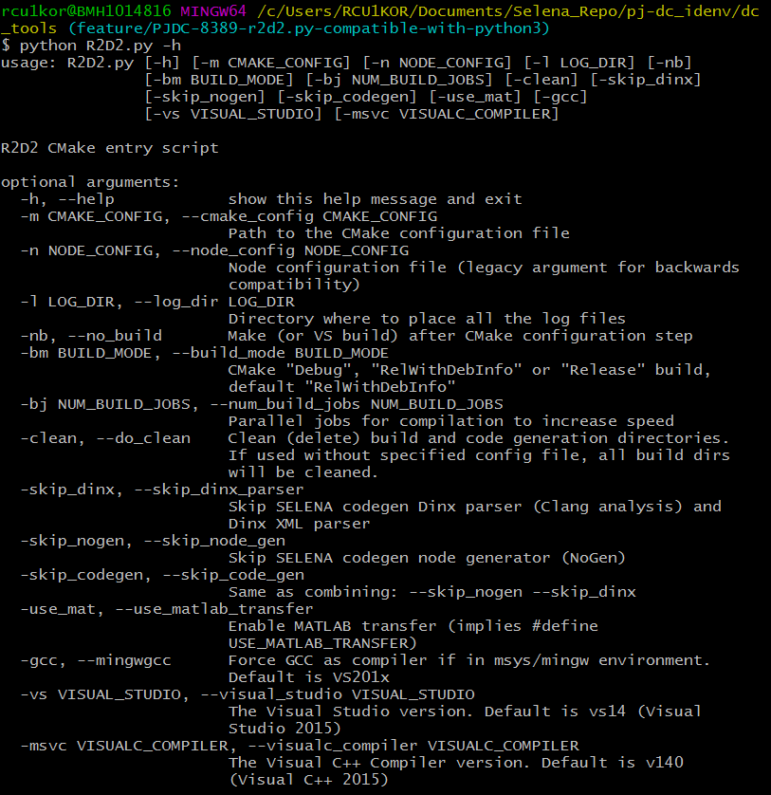
3.2. WHAT’S NEW IN THE SYSTEM TO BE DEVELOPED?
The current R2D2 script takes care of cleaning the build directory but the current system deletes the entire build directory irrespective of number of builds inside the directory. So, the objective is to check for the other builds in the build directory and if there are more than one builds found, show a warning to the developer and let the developer decide what to keep and what to remove.

4. PROBLEM ANALYSIS
4.1. PRODUCT DEFINITION
The R2D2 python script builds SELENA from given configuration and all the builds are located inside the build directory. The problem is when user tries to remove a build by specifying option ‘-c’ in the command, the script removes the entire build directory. The solution is to check whether there are more than one builds inside the build directory and take action accordingly.
4.2. FEASIBILITY ANALYSIS
The task at hand is completely feasible with only 1 developer required to edit and modify the python script. The man hours required is just a week, but for me, being an intern it took a month. The reason being, I had to learn python and entire process of building SELENA.

5. IMPLEMENTATION & TESTING
The script was successfully modified using the python module named ‘os’. Here all I had to do is check for existing builds and if the number is more than one display a warning message to developer else delete the entire build directory.
The pictures below depict the exact working.
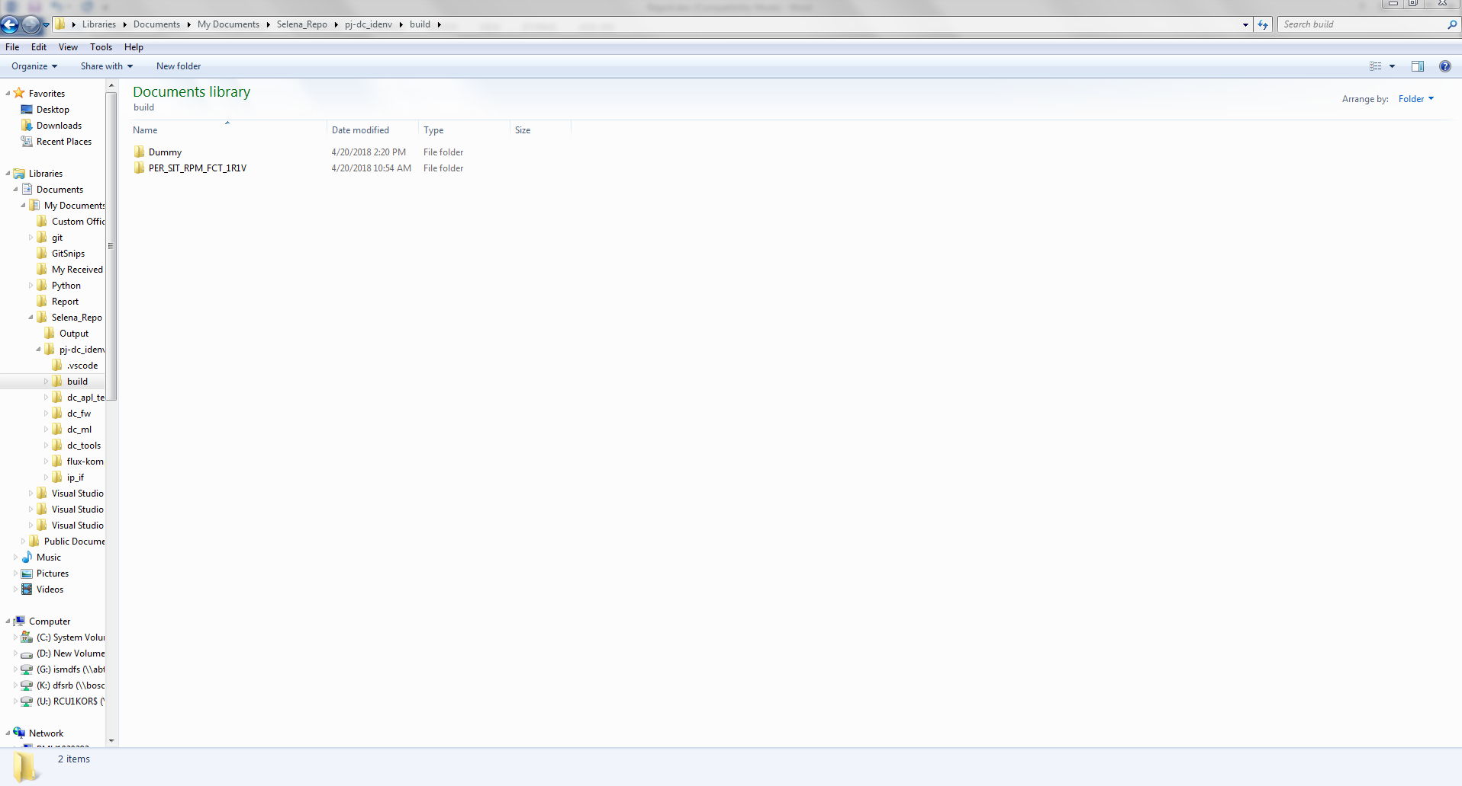
As you can see above there is one build and one dummy folder to test the working of R2D2 script.
Objective is to get a warning when trying to clean.
The below image shows the output from git bash where we run R2D2 with option ‘-c’.
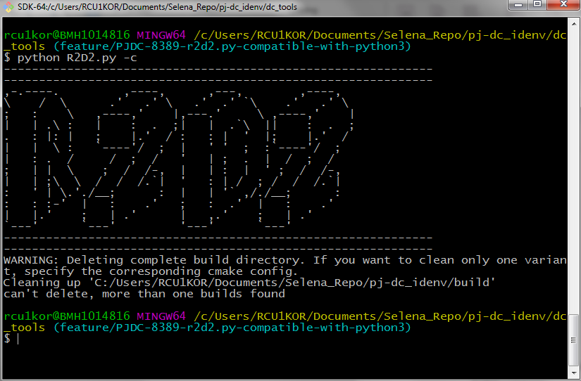
Have a look at the last line of the output. It clearly says “can’t delete, more than one build found”.
Now, it’s time to check whether it works for just one build.
Image below shows, we have just one build now.
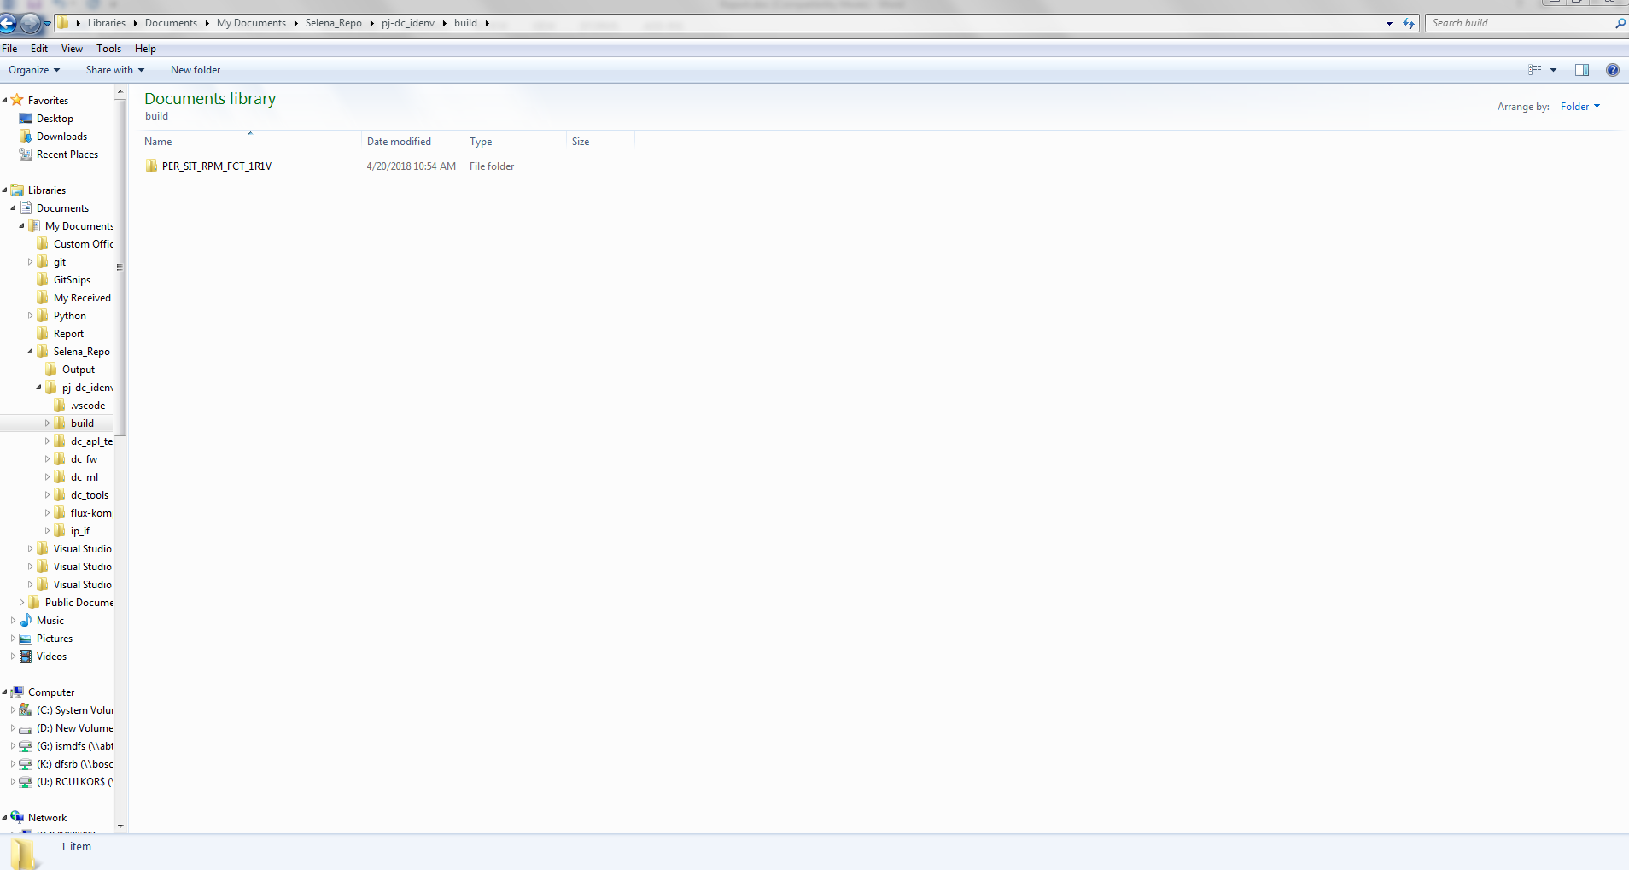
Here we run the R2D2 script again with option ‘-c’.
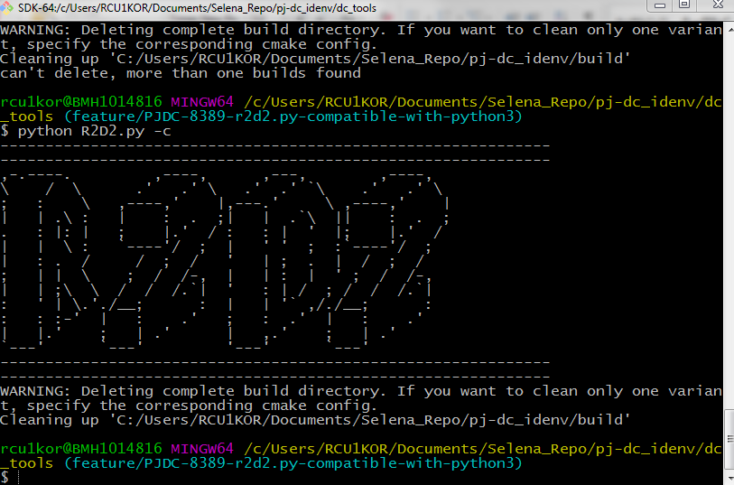
The image below confirms that build directory has been removed from the project folder.
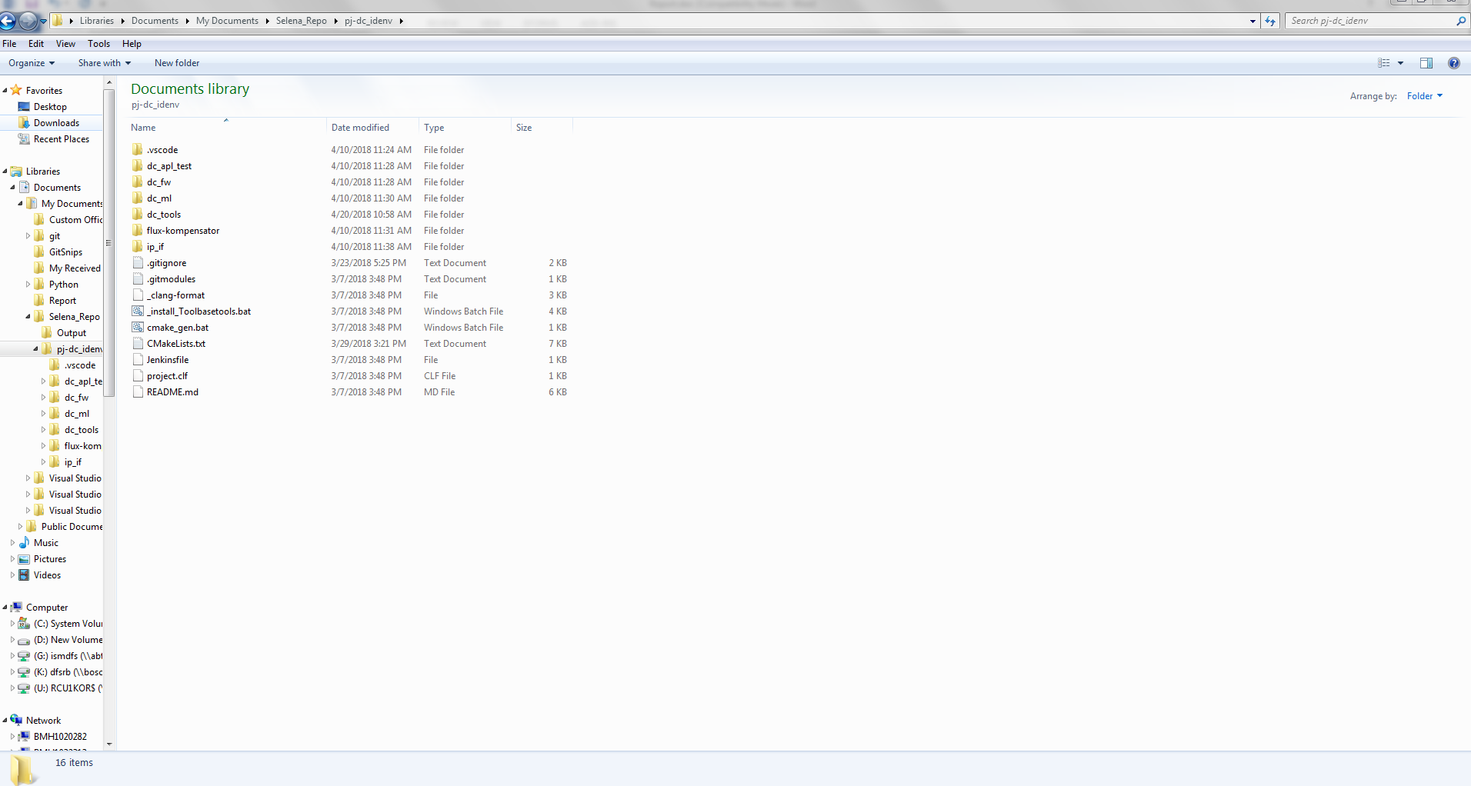
The script is working as expected.
6. REFERENCES
Inside Docupedia page, not accessible outside.
www.github.com
www.scaledagileframework.com/what-is-safe/

