CIS*3750 Lab Demo 1

Ralph Arvin, De Castro

Table of Contents

|  |  |
| --- | --- |
| Individual Contribution | 2-3 |
| Use Case | 2 |
| Classes | 3 |
|  |  |
|  |  |
|  |  |
|  |  |

Individual Contribution

**Use Case**

Title: Reskin application

Actors:

* Admin
* System

Pre-conditions

* Admin successfully logged in to the web portal.
* Admin clicked on the reskin application subsection.
* Admin is connected to an internet access.
* System is connected to the WDGPH server.

Main flow

1. System shows the reskin application subsection on the admin's screen.
2. Admin clicks on their selected theme.
3. Admin clicks Save.
4. System shows a pop-up box for confirmation.
5. Admin clicks Yes to confirm changes.

Alternative flows

*a. At any time, admin clicks on the close browser button:

1. System displays a warning pop-up message about losing changes.

2a. Admin clicks No.

1. System returns to the reskin application subsection.

2b. Admin clicks Yes.

1. System is closed.

*b. At any time, admin clicks on a button outside the reskin application subsection

without saving changes:

1. System displays a warning pop-up message about losing changes.

2a. Admin clicks No.

1. System returns to the reskin application subsection.

2b. Admin clicks Yes.

1. System proceeds to the subsection selected.

Post-conditions: The new selected theme is saved.

**Classes**

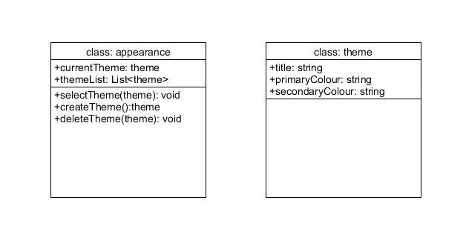

Figure 1: Classes for the Use Case, Reskin application

These are the classes required to fully implement the use case, reskin application. First, we have the ‘appearance’ class which comprises the list of themes we have on the system and the current theme selected. In this class, we have the methods that allow us to select, create and delete themes. Secondly, we have the ‘theme’ class which includes the title, primary colour and secondary colour as attributes. During the paper prototyping session, the users did not have any problems or concerns with this use case, therefore, we did not make any major changes.