Part 1.
Schematic of 4 terminal NMOSFET
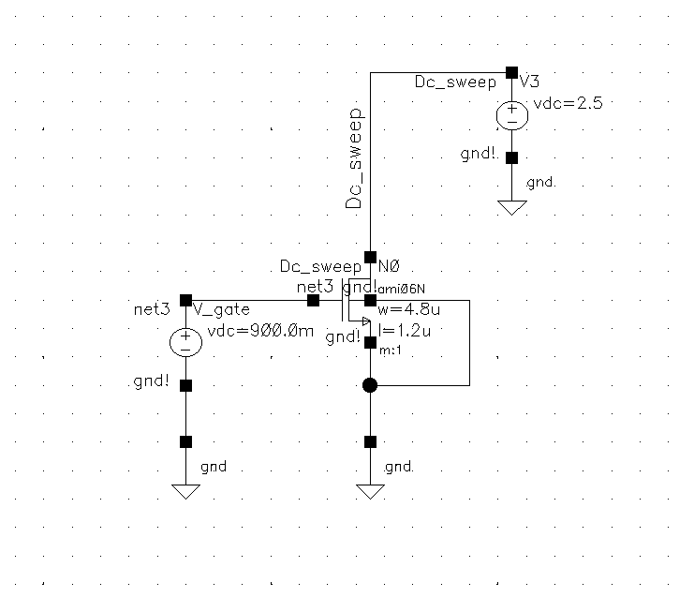

Fig 1: Schematic of 4 terminal NMOSFET

Question 1. Holding the Vgs = 0.9V, Vsb = 0V, run a DC simulation that will sweep the Vds of the transistor from 0V to 5V, in steps of 0.1mV. Plot Ids vs Vds. Extract the values of output resistance ro. Print the graphs and explain clearly how you extracted the parameters.

Answer: To find Id-Vd we run a DC sweep of drain voltage from 0 to 5V in steps of 0.1mV and keep source at ground and gate at 900mV.

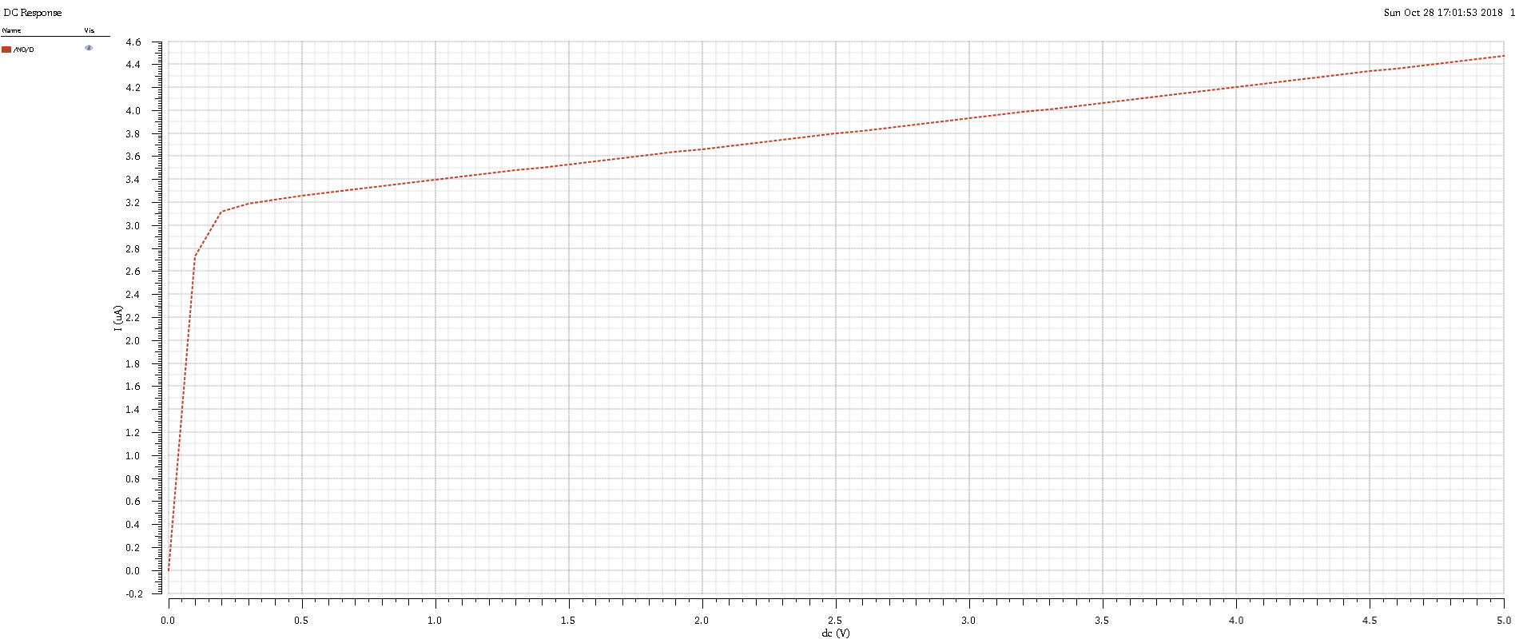
Fig 2: Id- Vgs DC Sweep

Now to find Rout we have to run an ac sweep
Steps: Replace Vdc with Vsin.
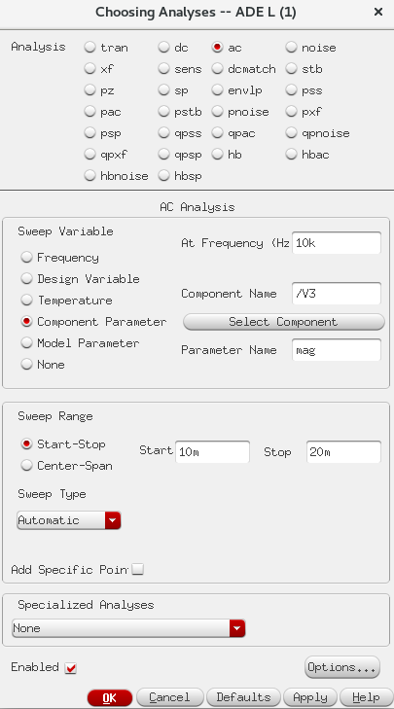
Fig 3: Ac analysis run

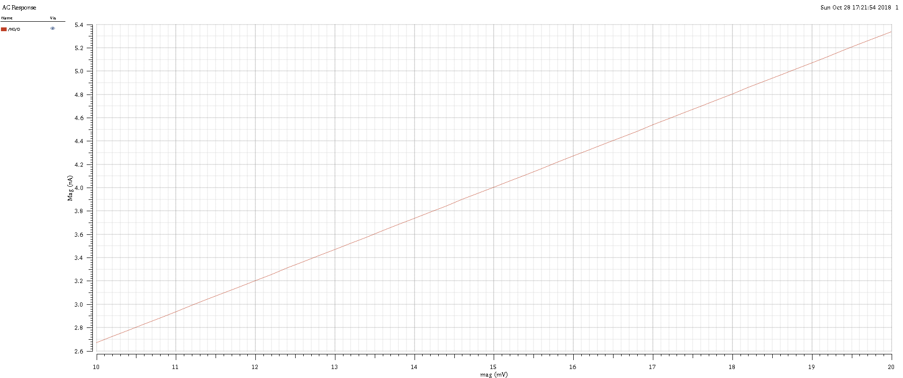
Fig 4 : id – vd AC analysis.

Next we open calculator tool and find derivative
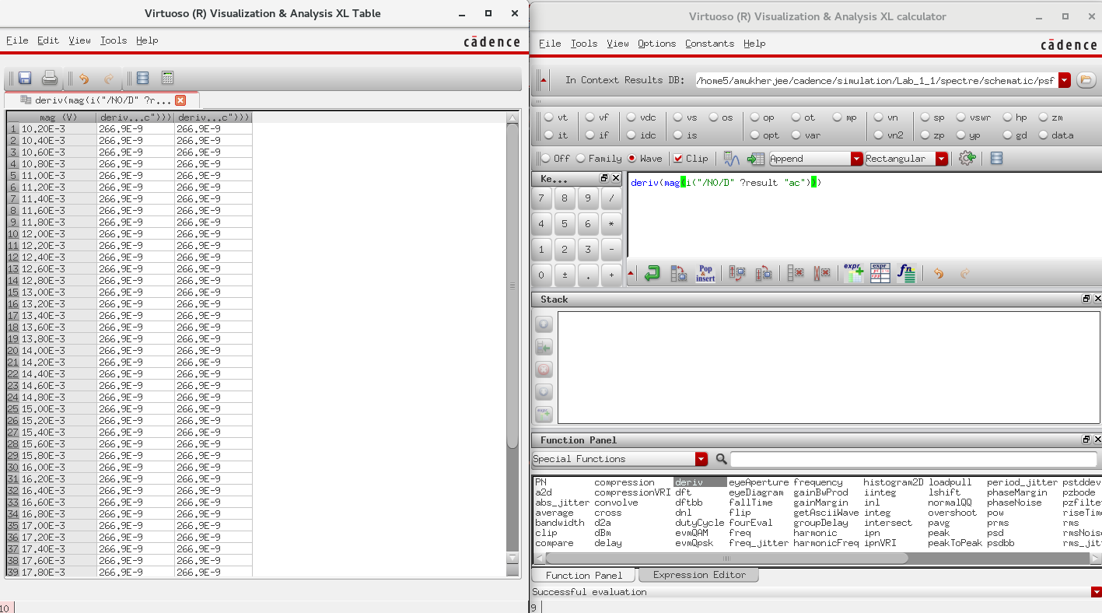
Fig 5: The Derivative of the id-vd ac analysis gives Gout.

Gout = 266 e -9 Amp/Volt
Rout- 1/Gout = 3.75 Mega Ohm

Question 2: Repeat the experiment 2. for different values of Vgs voltage (0.8, 1V and 1.1V). Extract the values of output resistance ro. How ro depends on the value of the current Id in the saturation?

Answer: Ro is inversely proportional to the value of Output current. As Vgs increases, I saturation increases and Rout decreases.
To do this we run a parametric analysis ac sweep.

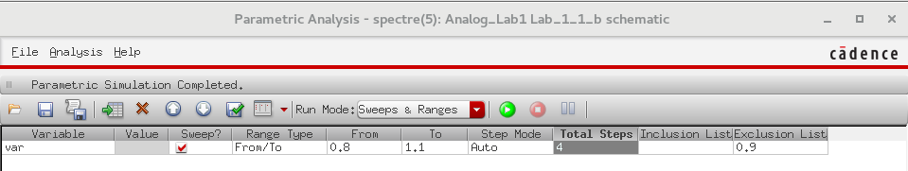
Fig 6: Parametric Analysis Setup

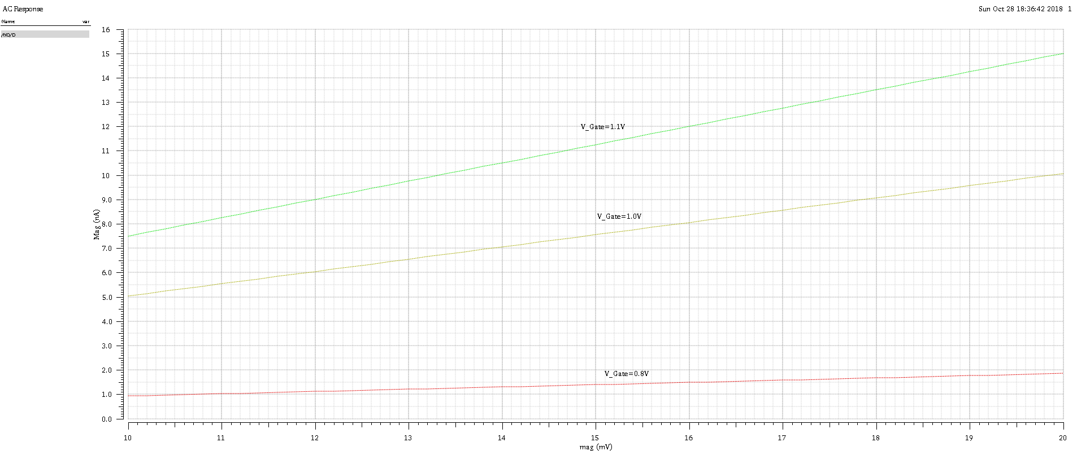
Fig 7: Id – Vd ac analysis for Vg = 0.8, 1, 1.1V

Now we extract Gout in by calculating the derivative of these plots.
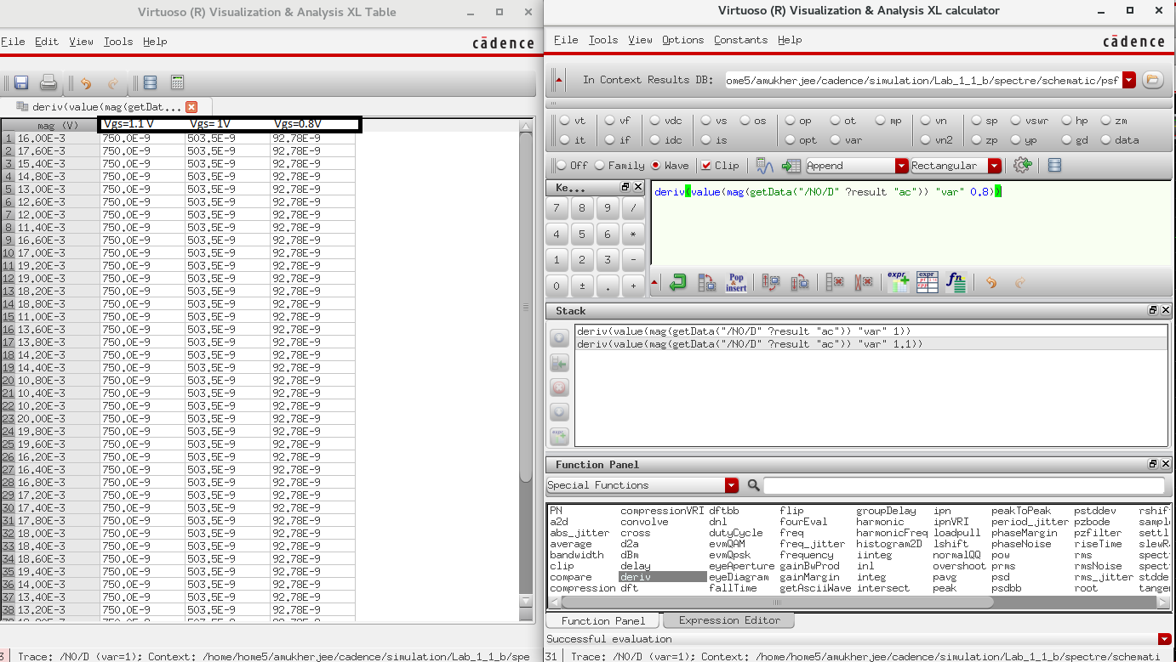
Fig 9: Gout calculated as derivative to previous plot.

Vgs = 0.8 V
Calculated Gout = 92.78 e-9 Amp/Volt
Rout = 1/ Gout = 10.778 Mega Ohm

Vgs = 1.0 V
Calculated Gout = 503.5 e-9 Amp/Volt
Rout = 1/ Gout = 1.98 Mega Ohm

Vgs = 1.1 V
Calculated Gout = 750 e-9 Amp/Volt
Rout = 1/ Gout = 1.33 Mega Ohm

Inference: As we increase Vgs, the saturation current increases with decreases rout.
(Rout = 1/lambda*Iout)

Question 3: Repeat the experiment 2. with Vgs = 0.9V, but with different sizing of the transistor (W/L): (2.4μm/0.6μm), (9.6μm/2.4μm) (14.4μm/3.6μm). Is there a difference in value of output
Resistance?
Answer: Yes there is a difference in the value of Rout due to channel length modulation occurring. In such the relationship is complicated. Below is an analysis.
To answer this we perform parametric analysis with 2 variables.
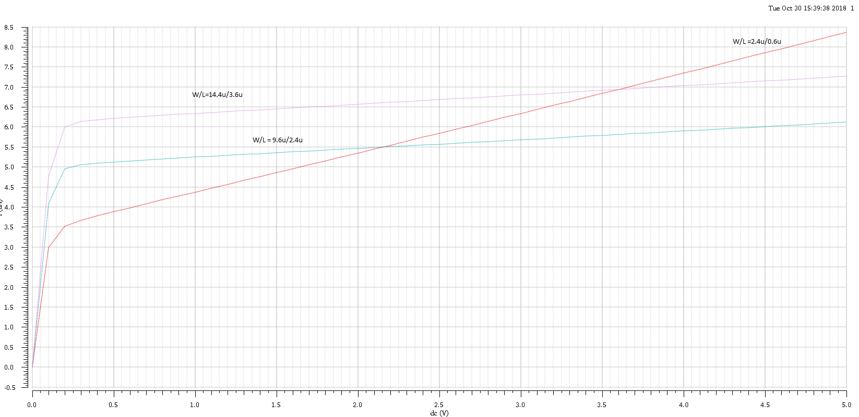
Fig 10: id –vd characteristics DC analysis
Now to find rout for different w/L‘s we do a parametric sweep with both lengths and width as variables 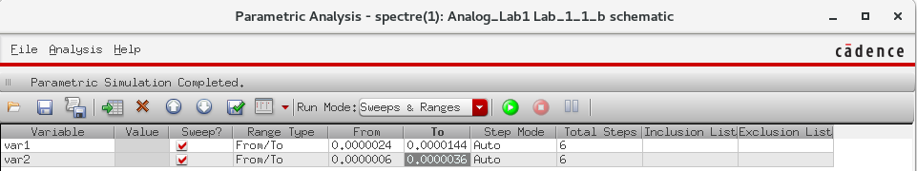
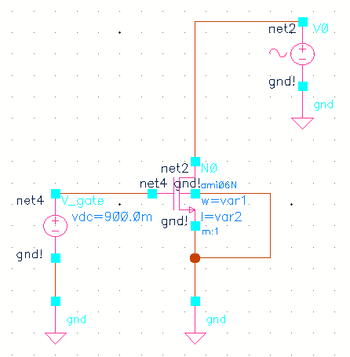
Fig 11. Schematic for Parametric Analysis with 2 variables
The id-vd ac analysis plot is shown below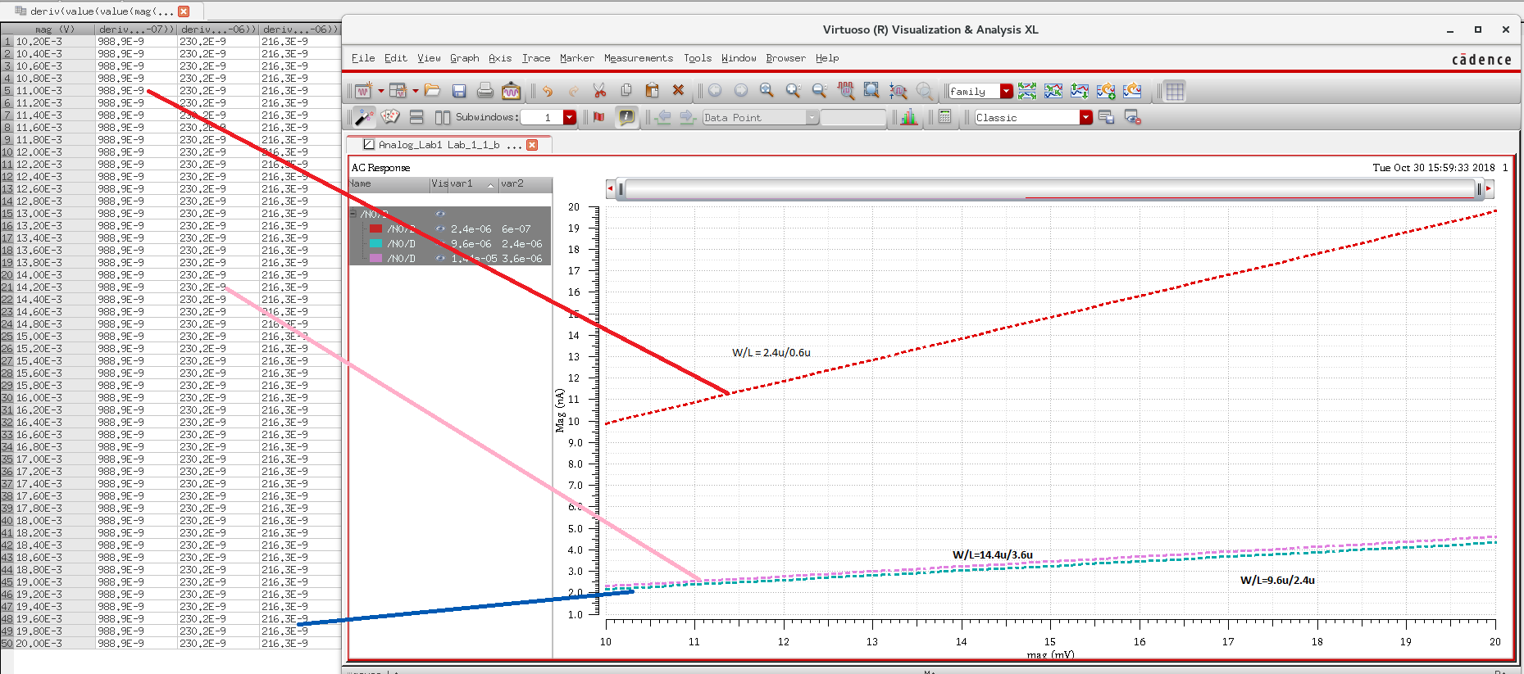
Fig 12: Id-Vd ac analysis

W/L = 2.4u/0.6u
Gout=988e-9 Amp/Volt
Rout = 1/Gout = 1.01 Mega Ohms

W/L = 9.6u/2.4u
Gout=216.3e-9 Amp/Volt
Rout = 1/Gout = 4.623 Mega Ohms

W/L = 14.4u/3.6u
Gout=230.2e-9 Amp/Volt
Rout = 1/Gout = 4.4 Mega Ohms

Inference: As the relationship of Rout with W/L is more complicated. In such we can say that as length increases the effect of channel length modulation decreases and Rout increases.

Part 2.
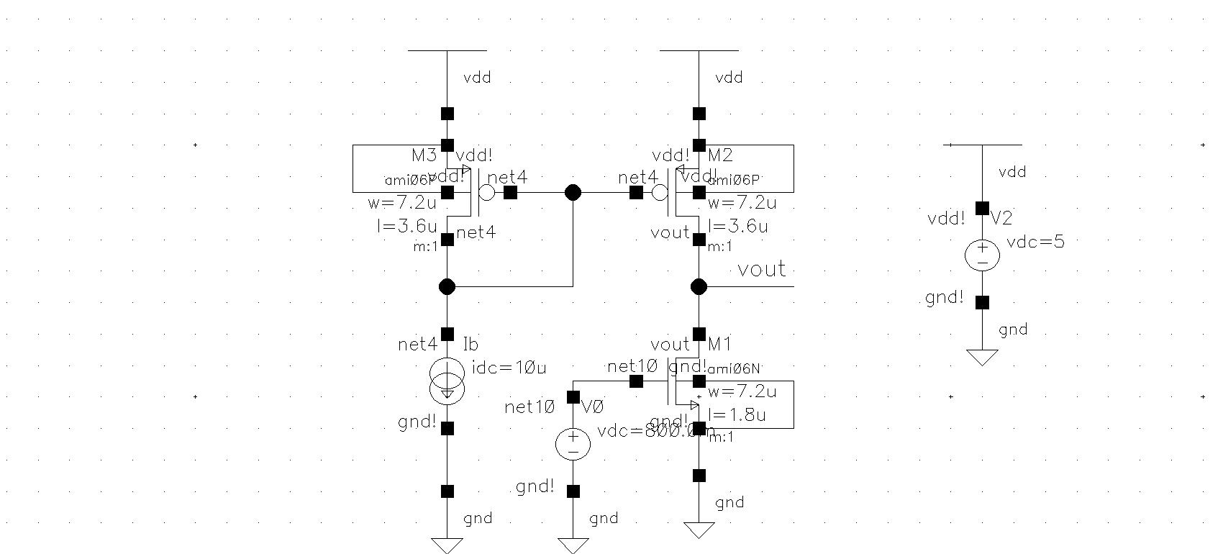
Fig 13: Schematic for Question 2
Question 1. Measure the gain of the amplifier using DC analysis and plot of ∂Vout/∂Vin and DC value of the input voltage VIN that provides the maximum gain of the amplifier. The step of the voltage sweep around the DC voltage with the maximum gain has to be 10μV.

Answer: The maximum Gain occurs at 985.84 mV

To Find Vin corresponding to maximum gain we follow the following steps.

- Plot Vout vs Vin with a big step size to check the range of saturation.
- Re run the simulation in that smaller range within that smaller range with step size 10uV

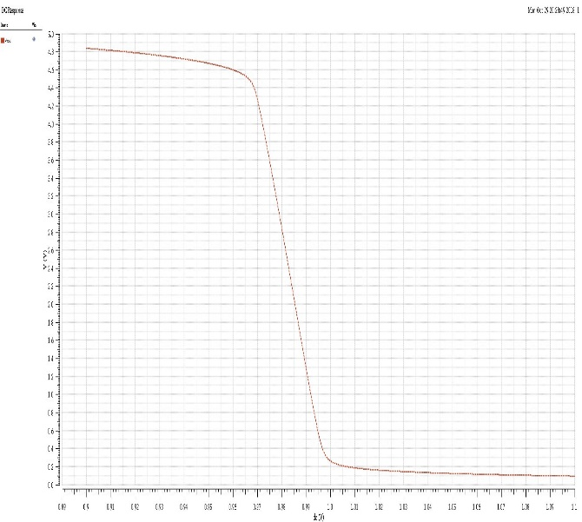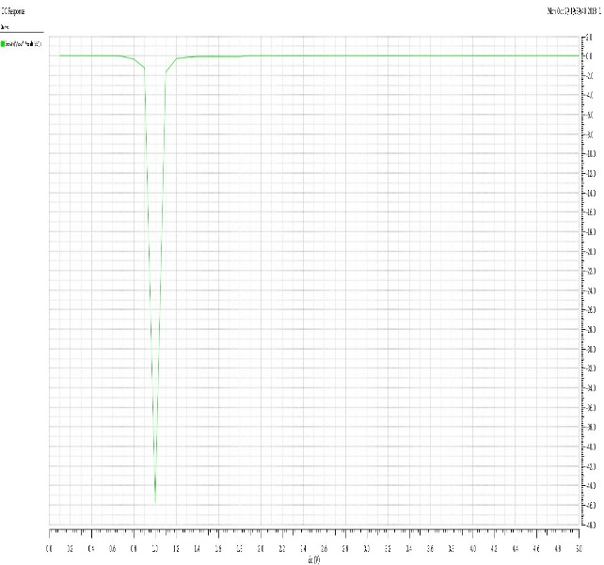
Fig14: (a). Vout vs. Vin (b) Derivative of part (a) Vs. Vin
From Fig 14. We re ran the simulation for a smaller range of 0.9 to 1.1V

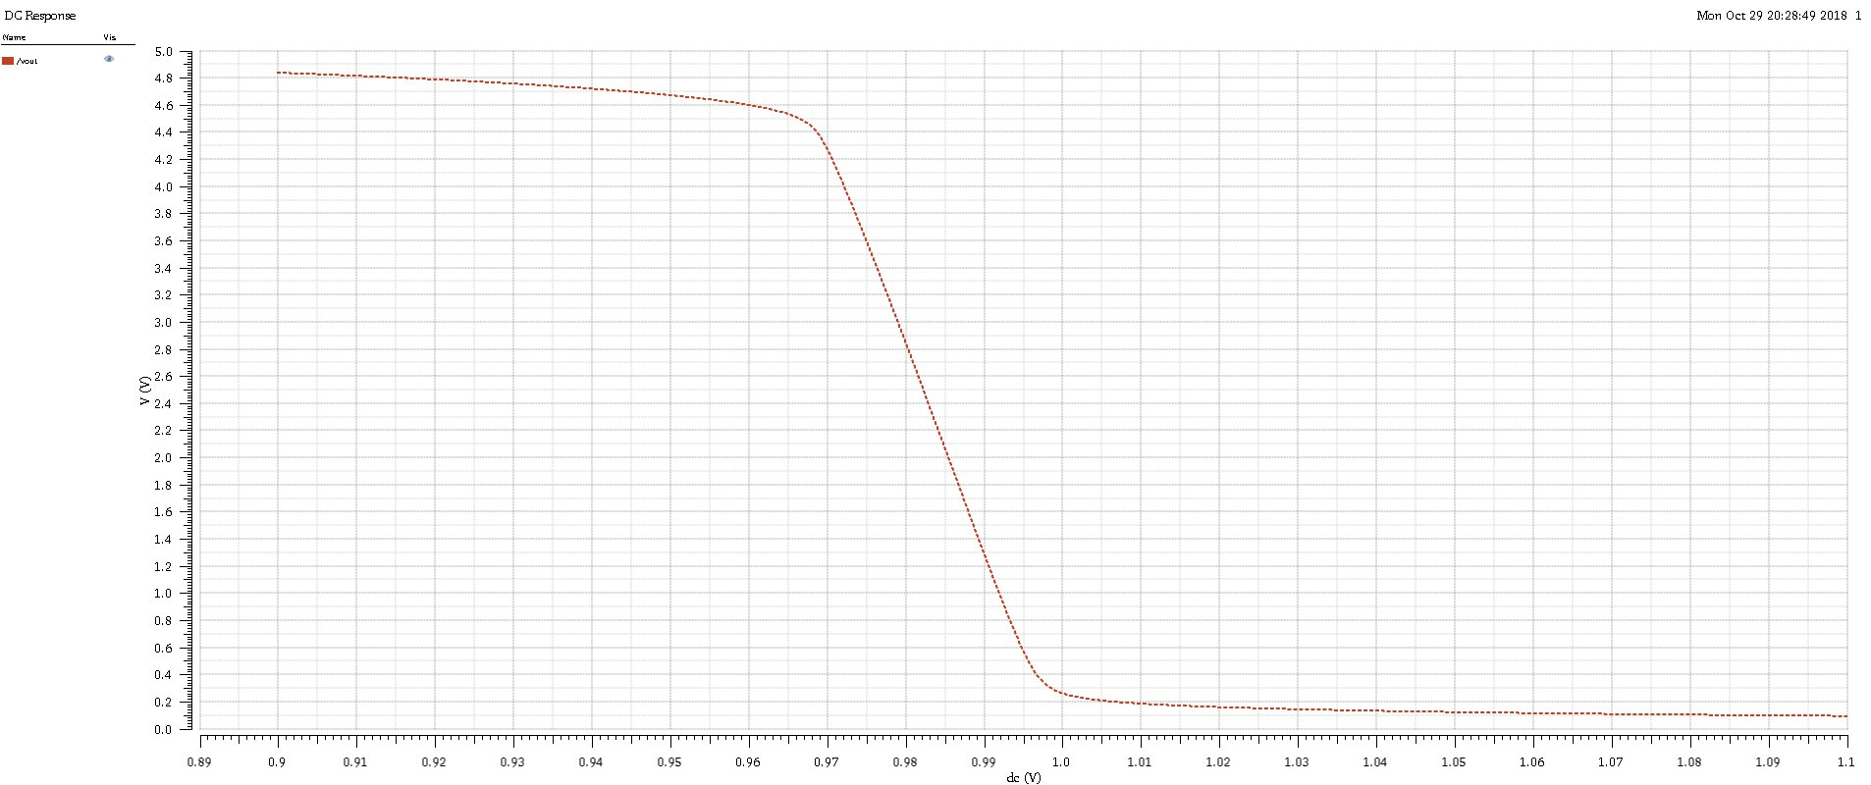
Fig 15. Vout vs Vin.

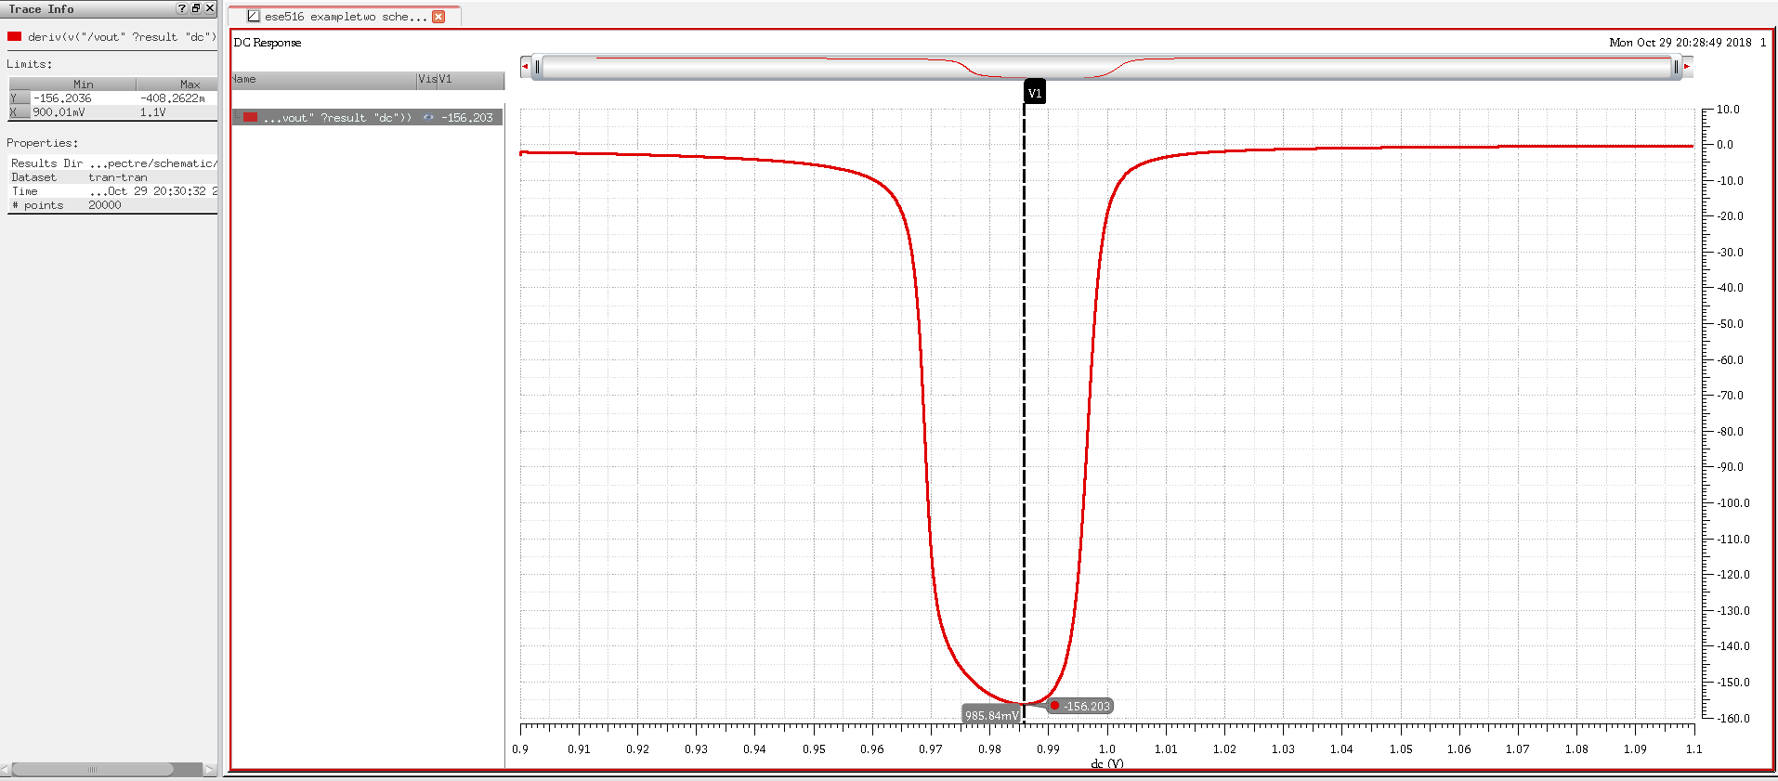

Fig 16. Gain Vs Vin.

The maximum Gain occurs at 985.84 mV

Question 2 : By keeping all the other parameters constant, change the width of the gain transistor W1 to 3.6μm, 10.8μm, 14.4μm and 18μm. How does the change of width affect the gain of amplifier?

Answer: The steps were followed as in Question 1 just that the widths were set as a variable and a parametric analysis was done

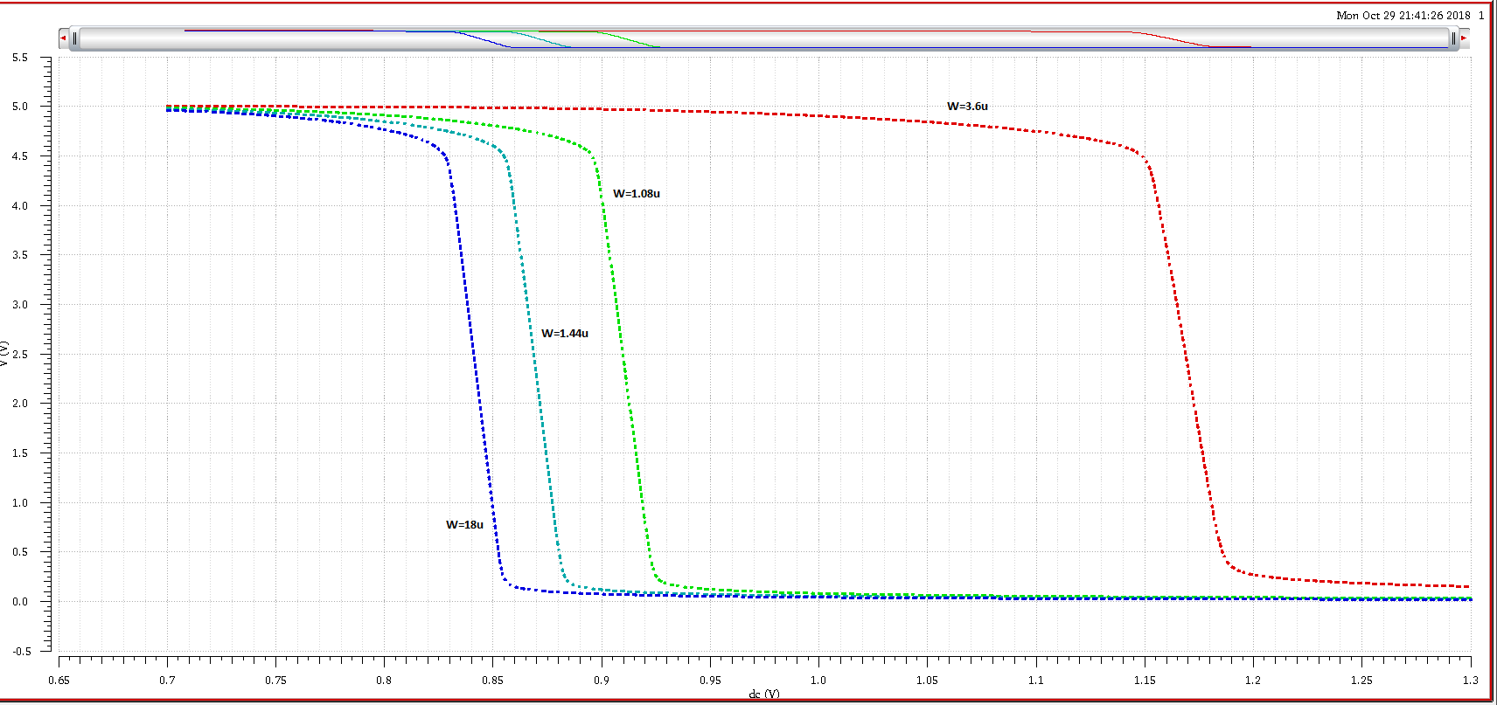

Fig 17 : Vout vs. Vin

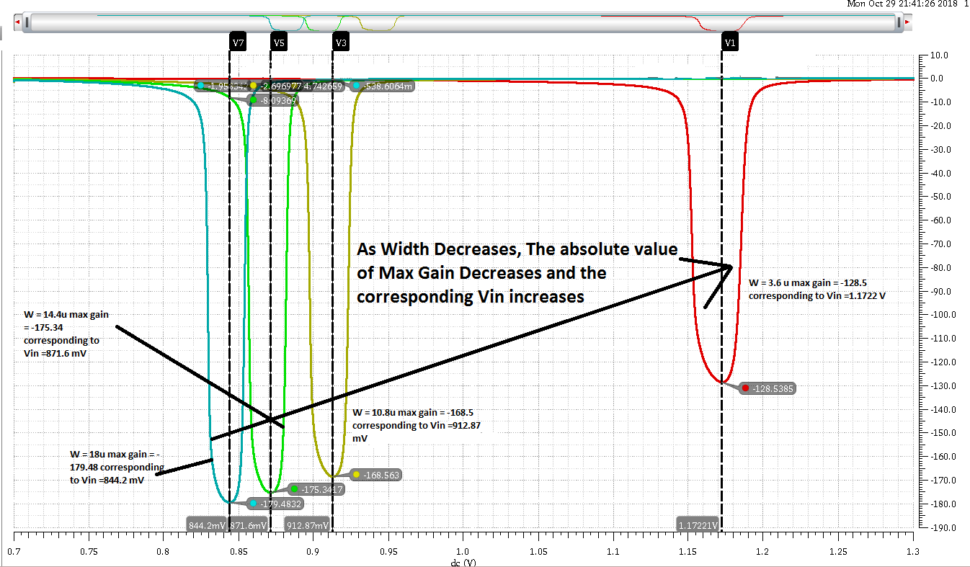
Fig 18: Gain Vs Vin for various Widths.

Inference: As width increases so does the absolute value of Max Gain and the corresponding VIN decreases.
Question 3: By keeping the constant W/L, change both the width and the length to (2.4μm/0.6μm), (4.8μm/1.2μm), (9.6μm/2.4μm) (14.4μm/3.6μm). Measure the gain. How is gain affected by changes in the length of the transistor?

Answer: As length Increases, the value of absolute Gain increases

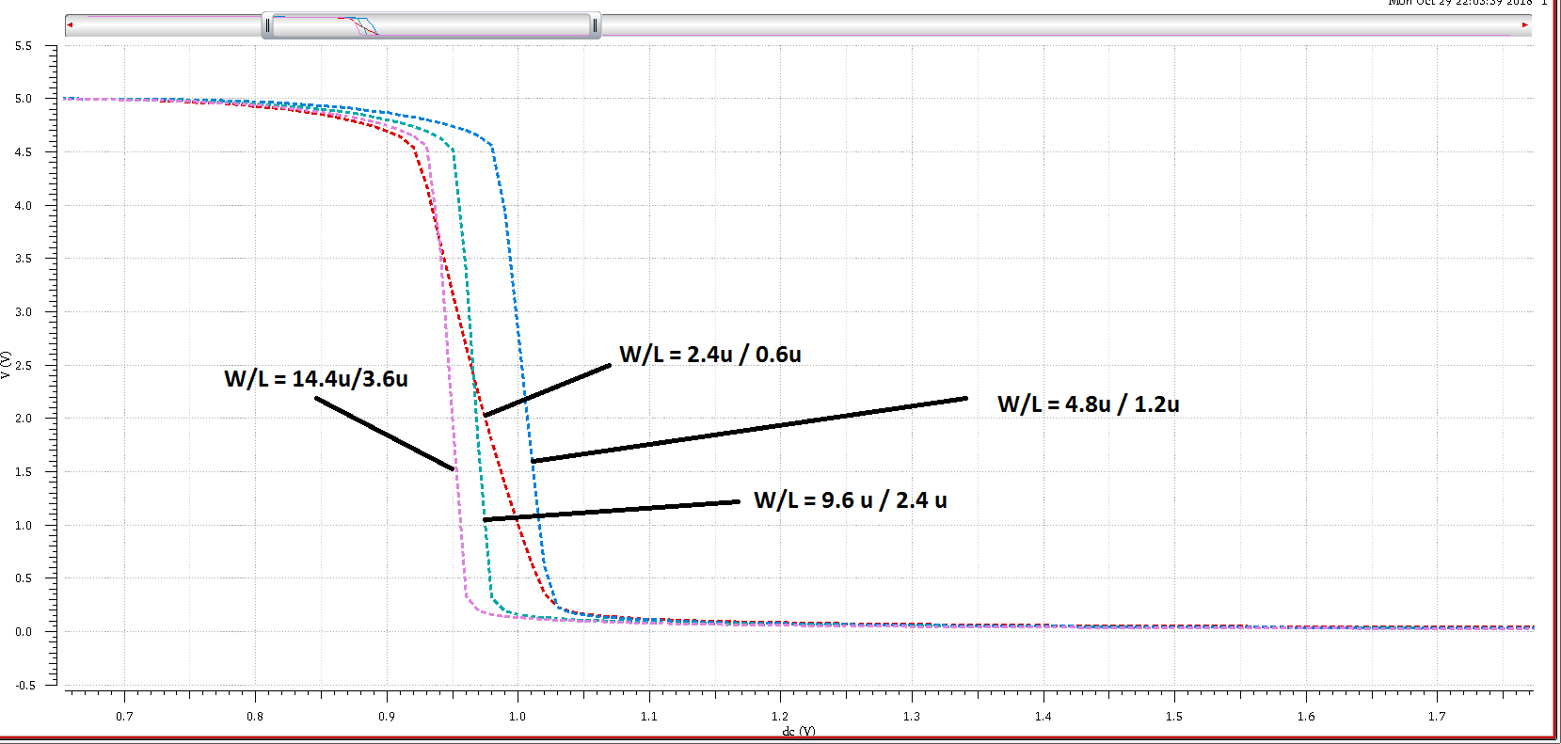
Fig 19. Vin Vs. Vout

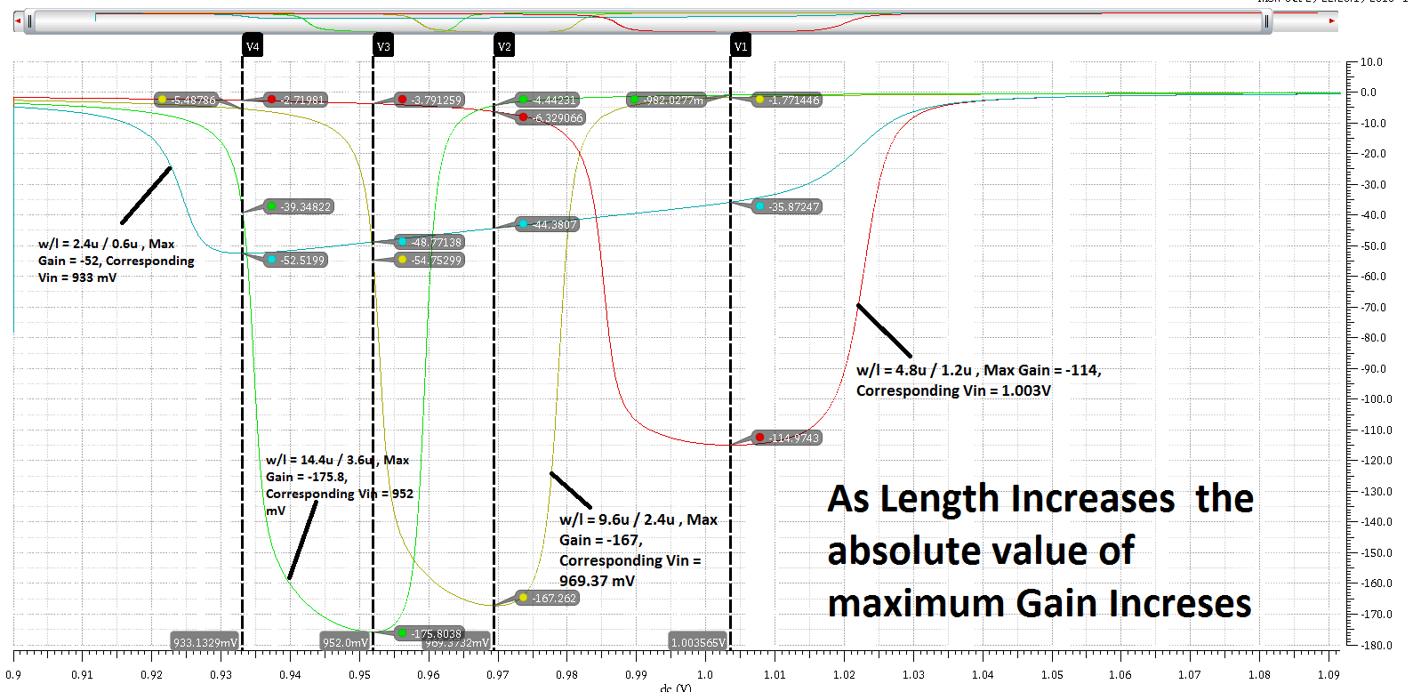
Fig 20: Gain vs. Vin

Inference : Gain is directly proportional to length for a common source amplifier.

Question 4: Keep the sizing of the transistor as in Part 1 and change the biasing current to 1μA, 50μA, 100μA and 500μA. What is the effect of the change in the biasing current on the gain?

Answer: As biasing Current Increases, the absolute value of Gain Decreases
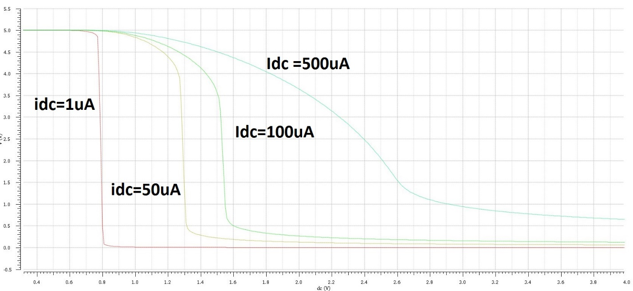
Fig 21: Vout vs. Vin

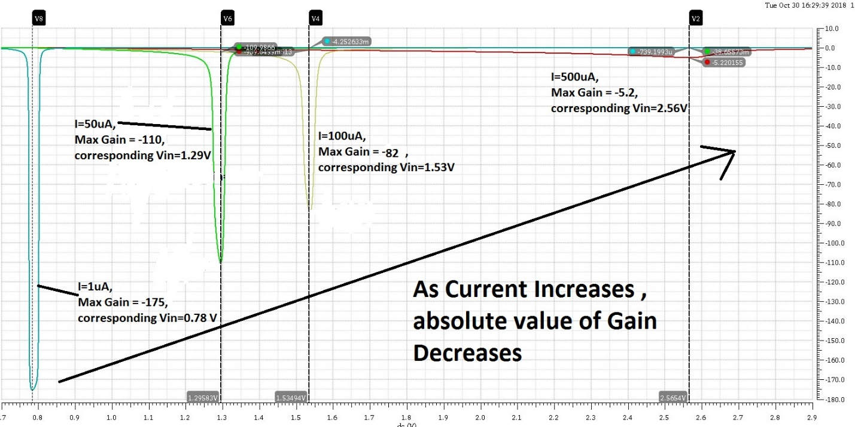
Fig 22: Gain Vs Vin
Inference: As biasing Current Increases, the absolute value of Gain Decreases

PART 3

Question 1. Add a capacitor of size 10pF to the output node of the amplifier. Use AC analysis to find the first pole of the amplifier transfer function. Calculate the location of the pole. How the measured value compares to the calculated one?

Answer: The First pole occurs at 8.296 kHz

To answer this question we use the Schematic for part 2 and add a 10pF capacitor to the output and to an AC analysis and sweep the frequency from 100 hz to 1M hz.

We then change the Y axis to dB20 to get the Bode plot for Gain Vs Freq.

To get the first pole we see at what frequency the Gain has dropped by 3 dB.

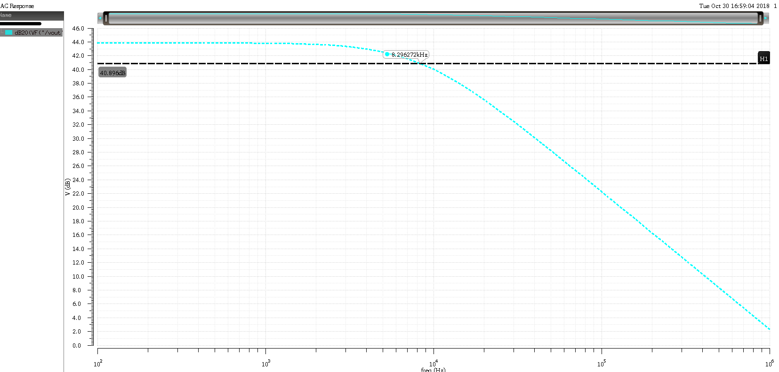

Fig 23: Gain in dB Vs. Freq. The First pole occurs at 8.296 kHz

Hand Calculation

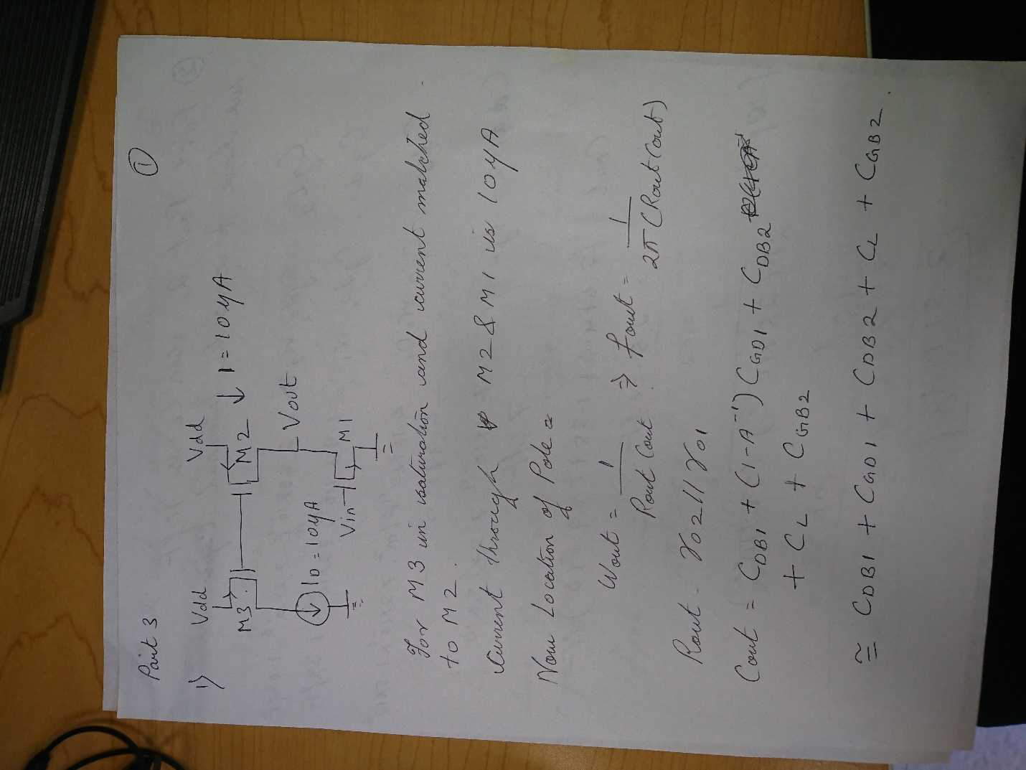

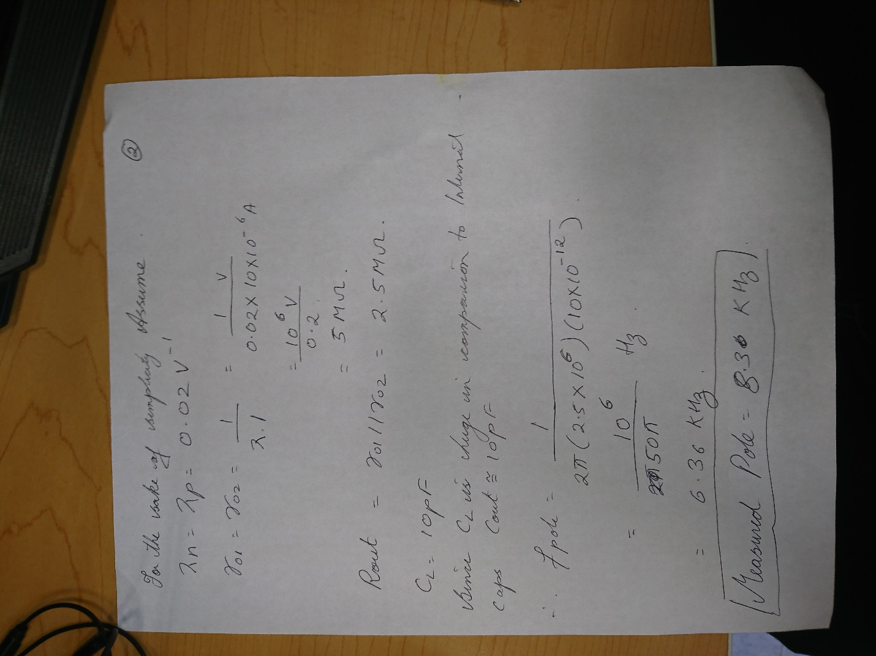

Thus the measured pole is at 8.296 kHz and calculated pole is at 6.36 kHz

Question 2: Change the size of the capacitor to 10fF. Calculate and measure the location of the pole (Note: count in the internal capacitance of the amplifier at the output node).

Answer: The first pole is pushed further in frequency to 2.7Mhz

For To get the first pole we see at what frequency the Gain has dropped by 3 dB
This time we sweep the freq from 100 to 100Mhz

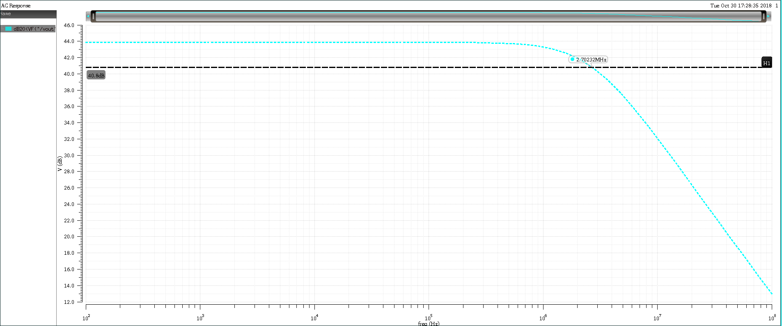
Fig 23: Gain in dB Vs. Freq. The First pole occurs at 2.7 Mhz

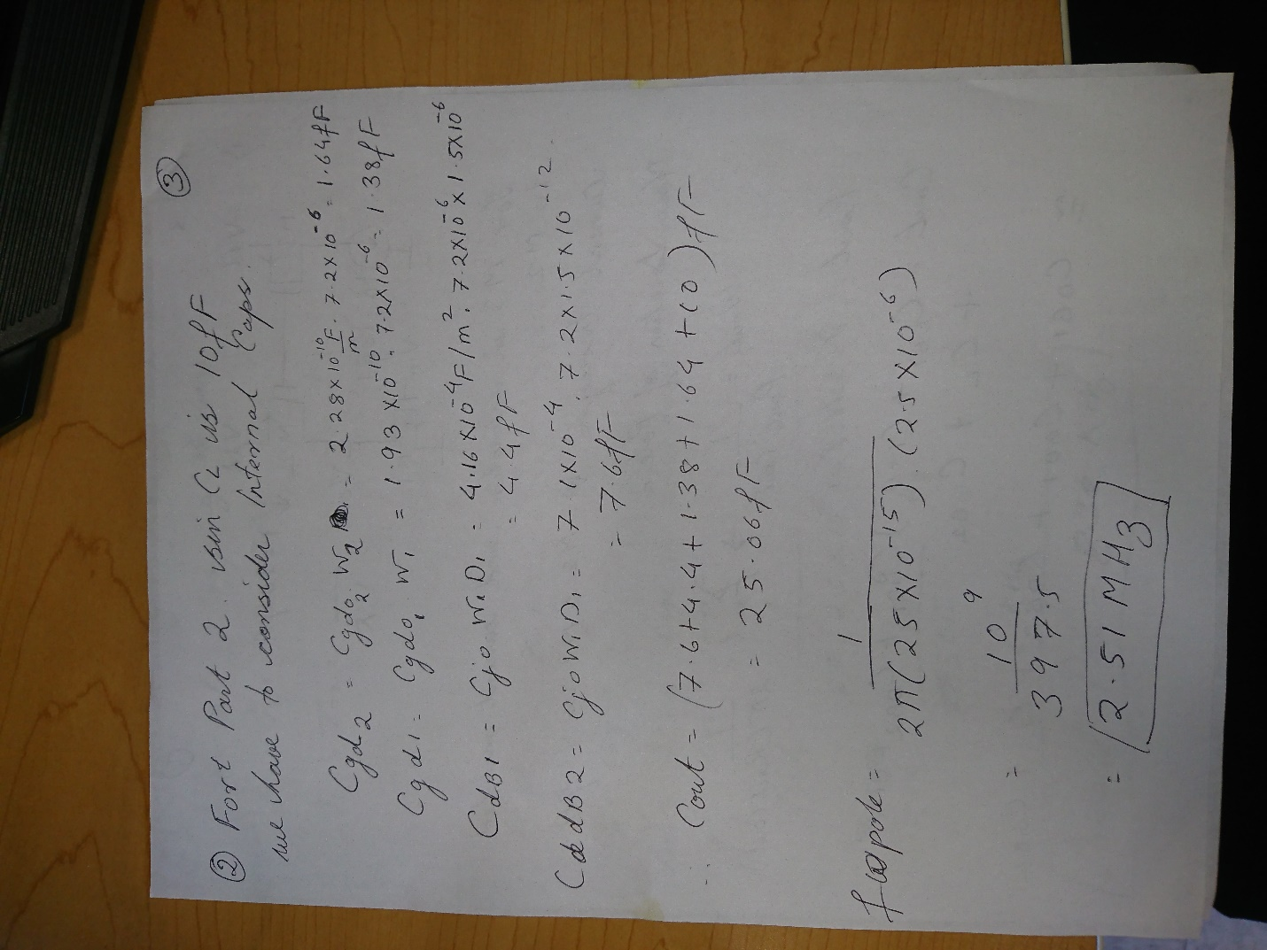

Thus the measured pole is at 2.7MHz and calculated pole is at 2.51 MHz

