*Heaven’s light is our guide*

RAJSHAHI UNIVERSITY OF ENGINEERING AND TECHNOLOGY

**

**Department Of Electrical & Computer Engineering**

**Course Title:**

**Bio Medical Engineering Sessional**

**Course Code:**

**ECE 4144**

**Experiment No. 2**

**Analysis of an Electroencephalogram (EEG) Signal**

|  |  |
| --- | --- |
| **Date of Experiment: 30 July, 2025** | **Date of Submission: 06 August, 2025** |

|  |  |  |
| --- | --- | --- |
| **Submitted to:** |  | **Submitted by:** |
| **Md Mayenul Islam** |  | **Syed Mahmudul Imran** |
| **Assistant Professor, EEE** |  | **Roll:2010058** |
| **RUET** |  | **ECE 2020-21** |

**Experiment No. 2**

**Name of the Experiment**

Analysis of an Electroencephalogram (EEG) Signal.

**Objective**

* Investigate EEG signal composition and characteristics.
* Identify types of brain waves (alpha, beta, delta, theta).
* Analyze EEG data from an open-source dataset due to unavailable recording tools.

**Theory**

EEG (Electroencephalography) is a non-invasive technique for monitoring brain activity via electrodes placed on the scalp. These signals, recorded in microvolts, reflect the combined neuronal activity and fall into several frequency bands:

|  |  |  |  |
| --- | --- | --- | --- |
| **Band** | **Frequency Range** | **Typical Mental State** | **Example of Filtered Bandwidth** |
| Delta (δ) | 0.5 – 4 Hz | Deep sleep, unconsciousness |  |
| Theta (θ) | 4 – 8 Hz | Drowsiness, meditation, light sleep, cognitive load |  |
| Alpha (α) | 8 – 13 Hz | Relaxation, calm alertness, eyes closed |  |
| Beta (β) | 13 – 30 Hz | Active thinking, attention, problem solving |  |
| Gamma  (γ) | 30 – 100 Hz | High-level cognition, perception, consciousness |  |

Electrodes follow the 10-20 International System, with labels indicating brain regions: Fp (prefrontal), F (frontal), C (central), T (temporal), P (parietal), and O (occipital).

**Experimental Observation**

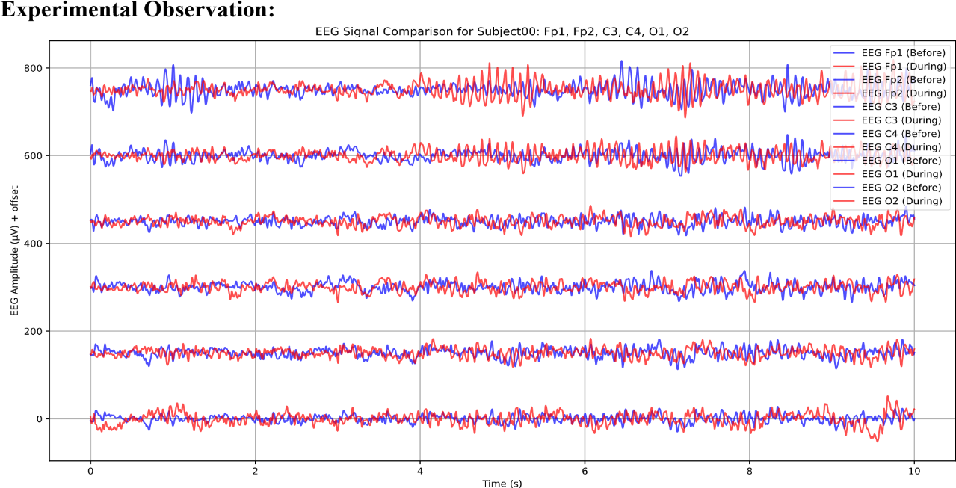Using PhysioNet EEG datasets, we examined signals from locations like Fp1, Fp2, C3, C4, O1, and O2. Each wave type reflected specific mental states: alpha during relaxation and beta during concentration. Data was pre-recorded; no live recordings were conducted.

Figure 1: A diagram of EEG signal in different frequencies.

**Discussion and Conclusion**

Despite not using real-time EEG equipment, the study effectively introduced EEG analysis through authentic datasets. We learned to recognize signal patterns, interpret brainwave frequencies, and understand electrode placements. The experiment clarified how mental states influence EEG signals, reinforcing core concepts of brain activity analysis.

**References:**

1. N. V. Thakor and Y.-S. Zhu, “Applications of adaptive filtering to ECG analysis: noise cancellation and arrhythmia detection,” *IEEE Transactions on Biomedical Engineering*, vol. 38, no. 8, pp. 785–794, Aug. 1991. doi: 10.1109/10.83589.
2. G. Pfurtscheller and F. H. Lopes da Silva, “Event-related EEG/MEG synchronization and desynchronization: basic principles,” *Clinical Neurophysiology*, vol. 110, no. 11, pp. 1842–1857, Nov. 1999. doi: 10.1016/S1388-2457(99)00141-8.
3. PhysioNet, “EEG Motor Movement/Imagery Dataset,” PhysioNet, 2019. [Online]. Available: https://physionet.org/content/eegmmidb/1.0.0/