**Experiment No:** 03

**Experiment Name:** Experimental Observation of Various Features of an ECG Signal Collected from PhysioNet Public Dataset

**Objectives:**

1. To measure RR, PP, and PR intervals using PhysioNet ECG data.
2. To relate temporal cardiac features to physiological parameters like heart rate.

An ECG records heart’s electrical activity via features such as the P wave, QRS complex, and T wave.

* **RR Interval:** Time between successive R peaks; used for heart rate and arrhythmia detection.
* **PP Interval:** Time between P peaks; assesses atrial rhythm.
* **PR Interval:** Time from P wave start to QRS onset; indicates atria-to-ventricle conduction time.

Heart rate (HR) is calculated from the RR interval:

$$\text{HR =}\frac{No. of peaks}{Time\left(s\right)} ×60$$

**Dataset Description:**

**MIT-BIH Arrhythmia Database** (PhysioNet) — 48 half-hour ECG recordings from 47 subjects (1975–1979).

* **Fs:** 360 Hz, ~110,000 annotations.
* ~60% inpatients, ~40% outpatients.

**Record Used:**

* 100 (files: .atr, .dat, .hea, .xws).

**Tools**

* MATLAB
* WFDB Toolbox for MATLAB

**Code:**

[sig, Fs, tm] = rdsamp('mit bih/100', 1);

plot(sig(1:3600, 1))

time = 10; %in seconds

no_of_r_peak = 13;

HR = (no_of_r_peak/time)*60;

fprintf('Heart Rate (bpm): %.2f\n', HR);

R_Peak_positions = [78 371 664 948 1232];

rri = diff(R_Peak_positions);

RR_mean = mean(rri);

fprintf('Mean R-R Interval (samples): %.2f\n', RR_mean);

rr_mean_second = RR_mean/360;

fprintf('Mean R-R Interval (seconds): %.4f\n', rr_mean_second);

P_Peak_positions = [311 605 885 1164 1467];

ppi= diff(P_Peak_positions);

PP_mean = mean(ppi);

fprintf('Mean P-P Interval (samples): %.2f\n', PP_mean);

pp_mean_second = PP_mean/360;

fprintf('Mean P-P Interval (seconds): %.4f\n', pp_mean_second);

**Output:**

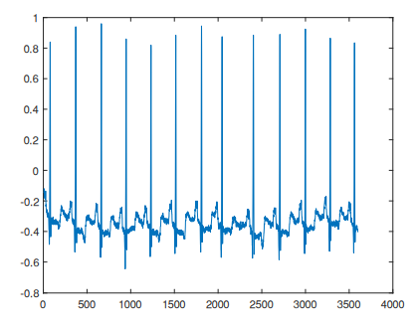

Heart Rate: 78 bpm  
Mean RR Interval: 0.8014 s  
Mean PP Interval: 0.8028 s

**Result & Discussion**

The analysis confirmed accurate extraction of ECG features from PhysioNet data.

* HR of 78 bpm aligns with a normal resting heart rate.
* RR and PP intervals showed consistent atrial and ventricular activity.  
  This validates PhysioNet data as a reliable source for ECG studies and arrhythmia detection.

**Reference:**

* PhysioNet, MIT-BIH Arrhythmia Database (2020).