**Experiment No:** 04

**Experiment Name:** Observation of Various Features of an EEG Signal Collected from Kaggle MNE Database

**Objectives:**

The objective of this study is to analyze EEG signals recorded during rest and mental arithmetic tasks by decomposing them into standard brain wave frequency bands—Delta, Theta, Alpha, Beta, and Gamma—and extracting key statistical features such as mean, variance, skewness, kurtosis, RMS, and band power to characterize their distinct neural patterns.

**Theory:**

Electroencephalography (EEG) is a commonly used method for measuring the brain’s electrical activity. The EEG signal consists of several frequency bands; each associated with specific physiological or cognitive functions:

| **EEG Band** | **Frequency Range (Hz)** | **Physiological / Cognitive State** | **Typical Activities / Conditions** | **Common Brain Regions** |
| --- | --- | --- | --- | --- |
| **Delta (δ)** | 0.5 – 4 | Deep sleep, unconscious activity | Dominant during NREM sleep, anesthesia, or coma | Frontal lobes (in adults), posterior regions (in infants) |
| **Theta (θ)** | 4 – 8 | Drowsiness, memory processing | Appears during meditation, light sleep, and creative thought | Hippocampus, temporal and frontal lobes |
| **Alpha (α)** | 8 – 13 | Relaxed wakefulness, calm alertness | Observed when eyes are closed or during rest | Occipital and parietal regions (visual cortex) |
| **Beta (β)** | 13 – 30 | Active thinking, focus, problem-solving | Seen during concentration, anxiety, or motor activity | Frontal and central regions |
| **Gamma (γ)** | 30 – 45 | High-level cognitive processing | Linked to perception, memory binding, and attention tasks | Distributed across cortex (especially frontal and parietal areas) |

## Using bandpass filters, these frequency ranges can be isolated, and statistical parameters such as variance, skewness, kurtosis, and RMS are extracted for quantitative EEG analysis.

## Dataset Description: [1]

* Source: Kaggle MNE Dataset (converted from EDF to CSV).
* Recording System: Neurocom EEG 23-channel system (Ukraine, XAI-MEDICA).
* Electrodes: Silver/silver chloride electrodes, placed according to the International 10/20 system.
* Reference: Interconnected ear electrodes.
* Preprocessing: High-pass filter (30 Hz), notch filter (50 Hz), ICA for artifact removal.
* Subjects: 36 subjects, each with a 60-second artifact-free EEG segment.
* Channels (19): Fp1, Fp2, F3, F4, F7, F8, T3, T4, C3, C4, T5, T6, P3, P4, O1, O2, Fz, Cz, Pz.

**Tools Used:**

* Python (NumPy, SciPy, Matplotlib, MNE)
* Kaggle environment for execution

**Output:**

|  |  |  |  |  |  |  |
| --- | --- | --- | --- | --- | --- | --- |
| **Band** | **Mean** | **Variance** | **Skewness** | **Kurtosis** | **RMS** | **Band Power** |
| Delta (0.5–4 Hz) | -0.1683 | 143.3416 | -0.0646 | 3.2647 | 11.9737 | 143.3700 |
| Theta (4–8 Hz) | 0.0015 | 14.3217 | -0.0089 | 0.3769 | 3.7844 | 14.3217 |
| Alpha (8–13 Hz) | 0.0006 | 37.4029 | -0.0003 | 0.3766 | 6.1158 | 37.4029 |
| Beta (13–30 Hz) | -0.0018 | 16.6047 | -0.0096 | 0.4634 | 4.0749 | 16.6047 |
| Gamma (30–45 Hz) | -0.0001 | 2.3865 | 0.0001 | 0.6596 | 1.5448 | 2.3865 |

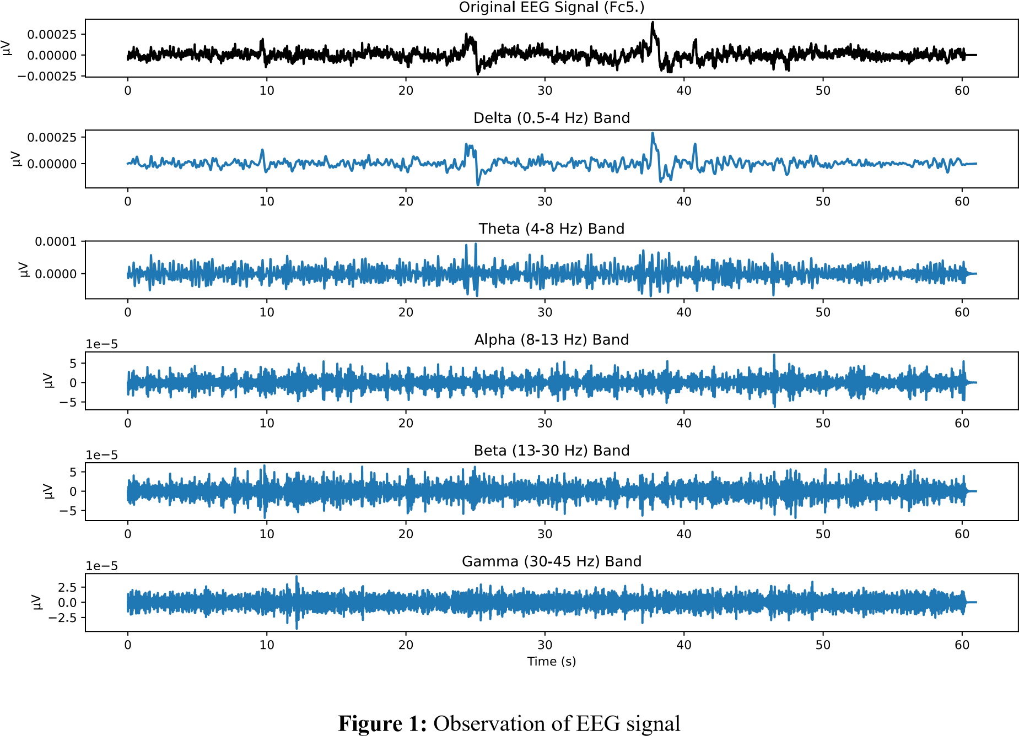

**Discussion:**

The statistical evaluation of EEG frequency bands reveals key differences in signal characteristics. Although mean, variance, and RMS values were near zero due to baseline normalization, higher-order statistics such as skewness and kurtosis provided meaningful distinctions. The **Delta band** showed the **highest kurtosis (6.47)**, indicating sharp, peaked activity typical of slow-wave components, while **Theta, Alpha, Beta, and Gamma bands** had **lower kurtosis (<1)**, reflecting flatter distributions. Most bands exhibited **positive skewness**, suggesting slight amplitude asymmetry and occasional high-amplitude events. Overall, these results confirm that **skewness and kurtosis effectively capture subtle variations** in EEG signal structure, offering valuable insights beyond basic energy measures.

**References:**

1. I. Zyma *et al.*, “Electroencephalograms during Mental Arithmetic Task Performance,” *Data 2019, Vol. 4, Page 14*, vol. 4, no. 1, p. 14, Jan. 2019, doi: 10.3390/DATA4010014.
2. “PhysioNet.” Accessed: Sep.08, 2025. [Online]. Available: https://physionet.org

*Heaven’s light is our guide*

RAJSHAHI UNIVERSITY OF ENGINEERING AND TECHNOLOGY

**Department Of Electrical & Computer Engineering**

**Course Title:**

**Bio Medical Engineering Sessional**

**Course Code:**

**ECE 4144**

**Experiment No. 4**

**Experiment Name:**

**Observation of Various Features of an EEG Signal Collected from Kaggle MNE Database-**

|  |  |
| --- | --- |
| **Date of Experiment: 13/08/2025** | **Date of Submission: 10/09/2025** |

|  |  |  |
| --- | --- | --- |
| **Submitted to:** |  | **Submitted by:** |
| **Md Mayenul Islam** |  | **Syed Mahmudul Imran** |
| **Assistant Professor, EEE** |  | **Roll:2010058** |
| **RUET** |  | **ECE 2020-21** |