**Experiment no.:** 01

**Experiment name:** Pick and Place Operation

**Objectives:**

• To understand the control architecture of the roboTEK-II robotic workstation and its four-degree-of-freedom joint coordination  
• To develop sequential BASIC-style programming commands for automated pick-and-place operations with precise positioning control  
• To integrate sensor feedback systems with actuator control in coordinated material handling workflows  
• To analyze timing requirements, positioning accuracy, and system performance in multi-stage robotic operations  
• To evaluate sequential programming effectiveness in industrial automation and identify optimization opportunities

**Theory:**

The roboTEK-II robotic workstation is an automated system designed for material handling applications. It consists of a robotic arm with four degrees of freedom: base (B) for rotation, shoulder (S) for vertical arm positioning, elbow (E) for arm extension, and jaw (J) for gripping objects. The system includes sensors for object detection and a conveyor belt for material transport.

The robotic arm operates through sequential programming where each MOVE command specifies the position of all four joints. The jaw parameter controls the gripper - lower values close the jaw for grasping, while higher values open it for releasing objects. The system also supports timing commands (WAIT) and conveyor control (CONVEYOR_ON/OFF) for complete automation.

The experiment follows a standard pick-and-place sequence: approach the object, grasp it, transport it to the destination, release it, and activate the conveyor for final transport to the storage area.

**Working Principle: (Code)**

MOVE B45 S35 E10 J100 ' Move to initial position with jaw open

MOVE B45 S33 E10 J20 ' Lower to pick and close jaw

MOVE B45 S70 E10 J20 ' Lift the object

MOVE B5 S70 E10 J20 ' Rotate towards conveyor

MOVE B5 S67 E1 J20 ' Lower towards conveyor

MOVE B5 S44 E1 J20 ' Lower further near conveyor

MOVE B5 S44 E1 J100 ' Release object (open jaw)

MOVE B5 S71 E1 J100 ' Return to home position

WAIT 2000 ' Wait before activating conveyor

CONVEYOR_ON ' Start conveyor

WAIT 5000 ' Let conveyor run for 5 seconds

CONVEYOR_OFF ' Stop conveyor

The MOVE command controls all four joints of the robotic arm simultaneously by specifying target positions for Base (B), Shoulder (S), Elbow (E), and Jaw (J) parameters. The WAIT command introduces time delays in milliseconds to ensure proper sequencing between operations. The CONVEYOR_ON and CONVEYOR_OFF commands control the conveyor belt system to start and stop material transport operations. These commands work together to create a coordinated sequence for automated pick-and-place operations.

**Result:**

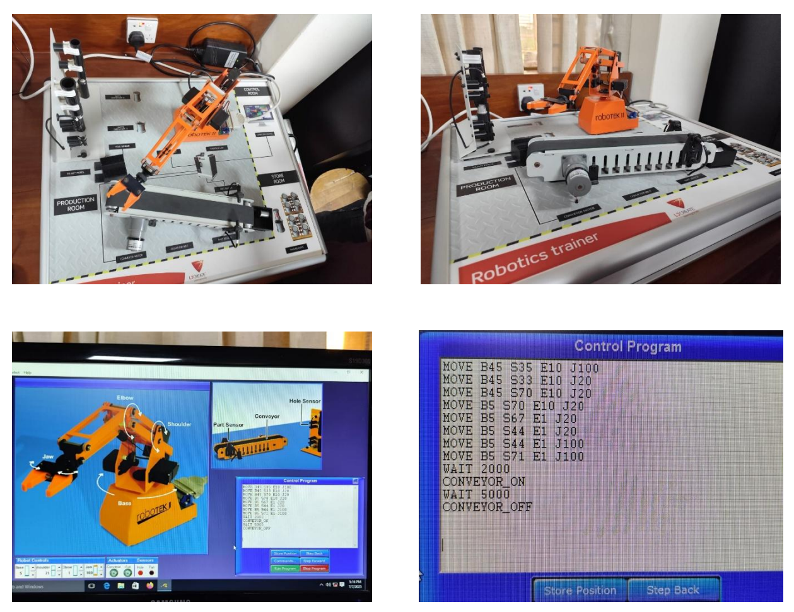

Figure : roboTEK-II prototype and simulation code

The experiment was successfully completed with the robotic arm picking up the object from its initial position and placing it on the conveyor belt. The conveyor system then transported the object to the designated "store room" area. All movements were executed smoothly without any collisions or errors, demonstrating effective coordination between the robotic arm and conveyor system.

**Discussion:**

The experiment demonstrated the effectiveness of sequential programming in robotic automation. The gradual lowering of the arm (S67 to S44) ensured gentle placement of the object on the conveyor, preventing damage. The 2-second wait before conveyor activation allowed the arm to clear the conveyor area safely. The sensors played a crucial role in accurate object detection and positioning, ensuring reliable operation throughout the process.

**Conclusion:**

The roboTEK-II robotic workstation successfully performed the pick-and-place operation, showcasing the integration of robotic control, sensor feedback, and conveyor automation. This experiment provides valuable insights into industrial automation processes and demonstrates the importance of proper sequencing and timing in robotic applications.

**References:**

1. roboTEK-II User Manual and Programming Guide
2. Industrial Robotics: Programming and Control Systems