**Experiment No.: 03**

**Experiment Name:** Speed Control of a DC motor using a closed loop feedback control with a PID controller

**Objectives:**

The aim of this study is to design and implement a closed-loop DC motor speed control system using a PID controller, analyze its impact on transient and steady-state performance, and compare the results with the open-loop response.

**Theory:**

A **DC motor** is one of the most fundamental electromechanical devices used in automation, robotics, and control systems due to its excellent speed control and quick response characteristics. The speed of a DC motor is directly proportional to the armature voltage and inversely proportional to the magnetic flux. Thus, by regulating the input voltage, the motor speed can be efficiently controlled. However, **external disturbances**, **load variations**, and **nonlinearities** in the motor and drive circuit often introduce **speed fluctuations**, affecting system performance.

To overcome these challenges, a **closed-loop feedback control system** is employed. In this configuration, the **actual motor speed** is continuously measured (feedback) and compared with the **reference (desired) speed**. The difference between them, known as the **error signal**, represents the deviation from the desired performance. This error is processed by a **PID controller (Proportional–Integral–Derivative controller)**, which dynamically adjusts the control input—typically the motor’s armature voltage—to minimize the error and maintain stable operation.

The **PID controller** is a combination of three control actions:

* **Proportional Control (P):** Produces an output that is proportional to the current error. This term provides fast correction and improves system responsiveness, but excessive proportional gain can lead to overshoot and oscillation.
* **Integral Control (I):** Integrates the error signal over time to eliminate **steady-state error**, ensuring the system output eventually reaches the reference speed. However, too much integral gain may slow down the response or cause instability.
* **Derivative Control (D):** Reacts to the rate of change of the error, providing a predictive action that **improves damping** and reduces overshoot, enhancing the system’s transient performance.

The **PID controller transfer function** is given by:

where , , and are the proportional, integral, and derivative gains, respectively.

Figure : Block diagram of speed control of DC motor

In the block diagram, the **reference speed** is compared with the **feedback speed** to generate an error signal, which passes through the **PID controller**. The controller output then drives the DC motor, and the resulting speed is continuously measured and fed back to close the loop.

The **closed-loop transfer function** of the system is expressed as:

where is the transfer function of the DC motor.

This closed-loop configuration ensures that the motor maintains a constant speed even under varying load conditions. The **PID controller parameters** can be tuned to achieve a desired balance between **rise time**, **overshoot**, **settling time**, and **steady-state error**, allowing precise control over the motor’s dynamic and steady-state performance. Such systems are widely used in applications like robotic arms, conveyor belts, and servo mechanisms where **speed accuracy and stability** are essential.

**Connection Diagram:**

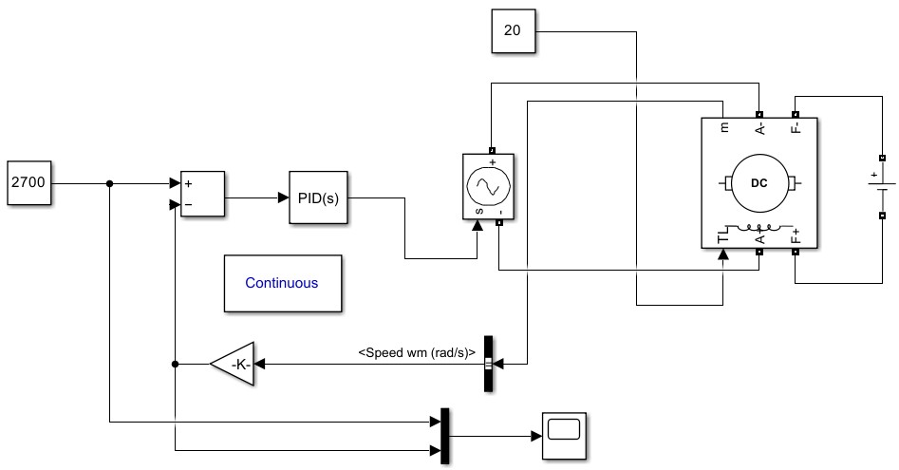

**Figure 2:** Connection diagram of Speed control of DC motor using PID

**Required Software:**

* MATLAB
* Simulink(Control System Toolbox)

**Output:**

Controller: PID

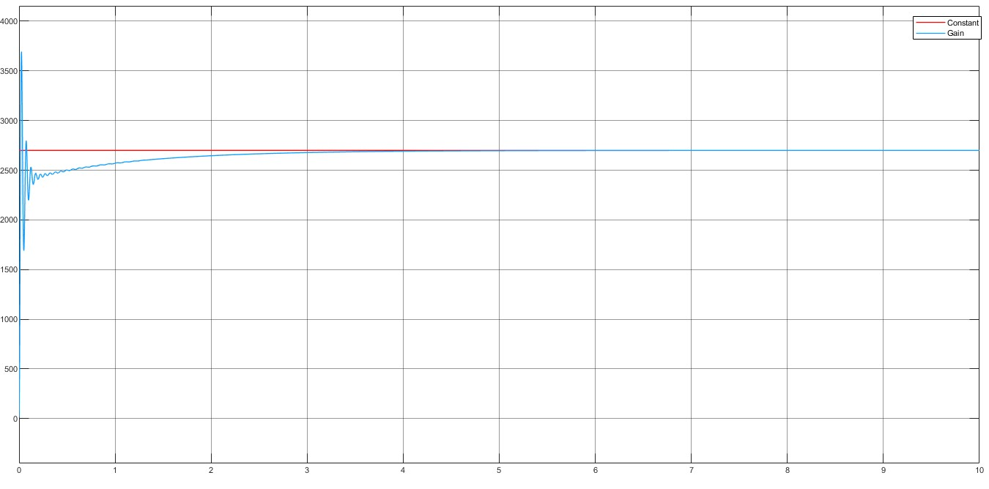

**Figure**

**3**

**:**

PID (Before

tuning)

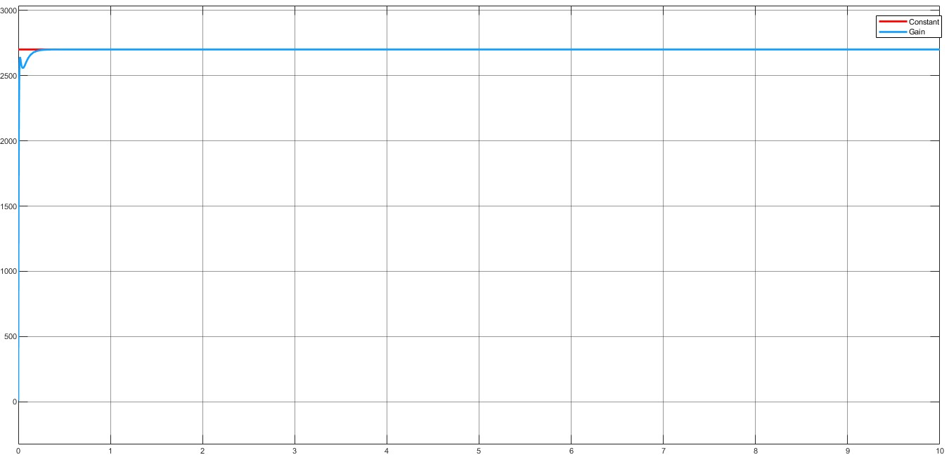

**Figure 4:** PID (After tuning)

Controller: PI

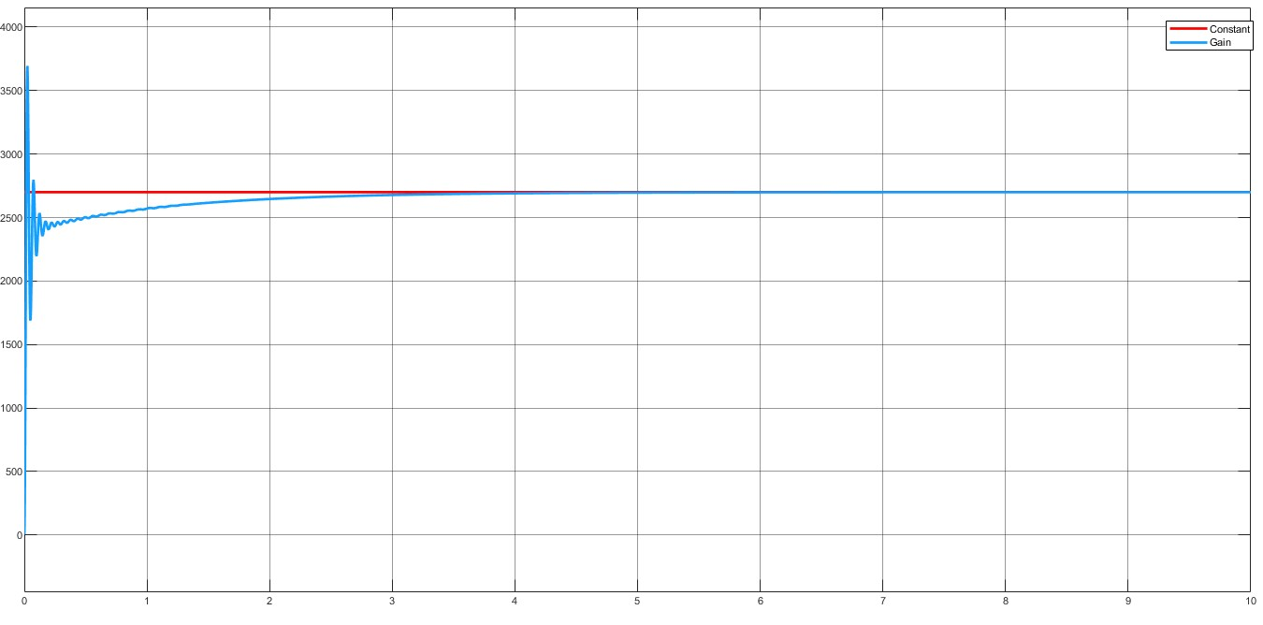

**Figure**

**5**

**:**

PI (Be

fore tuning)

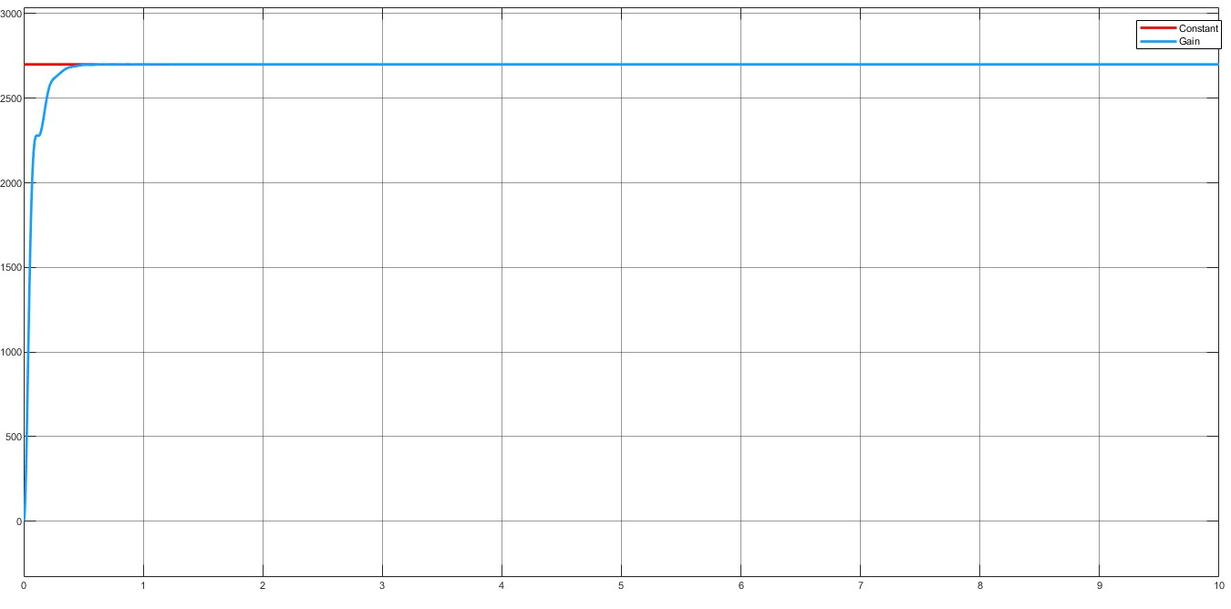

**Figure 6:** PI (After tuning)

Controller: PD

**Figure 7:** PD (Before tuning)

**Figure 8:** PD (After tuning)

Controller: P

**Figure 9:** P (Before tuning)

**Figure 10:** P (After tuning)

Controller: I

**Figure 11:** I (Before tuning)

**Figure 12:** I (After tuning)

**Result:**

The performance comparison of various controllers shows distinct characteristics: the **P controller** offers a fast response but retains steady-state error; the **I controller** removes steady-state error but causes a slower and potentially unstable response; the **PD controller** provides quick and stable behavior without eliminating steady-state error; and the **PI controller** achieves zero steady-state error with moderate overshoot. Among all, the **PID controller** delivered the most balanced performance, combining fast response, zero steady-state error, and acceptable overshoot. Parameter tuning led to notable improvements, with the PID controller achieving approximately **37.5% faster rise time**, **23.8% shorter settling time**, and **33% reduced overshoot**, emphasizing the importance of optimal gain selection for efficient system performance.

**Discussion:**

The implementation of the PID controller for DC motor speed control proved highly effective in meeting the desired performance goals. The **proportional gain** controlled the system’s response speed and steady-state error, with higher values improving accuracy but risking instability. The **integral gain** effectively removed steady-state error, enabling the motor to reach the target speed despite load or parameter variations, while the **derivative gain** enhanced damping, reducing overshoot and improving stability. Optimal tuning, achieved through **trial-and-error** and the **Ziegler–Nichols method**, provided a balanced trade-off between fast response and stability. The **Simulink environment** facilitated efficient design and tuning, offering real-time visualization and easy parameter adjustment, which greatly streamlined the controller optimization process.

**Conclusion:**

This experiment effectively verified the theoretical principles of closed-loop feedback and PID controller design through MATLAB Simulink simulation. The PID controller greatly enhanced DC motor speed regulation by eliminating steady-state error, minimizing response time, and ensuring stable performance under disturbances. Moreover, the systematic tuning process highlighted the distinct roles of each PID component and demonstrated how their combined action optimizes the overall dynamic and steady-state behavior of the system.

**References**

1. K. Ogata, Modern Control Engineering, 5th ed., Upper Saddle River: Prentice Hall, 2010.
2. N. S. Nise, Control Systems Engineering, 8th ed., Hoboken: John Wiley & Sons, 2019.
3. "MATLAB," [Online]. Available: https://www.mathworks.com/help/control/. [Accessed 31 August 2025].

