**Experiment No. 5**

**Experiment Name:** Root Locus and Time-Response Analysis of a DC Motor with PID, PI, and PD Controllers

**Objectives:**

The objective of this experiment is to generate and analyze the root locus of an armature-controlled DC motor, design suitable **PI**, **PD**, and **PID controllers** to meet desired transient-response specifications and compare their **closed-loop step responses**—including rise time, settling time, overshoot, and steady-state error—using MATLAB/Simulink simulations.

**Theory:**

A **standard armature-controlled DC motor** exhibits both electrical and mechanical dynamics that can be described by coupled differential equations. The **electrical subsystem** governs the armature circuit, while the **mechanical subsystem** represents the rotor’s motion.

* **Electrical equation:**

$$L\frac{di_{a}(t)}{dt}+Ri_{a}(t)+K_{e}ω(t)=v_{a}(t)$$

where $L$ is the armature inductance, $R$ is the armature resistance, $K_{e}$ is the back EMF constant, $ω(t)$ is the angular velocity, and $v_{a}(t)$ is the armature voltage input.

* **Mechanical equation:**

$$J\frac{dω(t)}{dt}+Bω(t)=K_{t}i_{a}(t)$$

where $J$ is the rotor inertia, $B$ is the viscous friction coefficient, and $K_{t}$ is the torque constant.

By taking the **Laplace transform** and eliminating the armature current $i_{a}(t)$, the **open-loop transfer function** (speed plant) of the DC motor can be derived as:

$$G(s)=\frac{Ω(s)}{V_{a}(s)}=\frac{K_{t}}{(Js+B)(Ls+R)+K_{e}K_{t}}$$

This transfer function describes how the motor’s angular speed $Ω(s)$ responds to an input voltage $V_{a}(s)$.

When a **unity feedback configuration** is applied with a controller $C(s)$, the **closed-loop transfer function** of the system becomes:

$$T(s)=\frac{C(s)G(s)}{1+C(s)G(s)}$$

and the **characteristic equation** is given by:

$$1+C(s)G(s)=0$$

This equation determines the system’s stability and transient behavior, which can be analyzed using the **root locus** method.

Depending on the control objective, different controller structures can be implemented:

* **PI Controller:**

$$C_{PI}(s)=K_{p}+\frac{K_{i}}{s}=\frac{K_{p}s+K_{i}}{s}$$

Provides zero steady-state error for step inputs and moderate transient response.

* **PD Controller:**

$$C_{PD}(s)=K_{p}+K_{d}s$$

Improves damping and transient response but does not eliminate steady-state error.

* **PID Controller:**

$$C_{PID}(s)=K_{p}+\frac{K_{i}}{s}+K_{d}s=\frac{K_{d}s^{2}+K_{p}s+K_{i}}{s}$$

Combines the benefits of P, I, and D control—fast response, zero steady-state error, and improved stability.

The **root locus method** is employed to study how the closed-loop poles of the system move as the loop gain varies. By introducing zeros through PI, PD, or PID controllers, the shape of the root locus is modified, allowing improved **damping ratio ($ζ$)** and **natural frequency ($ω_{n}$)** to meet desired transient specifications.

For a **dominant underdamped system**, transient response characteristics are estimated using the following standard relationships:

$$M_{p}≈100e^{-πζ/\sqrt{1-ζ^{2}}}\text{and}T_{s}(2\%)≈\frac{4}{ζω_{n}}$$

where $M_{p}$ is the **percent overshoot** and $T_{s}$ is the **settling time**.

By adjusting the controller parameters $K_{p}$, $K_{i}$, and $K_{d}$, the root locus can be shaped to achieve the desired damping ratio and natural frequency, thus optimizing system performance in terms of **speed, stability, and accuracy**.

**Required Software:**

* MATLAB
* Simulink

**Plant Model and Controller Design**

The simulation of the DC motor speed control system was carried out using the following motor parameters: $$J=0.01, B=0.1, K_{e}=K_{t}=0.01, R=1, L=0.5.$$

The controller gains were tuned as follows:

* **PI Controller: $K_{p}=23.665, K_{i}=43.66192, K_{d}=0$**
* **PD Controller: $K_{p}=530.43375, K_{i}=0, K_{d}=91.85$**
* **PID Controller: $K_{p}=594.048, K_{i}=1971.592, K_{d}=47.6$**

**Design Overview:**  
The **PI controller** introduces a pole at the origin, making the system type-1 and thus eliminating steady-state error for step inputs. Its zero placement enhances transient performance. The **PD controller** introduces a lead zero that increases the phase margin, thereby reducing overshoot and improving response speed, though some steady-state error persists due to the absence of integral action. The **PID controller** combines the advantages of both—its integral term removes steady-state error, the derivative term adds damping for improved stability, and the proportional term determines overall responsiveness.

**Code:**

clc;

clear all;

close all;

% --- DC Motor Parameters ---

J = 0.01;

B = 0.1;

Ke = 0.01;

Kt = 0.01;

R = 1;

L = 0.5;

% --- Transfer Function of the DC Motor ---

s = tf('s');

TF = Kt / ((J*s + B)*(L*s + R) + Ke*Kt);

%% ============================

%         PID Controller

% ============================

Kp = 346.4;

Ki = 1627;

Kd = 25.572;

C1 = pid(Kp, Ki, Kd);

CL1 = feedback(C1*TF, 1);

S1 = stepinfo(CL1);

disp('PID Parameters:');

disp(S1);

figure(1);

rlocus(C1*TF);

grid on;

title('Root Locus with PID');

figure(2);

step(CL1, 5);

grid on;

title('Step Response with Designed PID');

%% ============================

%          PI Controller

% ============================

Kp = 21.84;

Ki = 31.4277;

Kd = 0;

C2 = pid(Kp, Ki, Kd);

CL2 = feedback(C2*TF, 1);

S2 = stepinfo(CL2);

disp('PI Parameters:');

disp(S2);

figure(3);

rlocus(C2*TF);

grid on;

title('Root Locus with PI');

figure(4);

step(CL2, 5);

grid on;

title('Step Response with Designed PI');

%% ============================

%          PD Controller

% ============================

Kp = 513.83;

Ki = 0;

Kd = 86.67;

C3 = pid(Kp, Ki, Kd);

CL3 = feedback(C3*TF, 1);

S3 = stepinfo(CL3);

disp('PD Parameters:');

disp(S3);

figure(5);

rlocus(C3*TF);

grid on;

title('Root Locus with PD');

figure(6);

step(CL3, 5);

grid on;

title('Step Response with Designed PD');

**Output:**

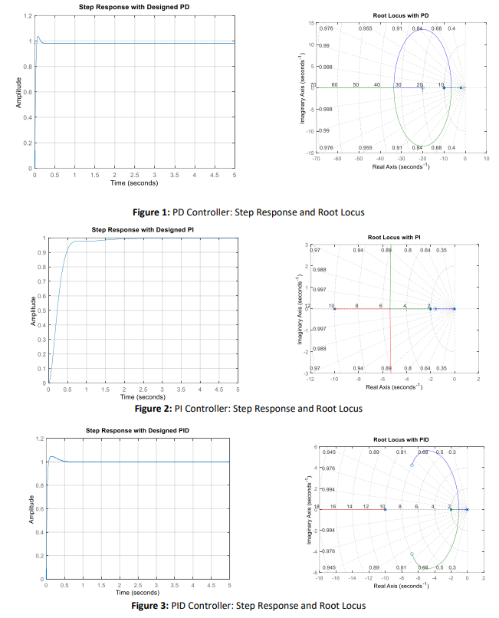

**Result:**

The simulation results demonstrate that all three controllers effectively stabilize the DC motor speed but exhibit distinct performance characteristics. The **PI controller** provides **type-1 system behavior**, eliminating steady-state error for step inputs while maintaining moderate overshoot and settling time. The **PD controller** achieves the **fastest transient response** with minimal overshoot, though it retains a small steady-state error due to the absence of integral action. The **PID controller** delivers the most **balanced performance**, combining the rapid response of the PD controller with the zero steady-state error of the PI controller. Overall, the PID configuration achieves the best trade-off between **speed, stability, and accuracy**, making it the most effective for precise DC motor speed control.

**Discussion:**

The **root-locus analysis** clearly explains the observed controller behaviors. The **PI controller** introduces a zero that shifts the dominant poles leftward, enhancing response speed while its pole at the origin ensures zero steady-state error. The **PD controller** provides a phase lead that increases damping and minimizes overshoot, though it leaves a small steady-state offset. The **PID controller** successfully integrates both effects, positioning the poles in a region that meets desired performance goals such as minimal overshoot and a settling time below 0.05 seconds. In practical applications, it is advisable to include a **low-pass filter** on the derivative term to suppress noise amplification and to perform **robustness checks**, such as parameter sensitivity analysis, to ensure stable performance under system variations.

**Conclusion:**

The **root-locus-based controller design** effectively guided the selection of PI, PD, and PID configurations for DC motor speed control. The **PI controller** eliminated steady-state error with a moderate response speed, the **PD controller** achieved high speed and strong damping at the cost of steady-state accuracy, and the **PID controller** provided the best overall performance with **low overshoot, fast settling, and negligible steady-state error**. The optimized gain values successfully met standard transient specifications, demonstrating the inherent trade-offs between **speed, damping, and accuracy** in practical control system design.

**References:**

1. K. Ogata, Modern Control Engineering, 5th ed., Prentice Hall, 2010.
2. G. F. Franklin, J. D. Powell, and A. Emami-Naeini, Feedback Control of Dynamic Systems, 7th ed., Pearson, 2014.
3. N. S. Nise, Control Systems Engineering, 7th ed., Wiley, 2015.
4. K. J. Åström and T. Hägglund, PID Controllers: Theory, Design, and Tuning, 2nd ed., ISA, 1995.

*Heaven’s light is our guide*

RAJSHAHI UNIVERSITY OF ENGINEERING AND TECHNOLOGY

**Department Of Electrical & Computer Engineering**

**Course title:**

**Control System and Robotics Sessional**

**(MTE 4118)**

**Lab Report**

**Submission Date:**

|  |  |
| --- | --- |
| **Submitted To:**  **Md. Sakib Hassan Chowdhury**  **Lecturer**  **Dept of MTE, RUET** | **Submitted By:**  **Syed Mahmudul Imran**  **Roll: 2010058** |