*Heaven’s light is our guide*

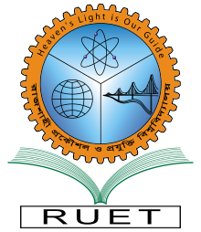RAJSHAHI UNIVERSITY OF ENGINEERING AND TECHNOLOGY

**

**Department Of Electrical & Computer Engineering**

**Course title:**

**Digital Signal Processing (ECE 4124)**

**Date of exp: 26/07/2025**

**Submission Date: 09/08/2025**

**Submitted To:**

**Md. Faysal Ahamed**

**Lecturer**

**Dept of ECE, RUET**

**Submitted By:**

**Syed Mahmudul Imran**

**Roll: 2010058**