**Exp No.: 03**

**Name of the Experiment:**

Design and Observation of CMOS Characteristics for **NAND** and **NOR** Gates

**Theory**

A CMOS logic gate is formed by a complementary pair of networks: a **pull-down network (PDN)** of nMOS devices that conducts for output $0$, and a **pull-up network (PUN)** of pMOS devices that conducts for output $1$. Series connections realize logical AND; parallel connections realize logical OR. The PUN is the dual of the PDN.

**CMOS 2-input NAND**

The Boolean function is

$$Y_{\text{NAND}}= \overline{A⋅B}$$

* **PDN (nMOS):** devices for $A$ and $B$**in series** implement $A⋅B$.
* **PUN (pMOS):** devices for $A$ and $B$**in parallel** implement $\overset{‾}{A}+\overset{‾}{B}$.  
  The output only falls when both inputs are high; for any other combination, at least one pMOS is on and the output is held high.

**CMOS 2-input NOR**

The Boolean function is

$$Y_{\text{NOR}}=\overline{A+B}$$

* **PDN (nMOS):** devices for $A$ and $B$**in parallel** implement $A+B$.
* **PUN (pMOS):** devices for $A$ and $B$**in series** implement $\overset{‾}{A}⋅\overset{‾}{B}$.  
  The output only rises when both inputs are low; otherwise at least one nMOS pulls it down.

**Truth Tables**

| **A** | **B** | $$Y_{\text{NAND}}$$ | $$Y_{\text{NOR}}$$ |
| --- | --- | --- | --- |
| 0 | 0 | 1 | 1 |
| 0 | 1 | 1 | 0 |
| 1 | 0 | 1 | 0 |
| 1 | 1 | 0 | 0 |

Key expectations include rail-to-rail swings, negligible static power, and propagation delay dominated by the longest conducting series path (NAND worst-case fall; NOR worst-case rise).

**Required Tools**

* **MICROWIND** – CMOS layout and analog simulation
* **DSCH** – schematic / logic capture (optional)
* **Word Processor** – documentation

**Circuit Diagram**

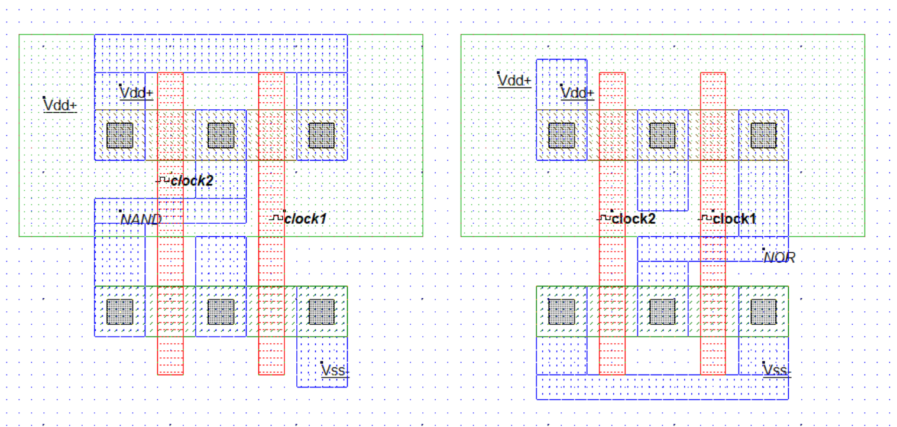

**Output**

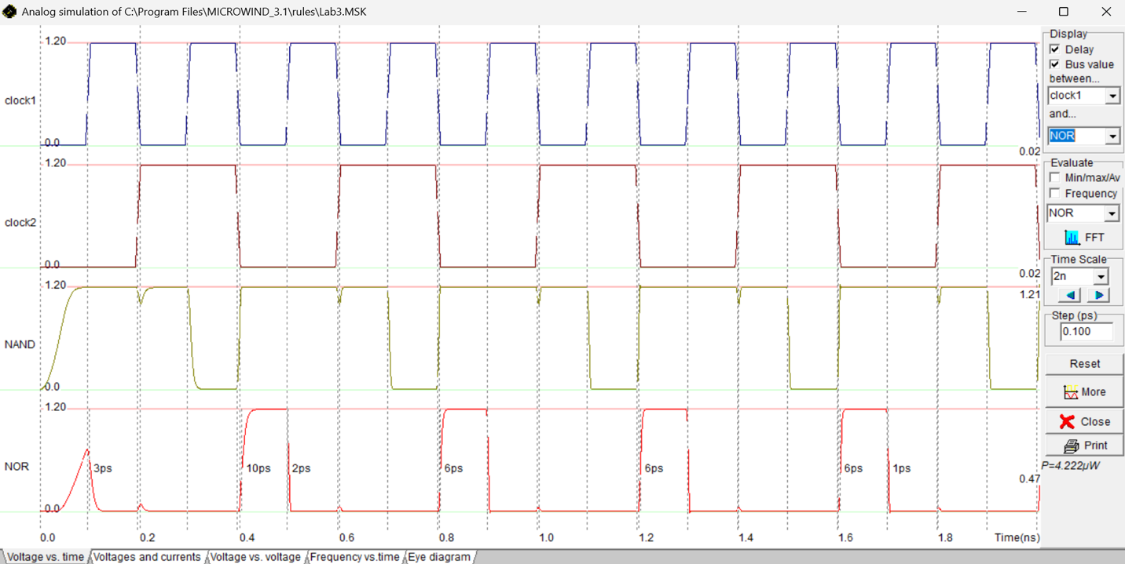

**Results**

Inputs were driven by two clocks (**clock1**, **clock2**). The displayed supply rail was approximately **1.2 V**, time scale **2 ns/div**, and simulation **step = 0.1 ps**.

* **NAND output:** stayed high except when both inputs were high, when it transitioned low—consistent with $\overline{A⋅B}$. Measured propagation-delay annotations on edges were around **3–10 ps** depending on direction and input vector ordering.
* **NOR output:** stayed low except when both inputs were low, when it transitioned high—consistent with $\overline{A+B}$. Delay markers indicated **~1–6 ps** on the shown events.
* The simulator’s power readout indicated $P≈4.222 μW$ average under the applied toggling activity.

These observations match the theoretical truth tables and the dual series/parallel topology of CMOS NAND/NOR.

**Discussion & Conclusion**

The NAND and NOR gates were realized with complementary CMOS pull-up and pull-down networks and verified in transient simulation. The outputs exhibited correct logic behavior with rail-to-rail levels, while measured delays (≈1–10 ps) reflected the expected dependence on transistor stacking: the NAND’s worst-case fall delay was larger due to series nMOS, and the NOR’s worst-case rise delay was larger due to series pMOS. The reported average power of about $4.2 μW$ confirmed low dynamic consumption and negligible static current. Hence, the CMOS implementations satisfied functional correctness and demonstrated characteristic delay asymmetries inherent to NAND/NOR structures.

**References**

1. R. J. Baker, *CMOS: Circuit Design, Layout, and Simulation*, Wiley-IEEE.
2. N. H. E. Weste and D. Harris, *CMOS VLSI Design: A Circuits and Systems Perspective*, Addison-Wesley.
3. MICROWIND/DSCH User Manuals, Microwind Inc.