1. Research Objective and Design Boundaries
The objective is not to implement three independent honeypot applications. Rather, a single generalized Additive Manufacturing (AM) honeypot framework interprets structured choices and instantiates one of several supported implementations. Reusable components include schema validation, capability checking, instance identity, lifecycle management, normalized telemetry, persistent evidence storage, and a read-only analysis dashboard. Platform-specific adapters support protocol translation and retain responsibility for starting, attaching to, and observing their respective software.
A configuration identifies already implemented capabilities. It does not automatically synthesize a complete new OctoPrint API, Klipper virtual MCU, or third-party integration. Custom functionality requires a coded and registered adapter or plugin. In managed mode, the framework owns the resources it starts; in attach mode it must preserve externally managed software.

2. Generalized Reference Architecture
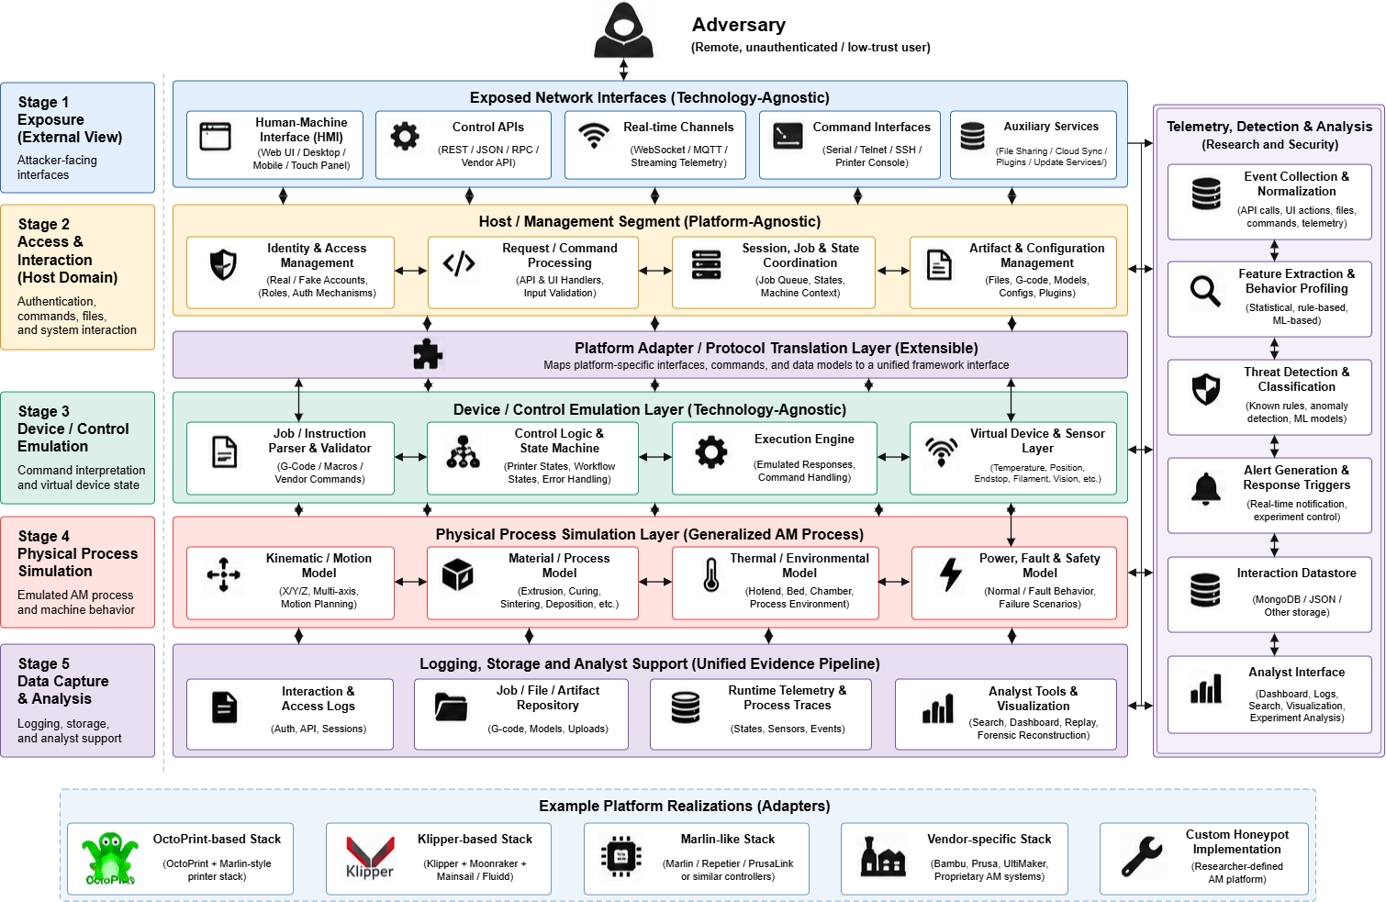
Fig. 1. Baseline architecture retained from the supplied generalized HoneyPrint diagram, reformatted in monochrome for academic presentation.
The top-to-bottom flow in Fig. 1 presents the generalized architectural view of the framework. Configuration supplies desired capabilities, while the core validates and resolves them. The architecture consists of five technical stages: exposure, access and interaction management, device and control emulation, physical process simulation, and data capture and analysis. An extensible platform adapter and protocol translation layer enables integration with different AM platforms, including OctoPrint, Klipper/Moonraker, and custom implementations. At the implementation level, four logical engines describe manufacturing workflow, exposed services, simulated physical state, and security/behavior. These are logical responsibilities rather than a requirement to launch four different processes. The resulting instance sends observations through a separate, non-blocking telemetry pipeline for collection, normalization, storage, and analysis.

2.1. AM reference-model mapping
AM process stage | Framework representation | Illustrative observable activity
1. Job intake and authorization | Workflow plugin + authorization model | Login, job submission, actor/session metadata
2. Build preparation | Artifact and preparation handlers | G-code upload, file changes, profile changes
3. Build execution | Platform adapter + printer simulator | Start, pause, cancel, temperatures, printer status
4. Post-processing | Optional equipment plugins | Wash, cure, finish process-state changes
5. Inspection and feedback | Optional quality/records plugins | Inspection queries, reports, approval events
These five stages are manufacturing lifecycle stages. They are not identical to the five technical layers of the earlier HoneyPrint architecture. A deployment may enable a subset, and the framework must report which stages are simulated versus provided natively by the real software.

3. Common Configuration and Build Procedure
schema_version: 1
instances:
- id: printer_01
platform: octoprint # octoprint | klipper | custom_lab
deployment: managed # managed | attach
printer_profile: profiles/ender3.yaml
simulation: virtual_printer
services: {web_port: 8081}
stages: [intake, preparation, execution]
telemetry:
backend: sqlite
capture_requests: true
capture_commands: true
capture_state_changes: true
All configuration values must be checked against declared adapter capabilities and a version-pinned deployment recipe. Secrets are supplied by environment references or a secret store, not embedded into example YAML. Unknown keys, port conflicts, inconsistent simulation choices, missing adapter implementations, and unsupported dependencies must fail validation before software launch.
Phase | Required operation | Output
Ask / configure | Choose platform, quantity, profile, mode and enabled services | Saved YAML and profile references
Validate | Check schema, adapter, recipe, ports, resources and capabilities | Resolved, redacted build plan
Prepare | Install or attach to approved software/runtime components | Prepared environment and setup report
Integrate | Connect simulation, platform instrumentation and collector | Connected instance
Launch / verify | Start in dependency order and prove event persistence | Health status and test evidence
Stop / restart | Respect ownership, drain queues and revalidate on config changes | Repeatable lifecycle result

4. Scenario A: Real OctoPrint Honeypot
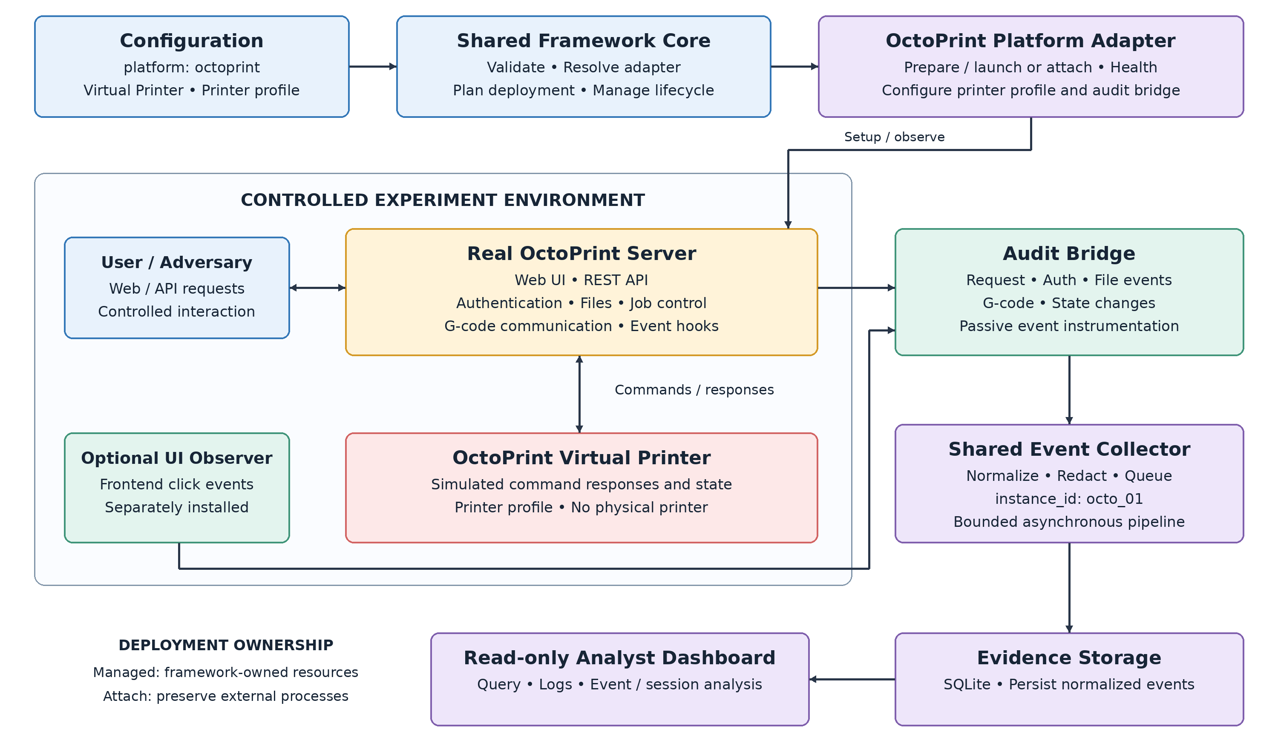
Fig. 2. Instantiation of the generalized framework when the configured platform is OctoPrint.
instances:
- id: octo_01
platform: octoprint
deployment: managed
printer_profile: profiles/ender3.yaml
simulation: virtual_printer
services: {web_port: 8081}
instrumentation: {plugin: honeyprint_audit, http: true, gcode: true}
The registry resolves the OctoPrint adapter and a validated launch recipe, then prepares the real OctoPrint server in a controlled environment. The adapter configures the virtual printer/profile and installs a framework-owned audit bridge. The normal OctoPrint web interface and API continue to handle commands; the audit bridge passively emits request, authentication, file, G-code, and state events that the implementation is able to observe. Click-level events not reflected in server requests require separately installed frontend instrumentation.
Successful validation requires a working OctoPrint UI, supported virtual printer responses, an observed test command, a persisted event tagged octo_01, and correct restart/stop behavior. Do not imply physical extrusion or measurement fidelity from the virtual printer alone.

5. Scenario B: Real Klipper / Moonraker / Mainsail Honeypot
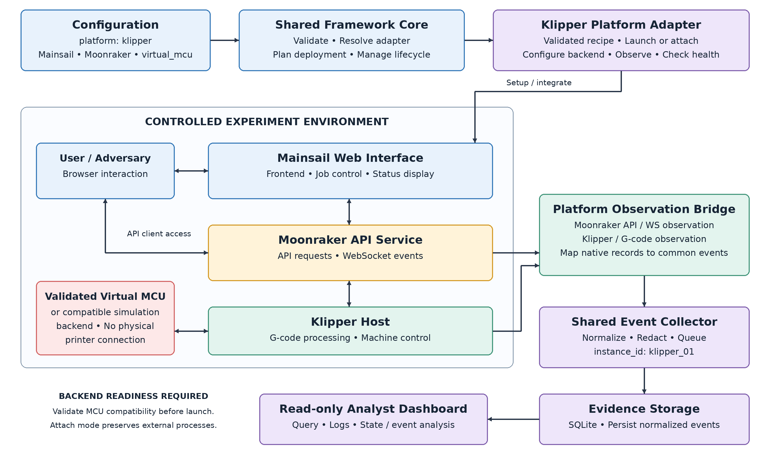
Fig. 3. Instantiation of the same framework with a real Klipper host, Moonraker API and Mainsail interface.
instances:
- id: klipper_01
platform: klipper
deployment: managed
printer_profile: profiles/voron.yaml
simulation: virtual_mcu
frontend: mainsail
api: moonraker
services: {web_port: 8082}
instrumentation: {moonraker_events: true, gcode: true}
The Klipper adapter selects a tested recipe for the three real software elements: Klipper host, Moonraker and Mainsail. These are not interchangeable with OctoPrint: Moonraker exposes an API and events, Mainsail is a frontend, and Klipper expects microcontroller communication. A compatible virtual MCU or validated simulation backend is therefore a required dependency for a hardware-free deployment, not merely a YAML flag. Its readiness should be established before reporting the honeypot healthy.
Moonraker WebSocket subscriptions, API request monitoring, and Klipper/G-code observation feed a platform bridge. The bridge maps platform-native records into the common telemetry schema. The framework should test temperature/status coherence between Mainsail, Moonraker and the simulated execution state. If a validated MCU backend is unavailable, validation must return a clear unsupported-capability result instead of claiming the stack has been successfully deployed.

6. Scenario C: Researcher-Defined Custom Honeypot
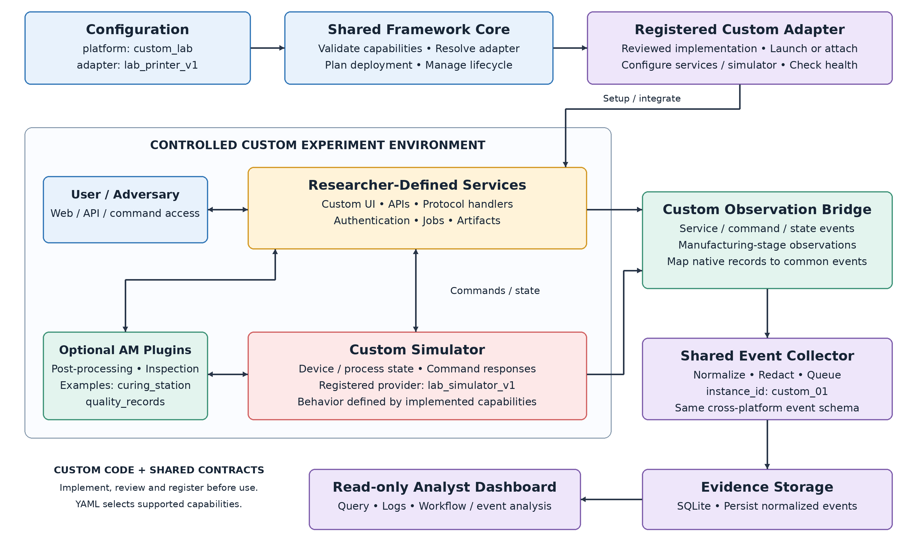
Fig. 4. Custom code instantiation: framework contracts stay fixed, while developer-owned services and simulators are replaceable.
instances:
- id: custom_01
platform: custom_lab
adapter: lab_printer_v1
deployment: managed
printer_profile: profiles/custom_lab.yaml
simulation: lab_simulator_v1
stages: [intake, preparation, execution, postprocessing, inspection]
services: {web_port: 8090}
extensions: [quality_records, curing_station]
We implements a new adapter that declares its capabilities, startup/deployment recipe, observation bridge, and optional simulator or manufacturing-stage plugins. After registration, the existing core can validate and instantiate it; the shared collector, storage format and dashboard need not be rewritten. Arbitrary Python paths or shell commands must not be executable directly from untrusted YAML; third-party plugins must be explicitly installed, reviewed, allowlisted and isolated.

6.1. Proposed adapter contract
class PlatformAdapter:
platform_id: str
def capabilities(self) -> dict: ...
def validate(self, cfg, context) -> None: ...
def prepare(self, plan) -> None: ...
def launch_or_attach(self, plan) -> object: ...
def health(self, instance) -> dict: ...
def observe(self, instance, sink) -> None: ...
def stop(self, instance, owned_only=True) -> None: ...
Extension points should separately cover PlatformAdapter, SimulatorProvider, ManufacturingStagePlugin, CameraProvider, StorageProvider, and EventNormalizer. A plugin manifest should declare identifier, API version, capabilities, supported platform/runtime versions, required permissions, health checks and test fixtures.

7. What Changes When a YAML Variable Changes?
Configuration change | Core response | Impact / limitation
platform: octoprint -> klipper | Select different registered adapter and recipe | Different real software stack; virtual MCU must be supported
printer_profile changed | Validate and apply supported model settings | Does not guarantee hardware-accurate physics
stages add postprocessing | Load registered stage plugin | Requires implemented stage behavior
simulation changed | Resolve simulator provider | Reject incompatible platform/backend pairs
instance count increased | Assign unique IDs, state, ports and volumes | Resources and per-instance logs must remain isolated
instrumentation enabled | Install or attach approved observers | Cannot promise capture of every click without UI hooks
platform: custom_lab | Resolve custom registered adapter | New code and validation tests are needed

8. Unified Observation, Storage, and Security
{
"event_id": "uuid",
"timestamp": "ISO-8601-UTC",
"instance_id": "octo_01",
"platform": "octoprint",
"source": "api|web|plugin|firmware",
"event_type": "printer.command",
"session_id": "opaque-session-ref",
"action": "start_print",
"outcome": "accepted",
"simulation": true
}
The platform bridge should be observational, minimize interference and send redacted events to a bounded asynchronous queue. A collector authenticates producers, validates the schema, deduplicates where appropriate, and writes to a selected backend (SQLite for first prototype; optional MongoDB/JSON adapters later). Queue admission is not durable persistence: end-to-end verification must read the stored event back. Health reporting must surface dropped records, backpressure and instrumentation outages.
Deploy honeypots on isolated networks with explicitly approved exposed ports, blocked physical device passthrough, constrained container privileges and outbound network policy. Uploaded artifacts must be inspected and stored without automatic execution. Separate real credentials from decoy accounts; do not record real passwords in clear text. Attach mode must not stop or overwrite existing platform processes.

9. Suggested Repository Layout
honeyprint/
configs/ # YAML and versioned profiles
core/ # schema, registry, planner, lifecycle, health
adapters/
octoprint/ # real OctoPrint recipe and audit bridge
klipper/ # Klipper/Moonraker/Mainsail recipe and observer
custom_lab/ # example custom adapter
simulators/ # virtual printer, MCU provider, physical models
manufacturing/ # five AM-stage plugins
telemetry/ # collector, normalized schema, writers
dashboard/ # read-only exploration/export
recipes/ # pinned software stack definitions
tests/ # contracts, integration and isolation tests

10 Implementation Logic and Verification
This chapter explains how configuration becomes an operating honeypot, how components exchange control and evidence, and how failures are handled. Sections 1–9 provide the reference design; the paths and identifiers below describe the supplied implementation. Platform behaviour is documented from source inspection. The measured verification scope is stated in Section 10.10.

10.1 Startup and control flow
run.sh prepares the core Python environment and pinned PyYAML and Paramiko dependencies, then invokes quickstart.py. Unless --config supplies explicit YAML, quickstart calls read_env() and build_config() in deployment/env_config.py. It validates the result, checks the runtime lock and ports, and calls deployment/bootstrap.py::install_selected() for selected platform dependencies. It then starts main.py run with the resolved configuration. A successful dependency build alone does not establish readiness.
Fig. 5. Launcher control flow. The analyst UI is optional; platform observers feed the separate pipeline in Fig. 6.
main.py creates the registry and FrameworkRuntime. core/runtime.py resolves plans, builds instances, opens storage and coordinates lifecycle controllers. quickstart waits for newly persisted start events for the expected instance IDs, then starts the analysis watcher and optional dashboard. Health degradation, child-process exit or termination requests lead to coordinated shutdown.

10.2 Configuration selection and precedence
read_env() accepts known literal key/value pairs, rejects duplicate or unknown keys, and performs no shell execution or variable interpolation. Process environment values override the selected .env file. Explicit launcher options override corresponding generated launcher settings; --config bypasses .env conversion entirely. Thus an exported HONEYPRINT_PLATFORM can override an edit in .env, and an explicit YAML launch does not use that file to select its platform.
build_config() maps HONEYPRINT_PLATFORM to configs/instances/octoprint.yaml, klipper.yaml, custom.yaml or all.yaml. It loads the printer profile, applies geometry overrides, revalidates the profile, and writes temporary profile.yaml and config.yaml files under .honeyprint/launch/. This translates environment choices into the same YAML interface used by the core. Single-platform mode overrides the selected YAML web port with HONEYPRINT_PORT, defaulting to 8081. The all selection rejects a single port or instance-ID override.
With custom selected, the default is custom_lab with lab_sim. HONEYPRINT_CUSTOM_CODE changes the instance to platform custom with custom_process. HONEYPRINT_CUSTOM_API_URL instead selects custom_api and attach mode; both selections clear manufacturing stages. Specifying code and API together is rejected. Configuration chooses registered behaviour; it cannot create a missing protocol implementation.

10.3 Worked platform switching example
Start with HONEYPRINT_PLATFORM=octoprint and HONEYPRINT_PORT=8081. The resulting instance selects OctoPrintAdapter, virtual_printer and the octoprint_managed recipe. To switch, stop the current run with Ctrl-C, wait for cleanup, change only the platform value to klipper, and run ./run.sh again. Configuration is read at startup; there is no file watcher or live reload.
Table 10.1. Decisions after a restart with the common port unchanged
Setting or result | OctoPrint selection | Klipper selection
Configuration / default ID | octoprint.yaml / octo_01 | klipper.yaml / klipper_01
Adapter / recipe | OctoPrintAdapter / octoprint_managed | KlipperAdapter / klipper_managed
Simulator / web interface | virtual_printer / OctoPrint UI | avr_sim / Mainsail
Address / evidence | 127.0.0.1:8081 / events.sqlite3 | 127.0.0.1:8081 / same database if runtime directory is unchanged
The interface changes because a different software stack now serves the selected port. The common validator, lifecycle and evidence contracts remain applicable. Keeping HONEYPRINT_RUNTIME_DIR unchanged retains earlier SQLite records, distinguished by instance and platform identity; it does not migrate native jobs or printer state. Klipper requires Docker and verified Mainsail assets, so missing dependencies can prevent the new selection from starting.

10.4 Validation and adapter resolution
core/config_loader.py parses YAML safely; core/validator.py checks schema, identities, ports, references and requested adapter capabilities. create_builtin_registry() in core/builtin_registry.py registers trusted factories. resolve_dependencies() resolves platform_adapter using the explicit adapter field or platform ID, constructs the adapter, and selects an explicit recipe or the adapter’s deployment-mode recipe. It checks platform/mode/simulator agreement, version pins, profile availability and registered dependencies, then freezes the plan. Factories for adapter and recipe metadata must have no launch side effects.
core/instance_builder.py rejects duplicate identities, shared adapter objects and port conflicts while creating separate state/resource records. Validation rejects inconsistent requests; planning resolves dependencies without starting services. Runtime checks still need to prove interpreter versions, backend communication and health. Pin metadata is therefore a reproducibility input, not evidence that deployment succeeded.

10.5 Platform implementation and communication
OctoPrintAdapter uses deployment/environment_manager.py to prepare an owned basedir, profile and credentials and start the pinned server with Virtual Printer. audit_plugin.py forwards bounded request metadata, command identifiers and native events through an authenticated local channel. Health checks include printer communication and observer health. Attach mode instead polls an existing server with an API key; it neither installs the audit plugin nor reconnects the printer, and HTTP/G-code audit flags are unsupported.
KlipperAdapter uses deployment/klipper_environment.py and the Docker recipe to run Klipper, Moonraker and compiled AVR firmware through SimulAVR. HTTP and WebSocket bridges expose selected native APIs and verified Mainsail assets; uploads are retained as evidence before forwarding to native virtual SD. Completion is obtained from native state/notifications. Command submission alone cannot prove that every uploaded line executed. Host service control and arbitrary file upload are excluded from the exposed bridge.
The built-in LabAdapter runs a local HTTP printer model. CustomProcessAdapter launches a trusted Python backend on a private port and exposes a bounded evidence proxy on the configured public port. CustomAPIAdapter instead proxies an existing HTTP(S) service and checks its health endpoint. Only the local bridge is owned in API attach mode. These mechanisms reuse event storage while preserving different backend ownership and protocol semantics.

10.6 Lifecycle ownership and failure recovery
LifecycleManager calls validate → prepare → launch_or_attach → observe → health. StateManager permits planned → preparing → prepared → starting → running, followed by stopping → stopped; failed instances require cleanup before another preparation. Running is not equivalent to ready: the adapter must return boolean health, and FrameworkRuntime must commit and read back a lifecycle start event before announcing readiness.
A returned handle declares owned_platform_resources; attach mode rejects a handle claiming platform ownership. stop() calls adapter.stop(owned_only=True), or cleanup_prepared() if preparation occurred without a handle. Failed cleanup retains recovery state/handles for retry; an adapter failure before returning a handle cannot be treated as proven cleanup. Ctrl-C or the authenticated local stop channel triggers manufacturing-service closure, reverse-order controller cleanup and final telemetry drain. Pending evidence or cleanup errors produce failure rather than a clean-stop report.

10.7 Manufacturing and simulation logic
plugins/simulators/printer.py parses the supported G-code subset into a detached candidate state and commits it only after successful execution; rejected commands leave the original state unchanged. Motion uses feedrate and elapsed time, thermal models approach targets, extrusion checks temperature and filament availability, and sensor faults can reject movement. M112 disables motion/heaters. These models implement bounded software behaviour, not calibrated printer physics.
plugins/manufacturing/pipeline.py requires an ordered stage prefix: job_intake, build_preparation, build_execution, post_processing and inspection. Intake bounds and hashes G-code; preparation preflights a copy; execution applies commands; post-processing cools the model; inspection reports process consistency. Accepted artifacts are retained with hash, quota and integrity checks. The custom HTTP job endpoint has its own simulation. core/manufacturing_service.py provides a trusted shadow API for other instances; it does not send those commands to OctoPrint, Klipper or hardware, and native configurations enable no stages by default.

10.8 Observation storage and analysis
Fig. 6. Evidence flow. Queue admission and dequeue precede durable database persistence.
The runtime sink applies capture flags before telemetry/normalizer.py supplies instance identity, UUID and UTC timestamp, validates metadata and redacts recognized credential keys. core/event_bus.py detaches records and rejects new arrivals when full while counting drops. telemetry/collector.py keeps a failed batch for retry before consuming more events. sqlite_storage.py commits batches atomically, deduplicates identical retries and rolls back conflicting event IDs. Queue and pending-batch memory do not survive process loss; graceful drain and stored-event readback are explicit checks. The optional SSH companion follows the same normalized event schema but persists through its own SQLiteStorage connection after the framework is ready; it does not enter the core EventBus queue shown in Fig. 6.
FrameworkRuntime monitors drops and adapter health and initiates cleanup on degradation. artifact_storage.py stores accepted G-code separately under content hashes, rejecting quota or integrity violations. telemetry/analysis/rules.py identifies observations such as 401/403, unknown endpoints, M112 and rejected commands; findings describe indicators, not proven attacks. The watcher writes derived alerts separately. dashboard/server.py reads evidence/alerts with filters and pagination and rejects writes, preserving raw evidence for later review.

10.9 Extensions source builds and security boundaries
For a trusted HTTP entry file, select custom and set HONEYPRINT_CUSTOM_CODE; examples/custom_server.py shows the contract. The backend binds HONEYPRINT_HOST/HONEYPRINT_PORT, receives HONEYPRINT_PROFILE_JSON and echoes HONEYPRINT_INSTANCE_TOKEN as X-HoneyPrint-Instance on its health endpoint. For an existing API, set HONEYPRINT_CUSTOM_API_URL and the health path instead. A new protocol requires a PlatformAdapter implementation plus registered capabilities, recipe and observation mapping. sdk/extensions.py validates api_version, name and plugins in the manifest; each plugin entry declares kind, id and factory. Registry collisions are rejected before registration; YAML does not import arbitrary code.
deployment/local_sources.py hashes and snapshots trusted source folders into separate build caches; bootstrap builds the selected version without editing the original folder. The optional source_camera.py helper is owned and health-checked, but video playback is independent of printer state. Trusted builds/custom Python are not sandboxed by registration. Keep credentials private, constrain network exposure and uploaded artifacts, and replace the packaged local admin/admin credential before any wider exposure. These are deployment conditions, not guarantees supplied by a config flag.

10.10 Common environment controls
The local .env file holds settings shared by whichever platform is selected. deployment/env_config.py::read_env() accepts only named literal keys and rejects duplicates; build_config() merges the selected platform YAML, resolves the common profile, validates runtime settings and writes a temporary instance configuration. A process environment value overrides the corresponding .env value. Changes become effective only after stopping the current run and starting ./run.sh again. The table abbreviates variable names by omitting their common HONEYPRINT_ prefix.
Common group | .env suffixes | Effect after restart
Selection and network | PLATFORM, PORT, INSTANCE_ID | Selects one adapter and the shared HTTP address; SSH has its own port.
Printer identity and geometry | PRINTER_NAME, PROFILE, WIDTH, DEPTH, HEIGHT, NOZZLE, HEATED_BED | Builds and revalidates the shared printer profile before the adapter starts.
Evidence and artifacts | RUNTIME_DIR, EVIDENCE_DB_NAME, ANALYSIS_DB_NAME, ARTIFACT_DIR, ARTIFACT_MAX_* | Selects the database and retained G-code locations and bounds storage; old evidence is not moved automatically.
Ingress and observation | UPLOAD_MAX_BYTES, REQUEST_MAX_BYTES, CAPTURE_* | Limits supported upload and request bodies and selects observation categories; lifecycle events remain mandatory.
Simulation options | PREHEAT_HOTEND_C, PREHEAT_BED_C, CAMERA_ENABLED, CAMERA_SOURCE | Supplies supported preheat presets and the managed OctoPrint camera; these do not create new hardware models.
Analysis and SSH | ANALYSIS_ENABLED, ANALYST_ENABLED, DASHBOARD_PORT, SSH_ENABLED, SSH_HOST, SSH_PORT, SSH_USERNAME, SSH_PASSWORD | Controls the local analysis UI and optional SSH companion; keep credentials out of Git.
The common template keeps SSH disabled by default. On the current Desktop deployment, .env selects Klipper, HTTP port 8084 and the loopback SSH port 2223; Docker already occupies 2222. The SSH username and password are configurable, but the document deliberately does not reproduce the private password value.

10.11 OctoPrint platform YAML
configs/platforms/octoprint.yaml is loaded only for HONEYPRINT_PLATFORM=octoprint (or the advanced all selection). Its source field chooses the trusted local OctoPrint tree, and python optionally selects a compatible interpreter; blank values use the framework-managed release and interpreter. These fields are separate from common .env identity, evidence and port controls.
The validated settings.appearance group controls native color and Fahrenheit display. settings.virtual_printer controls the simulated firmware identity and serial behavior: firmwareName appears in M115, while throttle, sendWait/waitInterval, rxBuffer, commandBuffer, supportM112, echoOnM117, sendBusy/busyInterval, simulateReset and okBeforeCommandOutput alter the corresponding Virtual Printer responses. deployment/octoprint_settings.py rejects unknown names, wrong types and values outside documented bounds before startup. The shared profile still supplies build volume, nozzle and heated-bed properties. Editing this YAML does not change Klipper or custom instances; restart applies accepted changes.
OctoPrint group | Fields within group | Effect after restart
Source and runtime | source, python | Selects the trusted OctoPrint source tree and optional compatible Python interpreter.
settings.appearance | color, showFahrenheitAlso | Changes the native UI accent color and whether Fahrenheit temperatures also appear.
Firmware identity | firmwareName (virtual_printer) | Changes the virtual firmware name reported by M115; the common printer name stays in .env.
Serial timing | throttle, sendWait, waitInterval, sendBusy, busyInterval | Controls simulated response pacing and optional idle wait or busy messages.
Serial buffers | rxBuffer, commandBuffer | Sets the virtual serial receive buffer and queued command capacity.
Command behavior | supportM112, echoOnM117, simulateReset, okBeforeCommandOutput | Controls emergency-stop support, display echo, connect-time reset and response order.

10.12 Klipper platform YAML
configs/platforms/klipper.yaml is loaded only for HONEYPRINT_PLATFORM=klipper (or all). The source field identifies the trusted Klipper source tree. settings.motion defines global and Z velocity/acceleration limits; settings.steppers defines X, Y and Z microsteps and rotation distances; settings.extruder defines drive calibration, filament diameter and extrusion-temperature bounds; settings.heated_bed sets its maximum temperature when the common profile enables a bed.
deployment/docker/klipper/settings.py checks numeric ranges, power-of-two microsteps and cross-field limits before the adapter generates the owned container's native printer.cfg. The common .env still supplies the public port, printer name/profile, preheat preset and evidence paths. These numeric settings change the virtual Klipper configuration; they do not calibrate the physical process model or modify OctoPrint. A restart is required, and a changed native configuration can require the isolated image to rebuild.
Klipper group | Fields within group | Effect after restart
Source | source | Selects the trusted Klipper source tree used for the managed backend.
settings.motion | max_velocity, max_accel, max_z_velocity, max_z_accel | Sets overall and Z-axis speed and acceleration bounds in the generated printer.cfg.
settings.steppers.x/y/z | microsteps, rotation_distance | Sets per-axis step resolution and travel per motor revolution.
settings.extruder drive | microsteps, rotation_distance, filament_diameter | Sets extrusion drive resolution and filament size in the native configuration.
settings.extruder thermal | min_extrude_temp, max_temp | Sets the minimum extrusion and maximum hotend temperatures.
settings.heated_bed | max_temp | Sets the bed temperature ceiling when the common profile enables a heated bed.

10.13 SSH printer-console decoy and verification
SSH is an optional common companion, not a platform adapter. .env controls SSH_ENABLED, SSH_HOST, SSH_PORT, SSH_USERNAME and SSH_PASSWORD. run.sh prepares pinned Paramiko; deployment/env_config.py validates the values; quickstart.py checks for one selected instance and a free SSH port. After core readiness, it launches services/ssh_decoy.py and owns its shutdown. A private 3072-bit RSA host key persists under the runtime directory.
The service accepts the configured decoy password and supports interactive or single-command sessions. help, status, M105, M115, ls, pwd, whoami and exit return fixed simulated responses; no host shell runs. It normalizes ssh.auth, ssh.session and ssh.command records for the selected instance and writes them to events.sqlite3 through telemetry/sqlite_storage.py. Username and command name are retained, while login passwords and command arguments are omitted. This separate SQLite connection bypasses the core EventBus shown in Fig. 6.
For the current local run, execute ./run.sh, then ssh -p 2223 admin@127.0.0.1 in another terminal using the password in .env; HTTP remains at http://127.0.0.1:8084. Ctrl-C stops both listeners. Verification covered accepted/rejected login, interactive and single-command replies, shared-database evidence, shutdown, 24 startup/configuration tests, and a bounded Klipper run reporting web and SSH readiness. These checks establish decoy behavior, not real printer control.

10.14 Telnet printer-console decoy and verification
Telnet is a second optional companion rather than a new platform adapter. The common .env controls TELNET_ENABLED, TELNET_HOST, TELNET_PORT, TELNET_USERNAME and TELNET_PASSWORD. deployment/env_config.py validates these values; quickstart.py rejects conflicts with the selected HTTP service, analyst dashboard and SSH port, then starts services/telnet_decoy.py after framework readiness. The default listener is 127.0.0.1:2323 and remains disabled until TELNET_ENABLED=true. Its lifecycle is owned by the launcher, so Ctrl-C closes the listener.
The service handles Telnet negotiation and a bounded input line, allows at most three password attempts per connection and never starts a host shell. It returns fixed virtual-printer replies for help, status, M105, M115, ls, pwd, whoami and exit. The service normalizes telnet.auth, telnet.session and telnet.command events and writes them to the selected shared events.sqlite3 through telemetry/sqlite_storage.py. Login passwords and command arguments are omitted from evidence. Telnet carries credentials without encryption; loopback binding confines the default listener to the local computer.
For manual verification on the current Desktop project, run HONEYPRINT_TELNET_ENABLED=true ./run.sh; in another terminal run telnet 127.0.0.1 2323, log in with the configured credentials and try help, status, M105 and exit. The default credentials are admin/admin unless locally overridden. tests/test_telnet_decoy.py additionally checks failed and successful login, fixed command responses, shared-database records and launcher shutdown. These checks demonstrate the decoy console, not real printer control.

