Ansible-Tutorial
Ansible- List of service going to see
- yum
- service
- copy -file src, dest
- file – create directory, state:absent, present,directory

lineinfile -regexp
name: Replace a localhost entry with our own
lineinfile:
path: /etc/hosts
regexp: '^127\.0\.0\.1'
line: 127.0.0.1 localhost
owner: root
group: root
mode: '0644'
- name: Make sure group wheel is not in the sudoers configuration
lineinfile:
path: /etc/sudoers
state: absent
regexp: '^%wheel'

- notify -> when there is any change here it will call the handler para
Eg:
tasks:
- name: “Install httpd”
yum:
name: httpd
state: absent
notify:
- remove the index file
handlers:
- name: remove the index file
file:
src: /var/www/html/index.html
state: absent

- name: Recursively find /tmp files older than 2 days
find:
paths: /tmp
age: 2d
recurse: yes
To print the message while running
# Example that prints the loopback address and gateway for each host
- debug:
msg: System {{ inventory_hostname }} has uuid {{ ansible_product_uuid }}

- debug:
msg: System {{ inventory_hostname }} has gateway {{ ansible_default_ipv4.gateway }}
when: ansible_default_ipv4.gateway is defined

# Example that prints return information from the previous task
- shell: /usr/bin/uptime
register: result

To check the syntax of the playbook
- ansible-playbook yum.yml –syntax-check

to be checked.
Ssh
facts
debug
Tags
roles
loop
handler and Notifications
Ansible Dynamic inventory
Ansible Template
Ansible Jinja template
Ansible variables
with_items

---
- name: Httpd Install
hosts: web
remote_user: root
become: true

tasks:
- name: "install HTTPD"
yum:
name: httpd
state: present
- name: "Start Service"
service:
name: httpd
state: started
- name: "Copy html file to web folder"
copy:
src: /root/index.html
dest: /var/www/html/index.html

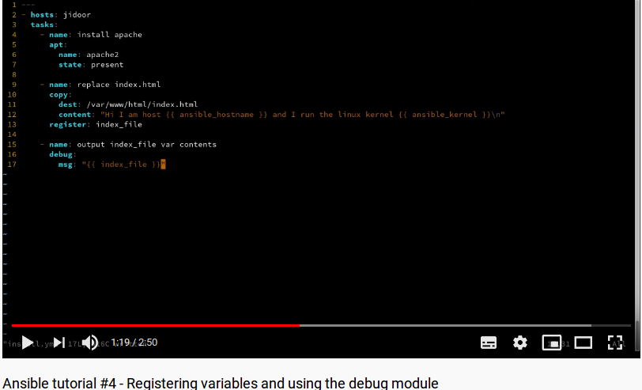
Ansible Register:
Register is used to register or store the output of some task as variables and it cane be viewed in console as debug:msg

