**Curriculum vitae**

**IMRAN HOSSEN BAPPY**

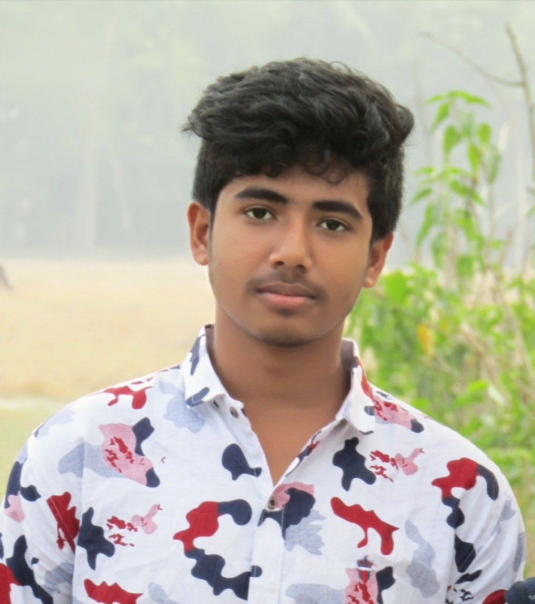

Address :Mathbaria,pirojpur

Phone :01724825061

Email :mbbappy84759@gmail.com

Facebook :Imran Hosen Bappy

Objective

Clothing designer with industry experience in women’s, men’s and children swear . Highly self motivated

And results driven. Take a keen interest in current trends and have a passion for all things fashion

And clothing related. Fast and effective. I want to be a part of your success by offering high motivation ,

Responsibility, quality work and keeping deadlines. I am working with following software: wilcom es 1.5 ,melco design shop v9, Corel Draw X6,,adobe Photoshop CS5.1 Adobe Illustrator CS5. I am using high quality fonts fgern.

Education

Exam :SSC

Session :2018-2019

Institution :K.M. LATIF Institution, Mathbaria

Board :Dhaka

Result :4.85

Exam Diploma in computer engineering

Session :2019-2020

Institution : Mangrove institute of science and technology

Board :Josser

Result :A+