Workspace Set Up

October 10, 2015

Table of Contents

Dictionary of Terms 3

Introduction 4

Tools and Components 4

JDK1.7 (Ignore if already configured) 4

Apache Maven 3 (Ignore if already configured) 4

Eclipse (Ignore if already configured) 6

Selenium2 6

Cucumber 6

Serenity (Formerly Thucydides) 7

ChromeDriver 7

Firefox browser, Firebug, Firepath 7

Final Configuration & Execution: 7

# Dictionary of Terms

|  |  |
| --- | --- |
|  |  |
|  |  |
|  |  |
|  |  |
|  |  |
|  |  |
|  |  |
|  |  |
|  |  |
|  |  |

# Introduction

The objective of this document is to describe the workspace of test automation and how to set it up in a develop environment.

# Tools and Components

To set up your workspace for developing and implementing test cases in proposed POC, you need following:

* JDK 1.7
* Apache Maven 3
* Eclipse as IDE
* Selenium2
* Cucumber, as the methodology used in testing
* Serenity for reporting
* Chromedriver
* Firefox browser, Firebug, Firepath

## JDK1.7 (Ignore if already configured)

Java is needed for this POC.

You can download JDK7 from [Java SE Development Kit 7u25](http://www.oracle.com/technetwork/java/javase/downloads/jdk7-downloads-1880260.html). (Or the latest version)

JDK is used in both development machine and JVM.

Create an environment variable “JAVA_HOME”. This environment variable should have the path to the maven.

## Apache Maven 3 (Ignore if already configured)

We use maven for building and executing test cases in POC. To install maven,

* Download the binary or zip file from [here](http://maven.apache.org/download.cgi)
* Install it.
* Create an environment variable called “M2_HOME”. This environment variable should have the path to the maven.
* Configure the system path to include maven
* Open a terminal and enter *mvn –v*. It shows the version of maven, if it is installed and configured properly.

Following screenshots illustrates above steps.

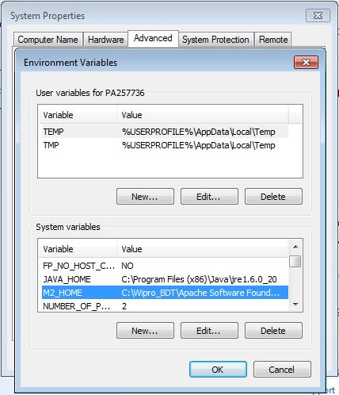

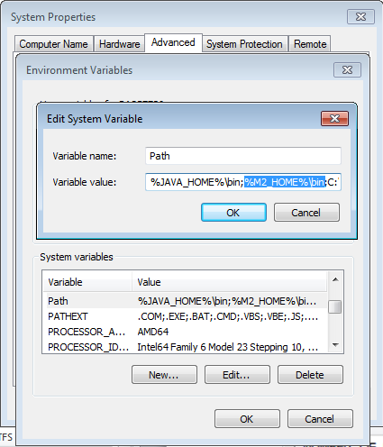

## Eclipse (Ignore if already configured)

Download and install the right version of eclipse from <http://www.eclipse.org/downloads/>.

Install maven plugin “m2eclipse”, if it is not installed. maven is used for building and executing Test Automation program. You can get m2eclipse from [here](http://eclipse.org/m2e/download/).

## Selenium2

Selenium2 (WebDriver) is the main component for testing websites in the automated test system. There is no need to download Selenium2 as it will be downloaded by Thucydides and Jbehave plugins.

## Cucumber

Cucumber JVM is the test framework that supports behaviour driven development in BDPOC project.

These jar files will be downloaded automatically by maven.

## Serenity (Formerly Thucydides)

Thucydides (Thoo-SID-a-dees) is a tool designed to make writing automated acceptance and regression tests easier. It provides features that make it easier to organize and structure your acceptance tests, associating them with the user stories or features that they test. As the tests are executed, Thucydides generates illustrated documentation describing how the application is used based on the stories described by the tests.

All necessary jar files will be downloaded by POM.xml.

## ChromeDriver

You need chromedriver in your path file, when you want to test using chrome browser. Get the latest version of [chromedriver](http://code.google.com/p/chromedriver/downloads/list) and put it in C:\Windows\System32.

## Firefox browser, Firebug, Firepath

Install [Mozilla Firefox](http://www.mozilla.org/en-US/firefox/new/) then install Firebug and Firepath Add-ons.

## Final Configuration & Execution:

If this is the first time, start from here:

Extract the project from the Zip files and place it any location.

Change the extensions of run.txt and run_Whisper.txt to .bat

Place the “settings.xml” file in C:\Users\<YourUserName>\.m2

Open the settings.xml and edit proxy information. Leave it if proxy is not required.

Open command prompt and go to the project location.

Execute the following command:

mvn clean install –Dwebdriver.driver=chrome –Dwebdriver.base.url=”http://au.whispir.com”

This will download all the requisite jars. If the build fails, resolve the issues and re-run the command until you get BUILD SUCCESS

If this is not the first time then start from here:

Open AcceptanceTestSuite in project folder and add the tags of the features that you want to run.

Open run_Whisper.bat file and enter/change Base URL, Browser if required.

Open command prompt, run the run_config.bat file and execution will start.