Introduction:

**Prolog** is a general-purpose logic programming language associated with artificial intelligence and computational linguistics.

* **Pro**gramming in **Log**ic
* Declarative language
* Emphasis on what rather than how
* It is widely used in the field of AI

Problem in Declarative Form

Basic Machine

Logic Machine

How to download Prolog software:

SWI-Prolog:

* SWI-Prolog offers a comprehensive *FREE SOFTWARE* Prolog environment.
* Link for downloading:

<http://www.swi-prolog.org/download/stable>

* A Self-installing executable for MS-Windows: **swipl-win.exe**
* Works on Windows XP and windows 7

LINUX versions are also available

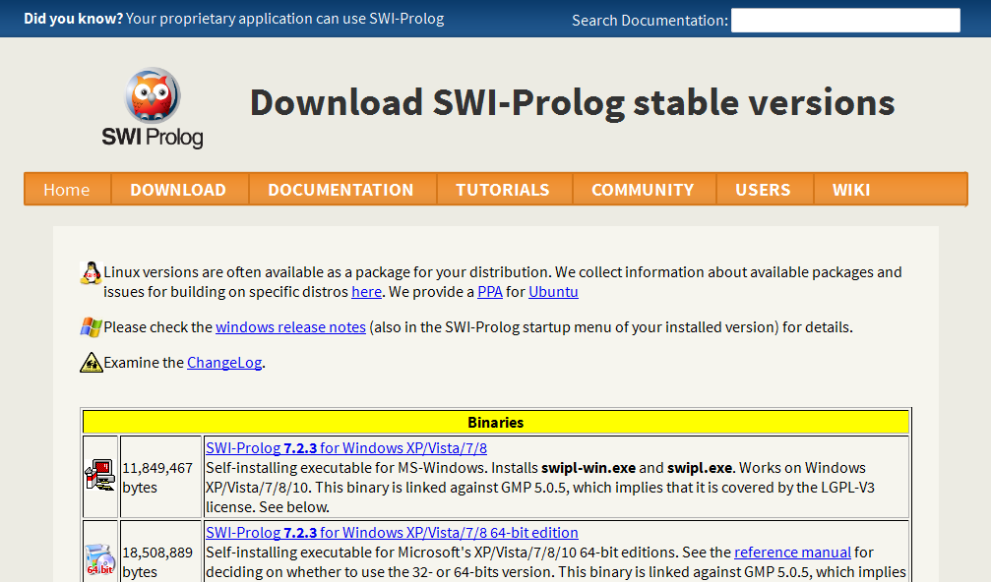

How to Install Prolog Software on our Local machine:

After download the link above Prolog Software and save our local pc any folder.

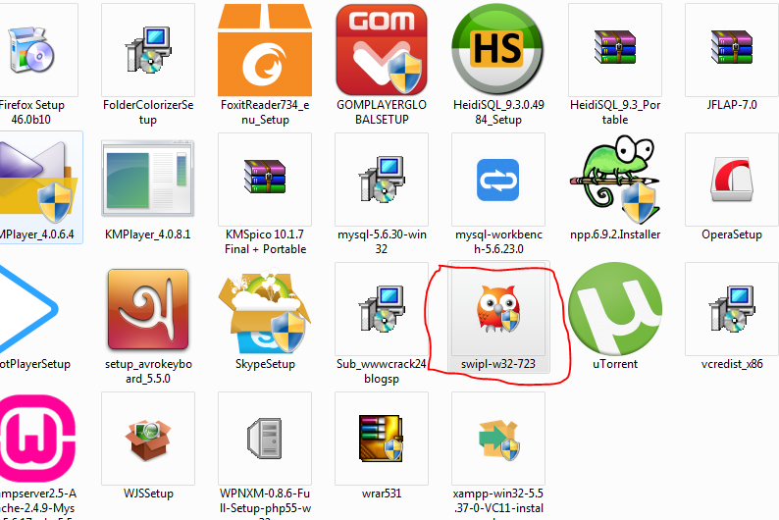Then open our root directory when save our file and click red color icon show.

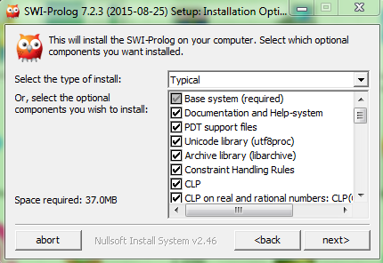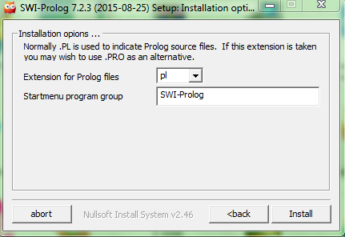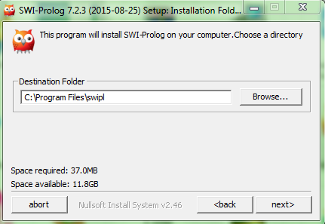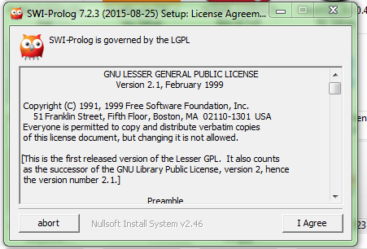

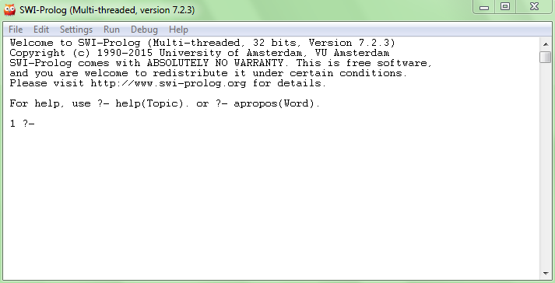After Installing the Prolog Software Now, we can see prolog software icon start menu bar and click the icon for prolog s/w.

Examples:

|  |  |
| --- | --- |
| **Predicate** | **Interpretation** |
| valuable(gold) | Gold is valuable. |
| owns (john, gold) | John owns gold. |
| father (john, Mary) | John is the father of Mary |
| gives (john, book, Mary) | John gives the book to Mary |

Reference:

* [www.**swi-prolog**.org/](http://www.swi-prolog.org/)
* <http://www.learnprolognow.org/>‎