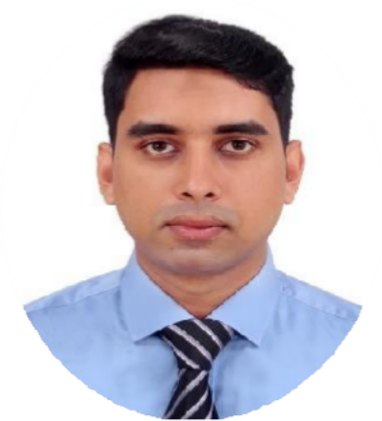
Md.Imran Ahmed

About

CONTACT ME

01626759580

imranicon01@gmail.com
I am excited to embark on a rewarding journey as a Software Engineer, harnessing my keen eye for detail, strong analytical skills, and systematic approach to problem-solving any software. My passion lies in ensuring the highest quality of software products by meticulously testing and validating every aspect of their functionality. I prosper on collaborating with diverse teams to deliver flawless results and exceed client expectations. My primary goal is to contribute to the success of a dynamic organization, while also advancing my expertise in manual testing and making a positive impact on the software development process.

Personal Interest

Babur Jayga,Khilgaon,Dhaka- 1219
Technology and Innovation Travel and Exploration
Fitness and Outdoor Activities Football,Cricket

SKILLS

Management: Agile,Change Management,Leadership, Communication,Mentorship

Technical Languages: C#,PHP,JavaScript,TypeScript, Python,SQL,HTML,CSS

Technologies :
Visual Studio Code 2019,RStudio,Weka,NetAcad

WORK EXPERIENCE

Software Engineer,Sonali BankPLC,Malibagh-Dhaka
October 2024-January2025
- Worked as a Software Engineer at Sonali Bank, specializing in the development and maintenance of CBC (Core Banking Solution) software.
- Handled system updates, bug fixes, and integration of new banking features to improve service efficiency.
- Collaborated with cross-functional teams to ensure software reliability, security, and compliance with banking regulations.

Projects
  - Book Borrowing Management System
Platform : Web Technology:HTML,CSS,JavaScript,AJAX, MySQL,MVC
Link:https://github.com/imrancaptain/Project
/

  - Metrorail-Station Management System
Platform:C# Technology:.Net
Link:https://github.com/imrancaptain/Project
/

Education
B.Sc in Computer Science and Engineering American International University- Bangladesh 2020- 2025 || CGPA : 3.17

Higher Secondary Certificate (HSC)
Quality Education College 2017 || GPA : 4.42

Secondary School Certificate (SSC)
Dakhin Banasree.M.High School 2015 || GPA: 4.72

REFERENCES

TOHEDUL ISLAM
Department Head of Computer Science, American International University Bangladesh Email: islamtohedul@aiub.edu

SYED NAFIUL SHEFAT
Department Head of Computer Science, American International University Bangladesh Email: nafiul.shefat@aiub.edu

