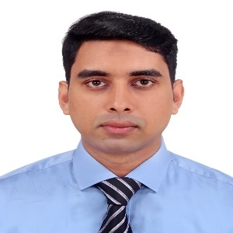
EDUCATION
- Reading,Technology and Innovation
- Travel and Exploration
- Sports
HOBBIES
Sc. in Computer Science and Engineering
American International University-Bangladesh
Graduated: 2025
Higher Secondary Certificate(HSC)
Quality Education College
2017
Secondary School Certificate(SSC)
Dhakin Banasree.M.High School
2015
2

Graduated: 2025

Md.Imran Ahmed
EXPERIENCE
Customer Service Officer
WeTechHub(Dhaka) 2026 – Present
- As a Customer Relationship Officer at WeTechHub, I manage and update customer data using CRM software to ensure accurate records and smooth communication.
- I handle inbound and outbound calls to assist clients, resolve queries, and maintain strong relationships.
- Additionally, I follow up with customers regarding services, provide support, and coordinate with internal teams to improve customer satisfaction.
Software Engineer
RS Apparels(Dhaka) 2025 – 2026
- Designed, developed, and maintained responsive web applications.
- Worked with front-end technologies such as HTML, CSS, JavaScript, and PHP/Laravel. Collaborated with cross-functional teams to develop new features and resolve technical issues. Optimized website performance and implemented best coding practices.
- Integrated APIs and improved user experience across platforms.

Software Engineer
Sonali Bank PLC(Dhaka) 2024-2025
- Worked as a Software Engineer at Sonali Bank, specializing in the development and maintenance of CBC (Core Banking Solution) software.
- Handled system updates, bug fixes, and integration of new banking features to improve service efficiency.
- Collaborated with cross-functional teams to ensure software reliability, security, and compliance with banking regulations.
API design, Testing

SUMMARY
Software engineer with 2+ years of experience building scalable backend systems and responsive frontend applications. Passionate about automation, Soft design, and solving real-world problems through clean, efficient code. Known for mentoring junior developers, improving team workflows, and writing maintainable solutions. Seeking to contribute to innovative teams that value quality, collaboration, and impact.
API design, Testing

LANGUAGES
- English
- Bangla
SKILLS
- HTML,CSS,PHP,Python, JS
- JavaScript,C#
- MySQL, MongoDB
- Docker, Git
- API design, Testing
- Management,Leadership,
Communication,Mentorship

CONTACT
Phone: 01626759580
Email: imranicon01@gmail.com
Address: Babur Jayga,Khilgaon,Dhaka-1219

