# CEE - 6490 Integrated River Basin/Watershed Planning and Management

## Water Demand and Supply Modelling for Logan City

### Project Progress Report

Submitted by: Nour A. Atallah

Mohamad Imran

Instructor: Dr. David Rosenberg

Submission: 03/01/2016

## Introduction

Urban areas are continuously changing with time in demographic and economic development context and to keep the development safe adequate supply of water plays an important role. Planning and management of water in urban areas is challenge. Logan city in Utah, second driest state in United States providing adequate water supply becomes a concern due to unpredictable weather and droughts. Management alternatives and trade-offs need to be introduced to help decision makers managing their available resources more effectively. Such alternatives need to be based on a systematic planning process that incorporates defining problems, collecting background data, setting performance metrics, identifying alternatives and then selecting interventions based on the performance metrics (1).

This is semester project progress report of the class Integrated River Basin/ Watershed Planning and Management, where the concepts of rational planning are used to manage available water resources in the Logan City in Cache County to meet the 2050 Municipal and Industrial (M&I) future demand.

## Stakeholder

Logan City was founded in 1859 and is located in Cache County, Utah. According to the [United States Census Bureau](https://en.wikipedia.org/wiki/United_States_Census_Bureau), the city has a total area of 18.5 square miles (48.0 km2), of which 18.0 square miles (46.5 km2) is land and 0.58 square miles (1.5 km2), or 3.16%, is water. Logan has a [humid continental climate](https://en.wikipedia.org/wiki/Humid_continental_climate) with very warm though usually dry summers and cold winters with moderate snowfall. Precipitation tends to be heaviest in the spring months (2).

## Problem Statement

The city of Logan is experiencing growth that consistently exceeds population projections. Moreover, the city is the commercial and institutional hub of a growing metropolitan area with many outlying residential communities and also home to Utah State University. Logan city is composed of multiple water supply systems, most of which exceed current demand. However, the future population will result in that these will be nearly at or have already exceeded their supply capacity which triggers the need to explore different management alternatives in order to meet the projected future demands (3)

## Research Objectives

The project will attempt to help water suppliers at the city of Logan to evaluate their current supply system. The project will illustrate some new technologies and strategies that can be used to improve the current water conservation plan. Moreover, a simulation model will be established to evaluate the reliability of the new system comparing to original one. The project main objectives are:

1. Assess the current water supply system applied by Logan water providers.
2. Make recommendations for structural and non-structural improvements to existing water supply systems.
3. Examine the reliability, resilience and vulnerability of the new and the current systems to check how much the new system will improve the current situation.

## Scope of Work

The scope of work for this project is within Logan city boundary as shown in Appendix II. The project will account for M&I demands and forecast such quantities in 2050. Agricultural water demands are not considered in the scope of this project.

## Institutional Analysis

The institutional analysis for Logan City is done to assess behavior of various water users involved for water issues. This helps to identify constraints within an organization and relationships among organizations. Major organization and users of water in Logan city are listed;

1. Logan city public works department - responsible for water distribution, waste water collection, water quality monitoring and metering
2. Logan fire department
3. Residential users
4. Utah water right divisions
5. Utah State University

## Performance Metrics

These are the performance metrics that will be used to check the satisfaction of the research objectives;

1. Determine the year in demand will exceed existing water supply at current consumption rate.
2. Reliability would be used as quantitative metric to evaluate the management alternatives for meeting objective.

## Water Sources and Rights

Total water rights available for municipal use in the city of Logan permitted from the State of Utah the owner of the water is 83 cfs (Division of Water Rights), 56cfs (Division of Drinking Water), while total available water during a peak demand season is 79 cfs (Division of Water Rights), 56 cfs (Division of Drinking Water). The city approved water rights are provided in Appendix III.

From the mentioned water sources it may seem that Logan has sufficient water rights for municipal use, following points must be considered.

1. All of Dewitt Springs water rights are governed by Kimball Decree (3) which reduces the amounts the City can divert based on flow in Logan River. The city has made trade agreements with two canal companies to allow the city to remove an additional 20 cfs from springs to make up for the losses due to Decree. Dewitt Springs Water Rights and Logan River flow are shown in Figure 2 in Appendix – III.
2. The actual flow available from Dewitt Springs in not usually controlled by rights but by the flow in spring itself, hydraulic capacity of pipe 28cfs and actual water demands. This is shown in Figure 3 in Appendix – III.
3. Current capacity is limited to 28cfs in Dewitt Springs based on 24in concrete section that has not been replaced.

## Municipal Water Supply Facilities

Logan City water demand is satisfied through the water that is available from springs and wells. The primary sources of water for the city of Logan are Dewitt Springs, four wells out which are located near Utah State University campus, the third is located near the center town, and the forth is at the south side of the town. The city also have a well on north side to supply irrigation water to canal companies in exchange for additional water diversion at Dewitt Springs. The total system capacity of Logan City is in Appendix – III.

### Secondary Water Supplies

In addition to the DeWitt spring which considered the main water source and the groundwater wells available, there are 17 canal companies in the town. However, the primary customers for these companies are agricultural user.

## Population Trend

The population in Logan increased by 30 percent during the period of 1990- 2000. This corresponds to a 2.7% average annual rate of change (AARC). The growth rate has accelerated during each of the previous four decades. However, the period of 2000 to 2010 experienced an economic recession and Logan’s growth rate reduced to an AARC of only 1.26%. This slower growth rate has been reflected further in the shift of growth to several of the surrounding communities. The Utah Government Office of Planning and Budget (GOPB) projected population growth in Cache County based on a rate of 1.5% AARC. However, over the period from 2000 to 2013, that growth rate has been around 1.0%.

Planners in the city of Logan have used “Population-Based Demand Forecasting Method” in predicting in the future water demand. For a most-likely growth rate scenario, historic growth rates for 1960-2010 (2.1% AARC), zoning and future development, planned annexations, and the increase in enrollment at USU were reviewed. The City is of the opinion that a growth rate of 2.1% AARC is more representative of the growth that can be anticipated till year 2050 (3).

Based on this method, calculations have been made until the year of 2050 with taking in considerations different scenarios for growth rate and attached in Appendix – IV.

## Management Alternative

Based on future population projections and water use attached in Appendix IV indicated that future demand will demand existing water supply sources before 2050. Therefore, the following structural and nonstructural management strategies and alternatives will be studied in this project:

1. Expanding the capacity of the existing supply system and treatment
2. Replace leaking water transmission lines and water meters
3. Buy agriculture water rights and divert water to fulfil city demand
4. Promote users to install water efficient appliances
5. Reduction of outdoor water usage
6. Water re-pricing

## Major Findings and Future Steps

Logan city is a major economic hub in Cache County and that trend will likely to continue with major population increase, highlighting the need of alternatives for reliable water supply system. The population data with water usage rate has been collected and future project will be made. Proposed structural and non-structural management alternatives have been proposed. Further steps include development of management alternative scenarios that will be evaluated against the performance criteria and future proposed actions will be measured and reliability of those alternatives will be determined.

# Appendices

### Appendix – I

# References

1. *Approaches to Planning Water Resources.* Lund, Jay R. 2008.

2. Wikipedia. *Logan, Utah.* [Online] [Cited: 02 28, 2016.] https://en.wikipedia.org/wiki/Logan,_Utah.

3. Department, Logan Public Works. *Water Conservation Plan.* Logan, UT : s.n., 2015.

### Appendix – II: Location of Study Area in Utah

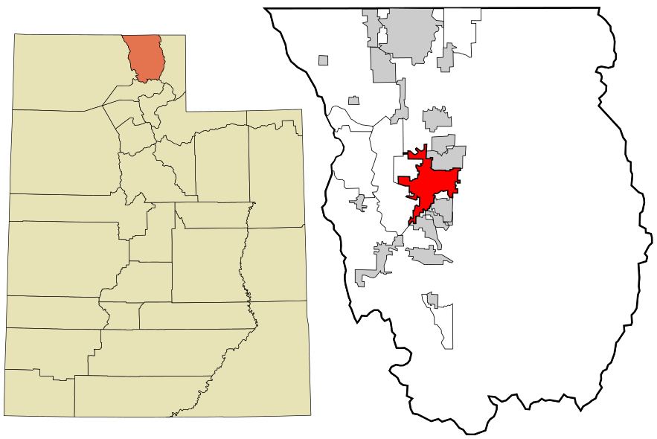

Source: Wikipedia Logan City Page

### Appendix- III Logan City Water Sources and Rights

|  |  |  |  |
| --- | --- | --- | --- |
| City of Logan Water Rights for Municipal Use | | | |
| Location | Priority | Flow | Water Right Number |
| DeWitt Spring | 1 May 1860 | 10 cfs | 25-3506 |
| DeWitt Spring1  (Apr- Sep) | 1 May 1900 | 4 cfs | 25-5429 |
| DeWitt Spring2  (Oct-Mar) | 17 March 1981 | 20 cfs | 25-8258 |
| Combined Right3 | 1961, 1963, 1978 | 49 cfs | A28759 |
| DeWitt Spring  (Apr-Sep)4 | 1865 | 10 cfs | Contract Exchange |
| DeWitt Spring  (Apr-Sep)4 | 1865 | 10 cfs | E1844 |
| Total Water Rights Available5 | | 83 cfs (Division of Water Rights)  56 cfs (Division of Drinking Water) | |
| Total Available Water During Peak Demand Season | | 79 cfs (Division of Water Rights)  56 cfs (Division of Drinking Water) | |

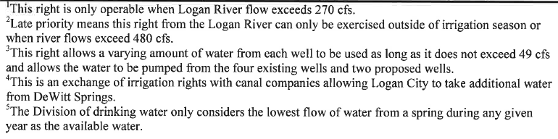

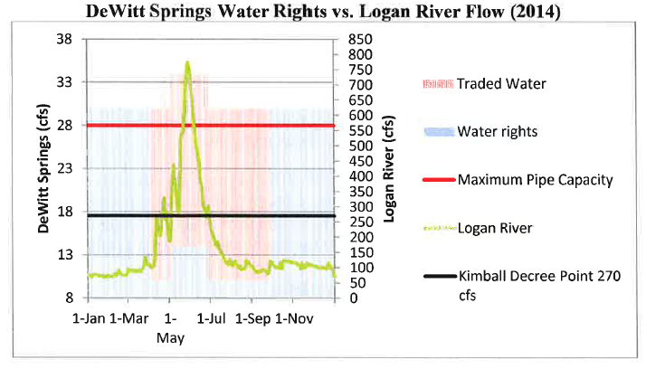

Figure 2 – Dewitt Springs Water Rights and Logan River Flow

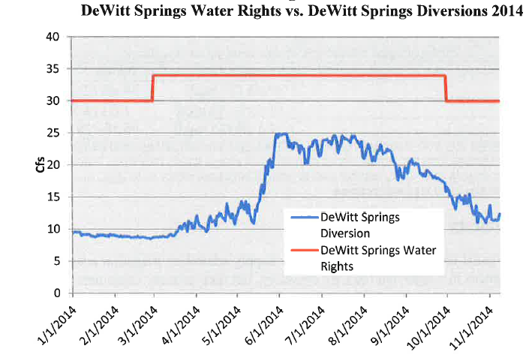

Figure 3 – Dewitt Spring Rights and Diversions

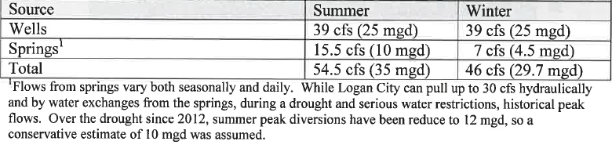

Table 1 – Logan City Municipal Water Production Facilities

## Appendix – IV Population and Water Demand Forecast

A rapid growth rate (Geometric) with R= 2.7%

A normal growth rate (Arithmetic) with R= 2.1%

A Slow growth rate (Declining) with R= 1.5%

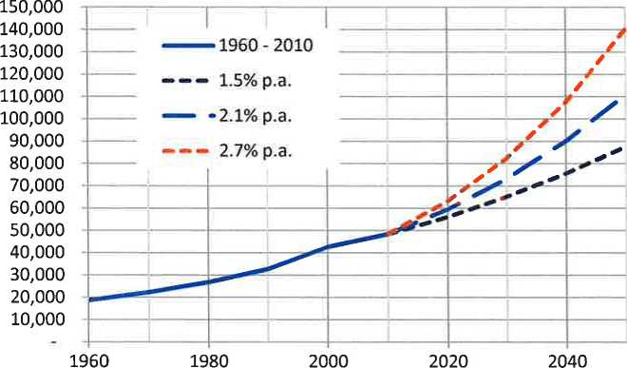

Figure 4 – Logan City Historic and Projected Population

|  |  |  |  |  |
| --- | --- | --- | --- | --- |
| Logan Historic and Projected Population, 1960-2050 | | | | |
| Year | Historic | 1.5% AARC | 2.1% AARC | 2.7%  AARC |
| 1960 | 18,731 |  |  |  |
| 1970 | 22,333 |  |  |  |
| 1980 | 26,844 |  |  |  |
| 1990 | 32,762 |  |  |  |
| 2000 | 42,670 |  |  |  |
| 2010 | 48,375 | 48,375 | 48,375 | 48,375 |
| 2020 |  | 56,141 | 59,550 | 63,143 |
| 2030 |  | 65,154 | 73,305 | 82,419 |
| 2040 |  | 75,614 | 90,239 | 107,581 |
| 2050 |  | 87,753 | 111,084 | 140,423 |

Table 2 – Summary of historic and projected population

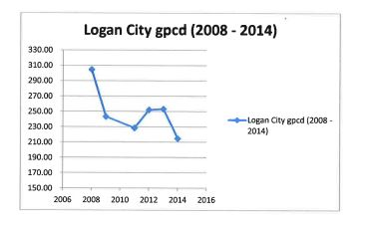

Figure 5 – Logan Average Daily Water Use