**Total Revenue by City:-**

Simple table:-

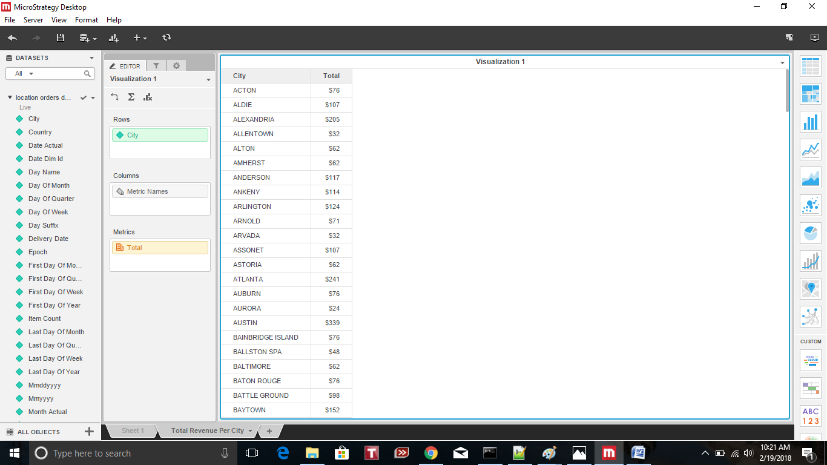

Bar Chart:-

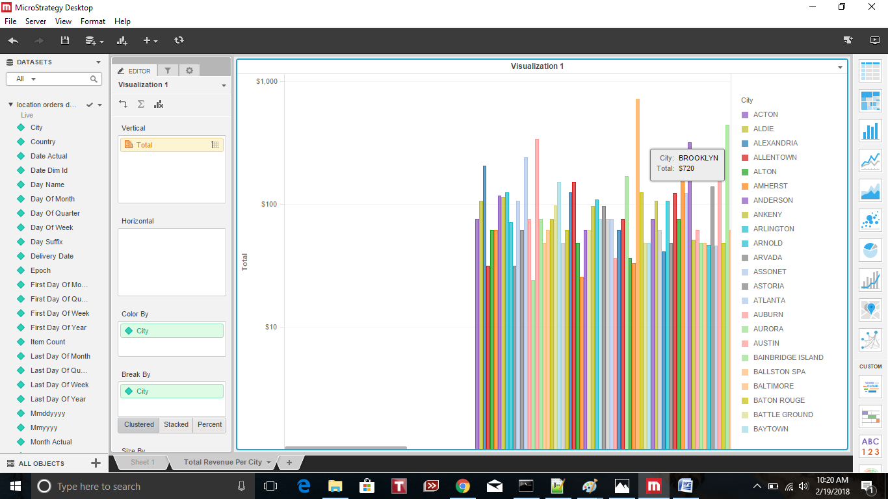

**Week by week order frequency in a line graph (the graph should contain a filter by city):**

**All city:-**

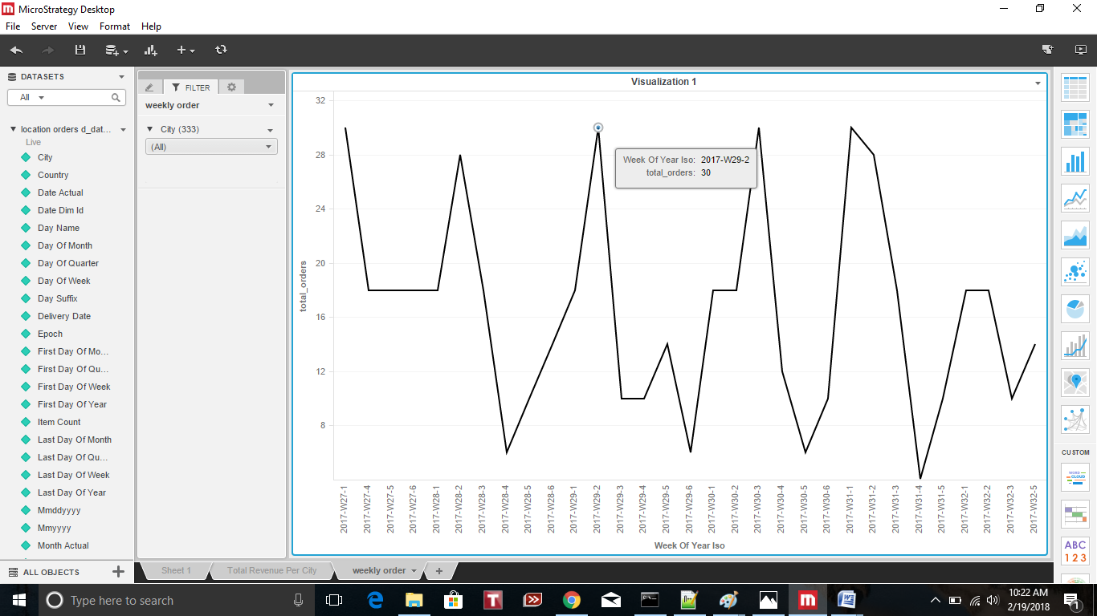

**City (Arlington):-**

