

***Results***

Classification accuracy averaged over sessions and the corresponding bitrates are plotted against the time needed to take a decision. Electrode configuration (II) in conjunction with BLDA as classification method was used for the graphs in and the bitrates were computed by applying the definition of Wolpaw et al. (2002) to the average accuracy curves. The bitrates for all possible combinations of electrode configuration and classification algorithm are listed in Table 2. Data for subject 5 are not included in Fig. 3 and in Table 2 because classification accuracies above chance level could not be obtained. During the experiments a speech therapist helped to communicate with subject 5. However it was not clear if the subject understood the instructions given before the experiments.

**Testclassification:**

This function takes as first input a list of files containing training data. The second input is the name of a file containing test data. The training files as well as the test file have to be generated with the function extract trials. The function computes a Bayesian linear discriminant from the training data and applies it to the test data. Results of testing are either shown in a simple plot or returned as an output argument.

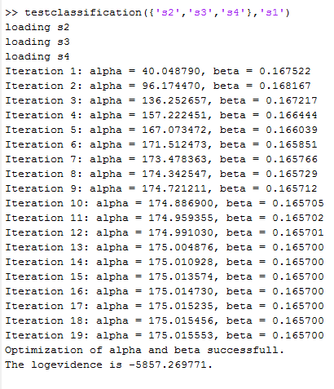

**Figure:** Test classification function output.

**Crossvalidate:**

This function takes a list of files as input. The input files have to be generated with extract trials. Given k files as input, cross validate uses test classification to compute a classifier from k-1 files and test it on the left-out file. This is done k times (once for each file in the list).Then the results are averaged and plotted as accuracy and bitrate curves.

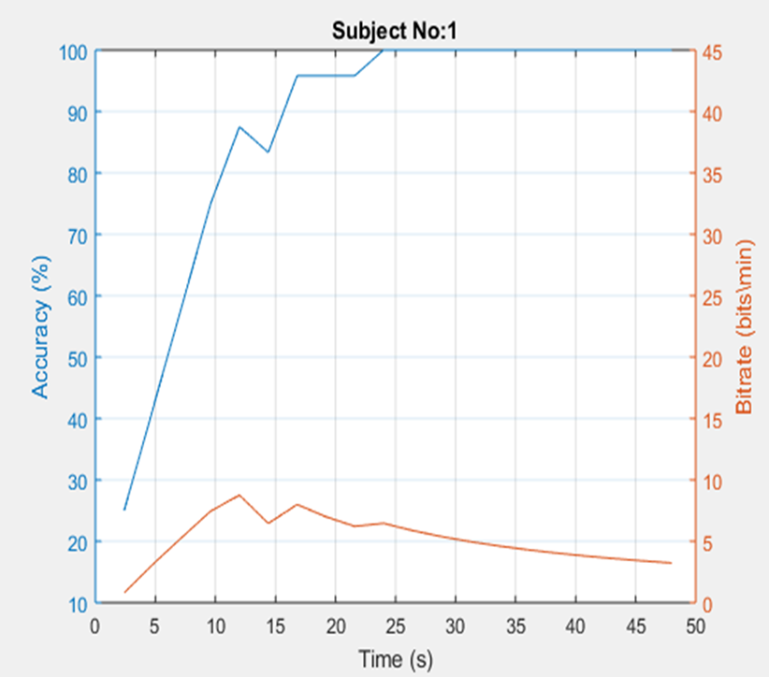

**Figure:** Accuracy of the classifier and Bitrate of the subject

Using different electrode configurations in conjunction with BLDA yielded the performance curves shown in Figure. The performance curves obtained with FLDA are shown in next figure. For both figures, classification accuracy was averaged over sessions and over all subjects. For both classification methods a strong increase in classification accuracy can be observed between the electrode configurations consisting of four and eight electrodes.

Using more than eight electrodes yielded only relatively small increases in performance for BLDA and resulted in a decrease of performance for FLDA. For the configurations consisting of four and eight electrodes, the classification accuracy and bitrates obtained with BLDA were slightly better than those obtained with FLDA. For the configurations consisting of more than eight electrodes the performance of BLDA was clearly better than that.

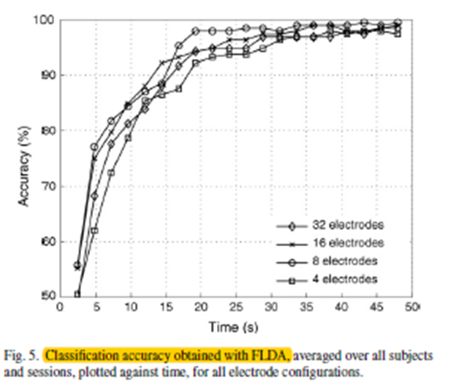

**Figure:** Classification accuracy obtained with BLDA, averaged over all subjects and sessions, plotted against time, for all electrode configurations.

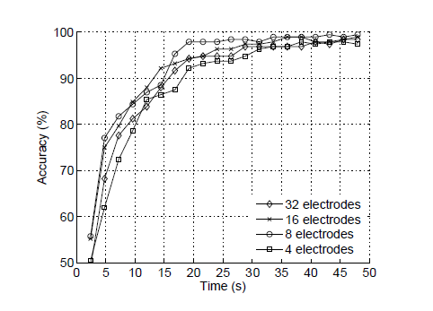

**Figure:** Classification accuracy obtained with FLDA, averaged over all subjects and sessions, plotted against time, for all electrode configurations.

P300-like peak in the target condition which is not present in the non-target condition. The latency of the P300 is higher for the disabled subjects (around 500ms) when compared to the one from able bodied subjects (around 300ms). The amplitude at the P300 peak is smaller for the disabled subjects (around 1.5 ¹V) than for the able-bodied subjects (around 2 V).

**Electrode configurations:**

The electrode configuration used in a BCI determines the suitability of the system for daily use. Clearly, systems that use only few electrodes take less time for setup and are more user friendly than systems with many electrodes. However, if too few electrodes are used not all features that are necessary for accurate classification can be captured and communication speed decreases. For P300-based BCI systems different electrode configurations have been described in the literature.

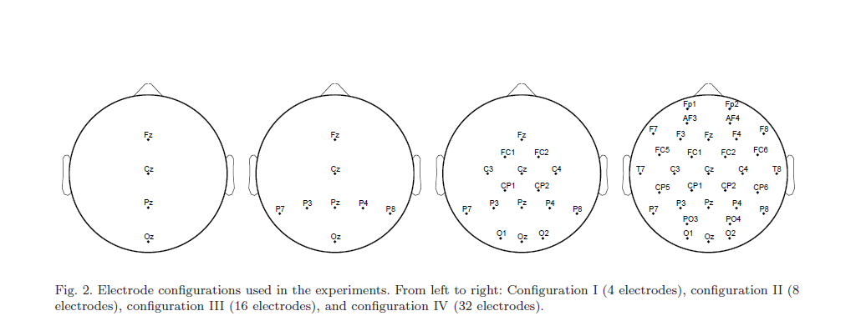

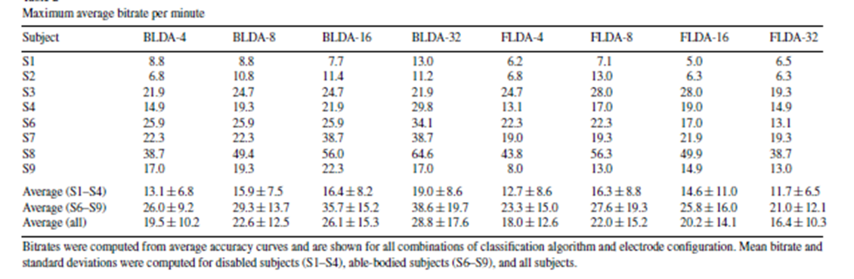

**Bayesian LDA (BLDA):**

BLDA can be seen as an extension of Fisher's Linear Discriminant Analysis (FLDA). In contrast to FLDA, in BLDA regularization is used to prevent overfitting to high dimensional and possibly noisy datasets. Through a Bayesian analysis the degree of regularization can be estimated automatically and quickly from training data without the need for time consuming cross-validation.

