EXPERIMENTAL SETUP :

Users were facing a laptop screen on which six images were displayed (see Fig. 1). The images showed a television,

a telephone, a lamp, a door, a window, and a radio. The images were selected according to an application scenario in which users can control electrical appliances via a BCI system.

The application scenario served however only as an example and was not pursued in further detail.

The images were flashed in random sequences, one image at a time. Each flash of an image

lasted for 100 ms and during the following 300 ms none of the images was flashed, i.e. the ISI was 400 ms.

The EEG was recorded at 2048 Hz sampling rate from 32 electrodes placed at the standard positions of the 10–20 international system.

A Biosemi Active Two amplifier was used for amplification and analog to digital conversion of the EEGsignals.

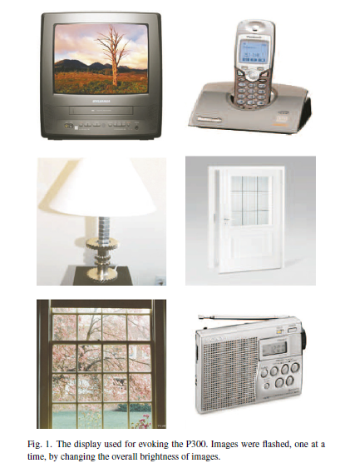

Signal processing and machine learning algorithms were implemented with MATLAB.

The stimulus display and the online access to the EEG signals were implemented as dynamic

link libraries (DLLs) in C.

The DLLs were accessed from MATLAB via a MEX interface.

SUBJECTS :

The system was tested with five disabled and four healthy subjects. The disabled subjects were all wheelchair-bound but had varying communication and limb muscle control abilities (see Table 1).

Subjects 1 and 2 were able to perform simple, slow movements with their arms and hands but were unable to control other extremities. Spoken communication with subjects 1 and 2 was possible, although both subjects suffered from milddysarthria .

Subject 3 was able to perform restricted movements with his left hand but was unable to move his arms or other extremities. Spoken communication with subject 3 was impossible.

However the patient was able to answer yes/no questions with eye blinks. Subject 4 had very little control over arm and hand movements. Spoken communication was possible with subject 4, although a mild dysarthria existed.

Subject 5 was only able to perform extremely slow and relatively uncontrolled movements with hands and arms.

Due to a severe hypophony and large fluctuations in the level of alertness, communication

with subject 5 was very difficult. Subjects 6–9 were Ph.D. students recruited from our laboratory

(all males, age 30±2.3). None of subjects 6–9 had known neurological deficits.

*Experimental schedule:*

Each subject completed four recording sessions. The first two sessions were performed on one day and the last two sessions on another day.

For all subjects the time between the first and the last session was less than two weeks. Each of the sessions consisted of six runs, one run for each of the six images.

The following protocol was used in each of the runs.

1. Subjects were asked to count silently howoften a prescribed image was flashed (for example: “Now please count how often the image with the television is flashed”).
2. The six images were displayed on the screen and a warning tone was issued.
3. Four seconds after the warning tone, a random sequence of flasheswas started and theEEGwas recorded.

The sequence of flashes was block- randomized, this means that after six flashes each image was flashed once, after twelve flashes each image was flashed twice, etc.

The number of blocks was chosen randomly between 20 and 25. On average 22.5 blocks of six flashes were displayed in one run, i.e. one run consisted on average of 22.5 target (P300) trials and 22.5×5 = 112.5 non-target (non-P300) trials .

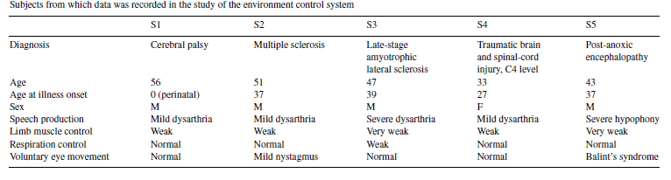

1. In the second, third, and fourth session the target image was inferred from theEEGwith a simple classifier.5 At the end of each run the image inferred by the classification algorithm was flashed five times to give feedback to the user.
2. After each run subjects were asked what their counting result was. This was done in order to monitor performance of the subjects. The duration of one run was approximately one minute and the duration of one session including setup of electrodes and short breaks between runs was approximately 30 min.
3. One session comprised on average 810 trials, and the whole data for one subject consisted on average of 3240 trials.

*Offline analysis:*

The impact of different electrode configurations and machine learning algorithms on classification accuracy was tested in an offline procedure. For each subject four-fold cross-validation was used to estimate average classification accuracy. More specifically, the data from three recording sessions were used to train a classifier and the data from the left-out session was used for validation. This procedure was repeated four times so each session served once for validation.

ELECTRODE SETUP :

There are two process for electrode set up . Invasive and non invasive

Invasive : In this process electrode is direct set up in grey matter.

Non Invasive : It does not involve in neurosurgery ..

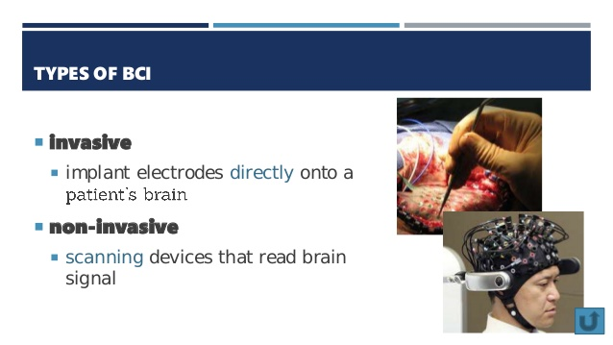

In this project non invasive is used .