A
Md Imran Hasan Shuvo 24-56808-1
Md. Arafat Al Shahrier 24-46816-1
Dhrubo Chandra Roy 23-55362-3
Nishat Tasnim Ema 23-55025-3
Kazi Sanjida Islam 23-52300-2
Suraiya Zabin 23-52746-2

Title:
Performance Analysis of Digital Modulation over AWGN Channel
Objective:
The objective of this experiment is to design and simulate a digital communication system using
MATLAB to transmit a text message through a noisy channel. The system involves converting a
message into binary ASCII code, generating a digital signal, and applying various digital modulation
techniques such as BASK, M-ASK, M-PSK, and M-QAM.
The experiment aims to analyze the performance of these modulation schemes over an AWGN
channel by observing constellation diagrams and evaluating bit error rate (BER) under different
Eb/No conditions. It also focuses on identifying the effect of noise, modulation order, and data rate on
system performance, and determining the threshold Eb/No at which accurate message recovery is no
longer possible.
Finally, the goal is to compare different modulation techniques and determine the most suitable
scheme for reliable communication in high data rate and noisy channel conditions.
Theory:
1. Binary Data Representation: In digital communication, textual information must first be
converted into a binary format. Each character is represented by a unique ASCII (American
Standard Code for Information Interchange) value. These ASCII values are then converted into
binary sequences of 7 or 8 bits. This binary representation forms the basic data to be transmitted
over a communication system.
2. Synchronous Serial Transmission: Synchronous transmission is a method where data is
transmitted as a continuous stream of bits without start and stop bits. Both the transmitter and
receiver are synchronized using a common clock signal. This method is more efficient than
asynchronous transmission as it reduces overhead and allows faster data transfer.
Unipolar NRZ Line Coding: Unipolar Non-Return-to-Zero (NRZ) is a line coding technique
where the signal level represents binary data directly:
i. Binary '1' is represented by a constant positive voltage.
ii. Binary '0' is represented by zero voltage.
4. Digital Modulation Techniques:
i. Binary Amplitude Shift Keying (BASK)
Binary Amplitude Shift Keying (BASK) is a digital modulation technique in which the amplitude of a
carrier signal is varied according to the binary data. For binary '1', the carrier is transmitted with a fixed
amplitude, while for binary '0', the carrier is either reduced or completely suppressed.
Mathematically, the BASK signal is expressed as:
s(t) = A·cos(2π·fc·t) for binary 1
s(t) = 0 for binary 0
BASK is simple to implement but highly sensitive to noise.
ii. M-ary Amplitude Shift Keying (4-ASK, 16-ASK)
In M-ASK, multiple amplitude levels are used to represent more than one bit per symbol, increasing
spectral efficiency:
• 4-ASK → 2 bits per symbol
• 16-ASK → 4 bits per symbol
3. This increases the data rate but also increases susceptibility to noise.
iii. Quadrature Phase Shift Keying (QPSK)
QPSK is a phase modulation technique where each symbol represents 2 bits. The carrier phase is shifted
among four distinct values (0°, 90°, 180°, 270°). It provides better noise immunity compared to ASK
and is widely used in modern systems.
iv. 8-PSK (8-Phase Shift Keying)
In 8-PSK, eight different phase shifts are used, allowing 3 bits per symbol. While it improves bandwidth
efficiency over QPSK, it requires a higher signal-to-noise ratio for reliable detection.
v. Quadrature Amplitude Modulation (16-QAM)
16-QAM combines both amplitude and phase variations to encode 4 bits per symbol. It is widely used
in modern communication systems due to its high spectral efficiency. However, it is more sensitive to
noise than pure phase-modulation schemes.
5. Additive White Gaussian Noise (AWGN):
The AWGN channel is the fundamental noise model used to analyze communication systems.
It assumes that noise is:
Additive — noise is added directly to the transmitted signal.
White — noise power is uniformly distributed across all frequencies.
Gaussian — the noise amplitude follows a normal (Gaussian) distribution.
System performance in an AWGN environment is measured using the Eb/N0 ratio, where Eb is
the energy per bit and N0 is the noise power spectral density. A higher Eb/N0 ratio indicates
better signal quality and lower error probability.
6. Constellation Diagram:
A constellation diagram is a graphical representation of modulated signals in the I–Q (In-phase
and Quadrature) plane. Each point on the diagram corresponds to a distinct symbol. In the
presence of noise, these points spread out from their ideal positions, indicating signal distortion
and the potential for detection errors.
7. Demodulation:
Demodulation is the process of extracting the original binary data from the received modulated
signal. In coherent demodulation, the receiver uses a locally generated carrier signal that is
synchronized in both frequency and phase with the transmitter, enabling accurate recovery of
the transmitted data.
8. Bit Error Rate (BER) :
Bit Error Rate (BER) is defined as the ratio of incorrectly received bits to the total number of
transmitted bits:
BER = (Number of Error Bits) / (Total Transmitted Bits)
BER decreases as the Eb/N0 ratio increases, indicating improved system performance. BER
analysis is the primary metric for evaluating the reliability of a digital communication link.
9. Threshold Eb/No:
There exists a minimum Eb/N0 value below which the receiver cannot correctly reconstruct the
transmitted message. This threshold defines the limit of reliable communication. Below this
point, the BER increases significantly and constellation points become highly distorted, making
symbol decisions unreliable.
code:
clc;
clear all;
close all;

VAL1 = 7;
Transmitted_Message = 'imranhasan';

good_EbNo_dB = VAL1 + 20;
snr = 10^(good_EbNo_dB/10);

% MESSAGE TO BINARY ASCII

b_data = asc2bn(Transmitted_Message);

disp('binary ASCII information at transmitter:');
disp(b_data);

x = b_data;

disp('Serial binary information at Transmitter (x):');
disp(x);

% unipolar NRZ signal, 1 kbps

bp = 1/1000;
br = 1/bp;
f = br*10;

tx_bit_signal = [];

for n = 1:length(x)
if x(n) == 1
se = 5*ones(1,100);
else
se = zeros(1,100);
end
tx_bit_signal = [tx_bit_signal se];
end

t1 = bp/100:bp/100:100*length(x)*(bp/100);

% BASK modulation and demodulation
% 1 bit per symbol

t2 = bp/99:bp/99:bp;
ss = length(t2);

m_bask = [];

for i = 1:length(x)

if x(i) == 1
AA = 5;
else
AA = 0;
end

y = AA*cos(2*pi*f*t2);
m_bask = [m_bask y];
end

t_bask_mod = bp/99:bp/99:bp*length(x);

signal_power = mean(abs(m_bask).^2);
noise_power = signal_power/snr;
noise = sqrt(noise_power)*randn(size(m_bask));

Rec_bask = m_bask + noise;

mn_bask = [];
amp_bask = [];

for n = ss:ss:length(Rec_bask)

t = bp/99:bp/99:bp;
carrier = cos(2*pi*f*t);

segment = Rec_bask((n-(ss-1)):n);
z = trapz(t,segment.*carrier);

detected_amp = 2*z/bp;
amp_bask = [amp_bask detected_amp];

if detected_amp >= 2.5
a = 1;
else
a = 0;
end

mn_bask = [mn_bask a];
end

mn_bask = mn_bask(1:length(x));
Received_Message_BASK = bin2asc(mn_bask);

disp('BASK Received Message:');
disp(Received_Message_BASK);

bit_bask = [];

for n = 1:length(mn_bask)
if mn_bask(n) == 1
se = 5*ones(1,100);
else
se = zeros(1,100);
end
bit_bask = [bit_bask se];
end

% 4-ASK modulation and demodulation
% 2 bits per symbol
% 00 = -3, 01 = -1, 10 = 1, 11 = 3

k = 2;

if mod(length(x),k) ~= 0
x4 = [x zeros(1,k-mod(length(x),k))];
else
x4 = x;
end

Ts = k*bp;
t2 = Ts/99:Ts/99:Ts;
ss = length(t2);

m_4ask = [];

for i = 1:2:length(x4)

if x4(i)==0 && x4(i+1)==0
AA = -3;
elseif x4(i)==0 && x4(i+1)==1
AA = -1;
elseif x4(i)==1 && x4(i+1)==0
AA = 1;
elseif x4(i)==1 && x4(i+1)==1
AA = 3;
end

y = AA*cos(2*pi*f*t2);
m_4ask = [m_4ask y];
end

t_4ask_mod = Ts/99:Ts/99:(length(x4)/2)*Ts;

signal_power = mean(abs(m_4ask).^2);
noise_power = signal_power/snr;
noise = sqrt(noise_power)*randn(size(m_4ask));

Rec_4ask = m_4ask + noise;

mn_4ask = [];
amp_4ask = [];

for n = ss:ss:length(Rec_4ask)

t = Ts/99:Ts/99:Ts;
carrier = cos(2*pi*f*t);

segment = Rec_4ask((n-(ss-1)):n);
z = trapz(t,segment.*carrier);

detected_amp = 2*z/Ts;
amp_4ask = [amp_4ask detected_amp];

if detected_amp < -2
bits = [0 0];
elseif detected_amp >= -2 && detected_amp < 0
bits = [0 1];
elseif detected_amp >= 0 && detected_amp < 2
bits = [1 0];
else
bits = [1 1];
end

mn_4ask = [mn_4ask bits];
end

mn_4ask = mn_4ask(1:length(x));
Received_Message_4ASK = bin2asc(mn_4ask);

disp('4-ASK Received Message:');
disp(Received_Message_4ASK);

bit_4ask = [];

for n = 1:length(mn_4ask)
if mn_4ask(n) == 1
se = 5*ones(1,100);
else
se = zeros(1,100);
end
bit_4ask = [bit_4ask se];
end

% 16-ASK modulation and demodulation
% 4 bits per symbol

k = 4;

if mod(length(x),k) ~= 0
x16 = [x zeros(1,k-mod(length(x),k))];
else
x16 = x;
end

Ts = k*bp;
t2 = Ts/99:Ts/99:Ts;
ss = length(t2);

m_16ask = [];

for i = 1:4:length(x16)

b1 = x16(i);
b2 = x16(i+1);
b3 = x16(i+2);
b4 = x16(i+3);

if b1==0 && b2==0 && b3==0 && b4==0
AA = -15;
elseif b1==0 && b2==0 && b3==0 && b4==1
AA = -13;
elseif b1==0 && b2==0 && b3==1 && b4==0
AA = -11;
elseif b1==0 && b2==0 && b3==1 && b4==1
AA = -9;
elseif b1==0 && b2==1 && b3==0 && b4==0
AA = -7;
elseif b1==0 && b2==1 && b3==0 && b4==1
AA = -5;
elseif b1==0 && b2==1 && b3==1 && b4==0
AA = -3;
elseif b1==0 && b2==1 && b3==1 && b4==1
AA = -1;
elseif b1==1 && b2==0 && b3==0 && b4==0
AA = 1;
elseif b1==1 && b2==0 && b3==0 && b4==1
AA = 3;
elseif b1==1 && b2==0 && b3==1 && b4==0
AA = 5;
elseif b1==1 && b2==0 && b3==1 && b4==1
AA = 7;
elseif b1==1 && b2==1 && b3==0 && b4==0
AA = 9;
elseif b1==1 && b2==1 && b3==0 && b4==1
AA = 11;
elseif b1==1 && b2==1 && b3==1 && b4==0
AA = 13;
elseif b1==1 && b2==1 && b3==1 && b4==1
AA = 15;
end

y = AA*cos(2*pi*f*t2);
m_16ask = [m_16ask y];
end

t_16ask_mod = Ts/99:Ts/99:(length(x16)/4)*Ts;

signal_power = mean(abs(m_16ask).^2);
noise_power = signal_power/snr;
noise = sqrt(noise_power)*randn(size(m_16ask));

Rec_16ask = m_16ask + noise;

mn_16ask = [];
amp_16ask = [];

for n = ss:ss:length(Rec_16ask)

t = Ts/99:Ts/99:Ts;
carrier = cos(2*pi*f*t);

segment = Rec_16ask((n-(ss-1)):n);
z = trapz(t,segment.*carrier);

detected_amp = 2*z/Ts;
amp_16ask = [amp_16ask detected_amp];

if detected_amp < -14
bits = [0 0 0 0];
elseif detected_amp >= -14 && detected_amp < -12
bits = [0 0 0 1];
elseif detected_amp >= -12 && detected_amp < -10
bits = [0 0 1 0];
elseif detected_amp >= -10 && detected_amp < -8
bits = [0 0 1 1];
elseif detected_amp >= -8 && detected_amp < -6
bits = [0 1 0 0];
elseif detected_amp >= -6 && detected_amp < -4
bits = [0 1 0 1];
elseif detected_amp >= -4 && detected_amp < -2
bits = [0 1 1 0];
elseif detected_amp >= -2 && detected_amp < 0
bits = [0 1 1 1];
elseif detected_amp >= 0 && detected_amp < 2
bits = [1 0 0 0];
elseif detected_amp >= 2 && detected_amp < 4
bits = [1 0 0 1];
elseif detected_amp >= 4 && detected_amp < 6
bits = [1 0 1 0];
elseif detected_amp >= 6 && detected_amp < 8
bits = [1 0 1 1];
elseif detected_amp >= 8 && detected_amp < 10
bits = [1 1 0 0];
elseif detected_amp >= 10 && detected_amp < 12
bits = [1 1 0 1];
elseif detected_amp >= 12 && detected_amp < 14
bits = [1 1 1 0];
else
bits = [1 1 1 1];
end

mn_16ask = [mn_16ask bits];
end

mn_16ask = mn_16ask(1:length(x));
Received_Message_16ASK = bin2asc(mn_16ask);

disp('16-ASK Received Message:');
disp(Received_Message_16ASK);

bit_16ask = [];

for n = 1:length(mn_16ask)
if mn_16ask(n) == 1
se = 5*ones(1,100);
else
se = zeros(1,100);
end
bit_16ask = [bit_16ask se];
end

% QPSK modulation and demodulation
% 2 bits per symbol

k = 2;

if mod(length(x),k) ~= 0
xq = [x zeros(1,k-mod(length(x),k))];
else
xq = x;
end

Ts = k*bp;
t2 = Ts/99:Ts/99:Ts;
ss = length(t2);

m_qpsk = [];

for i = 1:2:length(xq)

if xq(i)==0 && xq(i+1)==0
PH = 0;
elseif xq(i)==0 && xq(i+1)==1
PH = pi/2;
elseif xq(i)==1 && xq(i+1)==0
PH = pi;
elseif xq(i)==1 && xq(i+1)==1
PH = 3*pi/2;
end

y = cos(2*pi*f*t2 + PH);
m_qpsk = [m_qpsk y];
end

t_qpsk_mod = Ts/99:Ts/99:(length(xq)/2)*Ts;

signal_power = mean(abs(m_qpsk).^2);
noise_power = signal_power/snr;
noise = sqrt(noise_power)*randn(size(m_qpsk));

Rec_qpsk = m_qpsk + noise;

mn_qpsk = [];
IQ_qpsk = [];

for n = ss:ss:length(Rec_qpsk)

t = Ts/99:Ts/99:Ts;
carrier_cos = cos(2*pi*f*t);
carrier_sin = sin(2*pi*f*t);

segment = Rec_qpsk((n-(ss-1)):n);

I = 2*trapz(t,segment.*carrier_cos)/Ts;
Q = -2*trapz(t,segment.*carrier_sin)/Ts;

IQ_qpsk = [IQ_qpsk I + 1j*Q];

angle_value = atan2(Q,I);

if angle_value < 0
angle_value = angle_value + 2*pi;
end

if angle_value >= 7*pi/4 || angle_value < pi/4
bits = [0 0];
elseif angle_value >= pi/4 && angle_value < 3*pi/4
bits = [0 1];
elseif angle_value >= 3*pi/4 && angle_value < 5*pi/4
bits = [1 0];
else
bits = [1 1];
end

mn_qpsk = [mn_qpsk bits];
end

mn_qpsk = mn_qpsk(1:length(x));
Received_Message_QPSK = bin2asc(mn_qpsk);

disp('QPSK Received Message:');
disp(Received_Message_QPSK);

bit_qpsk = [];

for n = 1:length(mn_qpsk)
if mn_qpsk(n) == 1
se = 5*ones(1,100);
else
se = zeros(1,100);
end
bit_qpsk = [bit_qpsk se];
end

% 8-PSK modulation AND demodulation
% 3 bits per symbol

k = 3;

if mod(length(x),k) ~= 0
x8 = [x zeros(1,k-mod(length(x),k))];
else
x8 = x;
end

Ts = k*bp;
t2 = Ts/99:Ts/99:Ts;
ss = length(t2);

m_8psk = [];

for i = 1:3:length(x8)

b1 = x8(i);
b2 = x8(i+1);
b3 = x8(i+2);

if b1==0 && b2==0 && b3==0
PH = 0;
elseif b1==0 && b2==0 && b3==1
PH = pi/4;
elseif b1==0 && b2==1 && b3==0
PH = pi/2;
elseif b1==0 && b2==1 && b3==1
PH = 3*pi/4;
elseif b1==1 && b2==0 && b3==0
PH = pi;
elseif b1==1 && b2==0 && b3==1
PH = 5*pi/4;
elseif b1==1 && b2==1 && b3==0
PH = 3*pi/2;
elseif b1==1 && b2==1 && b3==1
PH = 7*pi/4;
end

y = cos(2*pi*f*t2 + PH);
m_8psk = [m_8psk y];
end

t_8psk_mod = Ts/99:Ts/99:(length(x8)/3)*Ts;

signal_power = mean(abs(m_8psk).^2);
noise_power = signal_power/snr;
noise = sqrt(noise_power)*randn(size(m_8psk));

Rec_8psk = m_8psk + noise;

mn_8psk = [];
IQ_8psk = [];

for n = ss:ss:length(Rec_8psk)

t = Ts/99:Ts/99:Ts;
carrier_cos = cos(2*pi*f*t);
carrier_sin = sin(2*pi*f*t);

segment = Rec_8psk((n-(ss-1)):n);

I = 2*trapz(t,segment.*carrier_cos)/Ts;
Q = -2*trapz(t,segment.*carrier_sin)/Ts;

IQ_8psk = [IQ_8psk I + 1j*Q];

angle_value = atan2(Q,I);

if angle_value < 0
angle_value = angle_value + 2*pi;
end

if angle_value >= 15*pi/8 || angle_value < pi/8
bits = [0 0 0];
elseif angle_value >= pi/8 && angle_value < 3*pi/8
bits = [0 0 1];
elseif angle_value >= 3*pi/8 && angle_value < 5*pi/8
bits = [0 1 0];
elseif angle_value >= 5*pi/8 && angle_value < 7*pi/8
bits = [0 1 1];
elseif angle_value >= 7*pi/8 && angle_value < 9*pi/8
bits = [1 0 0];
elseif angle_value >= 9*pi/8 && angle_value < 11*pi/8
bits = [1 0 1];
elseif angle_value >= 11*pi/8 && angle_value < 13*pi/8
bits = [1 1 0];
else
bits = [1 1 1];
end

mn_8psk = [mn_8psk bits];
end

mn_8psk = mn_8psk(1:length(x));
Received_Message_8PSK = bin2asc(mn_8psk);

disp('8-PSK Received Message:');
disp(Received_Message_8PSK);

bit_8psk = [];

for n = 1:length(mn_8psk)
if mn_8psk(n) == 1
se = 5*ones(1,100);
else
se = zeros(1,100);
end
bit_8psk = [bit_8psk se];
end

% 16-QAM MODULATION AND DEMODULATION
% 4 bits per symbol

k = 4;

if mod(length(x),k) ~= 0
xqam = [x zeros(1,k-mod(length(x),k))];
else
xqam = x;
end

Ts = k*bp;
t2 = Ts/99:Ts/99:Ts;
ss = length(t2);

m_16qam = [];

for i = 1:4:length(xqam)

b1 = xqam(i);
b2 = xqam(i+1);
b3 = xqam(i+2);
b4 = xqam(i+3);

if b1==0 && b2==0
I_level = -3;
elseif b1==0 && b2==1
I_level = -1;
elseif b1==1 && b2==0
I_level = 1;
elseif b1==1 && b2==1
I_level = 3;
end

if b3==0 && b4==0
Q_level = -3;
elseif b3==0 && b4==1
Q_level = -1;
elseif b3==1 && b4==0
Q_level = 1;
elseif b3==1 && b4==1
Q_level = 3;
end

y = I_level*cos(2*pi*f*t2) - Q_level*sin(2*pi*f*t2);
m_16qam = [m_16qam y];
end

t_16qam_mod = Ts/99:Ts/99:(length(xqam)/4)*Ts;

signal_power = mean(abs(m_16qam).^2);
noise_power = signal_power/snr;
noise = sqrt(noise_power)*randn(size(m_16qam));

Rec_16qam = m_16qam + noise;

mn_16qam = [];
IQ_16qam = [];

for n = ss:ss:length(Rec_16qam)

t = Ts/99:Ts/99:Ts;
carrier_cos = cos(2*pi*f*t);
carrier_sin = sin(2*pi*f*t);

segment = Rec_16qam((n-(ss-1)):n);

I_detect = 2*trapz(t,segment.*carrier_cos)/Ts;
Q_detect = -2*trapz(t,segment.*carrier_sin)/Ts;

IQ_16qam = [IQ_16qam I_detect + 1j*Q_detect];

if I_detect < -2
bits_I = [0 0];
elseif I_detect >= -2 && I_detect < 0
bits_I = [0 1];
elseif I_detect >= 0 && I_detect < 2
bits_I = [1 0];
else
bits_I = [1 1];
end

if Q_detect < -2
bits_Q = [0 0];
elseif Q_detect >= -2 && Q_detect < 0
bits_Q = [0 1];
elseif Q_detect >= 0 && Q_detect < 2
bits_Q = [1 0];
else
bits_Q = [1 1];
end

bits = [bits_I bits_Q];
mn_16qam = [mn_16qam bits];
end

mn_16qam = mn_16qam(1:length(x));
Received_Message_16QAM = bin2asc(mn_16qam);

disp('16-QAM Received Message:');
disp(Received_Message_16QAM);

bit_16qam = [];

for n = 1:length(mn_16qam)
if mn_16qam(n) == 1
se = 5*ones(1,100);
else
se = zeros(1,100);
end
bit_16qam = [bit_16qam se];
end

% FIGURE 1: TRANSMITTED NRZ + TIME-DOMAIN MODULATED SIGNALS

figure(1);
clf;

subplot(7,1,1);
plot(t1,tx_bit_signal,'LineWidth',2.5);
grid on;
axis([0 bp*length(x) -0.5 6]);
xlabel('time(sec)');
ylabel('Amplitude');
title('Transmitted Unipolar NRZ Signal');

subplot(7,1,2);
plot(t_bask_mod,m_bask);
grid on;
xlabel('time(sec)');
ylabel('Amplitude');
title('BASK Modulated Signal');

subplot(7,1,3);
plot(t_4ask_mod,m_4ask);
grid on;
xlabel('time(sec)');
ylabel('Amplitude');
title('4-ASK Modulated Signal');

subplot(7,1,4);
plot(t_16ask_mod,m_16ask);
grid on;
xlabel('time(sec)');
ylabel('Amplitude');
title('16-ASK Modulated Signal');

subplot(7,1,5);
plot(t_qpsk_mod,m_qpsk);
grid on;
xlabel('time(sec)');
ylabel('Amplitude');
title('QPSK Modulated Signal');

subplot(7,1,6);
plot(t_8psk_mod,m_8psk);
grid on;
xlabel('time(sec)');
ylabel('Amplitude');
title('8-PSK Modulated Signal');

subplot(7,1,7);
plot(t_16qam_mod,m_16qam);
grid on;
xlabel('time(sec)');
ylabel('Amplitude');
title('16-QAM Modulated Signal');

% FIGURE 2: TRANSMITTED NRZ + RECEIVED NOISY SIGNALS

figure(2);
clf;

subplot(7,1,1);
plot(t1,tx_bit_signal,'LineWidth',2.5);
grid on;
axis([0 bp*length(x) -0.5 6]);
xlabel('time(sec)');
ylabel('Amplitude');
title('Transmitted Unipolar NRZ Signal');

subplot(7,1,2);
plot(t_bask_mod,Rec_bask);
grid on;
xlabel('time(sec)');
ylabel('Amplitude');
title('BASK Received Signal with AWGN');

subplot(7,1,3);
plot(t_4ask_mod,Rec_4ask);
grid on;
xlabel('time(sec)');
ylabel('Amplitude');
title('4-ASK Received Signal with AWGN');

subplot(7,1,4);
plot(t_16ask_mod,Rec_16ask);
grid on;
xlabel('time(sec)');
ylabel('Amplitude');
title('16-ASK Received Signal with AWGN');

subplot(7,1,5);
plot(t_qpsk_mod,Rec_qpsk);
grid on;
xlabel('time(sec)');
ylabel('Amplitude');
title('QPSK Received Signal with AWGN');

subplot(7,1,6);
plot(t_8psk_mod,Rec_8psk);
grid on;
xlabel('time(sec)');
ylabel('Amplitude');
title('8-PSK Received Signal with AWGN');

subplot(7,1,7);
plot(t_16qam_mod,Rec_16qam);
grid on;
xlabel('time(sec)');
ylabel('Amplitude');
title('16-QAM Received Signal with AWGN');

% FIGURE 3: RECEIVED CONSTELLATION DIAGRAMS

figure(3);
clf;

subplot(3,2,1);
plot(amp_bask,zeros(size(amp_bask)),'.');
grid on;
xlabel('In-phase');
ylabel('Quadrature');
title('BASK Received Constellation');

subplot(3,2,2);
plot(amp_4ask,zeros(size(amp_4ask)),'.');
grid on;
xlabel('In-phase');
ylabel('Quadrature');
title('4-ASK Received Constellation');

subplot(3,2,3);
plot(amp_16ask,zeros(size(amp_16ask)),'.');
grid on;
xlabel('In-phase');
ylabel('Quadrature');
title('16-ASK Received Constellation');

subplot(3,2,4);
plot(real(IQ_qpsk),imag(IQ_qpsk),'.');
grid on;
xlabel('In-phase');
ylabel('Quadrature');
title('QPSK Received Constellation');

subplot(3,2,5);
plot(real(IQ_8psk),imag(IQ_8psk),'.');
grid on;
xlabel('In-phase');
ylabel('Quadrature');
title('8-PSK Received Constellation');

subplot(3,2,6);
plot(real(IQ_16qam),imag(IQ_16qam),'.');
grid on;
xlabel('In-phase');
ylabel('Quadrature');
title('16-QAM Received Constellation');

% FIGURE 4: DEMODULATED NRZ SIGNALS

t_rx = bp/100:bp/100:100*length(x)*(bp/100);

figure(4);
clf;

subplot(6,1,1);
plot(t_rx,bit_bask,'LineWidth',1.5);
grid on;
axis([0 bp*length(x) -0.5 6]);
title('BASK Demodulated NRZ');

subplot(6,1,2);
plot(t_rx,bit_4ask,'LineWidth',1.5);
grid on;
axis([0 bp*length(x) -0.5 6]);
title('4-ASK Demodulated NRZ');

subplot(6,1,3);
plot(t_rx,bit_16ask,'LineWidth',1.5);
grid on;
axis([0 bp*length(x) -0.5 6]);
title('16-ASK Demodulated NRZ');

subplot(6,1,4);
plot(t_rx,bit_qpsk,'LineWidth',1.5);
grid on;
axis([0 bp*length(x) -0.5 6]);
title('QPSK Demodulated NRZ');

subplot(6,1,5);
plot(t_rx,bit_8psk,'LineWidth',1.5);
grid on;
axis([0 bp*length(x) -0.5 6]);
title('8-PSK Demodulated NRZ');

subplot(6,1,6);
plot(t_rx,bit_16qam,'LineWidth',1.5);
grid on;
axis([0 bp*length(x) -0.5 6]);
title('16-QAM Demodulated NRZ');

% Q9: FIND Eb/N0 THRESHOLD WHERE MESSAGE CANNOT BE RECONSTRUCTED
% Original code above is unchanged.
% No start bit and no stop bit are added.

disp(' ');
disp('================ Q9: Eb/N0 THRESHOLD TEST ================');

rng(1);

modNames = {'BASK','4ASK','16ASK','QPSK','8PSK','16QAM'};
threshold_fail_EbNo = nan(1,length(modNames));
worstConst = cell(1,length(modNames));

EbNo_search_range = 30:-1:-5;

for s = 1:length(modNames)

currentMod = modNames{s};

for EbNo_test = EbNo_search_range

[rx_bits_temp, rx_msg_temp, ber_temp, const_temp] = simulate_oel_modulation_manual( ...
x, Transmitted_Message, currentMod, EbNo_test, bp, f);

if ~strcmp(Transmitted_Message, rx_msg_temp)
threshold_fail_EbNo(s) = EbNo_test;
worstConst{s} = const_temp;

fprintf('%s: Message first failed at Eb/N0 = %d dB, BER = %.5f\n', ...
currentMod, EbNo_test, ber_temp);

break;
end
end

if isnan(threshold_fail_EbNo(s))
fprintf('%s: Message did not fail from 30 dB down to -5 dB\n', currentMod);
end
end

% Q9: WORST-CASE RECEIVED CONSTELLATION DIAGRAMS

figure(5);
clf;

for s = 1:length(modNames)

subplot(3,2,s);

c = worstConst{s};

if isempty(c)
plot(0,0,'x');
title([modNames{s} ' Worst Case Not Found']);
else
if strcmp(modNames{s}, 'BASK') || strcmp(modNames{s}, '4ASK') || strcmp(modNames{s}, '16ASK')
plot(real(c),zeros(size(c)),'.');
else
plot(real(c),imag(c),'.');
axis equal;
end

title([modNames{s} ' Worst Case, Eb/N0 = ' num2str(threshold_fail_EbNo(s)) ' dB']);
end

grid on;
xlabel('In-phase');
ylabel('Quadrature');
end

% Q10: BER PROBABILITY PLOT FOR Eb/N0 = 10 TO 30 dB

rng(2);

EbNo_range = 10:1:30;
ber_test_bits = repmat(x, 1, 500);

BER = zeros(length(modNames), length(EbNo_range));

for s = 1:length(modNames)

currentMod = modNames{s};

for e = 1:length(EbNo_range)

EbNo_test = EbNo_range(e);

[rx_bits_temp, rx_msg_temp, ber_temp, const_temp] = simulate_oel_modulation_manual( ...
ber_test_bits, '', currentMod, EbNo_test, bp, f);

BER(s,e) = ber_temp;
end
end

figure(6);
clf;
hold on;

BER_plot = BER;
BER_plot(BER_plot == 0) = 1/length(ber_test_bits);

for s = 1:length(modNames)
semilogy(EbNo_range, BER_plot(s,:), '-o', 'LineWidth', 1.5);
end

grid on;
xlabel('Eb/N0 (dB)');
ylabel('Bit Error Probability / BER');
title('BER Probability vs Eb/N0 for Different Modulation Schemes');
legend(modNames, 'Location', 'southwest');
hold off;

disp('BER table: rows = modulation schemes, columns = Eb/N0 from 10 to 30 dB');
disp(array2table(BER, ...
'VariableNames', compose('EbNo_%ddB', EbNo_range), ...
'RowNames', modNames));

% LOCAL FUNCTIONS

function [rx_bits, rx_message, ber, const_points] = simulate_oel_modulation_manual(bits, tx_message, scheme, EbNo_dB, bp, f)

bits = bits(:).';
original_length = length(bits);
snr_local = 10^(EbNo_dB/10);

if strcmp(scheme,'BASK')
k = 1;
elseif strcmp(scheme,'4ASK')
k = 2;
elseif strcmp(scheme,'16ASK')
k = 4;
elseif strcmp(scheme,'QPSK')
k = 2;
elseif strcmp(scheme,'8PSK')
k = 3;
elseif strcmp(scheme,'16QAM')
k = 4;
else
error('Unknown modulation scheme');
end

if mod(length(bits),k) ~= 0
xpad = [bits zeros(1,k-mod(length(bits),k))];
else
xpad = bits;
end

Ts = k*bp;
t2 = Ts/99:Ts/99:Ts;
ss = length(t2);

tx_signal = [];

if strcmp(scheme,'BASK')

for i = 1:length(xpad)
if xpad(i) == 1
AA = 5;
else
AA = 0;
end

y = AA*cos(2*pi*f*t2);
tx_signal = [tx_signal y];
end

elseif strcmp(scheme,'4ASK')

for i = 1:2:length(xpad)
if xpad(i)==0 && xpad(i+1)==0
AA = -3;
elseif xpad(i)==0 && xpad(i+1)==1
AA = -1;
elseif xpad(i)==1 && xpad(i+1)==0
AA = 1;
elseif xpad(i)==1 && xpad(i+1)==1
AA = 3;
end

y = AA*cos(2*pi*f*t2);
tx_signal = [tx_signal y];
end

elseif strcmp(scheme,'16ASK')

for i = 1:4:length(xpad)

b1 = xpad(i);
b2 = xpad(i+1);
b3 = xpad(i+2);
b4 = xpad(i+3);

if b1==0 && b2==0 && b3==0 && b4==0
AA = -15;
elseif b1==0 && b2==0 && b3==0 && b4==1
AA = -13;
elseif b1==0 && b2==0 && b3==1 && b4==0
AA = -11;
elseif b1==0 && b2==0 && b3==1 && b4==1
AA = -9;
elseif b1==0 && b2==1 && b3==0 && b4==0
AA = -7;
elseif b1==0 && b2==1 && b3==0 && b4==1
AA = -5;
elseif b1==0 && b2==1 && b3==1 && b4==0
AA = -3;
elseif b1==0 && b2==1 && b3==1 && b4==1
AA = -1;
elseif b1==1 && b2==0 && b3==0 && b4==0
AA = 1;
elseif b1==1 && b2==0 && b3==0 && b4==1
AA = 3;
elseif b1==1 && b2==0 && b3==1 && b4==0
AA = 5;
elseif b1==1 && b2==0 && b3==1 && b4==1
AA = 7;
elseif b1==1 && b2==1 && b3==0 && b4==0
AA = 9;
elseif b1==1 && b2==1 && b3==0 && b4==1
AA = 11;
elseif b1==1 && b2==1 && b3==1 && b4==0
AA = 13;
elseif b1==1 && b2==1 && b3==1 && b4==1
AA = 15;
end

y = AA*cos(2*pi*f*t2);
tx_signal = [tx_signal y];
end

elseif strcmp(scheme,'QPSK')

for i = 1:2:length(xpad)

if xpad(i)==0 && xpad(i+1)==0
PH = 0;
elseif xpad(i)==0 && xpad(i+1)==1
PH = pi/2;
elseif xpad(i)==1 && xpad(i+1)==0
PH = pi;
elseif xpad(i)==1 && xpad(i+1)==1
PH = 3*pi/2;
end

y = cos(2*pi*f*t2 + PH);
tx_signal = [tx_signal y];
end

elseif strcmp(scheme,'8PSK')

for i = 1:3:length(xpad)

b1 = xpad(i);
b2 = xpad(i+1);
b3 = xpad(i+2);

if b1==0 && b2==0 && b3==0
PH = 0;
elseif b1==0 && b2==0 && b3==1
PH = pi/4;
elseif b1==0 && b2==1 && b3==0
PH = pi/2;
elseif b1==0 && b2==1 && b3==1
PH = 3*pi/4;
elseif b1==1 && b2==0 && b3==0
PH = pi;
elseif b1==1 && b2==0 && b3==1
PH = 5*pi/4;
elseif b1==1 && b2==1 && b3==0
PH = 3*pi/2;
elseif b1==1 && b2==1 && b3==1
PH = 7*pi/4;
end

y = cos(2*pi*f*t2 + PH);
tx_signal = [tx_signal y];
end

elseif strcmp(scheme,'16QAM')

for i = 1:4:length(xpad)

b1 = xpad(i);
b2 = xpad(i+1);
b3 = xpad(i+2);
b4 = xpad(i+3);

if b1==0 && b2==0
I_level = -3;
elseif b1==0 && b2==1
I_level = -1;
elseif b1==1 && b2==0
I_level = 1;
elseif b1==1 && b2==1
I_level = 3;
end

if b3==0 && b4==0
Q_level = -3;
elseif b3==0 && b4==1
Q_level = -1;
elseif b3==1 && b4==0
Q_level = 1;
elseif b3==1 && b4==1
Q_level = 3;
end

y = I_level*cos(2*pi*f*t2) - Q_level*sin(2*pi*f*t2);
tx_signal = [tx_signal y];
end
end

signal_power = mean(abs(tx_signal).^2);
noise_power = signal_power/snr_local;
noise = sqrt(noise_power)*randn(size(tx_signal));
Rec = tx_signal + noise;

rx_bits = [];
const_points = [];

for n = ss:ss:length(Rec)

t = Ts/99:Ts/99:Ts;
segment = Rec((n-(ss-1)):n);

if strcmp(scheme,'BASK')

carrier = cos(2*pi*f*t);
z = trapz(t,segment.*carrier);
detected_amp = 2*z/Ts;

const_points = [const_points detected_amp];

if detected_amp >= 2.5
a = 1;
else
a = 0;
end

rx_bits = [rx_bits a];

elseif strcmp(scheme,'4ASK')

carrier = cos(2*pi*f*t);
z = trapz(t,segment.*carrier);
detected_amp = 2*z/Ts;

const_points = [const_points detected_amp];

if detected_amp < -2
temp_bits = [0 0];
elseif detected_amp >= -2 && detected_amp < 0
temp_bits = [0 1];
elseif detected_amp >= 0 && detected_amp < 2
temp_bits = [1 0];
else
temp_bits = [1 1];
end

rx_bits = [rx_bits temp_bits];

elseif strcmp(scheme,'16ASK')

carrier = cos(2*pi*f*t);
z = trapz(t,segment.*carrier);
detected_amp = 2*z/Ts;

const_points = [const_points detected_amp];

if detected_amp < -14
temp_bits = [0 0 0 0];
elseif detected_amp >= -14 && detected_amp < -12
temp_bits = [0 0 0 1];
elseif detected_amp >= -12 && detected_amp < -10
temp_bits = [0 0 1 0];
elseif detected_amp >= -10 && detected_amp < -8
temp_bits = [0 0 1 1];
elseif detected_amp >= -8 && detected_amp < -6
temp_bits = [0 1 0 0];
elseif detected_amp >= -6 && detected_amp < -4
temp_bits = [0 1 0 1];
elseif detected_amp >= -4 && detected_amp < -2
temp_bits = [0 1 1 0];
elseif detected_amp >= -2 && detected_amp < 0
temp_bits = [0 1 1 1];
elseif detected_amp >= 0 && detected_amp < 2
temp_bits = [1 0 0 0];
elseif detected_amp >= 2 && detected_amp < 4
temp_bits = [1 0 0 1];
elseif detected_amp >= 4 && detected_amp < 6
temp_bits = [1 0 1 0];
elseif detected_amp >= 6 && detected_amp < 8
temp_bits = [1 0 1 1];
elseif detected_amp >= 8 && detected_amp < 10
temp_bits = [1 1 0 0];
elseif detected_amp >= 10 && detected_amp < 12
temp_bits = [1 1 0 1];
elseif detected_amp >= 12 && detected_amp < 14
temp_bits = [1 1 1 0];
else
temp_bits = [1 1 1 1];
end

rx_bits = [rx_bits temp_bits];

elseif strcmp(scheme,'QPSK') || strcmp(scheme,'8PSK') || strcmp(scheme,'16QAM')

carrier_cos = cos(2*pi*f*t);
carrier_sin = sin(2*pi*f*t);

I = 2*trapz(t,segment.*carrier_cos)/Ts;
Q = -2*trapz(t,segment.*carrier_sin)/Ts;

const_points = [const_points I + 1j*Q];

if strcmp(scheme,'QPSK')

angle_value = atan2(Q,I);

if angle_value < 0
angle_value = angle_value + 2*pi;
end

if angle_value >= 7*pi/4 || angle_value < pi/4
temp_bits = [0 0];
elseif angle_value >= pi/4 && angle_value < 3*pi/4
temp_bits = [0 1];
elseif angle_value >= 3*pi/4 && angle_value < 5*pi/4
temp_bits = [1 0];
else
temp_bits = [1 1];
end

rx_bits = [rx_bits temp_bits];

elseif strcmp(scheme,'8PSK')

angle_value = atan2(Q,I);

if angle_value < 0
angle_value = angle_value + 2*pi;
end

if angle_value >= 15*pi/8 || angle_value < pi/8
temp_bits = [0 0 0];
elseif angle_value >= pi/8 && angle_value < 3*pi/8
temp_bits = [0 0 1];
elseif angle_value >= 3*pi/8 && angle_value < 5*pi/8
temp_bits = [0 1 0];
elseif angle_value >= 5*pi/8 && angle_value < 7*pi/8
temp_bits = [0 1 1];
elseif angle_value >= 7*pi/8 && angle_value < 9*pi/8
temp_bits = [1 0 0];
elseif angle_value >= 9*pi/8 && angle_value < 11*pi/8
temp_bits = [1 0 1];
elseif angle_value >= 11*pi/8 && angle_value < 13*pi/8
temp_bits = [1 1 0];
else
temp_bits = [1 1 1];
end

rx_bits = [rx_bits temp_bits];

elseif strcmp(scheme,'16QAM')

I_detect = I;
Q_detect = Q;

if I_detect < -2
bits_I = [0 0];
elseif I_detect >= -2 && I_detect < 0
bits_I = [0 1];
elseif I_detect >= 0 && I_detect < 2
bits_I = [1 0];
else
bits_I = [1 1];
end

if Q_detect < -2
bits_Q = [0 0];
elseif Q_detect >= -2 && Q_detect < 0
bits_Q = [0 1];
elseif Q_detect >= 0 && Q_detect < 2
bits_Q = [1 0];
else
bits_Q = [1 1];
end

rx_bits = [rx_bits bits_I bits_Q];
end
end
end

rx_bits = rx_bits(1:original_length);
bit_errors = sum(bits ~= rx_bits);
ber = bit_errors/original_length;

if isempty(tx_message)
rx_message = '';
else
rx_message = bin2asc(rx_bits);
end
end

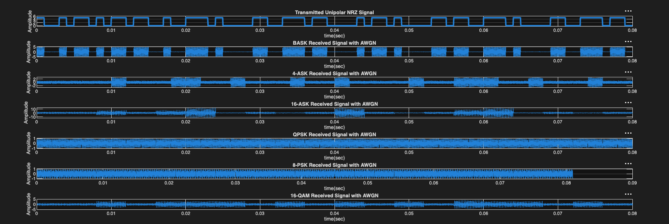

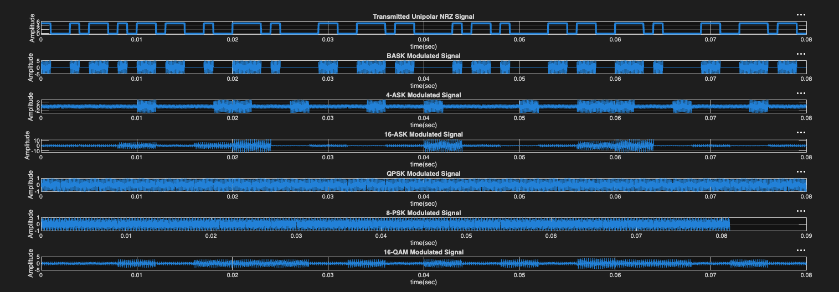
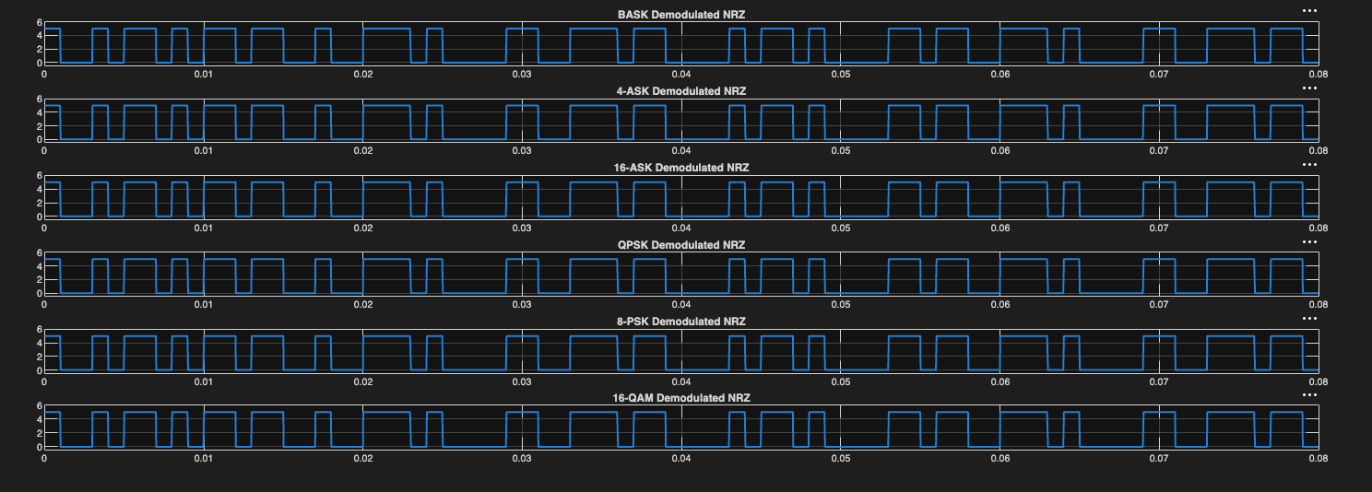
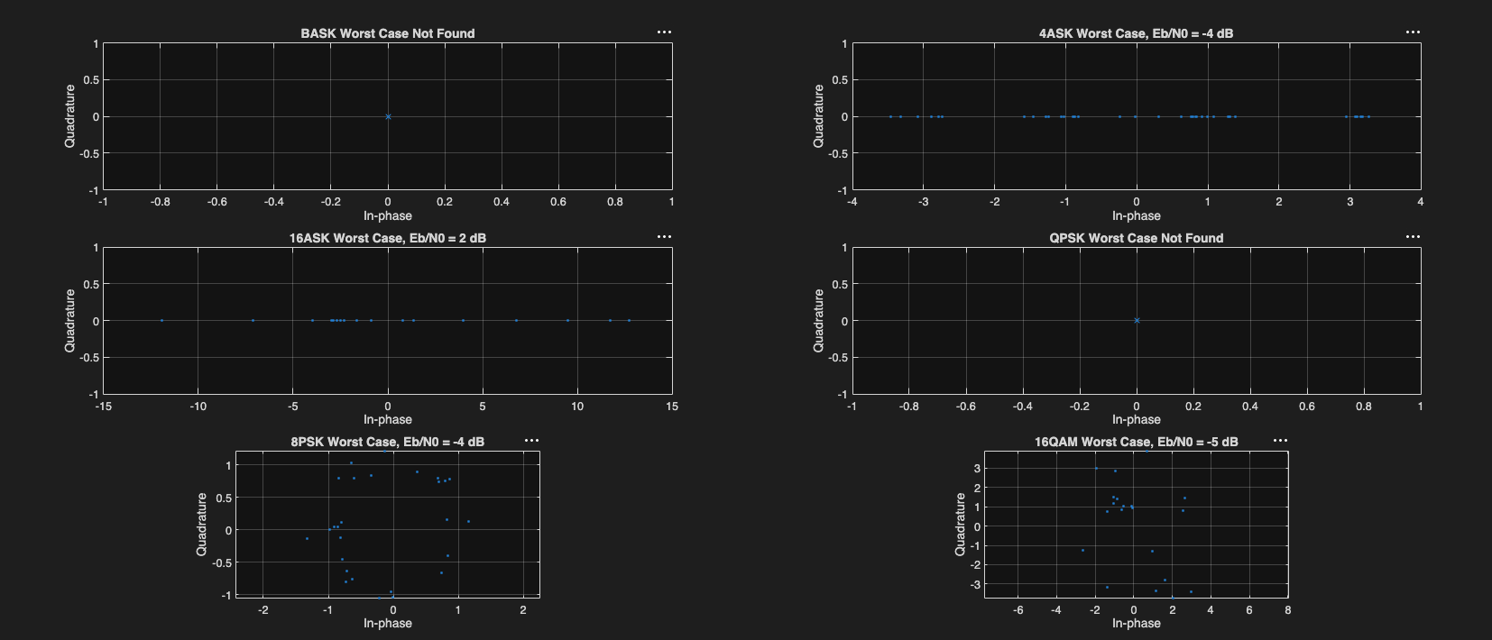
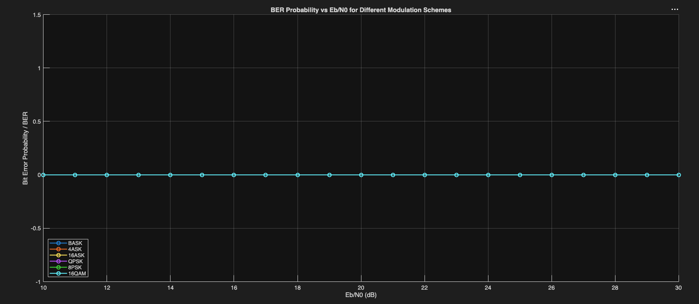

At the good channel condition, the value of Eb/N0 was calculated as:
good_EbNo_dB = VAL1 + 20
For this simulation, VAL1 = 7 Therefore:
Eb/N0 = 27 dB
At this 27 dB good channel condition, all modulation schemes successfully reconstructed the transmitted message. The transmitted message was: imranhasan
The message was first converted into ASCII binary using asc2bn().As it was a syncronus transmission, the transmitted binary sequence was directly assigned as:
x = b_data
Therefore, the total number of transmitted bits was:
10 characters × 8 bits = 80 bits
The unipolar NRZ signal was generated at a data rate of 1 kbps. In this signal, binary 1 was represented by 5V and binary 0 was represented by 0V.
Six modulation schemes were implemented and tested:
BASK
4-ASK
16-ASK
QPSK
8-PSK
16-QAM
For BASK, one bit was transmitted per symbol. For 4-ASK and QPSK, two bits were grouped together per symbol. For 8-PSK, three bits were grouped per symbol. For 16-ASK and 16-QAM, four bits were grouped per symbol.
Since some modulation schemes require fixed-size bit groups, zero padding was added when the bit length was not divisible by the number of bits per symbol. This padding was only used for modulation grouping and was removed after demodulation by cutting the recovered bitstream back to the original length. It was not a start bit or stop bit.
The demodulated NRZ plots looked almost the same for all schemes because all schemes recovered the same original binary sequence. This is expected because the final demodulated output represents only binary 1 and 0. If all schemes recover the message correctly, their demodulated NRZ waveforms will match.
The received constellation diagrams show how the symbols are affected by AWGN noise. For ASK modulation, BASK, 4-ASK, and 16-ASK constellation points appear on the real axis because only the amplitude changes. The quadrature component is zero. For PSK and QAM modulation, QPSK, 8-PSK, and 16-QAM constellation points appear on the I-Q plane because the signal contains both in-phase and quadrature components.
The modulation characteristics are:
BASK: 2 amplitude levels, 0 and 5
4-ASK: 4 amplitude levels, -3, -1, 1, 3
16-ASK: 16 amplitude levels from -15 to 15
QPSK: 4 phase points
8-PSK: 8 phase points
16-QAM: 16 I-Q grid points
In the good case, the received constellation points were close to their expected decision regions, so the message was recovered without error.
For Q9, the Eb/N0 value was reduced from 30 dB down to -5 dB to find the point where the received message could no longer be reconstructed correctly. The observed threshold result was:
BASK: Worst case not found
4-ASK: Worst case not found
16-ASK: Failed at Eb/N0 = 5 dB
QPSK: Worst case not found
8-PSK: Worst case not found
16-QAM: Failed at Eb/N0 = -5 dB
This means that, within the tested range, BASK, 4-ASK, QPSK, and 8-PSK did not fail for the short transmitted message IMRAN. This does not mean these schemes will never fail. It means that for this specific 40-bit message and this random AWGN condition, no reconstruction failure was found between 30 dB and -5 dB.
16-ASK failed at 5 dB because it has many amplitude levels placed close to each other. When noise increases, the detected amplitude can cross the decision boundary and become wrongly decoded.
16-QAM failed at -5 dB. Although 16-QAM also transmits 4 bits per symbol, it spreads its constellation points across both I and Q axes. Therefore, it generally performs better than 16-ASK under the same noisy condition.
The BER plot was generated for Eb/N0 values from 10 dB to 30 dB. Since the original message was short, the bit sequence was repeated many times to make the BER calculation more meaningful. In general, BER decreases as Eb/N0 increases. This is because higher Eb/N0 means the bit energy is stronger compared to the noise level.
The expected trend is:
Higher Eb/N0 means less noise effect and lower BER.
Lower Eb/N0 means more noise effect and higher BER.
Lower-order modulation schemes such as BASK and QPSK usually have better noise immunity because their decision regions are wider. Higher-order schemes such as 16-ASK and 16-QAM can send more bits per symbol, but they are more sensitive to noise.
Among the higher-order schemes, 16-QAM is generally better than 16-ASK because 16-QAM distributes the symbols in two dimensions using both I and Q components, while 16-ASK places all symbols only on one amplitude axis.
Conclusion:
This OEL simulation successfully designed and tested a digital communication system in MATLAB using the message IMRAN. The message was converted to ASCII binary, transmitted as a unipolar NRZ signal at 1 kbps, modulated using six modulation schemes, passed through an AWGN channel, demodulated, and reconstructed at the receiver.
At the good channel condition of Eb/N0 = 21 dB, all modulation schemes successfully recovered the original message.
The simulation showed that BASK uses simple on-off amplitude modulation. 4-ASK and 16-ASK use multiple amplitude levels. QPSK and 8-PSK use different phase positions. 16-QAM uses both amplitude and phase through I-Q components. Higher-order modulation sends more bits per symbol but is more sensitive to noise. 16-ASK was more sensitive to noise because its amplitude levels are closely spaced. 16-QAM provided better efficiency than 16-ASK because it uses two-dimensional I-Q mapping.
The worst-case threshold test showed that 16-ASK failed at 5 dB, while 16-QAM failed at -5 dB. Other modulation schemes did not fail within the tested range for the selected short message.
Therefore, for this simulation, 16-QAM provides a good balance between data rate and noise performance, while QPSK gives better reliability when robustness is more important than data rate.
Limitations:
The result depends on the random AWGN noise generated during simulation. Therefore, the exact threshold value can change slightly in different runs. Also, the transmitted message was short, so some schemes did not fail within the tested Eb/N0 range. A longer bitstream or repeated Monte Carlo simulation would give a more statistically reliable BER and threshold result.

