How to Make a YouTube Channel

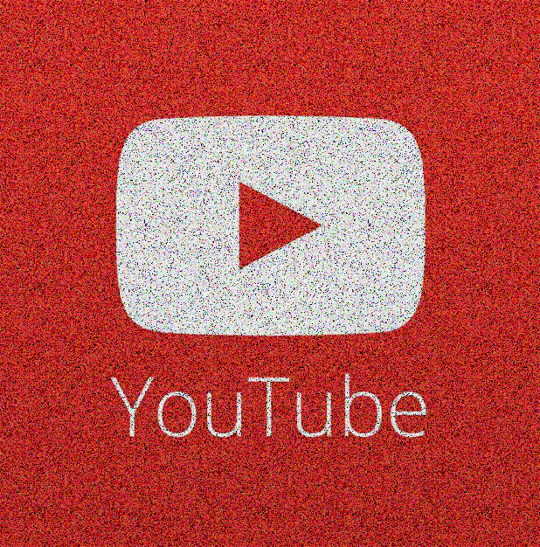

[This Photo](https://www.droidwiki.org/wiki/YouTube) by Unknown Author is licensed under [CC BY-SA](https://creativecommons.org/licenses/by-sa/3.0/)

M

aking a YouTube channel gives you a powerful platform to upload and share knowledge. You can also use YouTube to record your screen for free. In this article, I’ll show you

* Making a YouTube channel
* Customizing YouTube
  + Channel Art
  + Thumbnails

**YouTube**