HSC RESULT DATA ANALYSIS

1. Introduction

In this project we will study and analyse case study of HSC marks of previous 5 year(2011-2015) which is dependent on following 2 parameter:

1)Percentage students scoring:

a)Distinction b)First class c)Second class d)Fail

2)Percentage students passing each year

These analysis is done using python and we have studied various new functions

and modules in it.

The alignment standards should be as per in this provided sample document. Every image should have figure number and a label. and should be referred in the documentation by its number. Figures in section 1 should have numbers like fig. 1.1, fig. 1.2, etc. Figures in section 2 must be numbered as fig. 2.1…. so on.

1. Design

In our project we have made use of diferent modules or functions as discussed earlier. Let us see about them in details.

1. math module
   1. This module is always available. It provides access to the mathematical functions defined by the C standard.
   2. These functions cannot be used with complex numbers; use the functions of the

same name from the cmath module if you require support for complex numbers. The distinction between functions which support complex numbers and those which dont is made since most users do not want to learn quite as much mathematics as required to understand complex numbers.

1. matplotlib module
   1. Matplotlib is a Python 2D plotting library which produces publication quality figures in a variety of hardcopy formats and interactive environments across platforms.
   2. Matplotlib can be used in Python scripts, the Python and IPython shells, the Jupyter notebook, web application servers, and four graphical user interface tool 
   3. Matplotlib tries to make easy things easy and hard things possible.
2. pandas module
   1. Pandas is an open-source, BSD-licensed Python library providing high-performance, easy-to-use data structures and data analysis tools for the Python programming language. Python with Pandas is used in a wide range of fields including academic and commercial domains including finance, economics, Statistics, analytics, etc. Pandas library uses most of the functionalities of NumPy. 
   2. Various operations can be performed easily using pandas module.
3. REPORT ANALYSIS

Here we have used 4 types of graphs for analysis of HSC result which are as follows:

1. BAR GRAPH AND PLOT GRAPH :

In these graphs we have shown the percentage of students who have scored: distinction, first class, second class, who passed and who failed.

The following graphs are shown as below:

**Student passed with distinction**

In the following graph we have shown a bar graph and plot graph of students scoring distinction in 2011, 2012, 2013, 2014, 2015. In year 2015 more students passed in distinction in comparison with other years result. From the following graph observe that in 2015 almost 26.4% are pass in the exam with distinction which is maximum in five year.

 

**Student passed with First Class**

In the following graph we have shown a bar graph and plot graph of students passed with first class in 2011, 2012, 2013, 2014, 2015. . In year 2014 more students passed with first class in comparison with other years result. From the following graph observe that in 2014 almost 25.3% are pass with First class which is maximum in five year.



**Student passed with Second Class**

In the following graph we have shown a bar graph and plot graph of students passed with second class in 2011, 2012, 2013, 2014, 2015 . . In year 2011 more students passed in second class in comparison with other years result. From the following graph observe that in 2011 almost 34.5% are pass in the exam with Second Class which is maximum in five year.



**Student passed in each year**

In the following graph we have shown a bar graph and plot graph of students who fail in exam in 2011, 2012, 2013, 2014, 2015. In year 2013 more students passed in comparison with other years result. From the following graph observe that in 2013 almost 84% are pass in the exam which is maximum in five year.



**Student fail in exam**

In the following graph we have shown a bar graph and plot graph of students who fail in exam in 2011, 2012, 2013, 2014, 2015.In 2012 most number of students failed in comparison with other years. From the following graph observe that in 2011 almost 18% are fail in the exam which is maximum in five year.

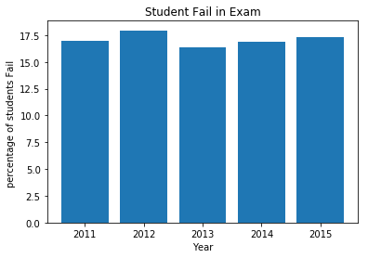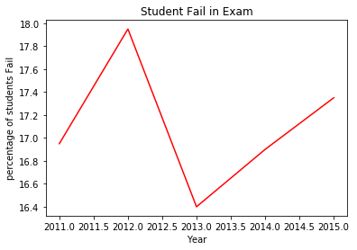

1. **HISTOGRAM GRAPH:**

Histogram graphs look as follows. Here we have combined the percentage of marks of Physics, Chemistry, Hindi, English, Chemistry and Biologyin 2011. The colours are also provided by the function so that we same separate and visualise marks.

Year 2011

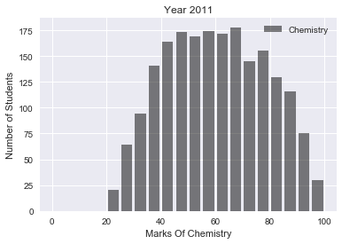 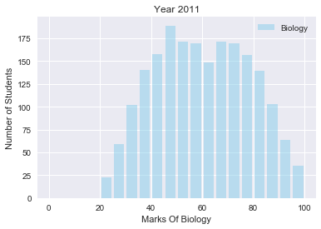

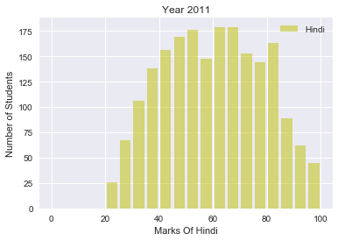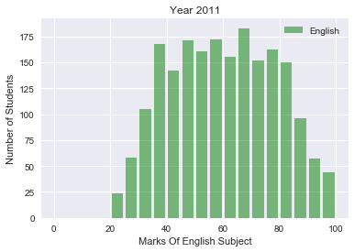

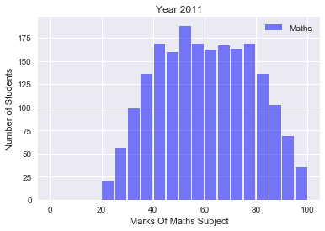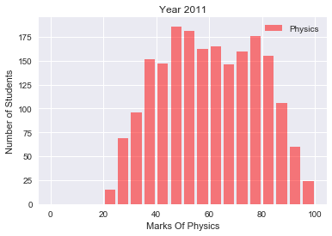

In year 2011 in subject Chemistry students getting marks between 65-70 are more compared to others. In Biology students getting 45-50 are large in numbers. In Hindi many students got marks between 60-80. In English many students got between 65-70.In Maths most of the students got between 55-60.and in Physics between 45-50.

Year 2012

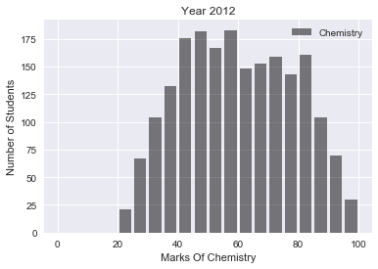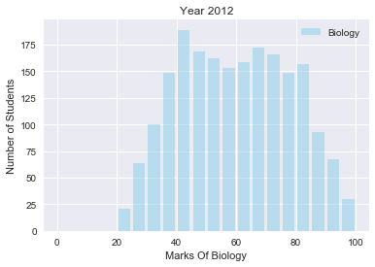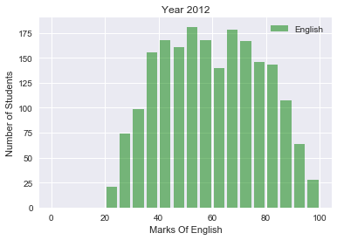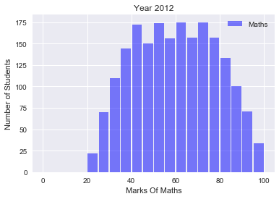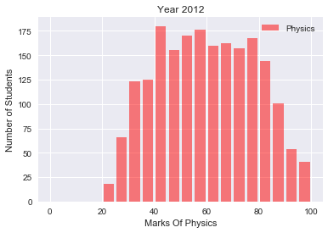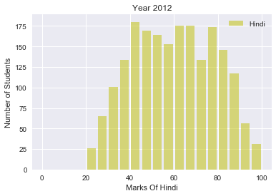

In year 2012 in subject Chemistry most of the students getting marks between 40-60 as compared to others. In Biology students getting 40-45 are large in numbers. In Hindi many students got marks between 40-45. In English many students got between 60-65.In Maths most of the students got between 55-60.and in Physics between 40-45.

Year 2013

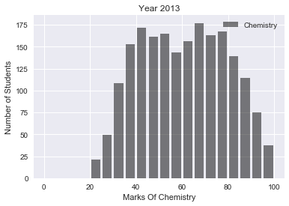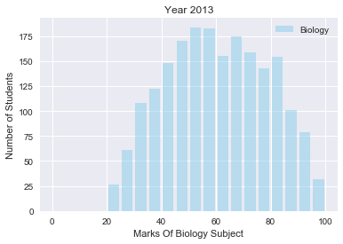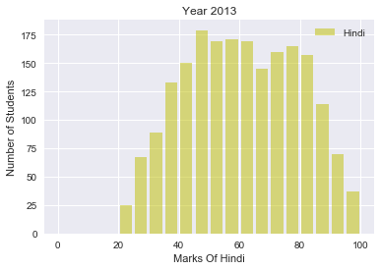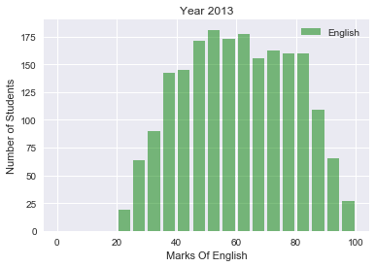

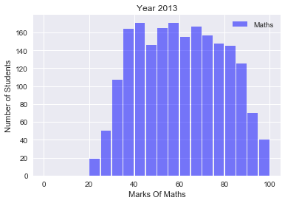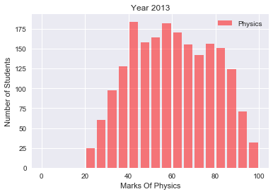

In year 2013 in subject Chemistry students getting marks between 65-70 are more compared to others. In biology students getting 45-50 are large in numbers. In Hindi many students got marks between 60-80. In English many students got between 65-70.In maths most of the students got between 55-60.and in physics between 45-50.

Year 2014

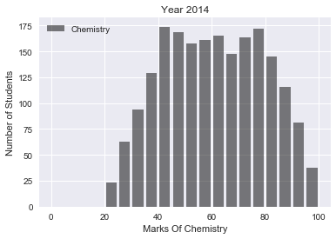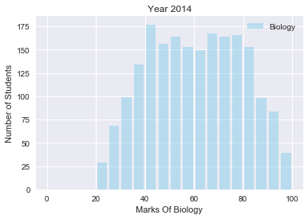 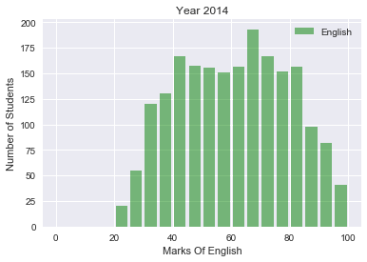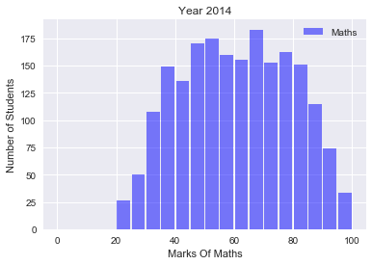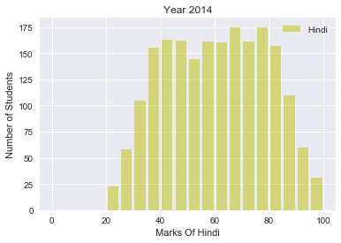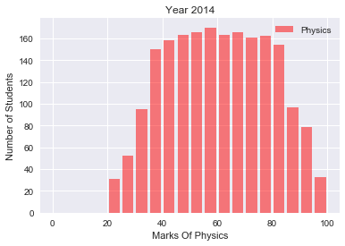

In year 2014 in subject Chemistry students getting marks between 65-70 are more compared to others. In Biology students getting 45-50 are large in numbers. In Hindi many students got marks between 60-80. In English many students got between 65-70.In Maths most of the students got between 55-60.and in Physics between 45-50.

Year 2015

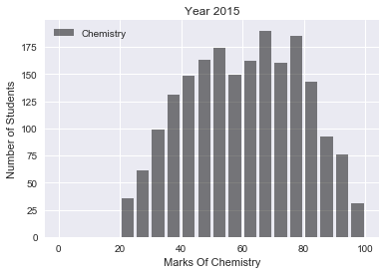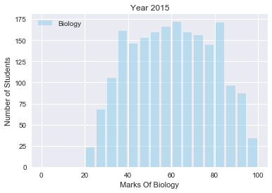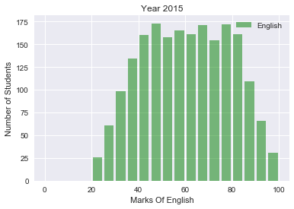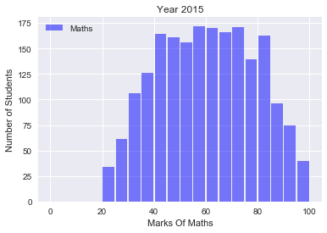

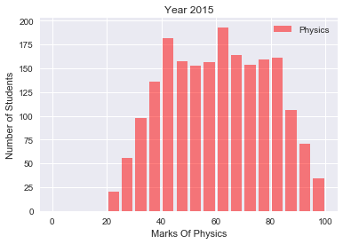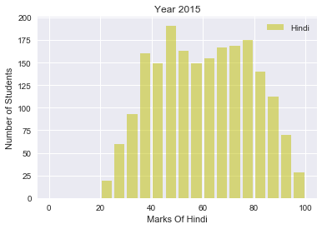

In year 2015 in subject Chemistry students getting marks between 65-70 are more compared to others. In Biology students getting 60-65 and 80-85 are large in numbers. In Hindi many students got marks between 45-50 and 75-80. In English many students got between 45-50.In maths most of the students got between 65-75 and in Physics between 60-65.

4)Pie Chart

In this graph we have represented the percentage of students who passed with distinction , first class, second class and failed students in the form of pie chart in each year.

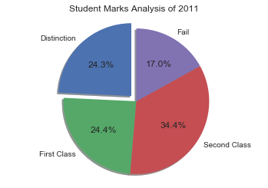

In year 2011 24.3% students passed with distinction , 24.4% students passed with first class , 34.4% students passed with second class and 17% students failed in examination. From the above Pie Chart we observe that in 2011 maximum number of student pass with Second Class .

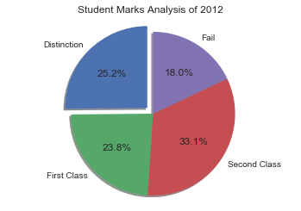

In year 2012 25.2% students passed with distinction , 23.8% students passed with first class , 33.1% students passed with second class and 18% students failed in examination . In this year also maximum student pass with Second Class

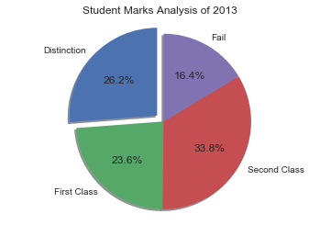

In year 2013 26.2% students passed with distinction , 23.6% students passed with first class , 33.8% students passed with second class and 16.4% students failed in examination. In the year minimum number of student Fail in the exam.

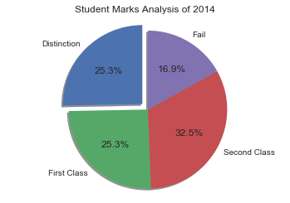

In year 2014, 25.3% students passed with distinction , 25.3% students passed with first class , 32.5% students passed with second class and 16.9% students failed in examination. In this year number of student who pass with Distinction and number of who pass with First class is same.

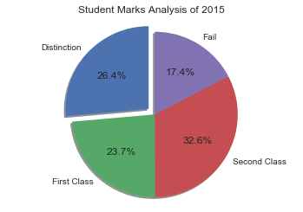

In year 2015, 26.4% students passed with distinction , 23.7% students passed with first class , 32.6% students passed with second class and 17.4% students failed in examination . In this year also maximum student pass with Second Class .

GITHUB LINK:

<https://github.com/imranpro/HSC-Result-Data-Analysis>

CONCLUSION:

We have studied various functions and modules in python from various modules like matplotlib , pandas etc. Also we have studied the case stude of data analysis of marks of HSC of previous 5 years.

REFERENCES:

www.tutorialspoint.com

[www.datacamp.com](http://www.datacamp.com)

matplotlib.org

pandas.pydata.org/pandas-docs **PROJ ECT TEAM**

SEA447-UZMA KAZI

SEA448-NIKHIL KESARKAR

SEA449-IMRAN KHAN

SEA450-YASH KHARADE

SEA451-OMKAR KHOT