**Air Pollution Monitoring Using NodeMCU and MQ135 Gas Sensor**

**SUBMITTED BY**

|  |  |  |
| --- | --- | --- |
| **NAME** | **REGD.NO** | **ROLL NO.** |
| **MD IMRAN** | **12115224** | **65** |
| **AQEEL RAI** | **12113416** | **51** |
| **KM NEHA** | **12114845** | **58** |
| **SUDHEER SINGH CHAUHAN** | **12114854** | **60** |

Under the Guidance

**DR. B. ARUN KUMAR**

School of Computer APPLICATION

Lovely Professional University, Phagwara

**(17 NOVEMBER 2022)**

**CONTENTS**

|  |  |
| --- | --- |
| DECLARATION | **2** |
| ACKNOWLEDGEMENT | **3** |
| ABSTRACT | **3** |
| INTRODUCTION | **4** |
| COMPONENTS REQUIRED | **5** |
| [MQ135 gas sensor](https://quartzcomponents.com/products/mq-135-air-quality-gas-sensor-module) | **5** |
| ESP8266 NodeMCU CP2102 Wi-Fi Development Board | **6** |
| 16x2 LCD Display (Green Backlight) | **8** |
| 10K Ohm Preset Potentiometer (POT) | **9** |
| MB102 Colored Breadboard - 830 Points | **10** |
| Male to Male and Female to Male Jumper Wires Combo | **10** |
| **BRIEF OVERVIEW OF MQ135 SENSOR** | **11** |
| diagram of air pollution monitoring system | **13** |
| Code | **14** |

**DECLARATION**

We hereby declare that we have completed our project (**AIR POLLUTION** **MONITORING SYSTEM**) at NODEMCU under the guidance of DR. **B. ARUN KUMAR.** We have worked full dedication during our project work for the award of degree of MCA (SCA), Lovely Professional University, Phagwara.

**Date – 17 NOV 2022**

**ACKNOWLEDGEMENT**

Primarily, we would like to thank God for being able to learn a new technology (**INTERNET OF THINGS**). Then We would like to express our special thanks of gratitude to the teacher and instructor of the course NodeMcu who provide us the golden opportunity to learn a new technology from home.

We would like to also thank our college **Lovely Professional University** for offering such a course which not only improved our electronic programming skill but also taught us other new technology.

Then we would like to thank my teacher and friends who have helped me with their valuable suggestions and guidance in choosing this course.

Finally, we would like to thank my all classmates who have helped us a lot and **ECE662** class teacher (**Arun sir**).

**ABSTRACT**

The air pollution rates now a days are drastically increasing in all the developed and the developing countries, which requires a more portable and cost-effective solution. The proposed system includes a design for monitoring air pollution and creating awareness among the public. This paper aims at using IOT along with cloud to make the services real time and faster. The proposed system is installed in a particular locality where there is acute air pollution. The level of each hazardous pollutant is monitored at periodic intervals. The Air Quality Index (AQI) for the observed pollutants is determined and awareness is created among the public through an android app which displays the level of each observed pollutant and the air quality index in that location. Thus, the quality of air in that area can be understood by the public by viewing the concentration of the gases in both numerical and graphical format. Further this system is to be extended in future by allowing the public to register themselves in an app which pushes weekly or monthly air quality report through message which reaches the user as a notification that is more comfortable in access.

**INTRODUCTION**

Air pollution is the worst environmental problem, and it causes a multitude of adverse effects on human health, water bodies and climate. The main source of air pollution in all major cities is due to vehicles and the second major source remains industries. The massive use of vehicles has resulted in a vital increase in toxins in the atmosphere. This is the cause of environmental pollution affecting human health. It has also resulted in other respiratory problems like asthma attacks and skin rashes. The Central Pollution control board has set a standard to these levels, but the public is reluctant to follow them. The pollutants which spoil the air are invisible, which has led to the negligence of the people. So, public acknowledgement is the prime requisite of today. Hence the proposed system solves this major issue. The air pollution monitoring system is installed in a particular locality where there are traces of acute air pollution to detect the constituent gases of air which may lead to harmful effects on human health and other living beings This system uses NodeMcu and several gas sensors to predict the level of various harmful gases like CO, NH3, particulate matter and smoke. Carbon Monoxide is given the highest preference, as it is a greenhouse gas and a major pollutant that is warming the earth. The previous products did not have an advantage of getting the pollution rates up to date. So, to overcome this, an android app is used, which the public can install to get regular updates on the quality of air in the area they live. The measured air quality level is also displayed in an android application which helps the users in getting updates about the current air quality. Users can view the air quality level in numerical as well as graphical format. In addition, the Air Quality Index (AQI) for the current pollution level is determined and displayed in the application along with health effects. Thus, this application lets the users take effective measures in advance to protect themselves from harmful effects.

There are [different types of gas sensors](https://quartzcomponents.com/pages/search-results-page?q=gas+sensor) to detect different gases. Here in this project, we are going to use **MQ135 gas sensor** to sense the pollution content in the surrounding area and then to monitor these values over the Webpage. The circuit consists of a simple connection and takes fewer components to have your own **IoT based air pollution monitoring system**. In this project, at first, we will be knowing about the MQ135 sensor and its internal circuit. Later we will be building an air pollution monitoring system using nodeMCU and MQ135 gas sensor and interface an LCD (16X2) display to nodeMCU, to show the pollution content value. Later, we will connect the nodeMCU to our LAN, by providing the SSID and password credentials and then we will be generating a webpage where we send the sensor data. The page will be refreshed for every time interval to show the updated values….

**COMPONENTS REQUIRED**

1.[MQ135 gas sensor](https://quartzcomponents.com/products/mq-135-air-quality-gas-sensor-module) (Smoke sensor)

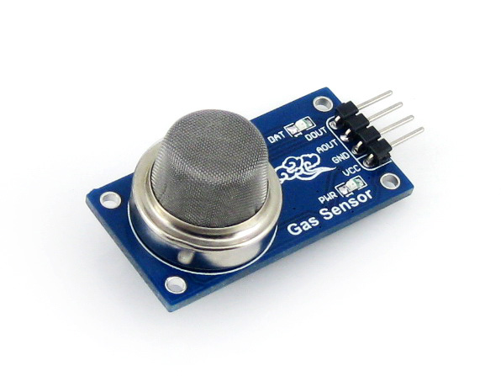

The MQ135 sensor is one of the most widely used in the MQ sensor series. It is a MOS (Metal Oxide Semiconductor) sensor. Metal oxide sensors are also known as **Chemoreceptors**because sensing is based on the change in resistance of the sensing material when exposed to gases.

The MQ135 gas sensor operates on 5V DC and consumes approximately 800mW.Itcandetect **LPG**, **Smoke**, **Alcohol**, **Propane**, **Hydrogen**, **Methane** and **Carbon Monoxide** concentrations ranging from 200 to 10000 ppm.

MQ135 has 4 pins.

* VCC (Positive)
* GND (Negative)
* D0 (Digital pin)
* A0 (Analog pin)

2.ESP8266 NodeMCU CP2102 Wi-Fi Development Board

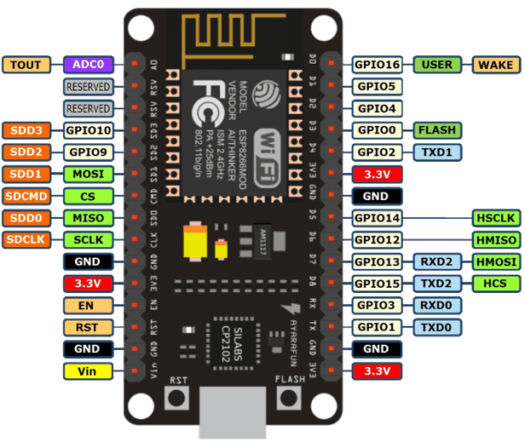

There are four power pins. **VIN** pin and three **3.3V** pins.

* **VIN** can be used to directly supply the NodeMCU/ESP8266 and its peripherals. Power delivered on **VIN** is regulated through the onboard regulator on the NodeMCU module – you can also supply 5V regulated to the **VIN** pin.
* **3.3V** pins are the output of the onboard voltage regulator and can be used to supply power to external components.

are the ground pins of NodeMCU/ESP8266.



 NodeMCU/ESP8266 has 17 GPIO pins which can be assigned to functions such as I2C, I2S, UART, PWM, IR Remote Control, LED Light and Button programmatically. Each digital enabled GPIO can be configured to internal pull-up or pull-down or set to high impedance. When configured as an input, it can also be set to edge-trigger or level-trigger to generate CPU interruptions.

 The NodeMCU is embedded with a 10-bit precision SAR ADC. The two functions can be implemented using ADC. Testing power supply voltage of VDD3P3 pin and testing input voltage of TOUT pin. However, they cannot be implemented at the same time.

 NodeMCU/ESP8266 has 2 UART interfaces (UART0 and UART1) which provide asynchronous communication (RS232 and RS485) and can communicate at up to 4.5 Mbps. UART0 (TXD0, RXD0, RST0 & CTS0 pins) can be used for communication. However, UART1 (TXD1 pin) features only data transmitting signal so, it is usually used for printing logs.

 NodeMCU/ESP8266 features two SPIs (SPI and HSPI) in slave and master modes. These SPIs also support the following general-purpose SPI features:

* 4 timing modes of the SPI format transfer
* Up to 80 MHz and the divided clocks of 80 MHz
* Up to 64-Byte FIFO

 The board has 4 channels of Pulse Width Modulation (PWM). The PWM output can be implemented programmatically and used for driving digital motors and LEDs. PWM frequency range is adjustable from 1000 μs to 10000 μs (100 Hz and 1 kHz).

 are used to control the NodeMCU/ESP8266. These pins include Chip Enable pin (EN), Reset pin (RST) and WAKE pin.

* **EN:** The ESP8266 chip is enabled when EN pin is pulled HIGH. When pulled LOW the chip works at minimum power.
* **RST:** RST pin is used to reset the ESP8266 chip.
* **WAKE:** Wake pin is used to wake the chip from deep sleep.

 Control Pins are used to control the NodeMCU/ESP8266. These pins include Chip Enable pin (EN), Reset pin (RST) and WAKE pin.

* **EN:** The ESP8266 chip is enabled when EN pin is pulled HIGH. When pulled LOW the chip works at minimum power.
* **RST:** RST pin is used to reset the ESP8266 chip.
* **WAKE:** Wake pin is used to wake the chip from deep sleep.

3.16x2 LCD Display (Green Backlight)

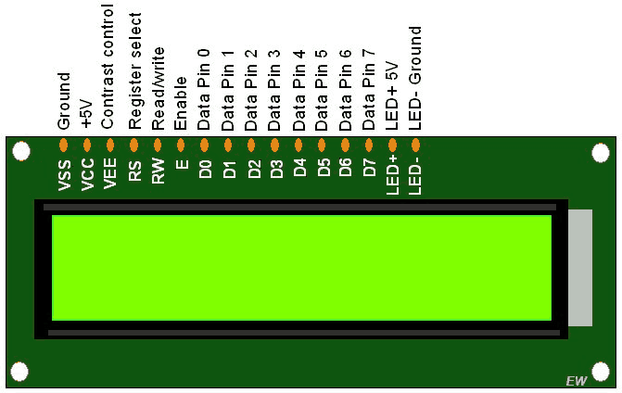

In LCD 16×2, the term LCD stands for Liquid Crystal Display that uses a plane panel display [technology](https://www.watelectronics.com/what-is-nanotechnology-types-and-its-applications/), used in screens of computer monitors & TVs, smartphones, tablets, mobile devices, etc. Both the displays like LCD & CRTs look the same but their operation is different. Instead of electrons diffraction at a glass display, a liquid crystal display has a backlight that provides [light](https://www.watelectronics.com/how-traffic-light-control-system-works/) to each pixel that is arranged in a rectangular [network](https://www.watelectronics.com/what-is-network-simulation-various-simulators-tools/).

4.10K Ohm Preset Potentiometer (POT)

A 10K Potentiometer is also known as a variable resistor. This Potentiometer is great for controlling the contrast on your LCD. This 10K potentiometer pinout is a variable resistor that can control the contrast on an LCD display.

5.MB102 Colored Breadboard - 830 Points

A breadboard is used to make up **temporary circuits** for testing or to try out an idea. No soldering is required so it is easy to change connections and replace components. Parts are not damaged and can be re-used afterwards.

**6.**Male to Male and Female to Male Jumper Wires Combo (Set Of 10+10)

A jumper wire is an electric wire that connects remote electric circuits used for printed circuit boards. By attaching a jumper wire on the circuit, it can be short-circuited and short-cut (jump) to the electric circuit.

7.BUZZER

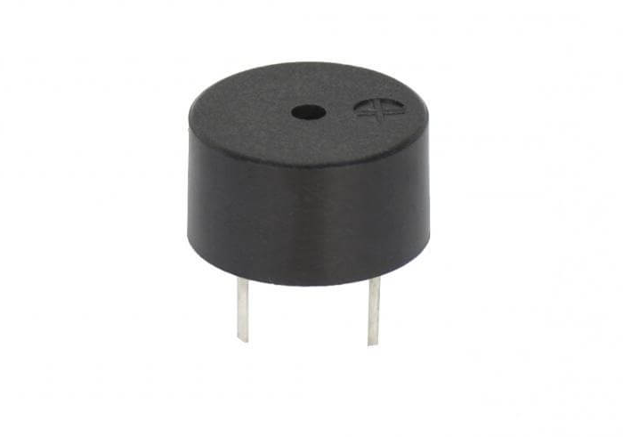

**It is a two leg device the longer leg is positive. If voltage is supplied it generates beep sound. Through analog write volume of beep can be controlled. If a buzzer is switched with different time intervals it generates a melody. This tutorial is for NodeMCU on Arduino IDE.**

**BRIEF OVERVIEW OF MQ2 SENSOR**

The MQ2 sensor is like a variable resistor, whose resistance depends on the gases surrounding it. To sense the gases, the MQ2 sensor contains a gas sensing material that is made up of SnO2. An electrode and electrode line of materials Au and Pt is present in the MQ2 sensor. A heater coil that is made up of Ni-Cr alloy, is used to provide the necessary working conditions for the sensor to work.  The MQ2 gas sensor is available in two formats, one in only sensor format and the other in module form. The difference between them is that the module format sensor contains an extra pin D0 along with an A0 pin, which gives only digital value. To find the ppm or to get the analog value, we will be using the A0 pin. As I am having the module format of the MQ2 sensor, I'm using this module in this project. The **MQ2 sensor module** contains four pins Vcc, GND, D0, and A0. Their connections will be shown in the circuit diagram section.

### ****IOT AIR POLLUTION MONITORING CIRCUIT DIAGRAM****

### The connections for the MQ2 gas sensor module and 16x2 LCD are shown below. The Vin pin and GND pin of the NodeMCU are connected to the power rails of the [Breadboard](https://quartzcomponents.com/products/colored-breadboard-mb-102-830-point), as shown in the below diagram. The VCC and GND pin of the [MQ2 gas sensor](https://quartzcomponents.com/products/mq-135-air-quality-gas-sensor-module), is connected to the positive and negative rail of the breadboard.

### Note: Potentiometer’s fixed ends are connected to the positive and ground rail of the breadboard, and its variable end, is connected to the 3rd pin (pin VEE) of the LCD (16X2). The remaining connection for the Lcd to nodeMCU are as follows:

|  |  |  |
| --- | --- | --- |
| s.no | ****LCD pins**** | ****Description**** |
| 1. | DB4 | Connected to the D4 pin of the nodeMCU |
| 2. | DB5 | Connected to the D5 pin of the nodeMCU |
| 3. | DB6 | Connected to the D6 pin of the nodeMCU |
| 4. | DB7 | Connected to the D7 pin of the nodeMCU |
| 5. | LED+ | Connected to the positive supply terminal of the power rail |
| 6. | LED- | Connected to the Ground supply terminal of the power rail |
| 7. | VSS | Connected to the ground terminal of the power rail. |
| 8. | Vcc | Connected to the positive supply of the power rail |
| 9. | vee | Check the above note |
| 10. | RS | Connected to the D0 terminal of the nodeMCU |
| 11. | R/W | Connected to the ground of the power rail |
| 12. | E | Connected to the D1 pin of the nodeMCU |

### NodeMCU IoT Air Pollution Monitoring System Circuit Diagram



### (diagram of air pollution monitoring system)

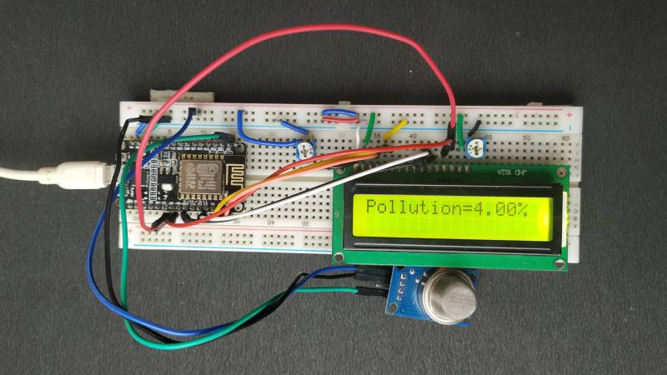

**Code**

**#include<ESP8266WiFi.h>**

**#include <ThingSpeak.h>**

**#include <LiquidCrystal.h>**

**LiquidCrystal lcd(D5, D4, D3, D2, D1, D0);**

**const int aqsensor = A0;**

**WiFiClient client;**

**long myChannelNumber = 1933420;**

**const char myWriteAPIKey[] = "VYJRSAWOA5RQFKD5";**

**void setup()**

**{**

**pinMode(D8, OUTPUT);**

**pinMode (aqsensor, INPUT); // MQ135 is connected as INPUT to ESP-8266**

**Serial.begin (115200);**

**lcd.clear(); // clear lcd**

**lcd.begin (16, 2);**

**WiFi.begin("Chauhan", "sudheer7");**

**{**

**delay(200);**

**Serial.print("..");**

**}**

**Serial.println();**

**Serial.println("NodeMCU is connected");**

**ThingSpeak.begin(client);**

**}**

**void loop() {**

**int ppm = analogRead(aqsensor); //read MQ135 analog outputs at A0 and store it in ppm**

**Serial.print("Air Quality:"); //print message in serail monitor**

**Serial.println(ppm); //print value of ppm in serial monitor**

**lcd.setCursor(0, 0); // set cursor of lcd to 1st row and 1st column**

**lcd.print("Air Quality : "); // print message on lcd**

**lcd.print(ppm); // print value of MQ135**

**lcd.setCursor(0, 1);**

**if (ppm < 180)**

**{**

**lcd.print("Safe Zone");**

**digitalWrite(D8, LOW);**

**}**

**else**

**{**

**lcd.print("Danger Zone");**

**digitalWrite(D8, HIGH);**

**}**

**delay(1000);**

**ThingSpeak.writeField(myChannelNumber, 1, ppm, myWriteAPIKey);**

**delay(100);**

**}**