Design and Development of Online School Management Website
Design Document

Version 1.0

Revision History
Date (dd/mm/yyyy) | Version | Description | Author
4/7/2019 | 1.0 | This project is an Internet based school management site that enables school management to effectively organize school activities. This web application will provide a centralized interface to management to monitor student’s status and manage financial fee related issues. Separate interfaces with limited access features will be provided to the students and their parents to monitor their progress in various subjects. | Test User

Table of Contents

- Introduction of Design Document
- Entity Relationship Diagram (ERD)
- Sequence Diagrams
- Architecture Design Diagram
- Class Diagram
- Database Design
- Interface Design
- Test Cases

Design Document

- Introduction of Design Document
This Software Design Description (SDD) describes the detailed structure of the components of the Online School Management Website and the precise implementation details required to satisfy the requirements as specified in the Software Requirements Specification (SRS). It is assumed that the reader has read the SRS, since this document also defines the implementation details of the desired behavior given the requirements within it. This document will build heavily on the Software Architecture Design Description (SDD) and so knowledge of the general system architecture is recommended prior to commencing this document.
Aim
The design description defined in this document serves multiple purposes:
• To describe the functional structure, data and algorithms to be implemented.
• To identify required system resources.
• To be used to assess the impact of requirement changes.
• To assist in producing test cases.
• To aid in maintenance activities.

- Entity Relationship Diagram (ERD)
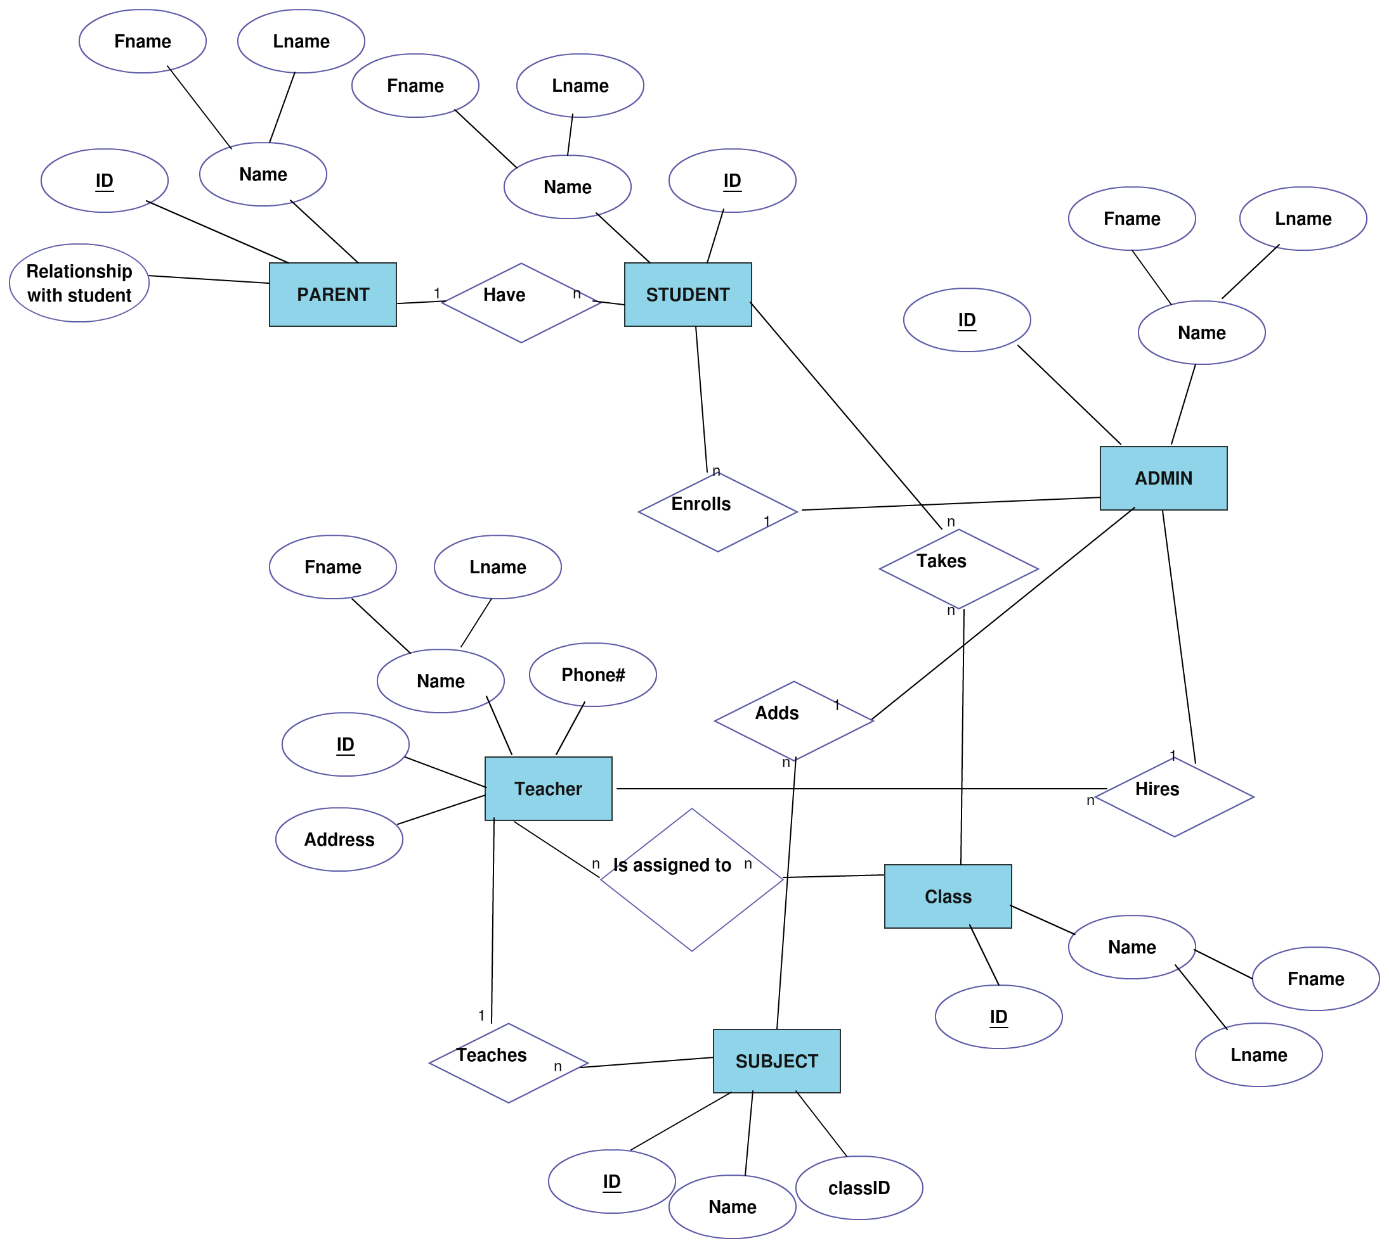

- Sequence Diag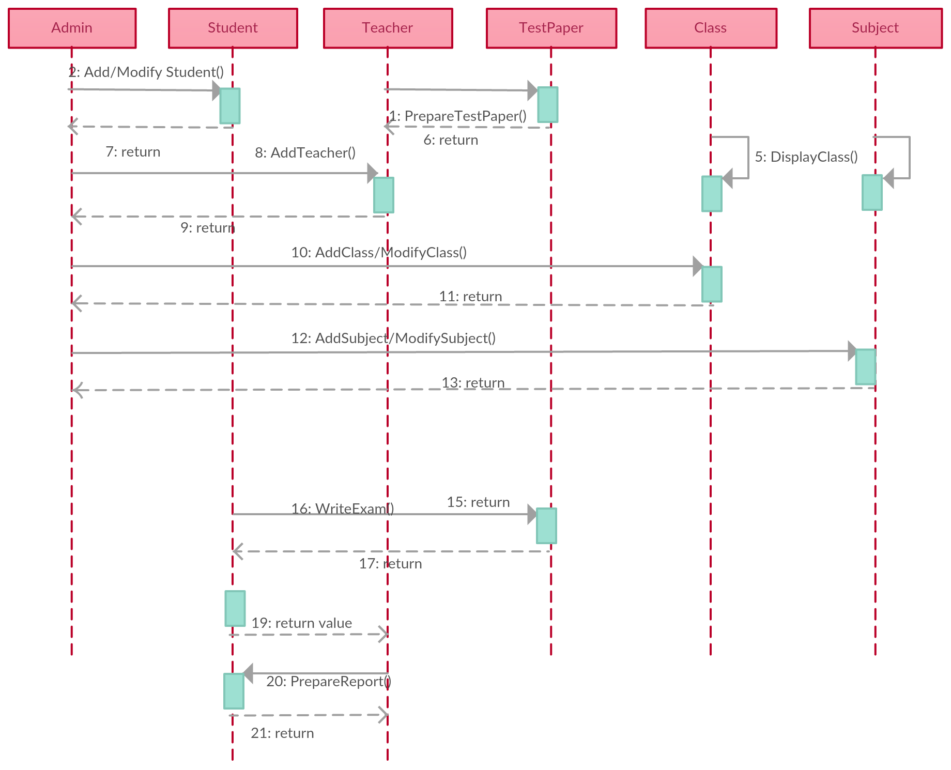
- Architecture Design Diagram

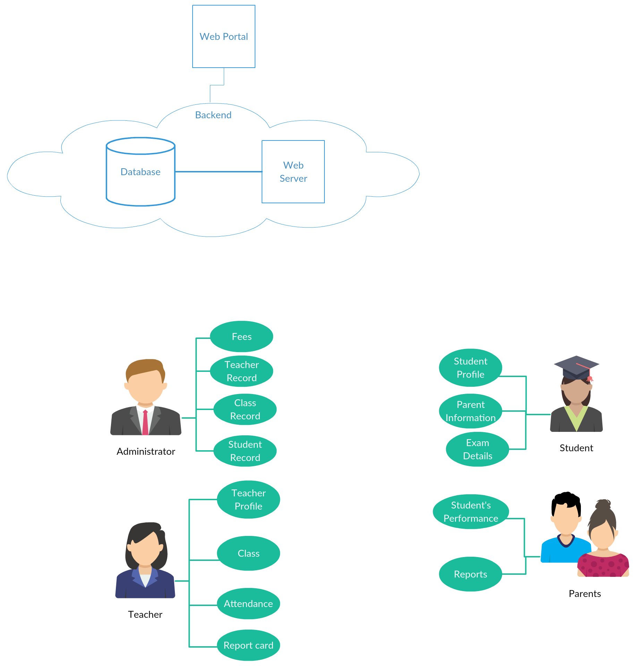

- Class Diagram

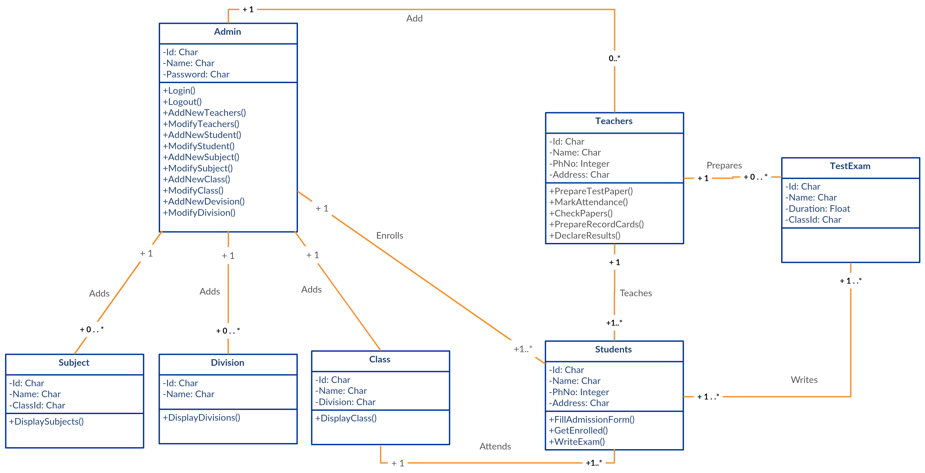

- Database Design

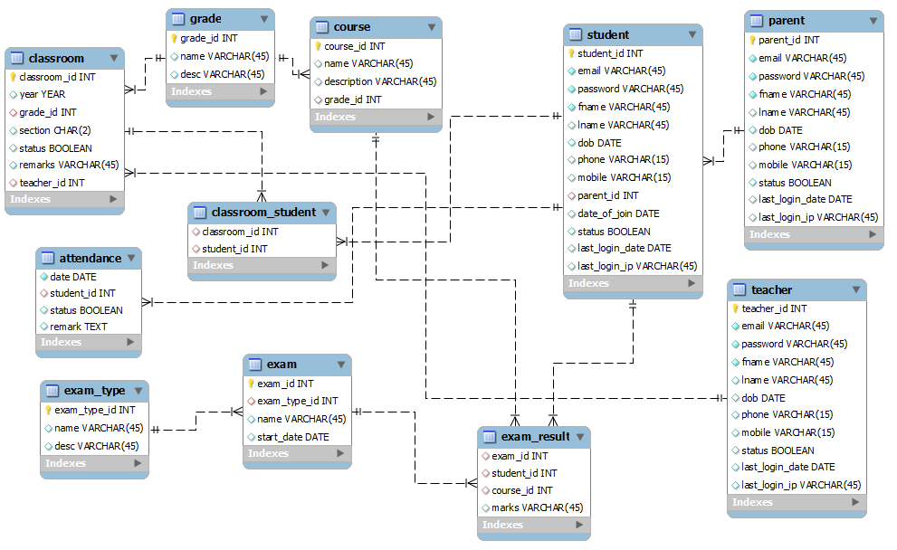

- Interface Design

Admin, Student, Teacher, Parent Login Screen

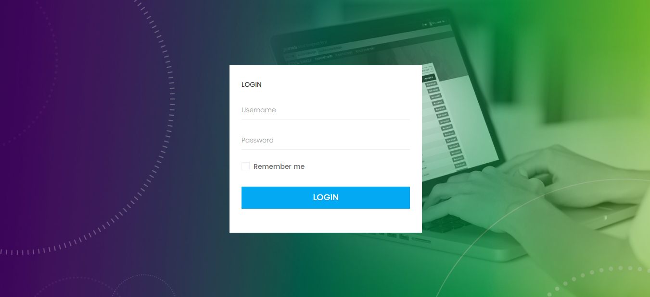

Admin Dashboard

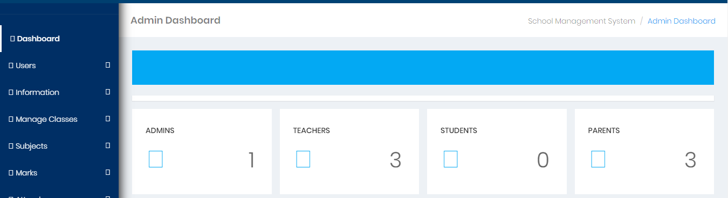

Add New Student

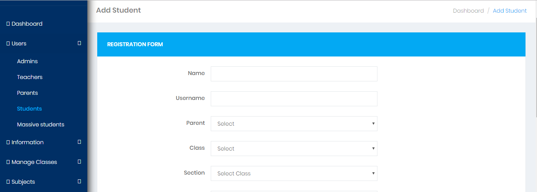

Add New Teacher

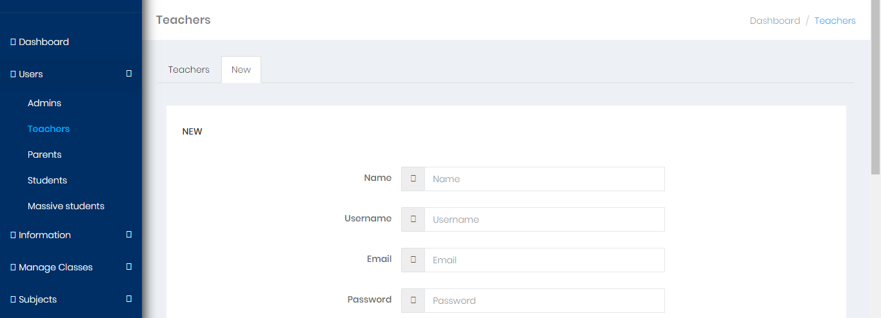

- Test Cases

Use Case Title | Login
Use Case Id | UC01
Actor(s) | Admin, Registered User(Student, Parent)
Pre-conditions | User must be registered in the system.  User must be on the login page of the website.
Actions | - User enters the required fields and clicks on the Login button.  - System validates the fields and user role from database and allows the user to login into the system.
Post-conditions | User successfully logged in into the system.
Author | MC150201295
Exceptions | Exception-1: Empty fields cannot be submitted.  Exception-2: Wrong username or password.

Use Case Title | Classes
Use Case Id | UC02
Actor(s) | Admin
Pre-conditions | User should be logged in.  User must be an Admin.  User must be on classes page.
Actions | - User clicks on the classes link to view all the classes.  - System gets all the classes from the database and shows it to the user.
Post-conditions | User successfully viewed the list of classes available.
Author | MC150201295
Exceptions

Use Case Title | Add Class
Use Case Id | UC03
Actor(s) | Admin
Pre-conditions | User should be logged in.  User must be an Admin.  User must be on classes page.
Actions | - User clicks on the Add Class button.  - System opens a new page to add a class.  - User enters all the required details.  - User clicks on the Add button to add the class into the system.  - System validates the required fields and registers the class into the database.
Post-conditions | User successfully added a new class into the system.
Author | MC150201295
Exceptions | Exception-1: Empty fields cannot be submitted.  Exception-2: Duplicate class name is not allowed.

Use Case Title | Update Class
Use Case Id | UC04
Actor(s) | Admin
Pre-conditions | User should be logged in.  User must be an Admin.  User must be on classes page.
Actions | - User clicks on the Edit button available against each classes listed on the Classes page.  - System opens a new page containing the class details.  - User modifies the fields and clicks on the Update button.  - System validates the required fields and updates the class in the database.
Post-conditions | User successfully updated a class from the system.
Author | MC150201295
Exceptions | Exception-1: Empty fields cannot be submitted.  Exception-2: Duplicate class name is not allowed.

Use Case Title | Students
Use Case Id | UC05
Actor(s) | Admin
Pre-conditions | User should be logged in.  User must be an Admin.  User must be on student’s page.
Actions | - User clicks on the student’s link to view all the students.  - System gets all the students from the database and shows it to the user.
Post-conditions | User successfully viewed the list of students available.
Author | MC150201295
Exceptions

Use Case Title | Add Student
Use Case Id | UC06
Actor(s) | Admin
Pre-conditions | User should be logged in.  User must be an Admin.  User must be on student’s page.
Actions | - User clicks on the Add Student button.  - System opens a new page to add a new student.  - User enters all the required details.  - User clicks on the Add button to add the student into the system.  - System validates the required fields and registers the student into the database.
Post-conditions | User successfully added a new student into the system.
Author | MC150201295
Exceptions | Exception-1: Empty fields cannot be submitted.  Exception-2: Duplicate Role id is not allowed.

Use Case Title | Update Student
Use Case Id | UC07
Actor(s) | Admin
Pre-conditions | User should be logged in.  User must be an Admin.  User must be on student’s page.
Actions | - User clicks on the Edit button available against each student’s listed on the student’s page.  - System opens a new page containing the student details.  - User modifies the fields and clicks on the Update button.  - System validates the required fields and updates the student information in the database.
Post-conditions | User successfully updated student from the system.
Author | MC150201295
Exceptions | Exception-1: Empty fields cannot be submitted.  Exception-2: Duplicate Role id is not allowed.

Use Case Title | Subjects
Use Case Id | UC08
Actor(s) | Admin
Pre-conditions | User should be logged in.  User must be an Admin.  User must be on subject’s page.
Actions | - User clicks on the subject’s link to view all the subject’s.  - System gets all the subject’s from the database and shows it to the user.
Post-conditions | User successfully viewed the list of subject’s available.
Author | MC150201295
Exceptions

Use Case Title | Add Subject
Use Case Id | UC09
Actor(s) | Admin
Pre-conditions | User should be logged in.  User must be an Admin.  User must be on subject’s page.
Actions | - User clicks on the Add Subject button.  - System opens a new page to add a subject.  - User enters all the required details.  - User clicks on the Add button to add the subject into the system.  - System validates the required fields and registers the subject into the database.
Post-conditions | User successfully added a new subject into the system.
Author | MC150201295
Exceptions | Exception-1: Empty fields cannot be submitted.

Use Case Title | Update Subject
Use Case Id | UC10
Actor(s) | Admin
Pre-conditions | User should be logged in.  User must be an Admin.  User must be on subject’s page.
Actions | - User clicks on the Edit button available against each subject listed on the subject’s page.  - System opens a new page containing the subject details.  - User modifies the fields and clicks on the Update button.  - System validates the required fields and updates the subject information in the database.
Post-conditions | User successfully updated a subject from the system.
Author | MC150201295
Exceptions | Exception-1: Empty fields cannot be submitted.  Exception-2: Duplicate subject name is not allowed.

Use Case Title | Search (retrieve any student record)
Use Case Id | UC11
Actor(s) | Admin
Pre-conditions | User should be logged in.  User must be an Admin.  Students list should be available in the system.
Actions | - User Types the name of the student or Roll Id into the search bar.  - User clicks on the Search button to start searching the student in the system.  - System validates the user input and search for the matching results.  - System shows all the matching results into a new page.
Post-conditions | User has successfully made a search.
Author | MC150201295
Exceptions | Exception-1: Empty search field is not allowed.

Use Case Title | Generate E-Mail
Use Case Id | UC12
Actor(s) | Admin
Pre-conditions | User should be logged in.  User must be an Admin.
Actions | - User clicks on the Send E-Mail button.  - System opens a new page to add a subject of email.  - User enters all the required details.  - User clicks on the Send Mail to send the email to the student and parents.
Post-conditions | User successfully sends the email.
Author | MC150201295
Exceptions | Exception-1: Empty fields cannot be submitted.

Use Case Title | Manage Student Finance
Use Case Id | UC13
Actor(s) | Admin
Pre-conditions | User should be logged in.  User must be an Admin.
Actions | - User clicks on the student’s payments link to view all the payments.  - System gets all the payments with status (paid - unpaid) from the database and shows it to the user.
Post-conditions | User successfully viewed student payments.
Author | MC150201295
Exceptions

Use Case Title | Add Payment
Use Case Id | UC14
Actor(s) | Admin
Pre-conditions | User should be logged in.  User must be an Admin.  User must be on student’s payments page.
Actions | - User clicks on the student payment button.  - System opens a new page to add a new payment.  - User enters all the required details.  - User clicks on the Add button to add the payment into the system.  - System validates the required fields and registers the student payment into the database.
Post-conditions | User successfully added a new payment into the system.
Author | MC150201295
Exceptions | Exception-1: Empty fields cannot be submitted.

Use Case Title | Update Payment
Use Case Id | UC15
Actor(s) | Admin
Pre-conditions | User should be logged in.  User must be an Admin.  User must be on student’s payments page.
Actions | - User clicks on the Edit button available against each payment listed on the student’s payments page.  - System opens a new page containing the payment details.  - User modifies the fields and clicks on the Update button.  - System validates the required fields and updates the subject information in the database.
Post-conditions | User successfully updated a subject from the system.
Author | MC150201295
Exceptions | Exception-1: Empty fields cannot be submitted.

Use Case Title | View Student Performance/Grades
Use Case Id | UC16
Actor(s) | Admin, Student, Parent
Pre-conditions | User must be logged in.
Actions | - User clicks on the performance tab to see performance and grades.
Post-conditions | User successfully viewed performance/grades.
Author | F1602BC44C
Exceptions

Use Case Title | View Student Profile
Use Case Id | UC17
Actor(s) | Admin, Student, Parent
Pre-conditions | User must be logged in.
Actions | - User clicks on the Profile button to see profile information.
Post-conditions | User successfully view profile.
Author | MC150201295
Exceptions

Use Case Title | View Announcements
Use Case Id | UC18
Actor(s) | Student, Parent
Pre-conditions | User must be logged in.
Actions | - User clicks on the Announcements button to see all announcements generated by admin.
Post-conditions | User successfully view announcements.
Author | MC150201295
Exceptions

Use Case Title | Password Recovery
Use Case Id | UC19
Actor(s) | Admin, Student, Parent
Pre-conditions | System should be running and user should be on the site.
Actions | - User clicks on the Forget Password link.  - System opens a new form to entering email address associate with the account.  - User enters the email address.  - System will check if entered email address exit in the systems database.  - Email will send to entered email with unique token link.  - The system will validate the incoming token exists in the database or not.  - User will enter new password.
Post-conditions | User has successfully change password into the system.
Author | MC150201295
Exceptions | Exception-1: Empty required field cannot be submitted.

