 | Assignment Cover Sheet
  
  
This cover sheet must be completed and added to the front of every assignment
Learner Name and Surname: | Imran Hossain Chowdhury
Learner Registration No. | 11248
Study Centre Name | Learn Key Institute
Qualification Title | Undergraduate Diploma in Software Design MQF (Lv.5) — Group A
Unit Reference No. | ICT-UDSDU2-LKI/MQF (Lv.5)
Unit Title | Unit 5: Service-Oriented Architecture and Microservices Fundamentals
Assignment Title | MaltaShop Ltd: Designing and Prototyping a Microservices Platform
Submission Date | 22/10/2026
Word Count | 4,303 words (excluding the front page, contents, figures, captions, tables, code, references and appendices)
Declaration of authenticity:
1. I declare that the attached submission is my own original work. No significant part of it has been submitted for any other assignment and I have acknowledged in my notes and bibliography all written and electronic sources used.
2. I acknowledge that my assignment will be subject to electronic scrutiny for academic honesty.
3. I understand that failure to meet these guidelines may instigate the centre's malpractice procedures and risk failure of the unit and / or qualification.
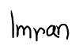  _________________  Learner signature  Date: | _________________  Tutor signature  Date:
Note:
Assignments must be submitted in typed PDF format only; handwritten assignments are not accepted.

Table of Contents
1. Architectural Evolution and Synthesis 3
1.1 Why the monolith cannot meet MaltaShop's scalability requirements 3
1.2 Monolith, ESB-based SOA or microservices 3
1.3 Distributed-systems principles and the new problems 5
2. Scalable System Design 6
2.1 Services, data and architecture 6
2.2 Design patterns and service interactions 8
2.3 Twelve-factor assessment 9
3. Lifecycle and Delivery Management 11
3.1 CI/CD pipeline for the Order service 11
3.2 Automated testing strategy for the Order service 12
3.3 Deployment strategy for the Payment service 13
4. Operational Excellence and Monitoring 17
4.1 Keeping checkout reliable at ten times normal traffic 17
4.2 Centralised logging and observability 18
4.3 Service mesh or resilience patterns first 20
5. Technical Leadership and Collaboration 22
5.1 Board briefing 22
5.2 Organising the developers and operations staff 23
5.3 Architecture Decision Records 24
6. Implementation and Prototyping 26
6.1 Keeping the place-order flow consistent 26
6.2 Dockerfile, Compose file and the path to production 30
6.3 Evidence and reflection 32
References 37
Appendix A: Git Repository 40
Appendix B: Prototype Source Code 41
B.1 docker-compose.yml 41
B.2 order-service/app/main.py 42
B.3 order-service/app/db.py 43
B.4 order-service/app/outbox.py 45
B.5 notification-service/app/consumer.py 46

1. Architectural Evolution and Synthesis

1.1 Why the monolith cannot meet MaltaShop's scalability requirements
All of MaltaShop's problems come from one fact: Catalogue, Orders, Payments, Customers and Notifications are built, released, scaled and crash as a single unit. On Black Friday the only way to add checkout capacity was to run more copies of the whole application, and every copy still wrote to one MySQL database, so checkout requests queued behind browsing traffic. The March incident shows the same coupling at run time: a fault in a non-essential feature stopped the essential one. Table 1 maps each limitation to the case facts and to the microservices response (Lewis and Fowler, 2014; Newman, 2021).
Table 1: Limitations of the monolith and how microservices address them
Limitation | Evidence in the case | Microservices response
Scaling is all or nothing | 8× traffic on Black Friday; checkout queued; site down for over two hours; one MySQL database on two VMs | Order, Payment and Inventory scale out on their own; catalogue reads come from a cache; each service has its own database, so browsing no longer competes with checkout
No fault isolation | A memory leak in e-mail notifications crashed checkout for 50 minutes | Notification runs in its own process and receives events; if it fails, orders still succeed and e-mails wait in the queue (proved in Section 6.3)
Code and data are entangled | A second payment provider took seven weeks | A Payment service with one adapter per provider behind a stable interface
Slow, risky releases | Every three weeks, on Friday evening, by hand, 40 minutes offline | Each service is deployed separately by an automated pipeline, with no downtime
No visibility | Local log files; no dashboard or alerts; customers report incidents | Central logs, metrics, traces and alerts (Section 4.2)

The common thread is independence. Microservices give each business capability its own process, data and release cycle, so MaltaShop can scale checkout without scaling e-mails, release Payment without retesting Catalogue, and lose Notification without losing sales.

1.2 Monolith, ESB-based SOA or microservices
Table 2 compares the three options for MaltaShop.
Table 2: The three options compared for MaltaShop
Criterion | Monolith (made modular) | Vendor's ESB-based SOA | Microservices
Scale checkout alone | No | Partly; the ESB is a shared bottleneck | Yes
Fault isolation | Low | Medium; the ESB is a single point of failure | High, if calls are asynchronous or protected
Weekly, independent releases | No; one release train | Limited; changes queue for the ESB team | Yes, per service
Where integration logic lives | In-process calls | In a central "smart" bus (Erl, 2005) | Smart endpoints, dumb pipes (Lewis and Fowler, 2014)
Cost and skills | Lowest | Licence fees, proprietary skills, lock-in | Containers, Kubernetes and monitoring; open-source tools

Organisational factors decide this choice as much as technical ones. Twelve developers are too many for one codebase but enough for three teams of four, each owning a few services, and Conway's law (Conway, 1968) says the system will mirror that structure anyway. The weekly release goal needs independent deployment, which neither the monolith nor a central bus provides. Against microservices: nobody has run Kubernetes, there are only two operations staff, and GDPR and card payments demand strong governance.
The ESB would recreate the original problem elsewhere: routing and transformation logic would move into a shared bus owned by one vendor and one team, adding licence cost and a new single point of failure. SOA's useful ideas, service contracts and reuse, survive in microservices without the bus.
Recommendation: move to microservices gradually, not by a rewrite. Using the strangler fig pattern (Fowler, 2004), extract Notification first, then Order, Inventory and Payment, and build Recommendation and the partner API as new services; Catalogue and Customer stay in the monolith until the platform has proved itself. The target is about eight services, not hundreds, which answers the CFO's concern (Fowler, 2015).

1.3 Distributed-systems principles and the new problems
Three principles shape the recommendation. Partial failure: some parts fail while others keep working (Rotem-Gal-Oz, 2006), so the checkout path is kept short and everything else is asynchronous; a failing Notification or Recommendation service cannot block an order. An unreliable network: calls time out and messages arrive twice, so every write carries an idempotency key and every consumer ignores events it has already processed (Section 6.1). Eventual consistency: without a shared database, Order, Inventory and Payment agree only after events have flowed (Vogels, 2009); MaltaShop accepts a few seconds of "order received, confirming payment", which customers already know from card payments.
The price is real: network latency between services, data spread over several databases with no cross-service joins, harder debugging, versioned contracts between teams, and a platform that two operations staff must learn. Sections 4 and 5 show how each is managed.

2. Scalable System Design

2.1 Services, data and architecture
MaltaShop is decomposed by business capability (Newman, 2021): each service owns one area of the business and its data, so a change to that area touches one service and one team. Table 3 lists the eight services and Figure 1 shows how they fit together. PostgreSQL is the default store because the team already knows relational databases; MongoDB suits Notification's varied message documents, and Redis serves recommendations in milliseconds.
Table 3: MaltaShop services
Service | Responsibility | Data owned | Data store
Catalogue | Products, prices, search; publishes ProductViewed | Products, categories, prices | PostgreSQL + Redis cache
Customer | Accounts, addresses, consent, GDPR requests | Customer profiles, consent records | PostgreSQL, personal data encrypted
Order | Places orders; owns order status; starts the saga | Orders, order lines, outbox | PostgreSQL
Inventory | Stock levels and reservations | Stock, reservations | PostgreSQL
Payment | Authorises and refunds through providers, one adapter each; never stores card numbers | Payment records, provider references | PostgreSQL
Notification | E-mail, SMS and push messages triggered by events | Messages sent, templates | MongoDB (messages vary in shape)
Partner | API for the 30 retailers and the courier: stock feeds, shipment updates | Partner accounts, feed history, shipments | PostgreSQL
Recommendation | "You may also like"; runs the data team's Python model | Features, event history | Redis (serving) + object storage (history)

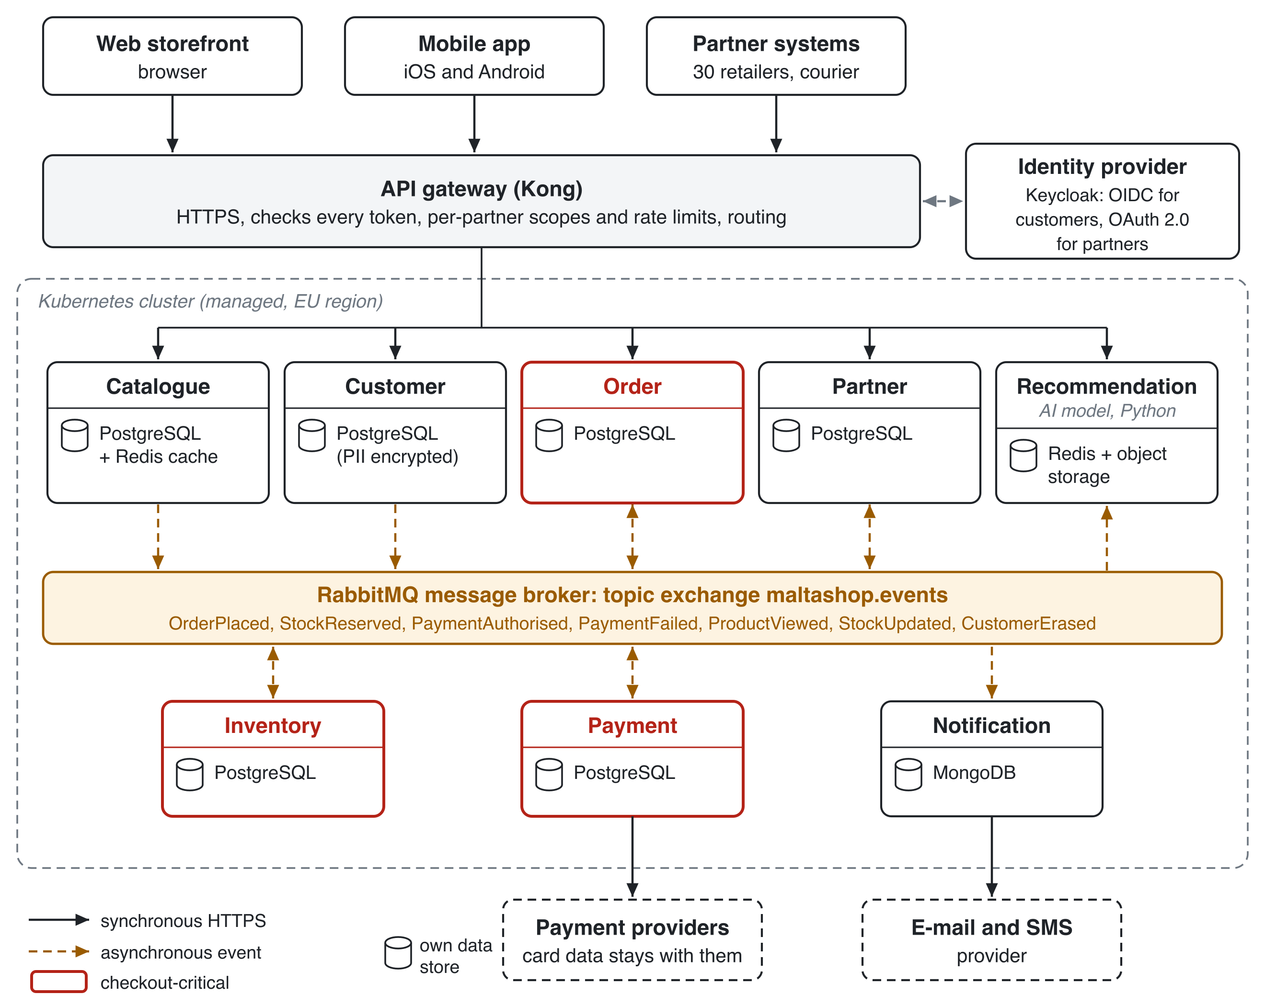
Figure 1: Container-level architecture of the target platform. Clients reach the services only through the API gateway, which checks tokens issued by the identity provider. Checkout-critical services are outlined in red; dashed arrows are events through RabbitMQ. Each service owns its data store; to save money, low-traffic services may share one managed PostgreSQL server with a separate database and credentials each, while Order and Payment have their own.
The AI Recommendation service sits beside checkout, not inside it. Browsing data (ProductViewed, from Catalogue) and order data (OrderPlaced) reach it as events on its own queue, so it receives a copy in near real time and can fall behind or fail without anyone waiting for it. The storefront asks it for suggestions through the gateway with a 200 ms timeout and shows best-sellers if it does not answer; checkout never calls it.
Authentication happens at the gateway. Customers log in through the identity provider (OpenID Connect) and send a short-lived token with each request. Each of the 30 retailers gets its own OAuth 2.0 client with scopes such as stock:write or orders:read and its own rate limit. Services check the scopes again, so one gateway mistake does not expose data.

2.2 Design patterns and service interactions
Table 4: Design patterns and why they were chosen
Pattern | Where | How it keeps services decoupled and robust
API gateway | In front of all services | One entry point for web, app and partners; authentication, rate limits and routing in one place; services can be split or moved without clients noticing
Database per service | Every service | No shared schema, so teams change their own tables freely; removes the shared-MySQL bottleneck; enforced by credentials and network rules
Publish–subscribe | OrderPlaced, StockReserved, ProductViewed and others | Producers do not know their consumers; Recommendation is added without changing Order; a slow consumer does not slow the producer
Saga with transactional outbox | Place-order flow | Keeps Order, Inventory and Payment consistent without a distributed transaction (Section 6.1)
Circuit breaker with timeouts | Gateway to Recommendation; Payment to providers | Stops waiting on a failing dependency and returns a fallback, preventing cascading failure (Nygard, 2018)
Strangler fig | Migration | The gateway moves one route at a time from the monolith to a new service; rolling back means routing back

The patterns in Table 4 come from Richardson (2018), but the case decides which ones matter: publish–subscribe answers the March incident and the AI requirement, database per service removes the MySQL bottleneck, and the strangler fig limits the risk of migration for a team new to microservices. Table 5 states whether each interaction is synchronous or asynchronous. The rule is simple: a call is synchronous only when the caller cannot answer its own user without the reply.
Table 5: Interaction matrix
From → to | Interaction | Style | Why
Storefront → Catalogue | Browse products | Sync (REST) | The customer is waiting for the page; answers are cached
Storefront → Order | Place order | Sync (REST); replies PENDING | The customer needs an order number at once
Order → Inventory | OrderPlaced | Async | Reserving stock must not hold the customer's request open
Inventory → Payment | StockReserved | Async | Payment is taken only once stock is held
Payment → Order, Inventory | PaymentAuthorised / PaymentFailed | Async | The saga's outcome: confirmation or compensation
Payment → payment provider | Authorise, refund | Sync (HTTPS), timeout and circuit breaker | External API; the idempotency key is the order ID
Order, Payment → Notification | Order events | Async | An e-mail must never slow or break checkout
Catalogue, Order → Recommendation | ProductViewed, OrderPlaced | Async | Near-real-time data without coupling to checkout
Storefront → Recommendation | Get suggestions | Sync, 200 ms timeout, fallback | Best-sellers are shown if it is slow
Partner → Inventory | StockUpdated | Async | Retailer feeds arrive in bursts; the queue smooths them
Customer → all | CustomerErased | Async | A GDPR erasure reaches every service holding personal data

2.3 Twelve-factor assessment
Table 6 assesses the design against seven of the twelve factors (Wiggins, 2017), with the evidence in the prototype.
Table 6: Twelve-factor assessment
Factor | How the design satisfies it | Evidence in the prototype
III Config | All settings come from environment variables; secrets from a secrets manager in production | config.py reads only environment variables; .env.example
IV Backing services | Databases and the broker are attached resources addressed by URL, so a local container can become a managed service without code changes | DATABASE_URL, MONGO_URL, RABBITMQ_URL
V Build, release, run | One image per commit; a release is that image plus environment configuration | CI builds one image per commit and tests that same image
VI Processes | Services keep no state in memory; any replica can serve any request | The outbox is in PostgreSQL, not in memory
IX Disposability | Fast start, safe stop: unacknowledged messages are redelivered and unsent outbox rows are retried | Manual acknowledgements; the resilience test in Section 6.3
X Dev/prod parity | The same images and the same database and broker engines everywhere | Compose runs PostgreSQL, MongoDB and RabbitMQ, as production will
XI Logs | Logs are an event stream to standard output, collected by the platform | JSON logs to stdout, read with docker compose logs

Twelve-factor services are what cloud-native infrastructure expects. Kubernetes can start, stop and replace any replica because none holds state (VI, IX); the autoscaler can add replicas because configuration is external (III); and the platform, not the code, decides where logs go (XI). The main gap is admin processes (XII): the prototype creates its tables at start-up, and this must become a versioned migration job before production.

3. Lifecycle and Delivery Management

3.1 CI/CD pipeline for the Order service
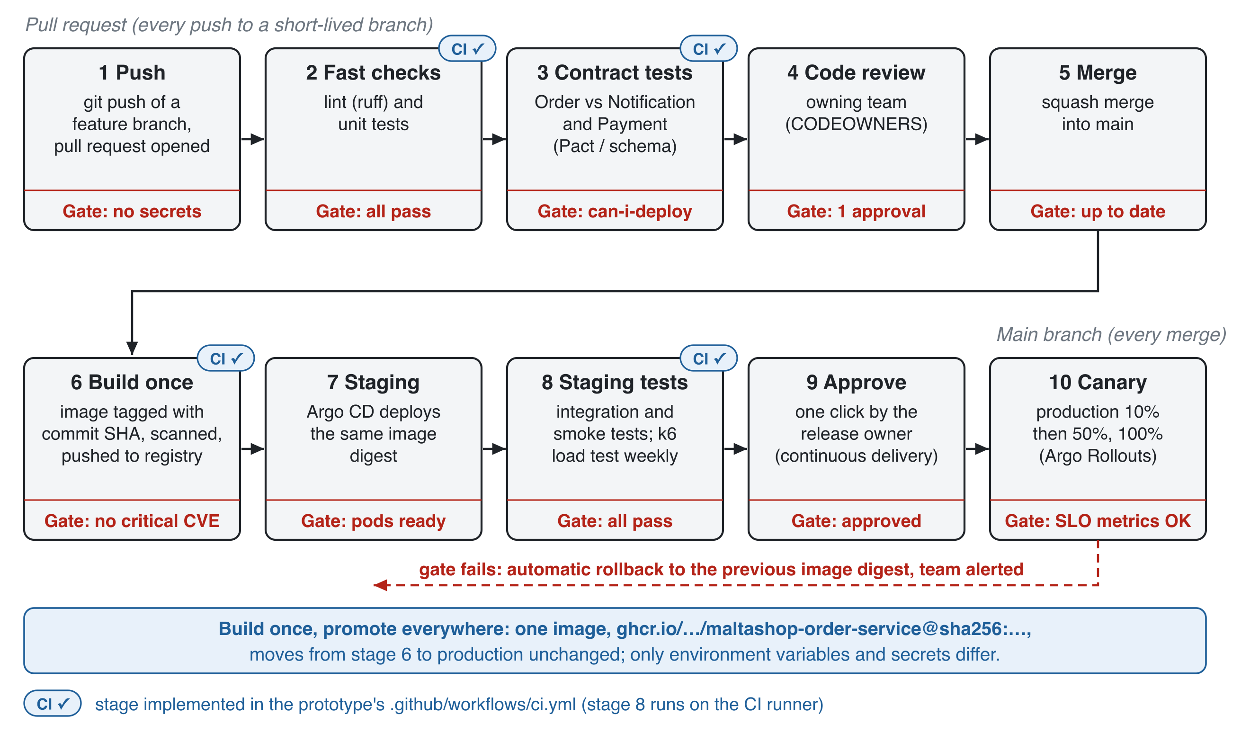
Figure 2: The CI/CD pipeline for the Order service, from a developer's git push to production. Each stage has a gate (red) that must pass before the change moves on. Blue tags mark the stages already automated in the prototype's GitHub Actions workflow.
Figure 2 has two halves. The pull-request half gives the developer feedback within minutes: lint and unit tests (stage 2), then contract tests (stage 3), which fail the build if Order would break a consumer such as Notification. A reviewer from the owning team must approve (stage 4) before the branch is merged.
The main-branch half produces and promotes the release. Stage 6 builds the container image once, tags it with the commit SHA, scans it and pushes it to the registry. From then on the image is never rebuilt: Argo CD deploys the same digest to staging, the integration and smoke tests (and a weekly load test) run against it, and after approval the same digest goes to production as a canary. This is "build once, promote everywhere" (Humble and Farley, 2010): what was tested is exactly what runs, environments differ only in configuration, and rolling back means redeploying the previous digest. The prototype already works this way: its workflow tests the images it has just built, without rebuilding them (Figure 3).
Branching follows trunk-based development (Hammant, 2017): short-lived feature branches merged at least every two days, with unfinished work hidden behind feature flags. Long-lived branches would bring back the large, risky merges of the three-week release train. The pipeline is itself an attack surface, so third-party actions are pinned to commit SHAs, each job gets only the permissions it needs, push protection blocks committed secrets, and only the pipeline can push images.
MaltaShop should choose continuous delivery, not continuous deployment, for now. Every merge produces a release candidate that could go live, but a person approves the production step (stage 9) for Order and Payment, because they handle money and the team is new to the platform. Weekly releases need nothing more. Once three months of DORA metrics show few failed changes, low-risk services such as Notification and Catalogue can move to continuous deployment.

3.2 Automated testing strategy for the Order service
Testing follows the test pyramid (Cohn, 2009; Vocke, 2018): many fast unit tests at the base and fewer, slower tests towards the top. Table 7 sets out what each level checks in the Order service and where it runs in Figure 2.
Table 7: Test pyramid for the Order service
Level | What is tested | Tools | Pipeline stage
Unit (many, milliseconds) | Pricing and totals; validation (unknown SKU, quantity 1–20); status changes PENDING → CONFIRMED or CANCELLED; events carry no personal data | pytest | 2, every push
Component (some, seconds) | The API with a real PostgreSQL and RabbitMQ in containers: idempotency key, outbox written in the same transaction, relay publishes | pytest, Testcontainers | 2, every push
Contract (one per pair) | OrderPlaced still meets Notification's needs; Order's calls still match Payment's API | JSON Schema now, Pact later | 3, before merge
End-to-end (few) | The whole place-order flow across services | smoke_test.py | 8, staging (prototype: CI runner)
Load (weekly, before sales) | Ten times normal checkout traffic; p95 latency and error rate | k6 | 8, weekly

The contract test in Listing 1 is between two named services: Order (provider) and Notification (consumer). The fields that Notification relies on are written down in contracts/order-placed.v1.schema.json. Order's build fails if its event no longer satisfies them, and Notification's build checks that it can handle the contract's example, so each side is tested on its own against the same contract.
Listing 1: Provider side of the OrderPlaced contract test (order-service/tests)
def test_order_placed_event_satisfies_the_consumer_contract():
lines = [OrderLine(sku="TV-55-4K", quantity=1),
OrderLine(sku="KETTLE-1.7L", quantity=2)]
order = {"order_id": uuid.uuid4(), "customer_id": "C-1001",
"status": "PENDING", "total_amount": order_total(lines),
"currency": "EUR", "items": price_lines(lines)}

event = json.loads(json.dumps(
order_placed_event(order, correlation_id=str(uuid.uuid4()))))

# raises ValidationError if the event breaks the consumer's contract
Draft202012Validator(SCHEMA, format_checker=FormatChecker()).validate(event)

When customer_id was renamed as an experiment, this test failed with "'customer_id' is a required property", which is exactly the breaking change it exists to stop. In production the schema files would be replaced by Pact (Pact Foundation, n.d.) and its can-i-deploy check, which also tells the pipeline which versions are safe to release together.

3.3 Deployment strategy for the Payment service
Table 8: Rolling, blue-green and canary deployment for Payment
Strategy | How it works | Strengths for Payment | Weaknesses for Payment
Rolling | Replaces pods a few at a time (the Kubernetes default) | No extra capacity; simple | No control over who gets the new version; a bad release reaches everyone gradually; rollback is another slow rollout
Blue-green | A full new copy runs beside the old one; all traffic switches at once (Fowler, 2010) | Instant switch and instant rollback | Double capacity; every customer meets the new version at the same moment
Canary | A small share of traffic goes to the new version and grows while metrics stay healthy (Sato, 2014) | Limits damage to a few payments; decisions based on real data | Needs good metrics and automation (Argo Rollouts); slower

Of the options in Table 8, canary is the right choice for Payment. A faulty payment release costs money directly and damages trust, so exposure should be limited and judged on real data. The canary sends 10% of payment traffic to the new version for 15 minutes, then 50%, then 100%. At each step Argo Rollouts compares the canary with the stable version on payment error rate, provider decline rate and p95 latency. The rollback procedure is:
- If any metric breaches its threshold, Argo Rollouts aborts automatically, sends all traffic back to the stable version within seconds and pages the on-call engineer.
- A payment retried during the switch cannot be charged twice, because the provider receives the order ID as its idempotency key.
- Database changes follow expand-and-contract (new columns first, old ones removed in a later release), so the previous version still works with the current schema.
- The engineer confirms recovery on the dashboard, records the failed image digest, and the fix goes through the normal pipeline.
Two DORA metrics (Forsgren, Humble and Kim, 2018) will show whether delivery improves (Table 9). Change failure rate cannot yet be baselined, because failed releases are not recorded today; it will be measured from the first pipeline release.
Table 9: DORA metrics: baseline and target
Metric | MaltaShop baseline (case facts) | Target within 12 months
Deployment frequency | Once every three weeks, whole site, 40 minutes offline | At least weekly per service with no downtime; daily for low-risk services
Time to restore service | 50 minutes (March) to over two hours (Black Friday); customers notice first | Under 30 minutes for checkout, with an alert before customers notice

Evidence: pipeline workflow file and a passing run
Listing 2 is the prototype's .github/workflows/ci.yml. It runs on every push and pull request to main: tests for both services, one image per service built and pushed once, then an integration test of those exact images.
Listing 2: The prototype's CI workflow (.github/workflows/ci.yml)
name: CI

# Runs on every push and pull request to main. Images are built ONCE per commit, tagged
# with the commit SHA, and the integration stage tests those exact images
# ("build once, promote everywhere"). Actions are pinned to a full commit SHA (the comment
# gives the version) so a moved or hijacked tag cannot change what runs in the pipeline.
on:
push:
branches: [main]
pull_request:
branches: [main]

permissions:
contents: read

env:
IMAGE_REGISTRY: ghcr.io/${{ github.repository_owner }}
IMAGE_TAG: ${{ github.sha }}

jobs:
test:
name: "Stage 1: lint, unit and contract tests (${{ matrix.service }})"
runs-on: ubuntu-24.04
strategy:
matrix:
service: [order-service, notification-service]
defaults:
run:
working-directory: ${{ matrix.service }}
steps:
- name: Check out repository
uses: actions/checkout@3d3c42e5aac5ba805825da76410c181273ba90b1 # v7.0.1

- name: Set up Python
uses: actions/setup-python@5fda3b95a4ea91299a34e894583c3862153e4b97 # v7.0.0
with:
python-version: "3.12"
cache: pip
cache-dependency-path: ${{ matrix.service }}/requirements*.txt

- name: Install dependencies
run: pip install -r requirements.txt -r requirements-dev.txt

- name: Lint (gate)
run: ruff check app tests

- name: Unit and contract tests (gate)
run: pytest -v

build:
name: "Stage 2: build and push image (${{ matrix.service }})"
needs: test
runs-on: ubuntu-24.04
permissions:
contents: read
packages: write
strategy:
matrix:
service: [order-service, notification-service]
steps:
- name: Check out repository
uses: actions/checkout@3d3c42e5aac5ba805825da76410c181273ba90b1 # v7.0.1

- name: Log in to GitHub Container Registry
uses: docker/login-action@dbcb813823bdd20940b903addbd779551569679f # v4.6.0
with:
registry: ghcr.io
username: ${{ github.actor }}
password: ${{ secrets.GITHUB_TOKEN }}

- name: Build once, tag with the commit SHA, push
uses: docker/build-push-action@c3c9e263c25d99ce0380d002d59b67737d91b0dc # v7.4.0
with:
context: ${{ matrix.service }}
push: true
tags: ${{ env.IMAGE_REGISTRY }}/maltashop-${{ matrix.service }}:${{ env.IMAGE_TAG }}

integration:
name: "Stage 3: integration test of the built images"
needs: build
runs-on: ubuntu-24.04
permissions:
contents: read
packages: read
steps:
- name: Check out repository
uses: actions/checkout@3d3c42e5aac5ba805825da76410c181273ba90b1 # v7.0.1

- name: Log in to GitHub Container Registry
uses: docker/login-action@dbcb813823bdd20940b903addbd779551569679f # v4.6.0
with:
registry: ghcr.io
username: ${{ github.actor }}
password: ${{ secrets.GITHUB_TOKEN }}

- name: Pull the images built in stage 2 (no rebuild)
run: docker compose pull order-service notification-service

- name: Start the whole system and wait until every container is healthy
run: docker compose up -d --no-build --wait

- name: Smoke test the place-order flow (gate)
run: python3 scripts/smoke_test.py

- name: Show service logs
if: always()
run: docker compose logs order-service notification-service

- name: Stop the system
if: always()
run: docker compose down -v

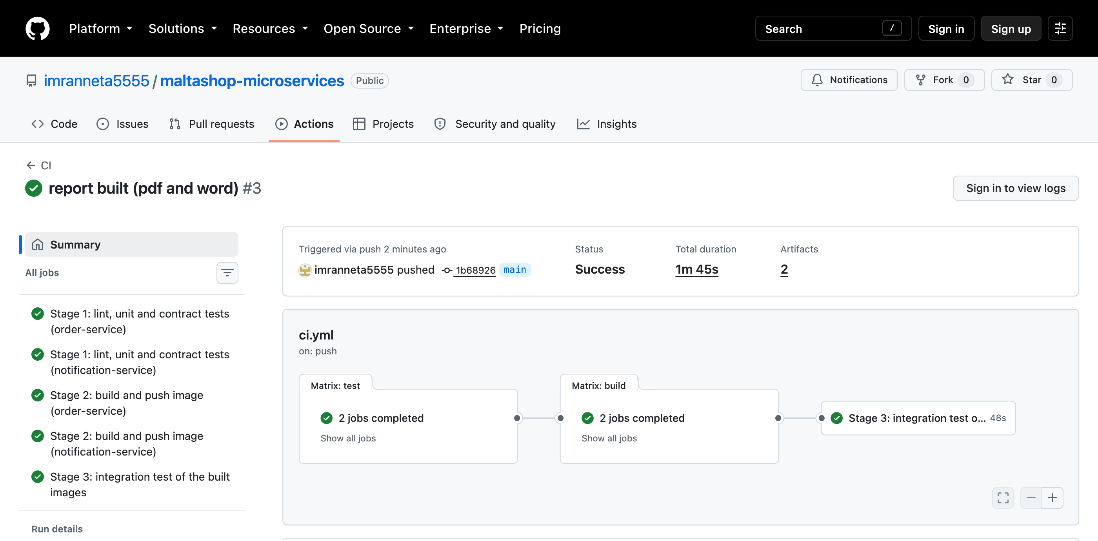
Figure 3: A passing run of the prototype's CI workflow on GitHub Actions. Stage 1 lints and tests both services, stage 2 builds each image once and pushes it to GitHub Container Registry, and stage 3 starts the whole system from those images and runs the smoke test.

4. Operational Excellence and Monitoring

4.1 Keeping checkout reliable at ten times normal traffic
Kubernetes keeps checkout reliable by constantly making the cluster match a declared state (Burns et al., 2022). Order, Payment and Inventory each run as a Deployment, which manages a ReplicaSet: if a pod crashes or its node fails, the ReplicaSet starts a replacement. Pods are spread across three availability zones, so losing a zone leaves two-thirds of the capacity.
Probes decide which pods receive traffic (Kubernetes, n.d.a). The readiness probe calls /health/ready, which checks the database; a pod that is starting, overloaded or cut off is removed from the load balancer instead of returning errors. The liveness probe calls /health/live and restarts a pod that hangs. Resource requests reserve CPU and memory so the scheduler only places pods where they fit, and limits cap each pod: the March memory leak would now restart one Notification pod, not take down checkout.
For the peak, the Horizontal Pod Autoscaler adds Order replicas when average CPU use passes 60%, from 3 up to 30 (Kubernetes, n.d.b), and the cluster autoscaler adds nodes when pods do not fit. Because autoscaling takes minutes, the minimum is raised before a planned sale, after a k6 test at ten times normal traffic on staging. Listing 3 shows these settings for the Order service.
Listing 3: Order service Deployment and autoscaler (excerpt)
apiVersion: apps/v1
kind: Deployment
metadata: {name: order-service}
spec:
replicas: 3
selector: {matchLabels: {app: order-service}}
template:
metadata: {labels: {app: order-service}}
spec:
topologySpreadConstraints: # spread replicas over three zones
- maxSkew: 1
topologyKey: topology.kubernetes.io/zone
whenUnsatisfiable: ScheduleAnyway
labelSelector: {matchLabels: {app: order-service}}
containers:
- name: order-service
# the exact image digest that passed the pipeline
image: ghcr.io/imranneta5555/maltashop-order-service@sha256:...
envFrom: [{secretRef: {name: order-service-config}}]
ports: [{containerPort: 8000}]
resources:
requests: {cpu: 250m, memory: 256Mi}
limits: {memory: 512Mi} # a leak ends in a restart
readinessProbe:
httpGet: {path: /health/ready, port: 8000}
periodSeconds: 5
failureThreshold: 2
livenessProbe:
httpGet: {path: /health/live, port: 8000}
periodSeconds: 10
failureThreshold: 3
---
apiVersion: autoscaling/v2
kind: HorizontalPodAutoscaler
metadata: {name: order-service}
spec:
scaleTargetRef: {apiVersion: apps/v1, kind: Deployment, name: order-service}
minReplicas: 3
maxReplicas: 30
metrics:
- type: Resource
resource: {name: cpu, target: {type: Utilization, averageUtilization: 60}}

All eight services and the gateway are stateless and run as Deployments. The stateful parts (PostgreSQL, MongoDB, Redis and RabbitMQ) stay outside the cluster as managed services, such as Amazon RDS with a standby in a second zone, so the team does not operate databases on Kubernetes in its first year.
Because nobody has run Kubernetes in production, the risk is reduced in steps: a managed control plane (Amazon EKS) in an EU region; all cluster configuration in Git, applied by Argo CD; training for the operations staff and one developer per team; an external specialist for set-up and the first three months of on-call; and Notification as the first service in production, because its failure does the least harm.

4.2 Centralised logging and observability
Today each server writes its own log file and nobody is alerted. Now every service must write one JSON object per line to standard output with the fields in Table 10, as the prototype already does (Figure 10).
Table 10: Mandatory log schema
Field | Example | Rule
timestamp | 2026-10-05T04:28:58.666Z | UTC, ISO 8601, milliseconds
level | INFO | DEBUG, INFO, WARNING or ERROR
service, version, environment | order-service, 1f3c9a2, production | Identify what logged it and which release
correlation_id | 8f2bdf1c-d1c3-… | From the X-Correlation-ID header, or created at the gateway; copied into every event and outgoing call
trace_id, span_id | 4bf92f3577b34da6… | From OpenTelemetry; links the log line to its trace
event | order.placed | Stable, searchable name
message | Order saved as PENDING | For people
Context | order_id, event_id, duration_ms | IDs only: no names, e-mail addresses or card data (European Parliament and Council of the European Union, 2016; PCI Security Standards Council, 2022)

Every service is instrumented with OpenTelemetry (OpenTelemetry, n.d.), and a Collector on each node removes personal-data fields and samples traces. Logs go to Loki, metrics to Prometheus and traces to Tempo, all viewed in Grafana and hosted by Grafana Cloud in an EU region (Figure 4; ADR-002 in Section 5.3).
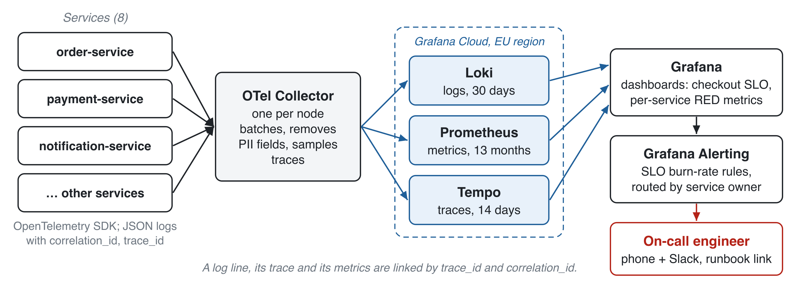
Figure 4: The observability pipeline. Services send JSON logs, metrics and traces through an OpenTelemetry Collector to Loki, Prometheus and Tempo; Grafana shows them together and its alert rules page the on-call engineer of the owning team, with a link to the runbook.
Checkout SLO: 99.9% of checkout requests (placing an order and confirming payment) succeed, without a server error and within 2 seconds, measured at the gateway over a rolling 30 days. This leaves an error budget of 0.1%, about 43 minutes of failure a month. The two alerts in Table 11 use the burn-rate method (Beyer et al., 2018).
Table 11: Checkout alerts
Alert | Metric | Threshold and duration | Severity | First runbook step
Checkout fast burn | Share of failed or slow checkout requests | Over 1.44% (budget burning 14.4× too fast) for both the last hour and the last 5 minutes | Critical: page on-call | Open the checkout dashboard; if anything was deployed in the last hour, roll it back first
Checkout slow burn | Same | Over 0.6% (6× too fast) for both the last 6 hours and the last 30 minutes | Warning: ticket for the owning team | Find which service's error rate rose on the RED dashboard, then search its logs by correlation ID

Replaying the March incident with this design shows the difference:
- Notification's memory grows after a release. Kubernetes restarts each pod at its 512 Mi limit, and an alert fires on more than three restarts in 15 minutes. Checkout is unaffected: orders are accepted and their events wait in RabbitMQ (Section 6.3), so the checkout alerts stay silent.
- The Notification dashboard shows memory climbing from the moment version 1.8 was deployed (deployments are marked on the graphs).
- In Loki the engineer filters Notification's ERROR lines and finds out-of-memory errors in the template renderer; following one correlation ID to its trace shows rendering time growing with every message.
- They roll Notification back to the previous image digest. The waiting events are then processed, and because the consumer ignores repeated event IDs, no customer receives a duplicate e-mail.
Detection takes minutes instead of waiting for complaints, and the failure costs e-mails, not sales.

4.3 Service mesh or resilience patterns first
A service mesh places a sidecar proxy (Envoy, in Istio) next to every pod, so all traffic between services passes through proxies that are configured centrally (Istio, n.d.). It adds fault tolerance without code changes: mutual TLS encrypts and authenticates every call; retries (with a budget) and timeouts are set per route; circuit breaking ejects failing instances; and traffic shifting sends, for example, 10% of calls to a new version, which is how canary releases are routed.
MaltaShop should not adopt a mesh now, but build resilience into the services and the gateway first. Most traffic between services goes asynchronously through RabbitMQ, which a mesh does not manage. The few synchronous calls (gateway to services, Payment to its providers) are protected by timeouts, retries with idempotency keys and circuit breakers (Nygard, 2018), and Argo Rollouts already handles canary traffic. A mesh would add a proxy to every pod, more memory and a complex control plane for two operations staff who are still learning Kubernetes. Revisit this after twelve months, or sooner if synchronous calls multiply or an auditor requires encryption inside the cluster; Linkerd or Istio's sidecar-free ambient mode would then be the lighter options.

5. Technical Leadership and Collaboration

5.1 Board briefing
To: the CEO and CFO. From: the Lead Solutions Architect. Subject: replacing the MaltaShop platform.
What I recommend. Today the shop is one large program: when one part fails or gets busy, everything fails: two hours offline last Black Friday, 50 minutes in March because of the e-mail feature, and 40 minutes offline for every update. I recommend splitting it, step by step, into about eight smaller parts, such as checkout, payments and e-mails, that run and fail separately.
What we gain.
- Checkout keeps working at ten times normal traffic, because we can strengthen checkout alone.
- A fault in e-mails or recommendations no longer stops sales.
- Weekly updates with no downtime (updates alone now cost about 11 hours offline a year).
- AI recommendations, 30 partner connections and new payment providers take weeks, not months.
What it costs (estimates). About €2,500 a month more for rented cloud services and monitoring, and about €30,000 in the first year for training and an outside expert. We rent ready-made services and avoid the integration vendor's licence fees.
The CFO's concern. It is right: this approach is overkill for small companies that rewrite everything into hundreds of parts. We will not do that. We split off only the parts causing our problems, one at a time, while the current shop keeps running. After the first part (e-mails, about three months) the board reviews the results and can stop with little lost.
Risks. The team must learn new tools, so we pay for training and help. For a while we pay for old and new systems together. More parts mean more to watch, so monitoring comes first.
Keeping the current system costs less this year, but cannot meet next year's goals.

5.2 Organising the developers and operations staff
The twelve developers become three stream-aligned teams of four, each owning whole business capabilities, and the two operations staff become a small platform team (Skelton and Pais, 2019):
- Checkout team: Order, Payment and Inventory.
- Storefront team: Catalogue, Customer, and Recommendation, built with the data team.
- Integrations team: Partner API, Notification, gateway routes, and the remaining monolith until it is retired.
- Platform team (two operations staff): the cluster, pipeline templates, observability, and second-line on-call support.
Service ownership. Every service has exactly one owning team, recorded in a service catalogue and a CODEOWNERS file. That team builds it, runs it and is paged for it.
Git workflow and code review. Trunk-based development with pull requests; one approval from the owning team and a green pipeline before merging; a change to another team's service is reviewed by that team.
API contracts. REST APIs are described in OpenAPI and events in JSON Schema, stored with the code. A breaking change needs a new version and the old one is kept for at least one release cycle; contract tests enforce this (Section 3.2).
Shared documentation. Each repository has a README, runbooks and Architecture Decision Records, linked from the service catalogue.
On-call and post-incident review. Each team has a weekly business-hours rota for its services, with the platform team as second line, and one shared rota out of hours; alerts are routed by owner label and link to a runbook. Reviews are blameless, held within five working days, built on a timeline from logs and traces, and their actions are tracked to completion. Table 12 lists three operational complexities this way of working creates, and how each is managed.
Table 12: Operational complexities and how each is managed
Complexity | Strategy
Debugging across team boundaries: one order passes through services owned by two or three teams | Mandatory correlation IDs and tracing (Section 4.2); one shared checkout dashboard; the team that owns the failing SLO leads the incident
Contract drift: one team changes an event or API and breaks another team's service | Consumer-driven contract tests in CI, a versioning policy, and contract changes reviewed by both teams
On-call load and knowledge silos: fourteen people now run eight services, more than two operations staff can carry | "You build it, you run it" rotas, a runbook for every alert, shared pipeline and deployment templates, and new on-call engineers paired with experienced ones

5.3 Architecture Decision Records
The two ADRs follow Nygard's (2011) format.
ADR-001: Message broker: RabbitMQ (managed). Status: accepted, October 2026.
Context. Order, Inventory, Payment, Notification and Recommendation must exchange events reliably. Even at ten times normal traffic the volume is modest (assumption: under 200 events per second), the operations staff have no event-streaming experience, and the broker must run on a laptop as well as in production.
Decision. RabbitMQ with topic exchanges, durable queues, publisher confirms and dead-letter queues; in production, managed RabbitMQ (Amazon MQ) in an EU region. Criteria: operational effort, team skills, cost, delivery guarantees, replay and lock-in; Table 13 shows the alternatives rejected.
Table 13: ADR-001: alternatives rejected
Alternative | Why rejected
Apache Kafka (managed) | Better replay and throughput, but more concepts to learn (partitions, offsets) and a higher cost than MaltaShop's volume justifies
The vendor's ESB | Licence cost, a central team and business logic in the bus (Section 1.2)
Amazon SNS and SQS | Cheap and simple, but ties every service to one cloud provider and cannot run in Docker Compose for development

Consequences. RabbitMQ is well known, runs identically in the prototype and in production, and its per-message acknowledgements fit the saga. Queues delete messages once consumed, so Recommendation keeps its own event history. Technical debt accepted: high-volume streaming or replay for many consumers would need RabbitMQ Streams or Kafka; publishing sits in one small module per service to contain that change.
ADR-002: Observability stack: OpenTelemetry with Grafana Cloud. Status: accepted, October 2026.
Context. Logs are local files and customers report incidents. The team needs logs, metrics, traces and alerts in one place, on a limited budget, run by two operations staff, with personal data kept in the EU.
Decision. Instrument every service with OpenTelemetry and use Grafana Cloud (Loki, Prometheus, Tempo, Grafana Alerting) in an EU region. Criteria: cost at MaltaShop's volume, operational effort, vendor neutrality, all three signals in one tool, and EU data residency; Table 14 shows the alternatives rejected.
Table 14: ADR-002: alternatives rejected
Alternative | Why rejected
Self-hosted Elastic (ELK) stack | Powerful search, but running Elasticsearch clusters needs time and skills the operations staff do not have
Datadog | Excellent, but per-host and per-gigabyte pricing grows fast and its agents increase lock-in
Cloud provider tools only (CloudWatch) | Cheaper, but weaker tracing and dashboards, and tied to one provider

Consequences. There is nothing to operate, and OpenTelemetry lets the backend change without touching service code. The bill grows with log volume, so production logs exclude DEBUG, are kept 30 days, and only 10% of normal traces are stored (all error traces are kept). Technical debt accepted: dashboards and alerts are first built by hand and must later move into code (Terraform) to be reviewed and versioned like the services.
Effect on the project. Both decisions favour tools the team can run now over the most powerful option, which raises the chance of meeting the 12-month goals: MaltaShop's scarcest resource is operations time, not technology. The debt is deliberate and written down, so future teams know what was traded and when to revisit it, instead of discovering it during an incident.

6. Implementation and Prototyping
The prototype implements the place-order flow: the Order service (FastAPI, PostgreSQL) exposes POST /orders, and the Notification service (FastAPI, MongoDB) consumes the OrderPlaced event through RabbitMQ. Each has a Dockerfile, one docker compose up starts everything, and the repository's README explains what it is, how to run it and its environment variables (Appendix A).

6.1 Keeping the place-order flow consistent
An order touches three databases (Order, Inventory and Payment), so one ACID transaction is impossible, and a two-phase commit would lock all three and fail whenever one is down. The flow is therefore a saga (Garcia-Molina and Salem, 1987; Richardson, 2018): a sequence of local transactions, each publishing an event that triggers the next, with a compensating action that undoes a step if a later one fails (Figure 5, Table 15).
I chose choreography rather than orchestration. With three participants and one main path, the events are easy to follow and no orchestrator service has to be built and run, while Order still records the state of every order. If the flow grows to include returns or split deliveries, an orchestrator would become easier to manage.
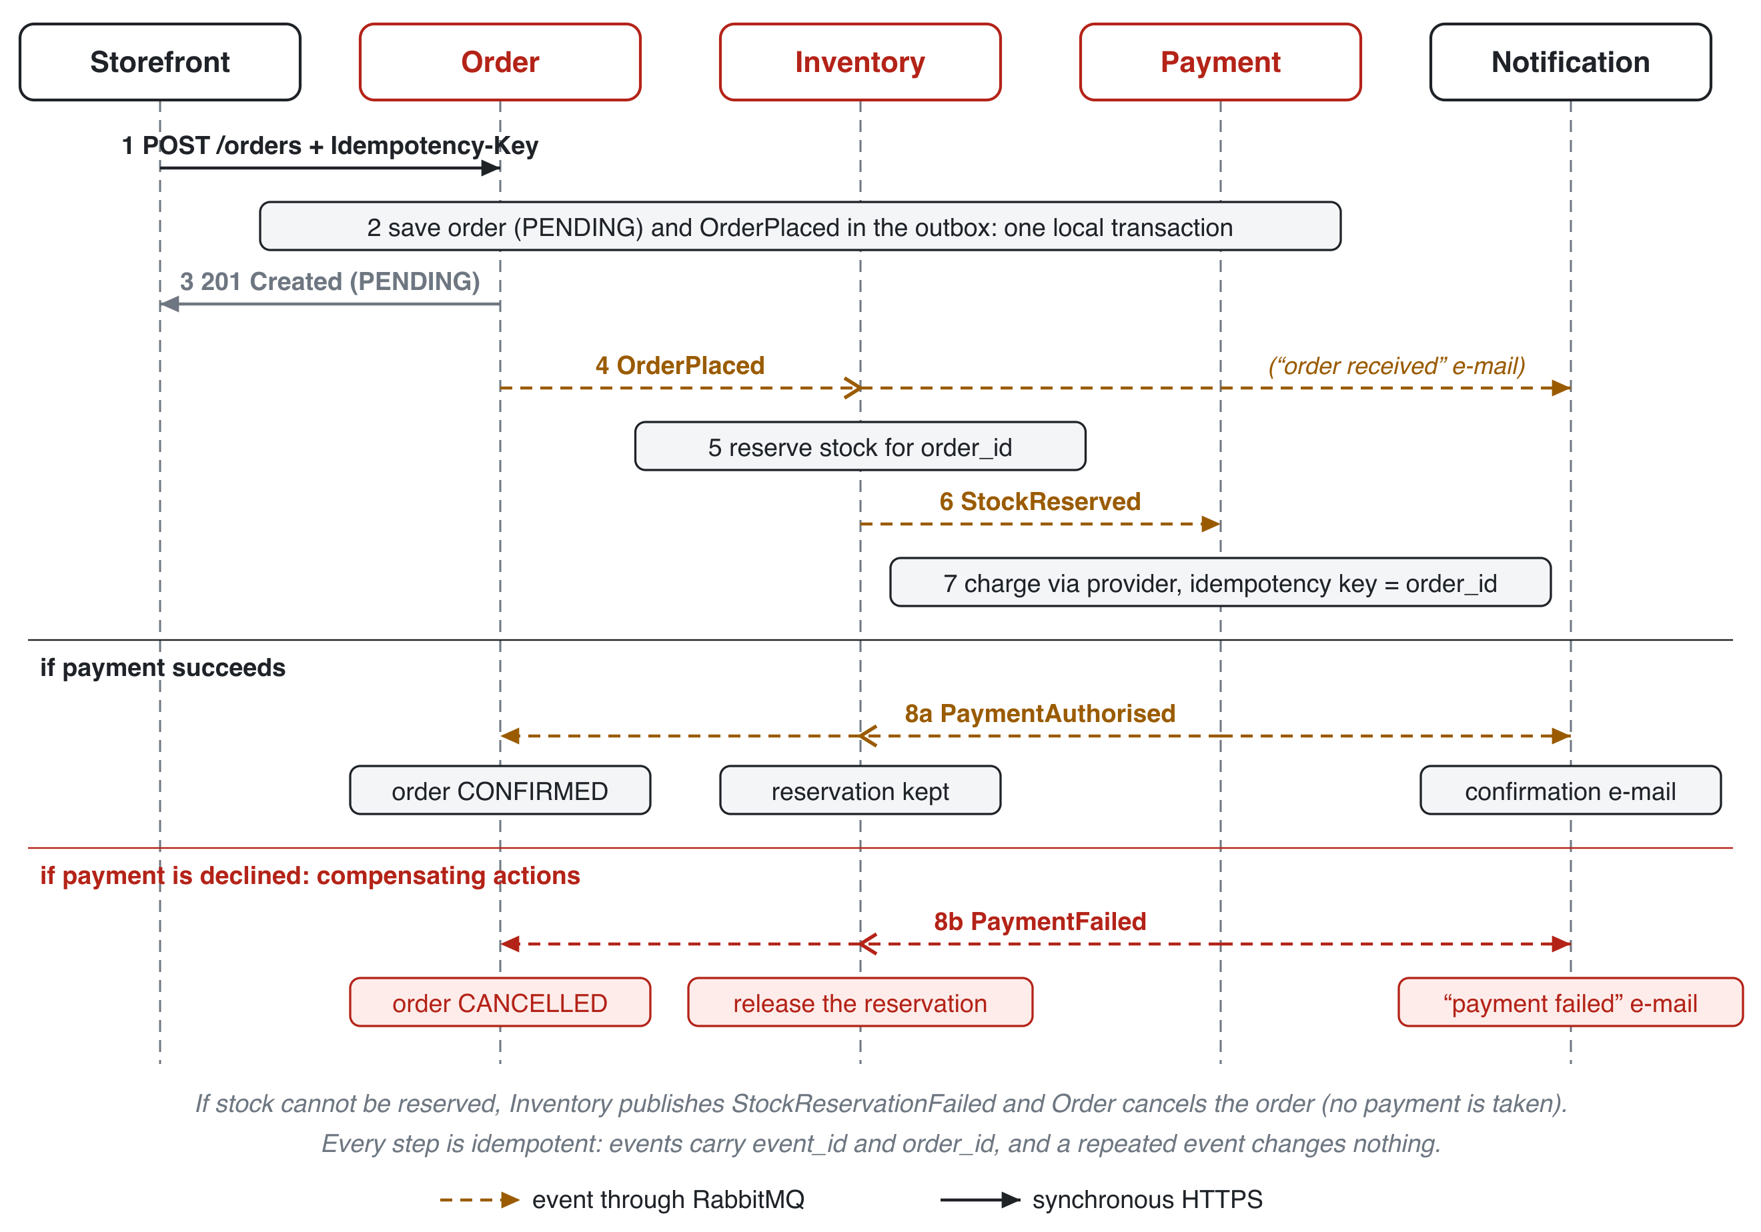
Figure 5: The place-order saga (choreography). Each service commits a local transaction and publishes an event; the red path shows the compensating actions taken when payment is declined. Only Order (steps 1–4) and Notification are built in the prototype.
Table 15: Saga steps and compensating actions
Step | Service | Local transaction | Compensating action
1 | Order | Create order as PENDING and save OrderPlaced in the outbox | Mark the order CANCELLED
2 | Inventory | Reserve stock for the order ID | Release the reservation
3 | Payment | Authorise the payment with the provider | Void or refund the authorisation
4 | Order | Mark the order CONFIRMED | None: the final step

Three techniques make every step safe to repeat:
- Idempotent API. POST /orders takes an Idempotency-Key header. The key is a unique column, so a retried request returns the original order and writes nothing (Listing 4; Figure 11).
- Transactional outbox. The order and its event are saved in the same local transaction, so there is never an order without its event or an event without its order (Richardson, n.d.). A relay publishes the event and marks it sent only after RabbitMQ confirms it (Listing 5); a crash in between causes a duplicate, never a loss.
- Idempotent consumer. The consumer acknowledges a message only after its work is saved, and a unique index on event_id makes a repeated event harmless (Listing 6).
The framework and broker do much of this work. PostgreSQL provides the transaction, the unique constraint and ON CONFLICT DO NOTHING; RabbitMQ provides durable queues, persistent messages, publisher confirms, manual acknowledgements and dead-letter queues (RabbitMQ, n.d.); and FastAPI's pydantic models reject an invalid order before anything is written.
Listing 4: Idempotent order creation with the transactional outbox (order-service/app/db.py, annotated excerpt)
# (1) one local PostgreSQL transaction for the order AND its event
with connect() as conn, conn.transaction():
order = conn.execute(
"""INSERT INTO orders (order_id, idempotency_key, customer_id, status,
total_amount, currency, items, correlation_id)
VALUES (gen_random_uuid(), %s, %s, 'PENDING', %s, %s, %s, %s)
ON CONFLICT (idempotency_key) DO NOTHING
RETURNING *""",
(idempotency_key, request.customer_id, order_total(request.items),
CURRENCY, Jsonb(price_lines(request.items)), correlation_id),
).fetchone()
# (2) the key was used before: nothing was written, return the original
if order is None:
existing = conn.execute("SELECT * FROM orders WHERE idempotency_key = %s",
(idempotency_key,)).fetchone()
return existing, False

# (3) the OrderPlaced event goes into the outbox in the same transaction
event = order_placed_event(order, correlation_id)
conn.execute(
"INSERT INTO outbox (event_id, event_type, routing_key, payload) "
"VALUES (%s, %s, %s, %s)",
(event["event_id"], event["event_type"], "order.placed", Jsonb(event)),
)
# (4) commit: both rows are saved, or neither is
return order, True

Listing 5: The outbox relay publishes with confirms (order-service/app/outbox.py, annotated excerpt; logging omitted)
# (1) take unsent events and lock them, so two relays never send the same row
rows = conn.execute(
"""SELECT event_id, event_type, routing_key, payload FROM outbox
WHERE published_at IS NULL ORDER BY created_at LIMIT 50
FOR UPDATE SKIP LOCKED"""
).fetchall()
for row in rows:
event = row["payload"]
channel.basic_publish(
exchange=config.EVENTS_EXCHANGE,
routing_key=row["routing_key"],
body=json.dumps(event).encode(),
properties=pika.BasicProperties(
content_type="application/json",
# (2) persistent: the message survives a broker restart
delivery_mode=pika.DeliveryMode.Persistent,
message_id=str(row["event_id"]),
# (3) the request's correlation ID travels with the event
correlation_id=event["correlation_id"],
type=row["event_type"],
),
# (4) with confirm_delivery() on, this returns only once the broker
# has stored the message, and fails if no queue would receive it
mandatory=True,
)
# (5) marked as sent only after the broker's confirmation
conn.execute("UPDATE outbox SET published_at = now() WHERE event_id = %s",
(row["event_id"],))

Listing 6: The idempotent consumer (notification-service/app/consumer.py, annotated excerpt; logging shortened)
def on_message(self, channel, method, properties, body) -> None:
# (1) log with the correlation ID that came with the event
token = correlation_id.set(properties.correlation_id)
try:
event = json.loads(body)
notification = build_notification(event)
# (2) unique index on event_id: save() returns False for a repeat
if store.save(notification):
log_event(log, logging.INFO, "notification.sent", ...)
else:
log_event(log, logging.INFO, "event.duplicate", ...)
# (3) acknowledge only after the notification is saved
channel.basic_ack(method.delivery_tag)
except (ValueError, MalformedEvent):
# (4) a message that can never be processed goes to the dead-letter queue
channel.basic_nack(method.delivery_tag, requeue=False)
except PyMongoError:
# (5) the store is down: put the message back and try again later
time.sleep(2)
channel.basic_nack(method.delivery_tag, requeue=True)
finally:
correlation_id.reset(token)

6.2 Dockerfile, Compose file and the path to production
Listing 7: order-service/Dockerfile (the Notification service's is the same apart from its label)
# syntax=docker/dockerfile:1

# ---- Stage 1: install the dependencies into a virtual environment ----
FROM python:3.12-slim AS build
RUN python -m venv /opt/venv
ENV PATH="/opt/venv/bin:$PATH"
COPY requirements.txt .
RUN pip install --no-cache-dir -r requirements.txt

# ---- Stage 2: the runtime image gets only the venv and the code (no pip cache, no build files) ----
FROM python:3.12-slim
LABEL org.opencontainers.image.source="https://github.com/imranneta5555/maltashop-microservices" \
org.opencontainers.image.description="MaltaShop Order service"
ENV PATH="/opt/venv/bin:$PATH" \
PYTHONDONTWRITEBYTECODE=1 \
PYTHONUNBUFFERED=1
RUN useradd --uid 10001 --no-create-home --shell /usr/sbin/nologin app
WORKDIR /app
COPY --from=build /opt/venv /opt/venv
COPY app ./app
USER 10001
EXPOSE 8000
HEALTHCHECK --interval=10s --timeout=3s --start-period=15s --retries=3 \
CMD ["python", "-c", "import urllib.request; urllib.request.urlopen('http://localhost:8000/health/ready', timeout=2)"]
CMD ["uvicorn", "app.main:app", "--host", "0.0.0.0", "--port", "8000", "--no-access-log"]

The key choices in Listing 7 are:
- Base image. python:3.12-slim is an official, regularly patched Debian image: small, yet compatible with the ready-built wheels of psycopg and pymongo (Alpine's musl library often forces slow source builds). In production the tag would be pinned to a digest.
- Multi-stage build. The first stage installs the dependencies into a virtual environment; the final image copies only that environment and the application code (Docker, n.d.). No pip cache, build files or tests reach production, so the image is smaller and has less to attack.
- Non-root user. The process runs as user 10001, so an attacker who compromised the service would not be root in the container.
- Health checks. HEALTHCHECK calls /health/ready; Compose starts each service only when its database and the broker are healthy (condition: service_healthy), and Kubernetes will use the same endpoints for its probes.
- Configuration through environment variables. Every setting has a development default in Compose and nothing environment-specific is baked into the image, which is what makes "build once, promote everywhere" possible.
Listing 8: docker-compose.yml (excerpt, passwords shortened; the full file is in Appendix B.1)
services:
order-service:
build: ./order-service
# CI sets IMAGE_REGISTRY and IMAGE_TAG to run the image it has just built
image: ${IMAGE_REGISTRY:-local}/maltashop-order-service:${IMAGE_TAG:-dev}
environment:
SERVICE_NAME: order-service
DATABASE_URL: postgresql://order_service:<password>@order-db:5432/orders
RABBITMQ_URL: amqp://maltashop:<password>@rabbitmq:5672/%2F
ports: ["8001:8000"]
depends_on:
order-db: {condition: service_healthy}
rabbitmq: {condition: service_healthy}
networks: [order-net, events-net] # its own database and the broker only
order-db:
image: postgres:16-alpine
healthcheck:
test: ["CMD-SHELL", "pg_isready -U order_service -d orders"]
networks: [order-net]
networks:
order-net:
notification-net:
events-net:

As Listing 8 shows, separate networks enforce database per service: the Order service cannot even reach the Notification service's database (Figure 6). One command starts all five containers, and Compose waits until each is healthy (Figure 7).
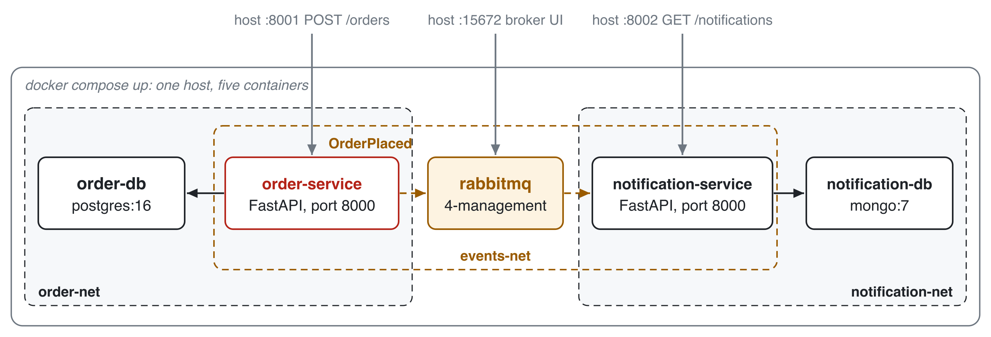
Figure 6: The prototype under Docker Compose. Each service shares a private network with its own database, and both share an events network with RabbitMQ; only the three ports shown are open to the host.
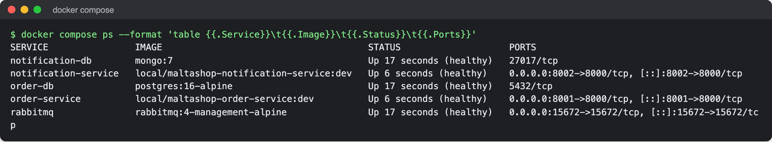
Figure 7: After docker compose up -d --build --wait, all five containers are running and healthy.
Table 16 lists the cloud-native tools needed to take the prototype from a laptop to production, and what each adds.
Table 16: From laptop to production
Tool | What it adds
Container registry (GitHub Container Registry or Amazon ECR) | Stores tested images by digest; scans them for known vulnerabilities
Kubernetes (Amazon EKS) | Replicas across zones, self-healing and autoscaling (Section 4.1)
Helm charts | One parameterised deployment template per service, replacing Compose
Argo CD (GitOps) | Applies what is in Git to the cluster, with an audit trail and easy rollback
Argo Rollouts | Canary releases with automatic analysis and rollback (Section 3.3)
Managed PostgreSQL, MongoDB and RabbitMQ | Backups, failover and patching without in-house database experts
AWS Secrets Manager with External Secrets | Replaces the development passwords in Compose with managed, rotated secrets
OpenTelemetry Collector and Grafana Cloud | Central logs, metrics, traces and alerts (Section 4.2)
Kong API gateway and Keycloak | Authentication, per-partner scopes and rate limits
Terraform | The cluster, databases and broker defined as reviewable code

6.3 Evidence and reflection
Figures 8 to 14 come from one run of evidence/capture.py on a freshly started system.
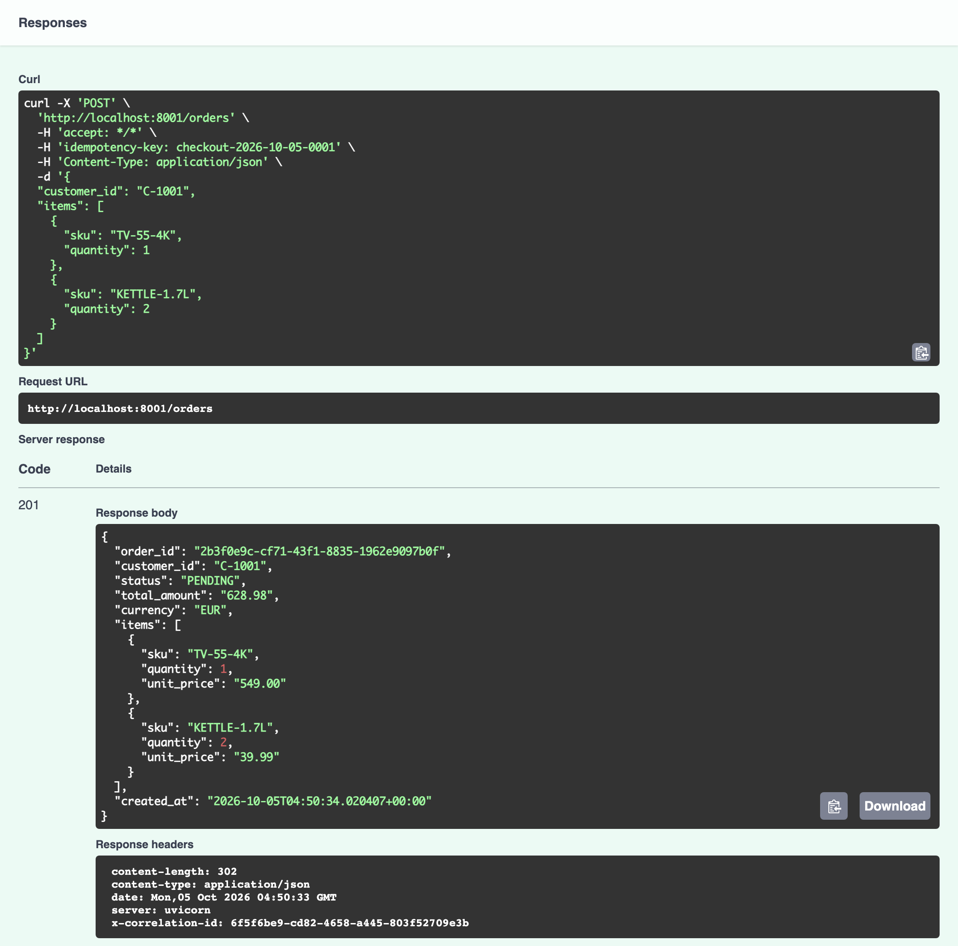
Figure 8: An order placed through the Order service's API documentation page (Swagger UI): the request, sent with an Idempotency-Key, and the 201 Created response with the order as PENDING, the total priced by the service, and the generated X-Correlation-ID header.
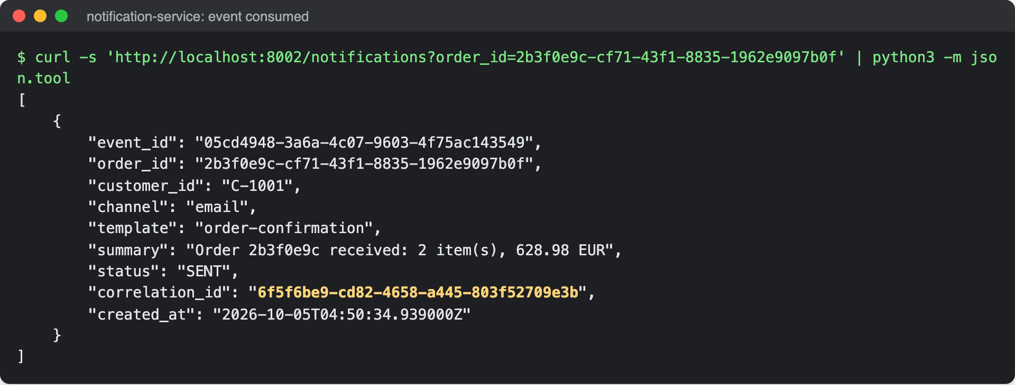
Figure 9: The Notification service consumed the OrderPlaced event and stored a notification in its own MongoDB database, carrying the same order ID and correlation ID.
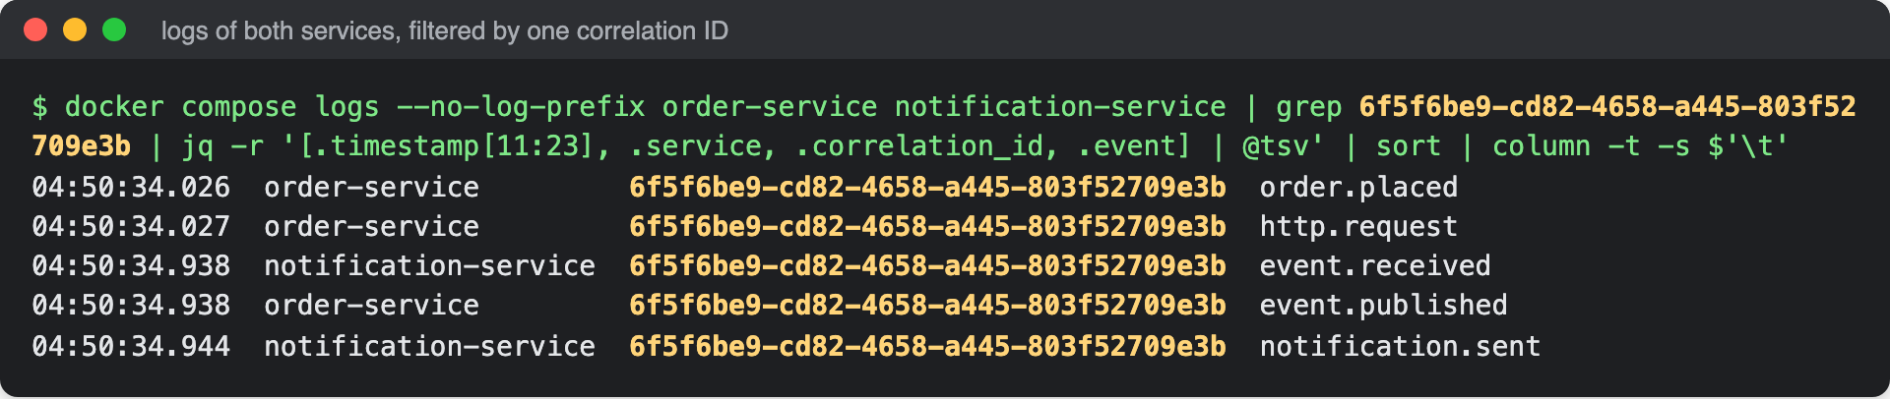
Figure 10: Log output of both services filtered by one correlation ID: the request, the outbox publish, and the event received and processed by the Notification service.
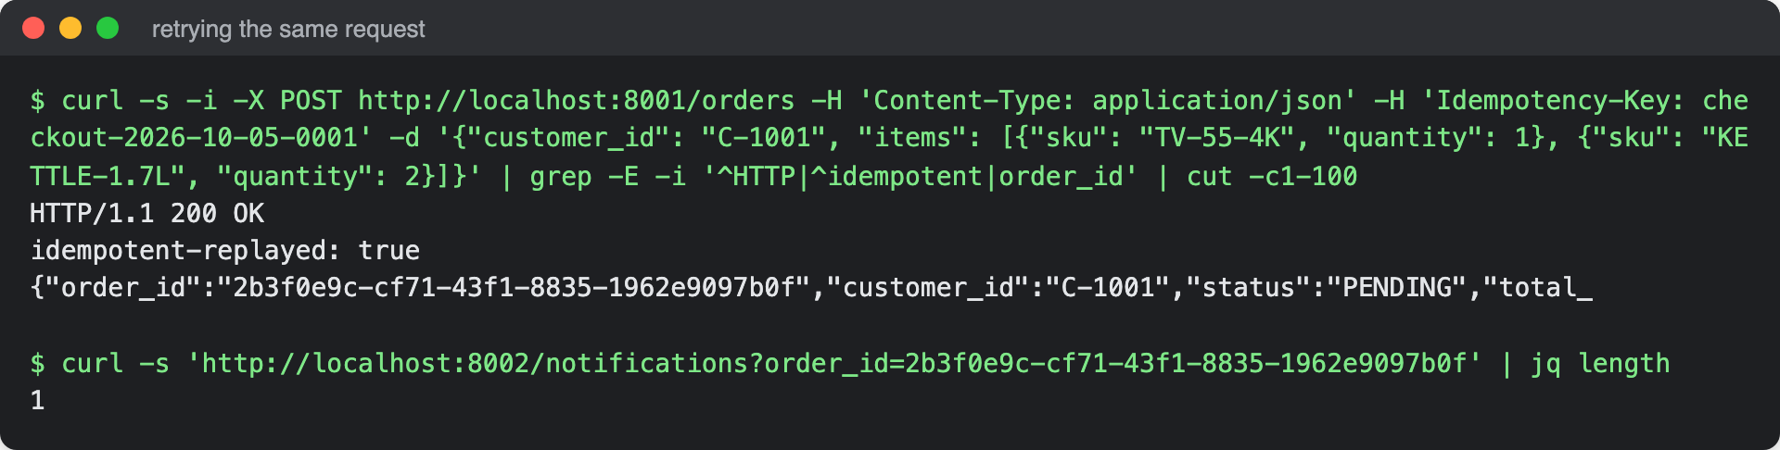
Figure 11: Retrying the same request with the same Idempotency-Key returns the original order (200 OK, Idempotent-Replayed), and there is still exactly one notification.
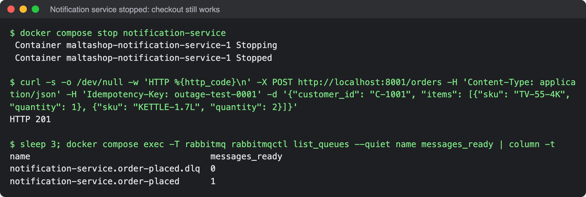
Figure 12: Resilience test: with the Notification service stopped, an order is still accepted (HTTP 201) and its event waits in the Notification service's queue.
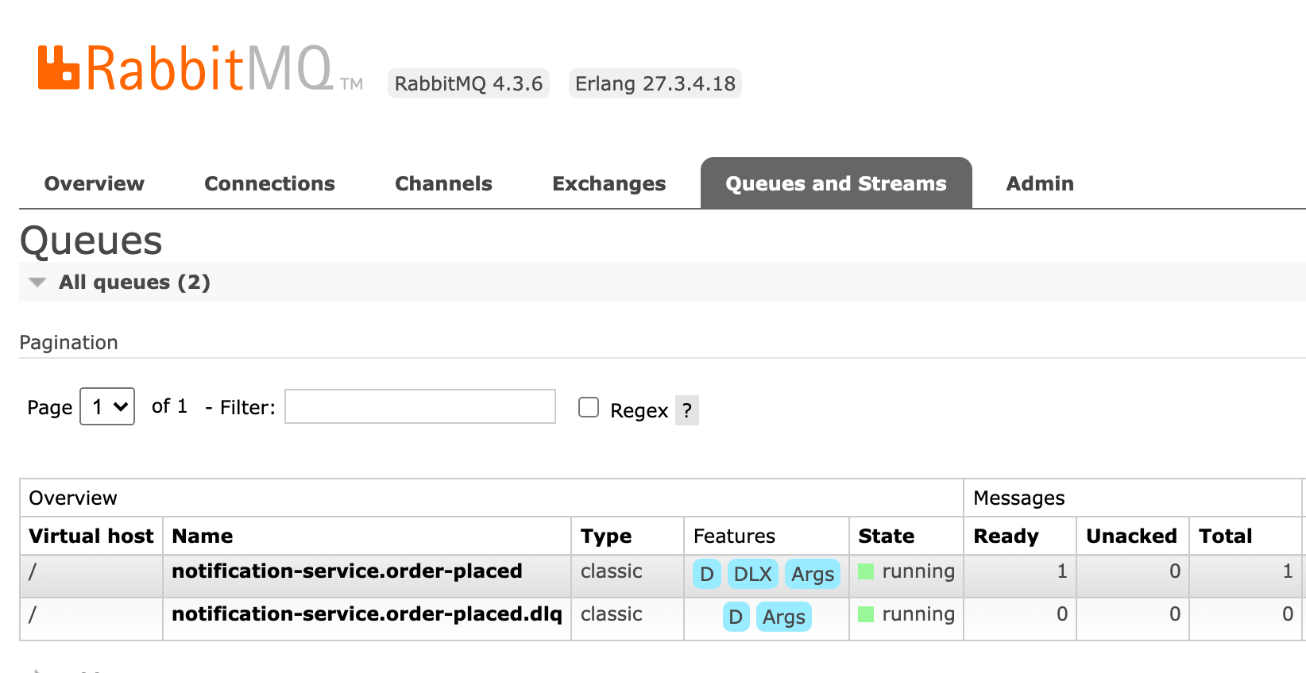
Figure 13: The RabbitMQ management page during the test: one message ready in notification-service.order-placed, and the dead-letter queue empty.
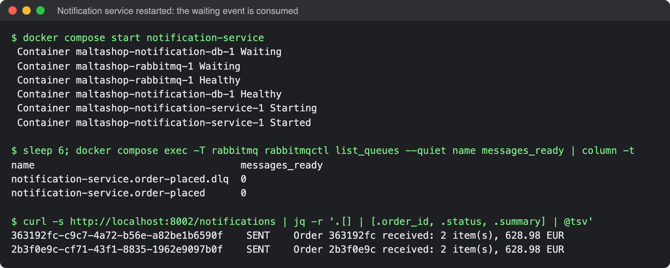
Figure 14: After the Notification service restarts, the waiting event is consumed: the queue is empty and both orders have a notification.
What the prototype proves. Two services with separate databases and networks cooperate only through a REST call and an event, which is the core of the design. Figures 12 to 14 show that the March incident cannot recur in the same form: with Notification stopped, orders were still accepted, the event waited in RabbitMQ and was processed when Notification returned. Figure 11 shows that a retried checkout creates no duplicate order or e-mail, and Figure 10 shows one correlation ID following an order across both services, which is what makes the logging design in Section 4.2 work. The CI pipeline tests the exact images it built.
Where it falls short. It has two services, not eight: without Inventory and Payment, the saga's compensations are designed (Figure 5) but never executed. There is no gateway, authentication or tracing, only correlation IDs. The outbox is polled every second, so an event can wait up to a second before it is published (compare the order.placed and event.published times in Figure 10). Every container is a single instance, and the passwords are development defaults.
What I would change before production. Add Inventory and Payment with their compensations, and test the failure paths automatically; replace polling with PostgreSQL LISTEN/NOTIFY or change-data capture; run schema changes as versioned migrations; add OpenTelemetry tracing, the gateway and Keycloak; move secrets into a secrets manager; and run the load test at ten times normal traffic on Kubernetes before the first sale.

References
Beyer, B., Murphy, N.R., Rensin, D.K., Kawahara, K. and Thorne, S. (eds) (2018) The Site Reliability Workbook: Practical Ways to Implement SRE. Sebastopol, CA: O'Reilly Media.
Burns, B., Beda, J., Hightower, K. and Evenson, L. (2022) Kubernetes: Up and Running. 3rd edn. Sebastopol, CA: O'Reilly Media.
Cohn, M. (2009) Succeeding with Agile: Software Development Using Scrum. Upper Saddle River, NJ: Addison-Wesley.
Conway, M.E. (1968) 'How do committees invent?', Datamation, 14(4), pp. 28–31.
Docker (n.d.) Multi-stage builds. Available at: https://docs.docker.com/build/building/multi-stage/ (Accessed: 5 October 2026).
Erl, T. (2005) Service-Oriented Architecture: Concepts, Technology, and Design. Upper Saddle River, NJ: Prentice Hall.
European Parliament and Council of the European Union (2016) 'Regulation (EU) 2016/679 of the European Parliament and of the Council of 27 April 2016 on the protection of natural persons with regard to the processing of personal data and on the free movement of such data (General Data Protection Regulation)', Official Journal of the European Union, L 119, 4 May, pp. 1–88.
Forsgren, N., Humble, J. and Kim, G. (2018) Accelerate: The Science of Lean Software and DevOps. Portland, OR: IT Revolution Press.
Fowler, M. (2004) StranglerFigApplication. Available at: https://martinfowler.com/bliki/StranglerFigApplication.html (Accessed: 5 October 2026).
Fowler, M. (2010) BlueGreenDeployment. Available at: https://martinfowler.com/bliki/BlueGreenDeployment.html (Accessed: 5 October 2026).
Fowler, M. (2015) MonolithFirst. Available at: https://martinfowler.com/bliki/MonolithFirst.html (Accessed: 5 October 2026).
Garcia-Molina, H. and Salem, K. (1987) 'Sagas', ACM SIGMOD Record, 16(3), pp. 249–259.
Hammant, P. (2017) Trunk Based Development. Available at: https://trunkbaseddevelopment.com (Accessed: 5 October 2026).
Humble, J. and Farley, D. (2010) Continuous Delivery: Reliable Software Releases through Build, Test, and Deployment Automation. Upper Saddle River, NJ: Addison-Wesley.
Istio (n.d.) The Istio service mesh. Available at: https://istio.io/latest/about/service-mesh/ (Accessed: 5 October 2026).
Kubernetes (n.d.a) Configure liveness, readiness and startup probes. Available at: https://kubernetes.io/docs/tasks/configure-pod-container/configure-liveness-readiness-startup-probes/ (Accessed: 5 October 2026).
Kubernetes (n.d.b) Horizontal Pod Autoscaling. Available at: https://kubernetes.io/docs/tasks/run-application/horizontal-pod-autoscale/ (Accessed: 5 October 2026).
Lewis, J. and Fowler, M. (2014) Microservices: a definition of this new architectural term. Available at: https://martinfowler.com/articles/microservices.html (Accessed: 5 October 2026).
Newman, S. (2021) Building Microservices: Designing Fine-Grained Systems. 2nd edn. Sebastopol, CA: O'Reilly Media.
Nygard, M. (2011) Documenting architecture decisions. Available at: https://cognitect.com/blog/2011/11/15/documenting-architecture-decisions (Accessed: 5 October 2026).
Nygard, M.T. (2018) Release It! Design and Deploy Production-Ready Software. 2nd edn. Raleigh, NC: Pragmatic Bookshelf.
OpenTelemetry (n.d.) OpenTelemetry documentation. Available at: https://opentelemetry.io/docs/ (Accessed: 5 October 2026).
Pact Foundation (n.d.) Introduction to Pact. Available at: https://docs.pact.io/ (Accessed: 5 October 2026).
PCI Security Standards Council (2022) Payment Card Industry Data Security Standard: Requirements and Testing Procedures, v4.0. Wakefield, MA: PCI Security Standards Council.
RabbitMQ (n.d.) Consumer acknowledgements and publisher confirms. Available at: https://www.rabbitmq.com/docs/confirms (Accessed: 5 October 2026).
Richardson, C. (2018) Microservices Patterns: With Examples in Java. Shelter Island, NY: Manning.
Richardson, C. (n.d.) Pattern: Transactional outbox. Available at: https://microservices.io/patterns/data/transactional-outbox.html (Accessed: 5 October 2026).
Rotem-Gal-Oz, A. (2006) Fallacies of distributed computing explained. Available at: https://www.rgoarchitects.com/Files/fallacies.pdf (Accessed: 5 October 2026).
Sato, D. (2014) CanaryRelease. Available at: https://martinfowler.com/bliki/CanaryRelease.html (Accessed: 5 October 2026).
Skelton, M. and Pais, M. (2019) Team Topologies: Organizing Business and Technology Teams for Fast Flow. Portland, OR: IT Revolution Press.
Vocke, H. (2018) The Practical Test Pyramid. Available at: https://martinfowler.com/articles/practical-test-pyramid.html (Accessed: 5 October 2026).
Vogels, W. (2009) 'Eventually consistent', Communications of the ACM, 52(1), pp. 40–44.
Wiggins, A. (2017) The Twelve-Factor App. Available at: https://12factor.net/ (Accessed: 5 October 2026).

Appendix A: Git Repository
The prototype, its tests, the CI workflow, the diagrams and the scripts that build this report are in a public GitHub repository, shared with the lecturer: https://github.com/imranneta5555/maltashop-microservices
To run the prototype, clone the repository and start it with Docker Compose. The README explains the endpoints and every environment variable.
git clone https://github.com/imranneta5555/maltashop-microservices.git
cd maltashop-microservices
docker compose up --build -d --wait
python3 scripts/smoke_test.py

The commit history below, oldest first, shows the prototype being built step by step (it was taken when this report was built).
fa69137 2026-10-05 10:02 project skeleton and readme outline
9f14f67 2026-10-05 10:04 order service: order rules, pricing and OrderPlaced event with unit tests
df55546 2026-10-05 10:06 order service: POST /orders with PostgreSQL, idempotency key and outbox table
393458d 2026-10-05 10:10 order service: outbox relay publishes OrderPlaced to RabbitMQ with publisher confirms
95b02c4 2026-10-05 10:11 notification service: idempotent OrderPlaced consumer with MongoDB store and dead-letter queue
e720307 2026-10-05 10:14 dockerfiles for both services and docker compose for the whole system
0828c68 2026-10-05 10:15 OrderPlaced contract with provider and consumer contract tests, end-to-end smoke test
2b70c17 2026-10-05 10:16 ci: test, build-once image push to GHCR, and integration stage on the built images
bd64289 2026-10-05 10:16 readme: what the system is, how to run it, endpoints and environment variables
d734444 2026-10-05 10:22 ci: pin actions to commit SHAs, move to node24 releases, pin runner to ubuntu-24.04
ce0fd98 2026-10-05 10:25 diagrams: architecture, ci/cd pipeline, observability, saga and prototype topology
643179a 2026-10-05 10:29 evidence: demo capture script, transcripts and screenshots of the running prototype
d4114f7 2026-10-05 10:54 order service: wrap long lines that the report quotes
2192cf9 2026-10-05 10:54 evidence: larger terminal text, tighter crops and the ci run screenshot
1dac862 2026-10-05 10:54 docs: architecture decision records; readme covers docs, evidence and report
092eb10 2026-10-05 10:54 report: sections 1 to 6, references and the build scripts
1b68926 2026-10-05 10:54 report built (pdf and word)

Appendix B: Prototype Source Code
The Compose file and the source files quoted in Section 6.1, in full. The Dockerfile and the CI workflow are in Listings 7 and 2.

B.1 docker-compose.yml
# MaltaShop prototype: start everything with `docker compose up --build`.
# Every value can be overridden from a .env file (see .env.example); the defaults are for a laptop only.
name: maltashop

services:
# ---------- Order service and the database only it can reach ----------
order-service:
build: ./order-service
image: ${IMAGE_REGISTRY:-local}/maltashop-order-service:${IMAGE_TAG:-dev}
environment:
SERVICE_NAME: order-service
DATABASE_URL: postgresql://order_service:${ORDER_DB_PASSWORD:-order_dev_password}@order-db:5432/orders
RABBITMQ_URL: amqp://${RABBITMQ_USER:-maltashop}:${RABBITMQ_PASSWORD:-maltashop_dev_password}@rabbitmq:5672/%2F
EVENTS_EXCHANGE: maltashop.events
OUTBOX_POLL_SECONDS: "1"
LOG_LEVEL: ${LOG_LEVEL:-INFO}
ports:
- "8001:8000"
depends_on:
order-db:
condition: service_healthy
rabbitmq:
condition: service_healthy
networks: [order-net, events-net]
restart: unless-stopped

order-db:
image: postgres:16-alpine
environment:
POSTGRES_DB: orders
POSTGRES_USER: order_service
POSTGRES_PASSWORD: ${ORDER_DB_PASSWORD:-order_dev_password}
volumes:
- order-db-data:/var/lib/postgresql/data
healthcheck:
test: ["CMD-SHELL", "pg_isready -U order_service -d orders"]
interval: 5s
timeout: 3s
retries: 12
networks: [order-net]

# ---------- Notification service and the database only it can reach ----------
notification-service:
build: ./notification-service
image: ${IMAGE_REGISTRY:-local}/maltashop-notification-service:${IMAGE_TAG:-dev}
environment:
SERVICE_NAME: notification-service
MONGO_URL: mongodb://notification_service:${NOTIFICATION_DB_PASSWORD:-notification_dev_password}@notification-db:27017/?authSource=admin
MONGO_DB: notifications
RABBITMQ_URL: amqp://${RABBITMQ_USER:-maltashop}:${RABBITMQ_PASSWORD:-maltashop_dev_password}@rabbitmq:5672/%2F
EVENTS_EXCHANGE: maltashop.events
QUEUE_NAME: notification-service.order-placed
LOG_LEVEL: ${LOG_LEVEL:-INFO}
ports:
- "8002:8000"
depends_on:
notification-db:
condition: service_healthy
rabbitmq:
condition: service_healthy
networks: [notification-net, events-net]
restart: unless-stopped

notification-db:
image: mongo:7
environment:
MONGO_INITDB_ROOT_USERNAME: notification_service
MONGO_INITDB_ROOT_PASSWORD: ${NOTIFICATION_DB_PASSWORD:-notification_dev_password}
volumes:
- notification-db-data:/data/db
healthcheck:
test: ["CMD", "mongosh", "--quiet", "--eval", "db.adminCommand('ping').ok"]
interval: 5s
timeout: 5s
retries: 12
networks: [notification-net]

# ---------- Message broker shared by both services ----------
rabbitmq:
image: rabbitmq:4-management-alpine
environment:
RABBITMQ_DEFAULT_USER: ${RABBITMQ_USER:-maltashop}
RABBITMQ_DEFAULT_PASS: ${RABBITMQ_PASSWORD:-maltashop_dev_password}
ports:
- "15672:15672" # management UI: http://localhost:15672
healthcheck:
test: ["CMD", "rabbitmq-diagnostics", "-q", "ping"]
interval: 10s
timeout: 5s
retries: 12
networks: [events-net]

# Separate networks: each service can reach its own database and the broker, but not the
# other service's database. "Database per service" is enforced, not just agreed.
networks:
order-net:
notification-net:
events-net:

volumes:
order-db-data:
notification-db-data:

B.2 order-service/app/main.py
"""Order service: the REST API for placing orders."""
import logging
import time
import uuid
from contextlib import asynccontextmanager
from uuid import UUID

from fastapi import FastAPI, Header, HTTPException, Request, Response
from fastapi.concurrency import run_in_threadpool

from . import db
from .domain import PlaceOrderRequest
from .logging_setup import correlation_id, log_event, setup_logging
from .outbox import OutboxRelay

setup_logging()
log = logging.getLogger("order.api")

@asynccontextmanager
async def lifespan(app: FastAPI):
await run_in_threadpool(db.create_schema)
relay = OutboxRelay()
relay.start()
log_event(log, logging.INFO, "service.started", "Order service started; outbox relay running")
yield
relay.stop()

app = FastAPI(title="MaltaShop Order Service", version="0.1.0", lifespan=lifespan)

@app.middleware("http")
async def correlation_and_access_log(request: Request, call_next):
"""Reuses the caller's X-Correlation-ID (or creates one) and logs every request as JSON."""
token = correlation_id.set(request.headers.get("X-Correlation-ID") or str(uuid.uuid4()))
started = time.perf_counter()
try:
response = await call_next(request)
response.headers["X-Correlation-ID"] = correlation_id.get()
if not request.url.path.startswith("/health"):
log_event(log, logging.INFO, "http.request",
f"{request.method} {request.url.path} -> {response.status_code}",
method=request.method, path=request.url.path, status=response.status_code,
duration_ms=round((time.perf_counter() - started) * 1000, 1))
return response
finally:
correlation_id.reset(token)

def to_json(order: dict) -> dict:
return {
"order_id": str(order["order_id"]),
"customer_id": order["customer_id"],
"status": order["status"],
"total_amount": str(order["total_amount"]),
"currency": order["currency"],
"items": order["items"],
"created_at": order["created_at"].isoformat(),
}

@app.post("/orders", status_code=201)
def place_order(body: PlaceOrderRequest, response: Response,
idempotency_key: str | None = Header(default=None, max_length=100)) -> dict:
"""Places an order. Send an Idempotency-Key header so a retried request cannot create a duplicate."""
key = idempotency_key or str(uuid.uuid4())
order, created = db.place_order(body, key, correlation_id.get())
if created:
log_event(log, logging.INFO, "order.placed", "Order saved as PENDING; OrderPlaced queued in outbox",
order_id=str(order["order_id"]), customer_id=order["customer_id"],
total_amount=str(order["total_amount"]))
else:
response.status_code = 200
response.headers["Idempotent-Replayed"] = "true"
log_event(log, logging.INFO, "order.replayed",
"Idempotency-Key seen before: original order returned, nothing written",
order_id=str(order["order_id"]))
return to_json(order)

@app.get("/orders/{order_id}")
def get_order(order_id: UUID) -> dict:
order = db.get_order(str(order_id))
if order is None:
raise HTTPException(status_code=404, detail="order not found")
return to_json(order)

@app.get("/health/live")
def live() -> dict:
return {"status": "ok"}

@app.get("/health/ready")
def ready() -> dict:
# Ready means "can take orders": that needs the database. A broker outage does not
# make the service unready, because new events wait safely in the outbox table.
try:
db.ping()
except Exception as error:
raise HTTPException(status_code=503, detail="database unavailable") from error
return {"status": "ready"}

B.3 order-service/app/db.py
"""The Order service's own PostgreSQL database. No other service connects to it."""
import psycopg
from psycopg.rows import dict_row
from psycopg.types.json import Jsonb

from . import config
from .domain import CURRENCY, PlaceOrderRequest, order_placed_event, order_total, price_lines

SCHEMA = """
CREATE TABLE IF NOT EXISTS orders (
order_id UUID PRIMARY KEY,
idempotency_key TEXT NOT NULL UNIQUE,
customer_id TEXT NOT NULL,
status TEXT NOT NULL CHECK (status IN ('PENDING', 'CONFIRMED', 'CANCELLED')),
total_amount NUMERIC(10, 2) NOT NULL,
currency CHAR(3) NOT NULL,
items JSONB NOT NULL,
correlation_id TEXT NOT NULL,
created_at TIMESTAMPTZ NOT NULL DEFAULT now()
);
CREATE TABLE IF NOT EXISTS outbox (
event_id UUID PRIMARY KEY,
event_type TEXT NOT NULL,
routing_key TEXT NOT NULL,
payload JSONB NOT NULL,
created_at TIMESTAMPTZ NOT NULL DEFAULT now(),
published_at TIMESTAMPTZ
);
CREATE INDEX IF NOT EXISTS outbox_unpublished ON outbox (created_at) WHERE published_at IS NULL;
"""

def connect() -> psycopg.Connection:
return psycopg.connect(config.DATABASE_URL, row_factory=dict_row, connect_timeout=5)

def create_schema() -> None:
with connect() as conn:
conn.execute(SCHEMA)

def ping() -> None:
with connect() as conn:
conn.execute("SELECT 1")

def place_order(request: PlaceOrderRequest, idempotency_key: str, correlation_id: str) -> tuple[dict, bool]:
"""Saves a PENDING order and its OrderPlaced event in ONE local transaction (transactional outbox).

Returns (order, created). If the idempotency key was seen before, the original order is
returned with created=False and nothing new is written, so a retried request is harmless.
"""
with connect() as conn, conn.transaction():
order = conn.execute(
"""INSERT INTO orders (order_id, idempotency_key, customer_id, status,
total_amount, currency, items, correlation_id)
VALUES (gen_random_uuid(), %s, %s, 'PENDING', %s, %s, %s, %s)
ON CONFLICT (idempotency_key) DO NOTHING
RETURNING *""",
(idempotency_key, request.customer_id, order_total(request.items),
CURRENCY, Jsonb(price_lines(request.items)), correlation_id),
).fetchone()
if order is None: # a retry of a request that was already handled
existing = conn.execute("SELECT * FROM orders WHERE idempotency_key = %s",
(idempotency_key,)).fetchone()
return existing, False

event = order_placed_event(order, correlation_id)
conn.execute(
"INSERT INTO outbox (event_id, event_type, routing_key, payload) "
"VALUES (%s, %s, %s, %s)",
(event["event_id"], event["event_type"], "order.placed", Jsonb(event)),
)
return order, True

def get_order(order_id: str) -> dict | None:
with connect() as conn:
return conn.execute("SELECT * FROM orders WHERE order_id = %s", (order_id,)).fetchone()

B.4 order-service/app/outbox.py
"""Outbox relay: publishes the events that place_order() saved, then marks them as sent.

Runs as a background thread. A row is marked as published only after RabbitMQ has
confirmed the message, so a crash can cause a repeat but never a loss (at-least-once
delivery). Consumers therefore ignore an event_id they have already processed.
"""
import json
import logging
import threading

import pika

from . import config, db
from .logging_setup import correlation_id, log_event

log = logging.getLogger("order.outbox")

class OutboxRelay(threading.Thread):
def __init__(self) -> None:
super().__init__(name="outbox-relay", daemon=True)
self._stopping = threading.Event()
self._connection: pika.BlockingConnection | None = None
self._channel = None

def stop(self) -> None:
self._stopping.set()

def run(self) -> None:
while not self._stopping.is_set():
try:
self.publish_pending()
except Exception as error: # broker or database down: events stay in the outbox
log_event(log, logging.WARNING, "outbox.retry", f"Publish failed, will retry: {error!r}")
self._disconnect()
self._stopping.wait(config.OUTBOX_POLL_SECONDS)
self._disconnect()

def publish_pending(self) -> None:
channel = self._get_channel()
with db.connect() as conn, conn.transaction():
rows = conn.execute(
"""SELECT event_id, event_type, routing_key, payload FROM outbox
WHERE published_at IS NULL ORDER BY created_at LIMIT 50
FOR UPDATE SKIP LOCKED"""
).fetchall()
for row in rows:
event = row["payload"]
token = correlation_id.set(event["correlation_id"])
try:
channel.basic_publish(
exchange=config.EVENTS_EXCHANGE,
routing_key=row["routing_key"],
body=json.dumps(event).encode(),
properties=pika.BasicProperties(
content_type="application/json",
delivery_mode=pika.DeliveryMode.Persistent, # survives a broker restart
message_id=str(row["event_id"]),
correlation_id=event["correlation_id"],
type=row["event_type"],
),
mandatory=True, # fail if no queue is bound, rather than drop the event
) # with publisher confirms on, this returns only once the broker has the message
conn.execute("UPDATE outbox SET published_at = now() WHERE event_id = %s",
(row["event_id"],))
log_event(log, logging.INFO, "event.published",
f"Published {row['event_type']} to {config.EVENTS_EXCHANGE}",
event_id=str(row["event_id"]), order_id=event["data"]["order_id"],
routing_key=row["routing_key"])
finally:
correlation_id.reset(token)
self._connection.process_data_events(time_limit=0) # keeps the AMQP heartbeat alive

def _get_channel(self):
if self._channel is None or self._channel.is_closed:
self._connection = pika.BlockingConnection(pika.URLParameters(config.RABBITMQ_URL))
self._channel = self._connection.channel()
self._channel.exchange_declare(exchange=config.EVENTS_EXCHANGE, exchange_type="topic",
durable=True)
self._channel.confirm_delivery()
return self._channel

def _disconnect(self) -> None:
try:
if self._connection is not None and self._connection.is_open:
self._connection.close()
except Exception:
pass
self._connection = self._channel = None

B.5 notification-service/app/consumer.py
"""Consumes OrderPlaced events from RabbitMQ in a background thread.

A message is acknowledged only after its notification is stored (manual ack), so if the
service crashes first, RabbitMQ delivers the message again. Messages that can never be
processed go to a dead-letter queue instead of being retried for ever.
"""
import json
import logging
import threading
import time

import pika
from pymongo.errors import PyMongoError

from . import config, store
from .handlers import MalformedEvent, build_notification
from .logging_setup import correlation_id, log_event

log = logging.getLogger("notification.consumer")
DEAD_LETTER_EXCHANGE = f"{config.EVENTS_EXCHANGE}.dlx"
DEAD_LETTER_QUEUE = f"{config.QUEUE_NAME}.dlq"

class OrderPlacedConsumer(threading.Thread):
def __init__(self) -> None:
super().__init__(name="order-placed-consumer", daemon=True)
self.connected = False

def run(self) -> None:
while True:
try:
connection = pika.BlockingConnection(pika.URLParameters(config.RABBITMQ_URL))
channel = connection.channel()
self.declare_topology(channel)
channel.basic_qos(prefetch_count=10) # at most 10 unacknowledged messages at a time
channel.basic_consume(queue=config.QUEUE_NAME, on_message_callback=self.on_message)
self.connected = True
log_event(log, logging.INFO, "consumer.started", f"Consuming from {config.QUEUE_NAME}")
channel.start_consuming()
except pika.exceptions.AMQPError as error:
self.connected = False
log_event(log, logging.WARNING, "consumer.reconnect",
f"Broker connection lost, retrying in 3 s: {error!r}")
time.sleep(3)

@staticmethod
def declare_topology(channel) -> None:
"""The consumer owns its queue: durable, bound to order.placed, with a dead-letter queue."""
channel.exchange_declare(config.EVENTS_EXCHANGE, exchange_type="topic", durable=True)
channel.exchange_declare(DEAD_LETTER_EXCHANGE, exchange_type="fanout", durable=True)
channel.queue_declare(DEAD_LETTER_QUEUE, durable=True)
channel.queue_bind(DEAD_LETTER_QUEUE, DEAD_LETTER_EXCHANGE)
channel.queue_declare(config.QUEUE_NAME, durable=True,
arguments={"x-dead-letter-exchange": DEAD_LETTER_EXCHANGE})
channel.queue_bind(config.QUEUE_NAME, config.EVENTS_EXCHANGE, routing_key="order.placed")

def on_message(self, channel, method, properties, body) -> None:
token = correlation_id.set(properties.correlation_id) # same ID the Order service logged
try:
event = json.loads(body)
log_event(log, logging.INFO, "event.received", f"Received {event.get('event_type')}",
event_id=event.get("event_id"), order_id=event.get("data", {}).get("order_id"))
notification = build_notification(event)
if store.save(notification):
log_event(log, logging.INFO, "notification.sent",
f"Order confirmation recorded for customer {notification['customer_id']}",
order_id=notification["order_id"], event_id=notification["event_id"])
else:
log_event(log, logging.INFO, "event.duplicate",
"Event already processed, ignored (idempotent consumer)",
event_id=notification["event_id"])
channel.basic_ack(method.delivery_tag)
except (ValueError, MalformedEvent) as bad: # bad JSON or missing fields: never retry
log_event(log, logging.ERROR, "event.rejected", f"Sent to dead-letter queue: {bad}")
channel.basic_nack(method.delivery_tag, requeue=False)
except PyMongoError as error: # temporary: put it back and try again shortly
log_event(log, logging.WARNING, "store.unavailable", f"Will be redelivered: {error!r}")
time.sleep(2)
channel.basic_nack(method.delivery_tag, requeue=True)
finally:
correlation_id.reset(token)

