Grist Report Project

# Introduction:

In this document I will try to explain you how this project code will run and how I created it. My English is not good. Sorry for it.

# Project Code:

You can download the project code from my github profile. Please open this link.

<https://github.com/imranqau5373/HealthAssesment>

Download the code see in screen shot below.

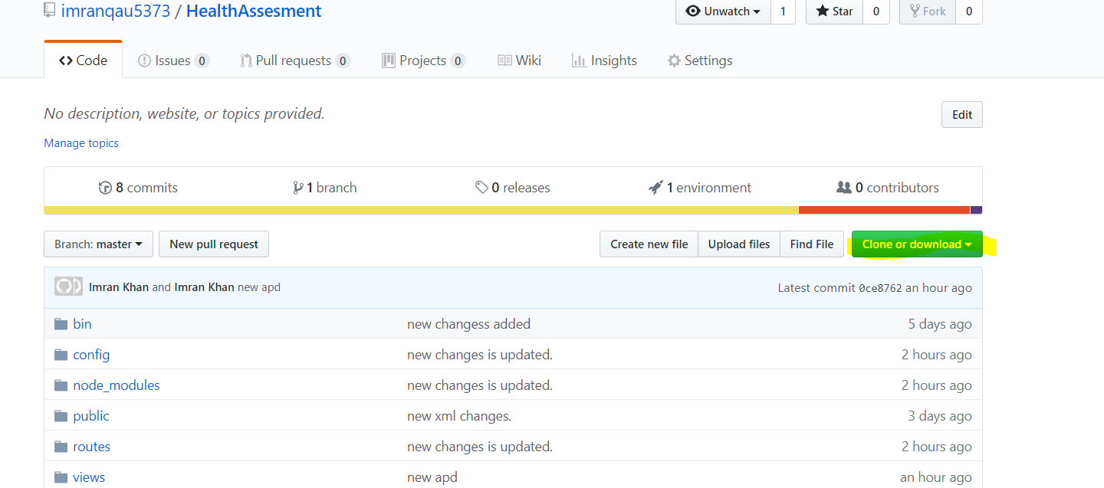

When you download the code. Extract it and open it in visual studio code.

Project directory should be Like see in screen shot below.

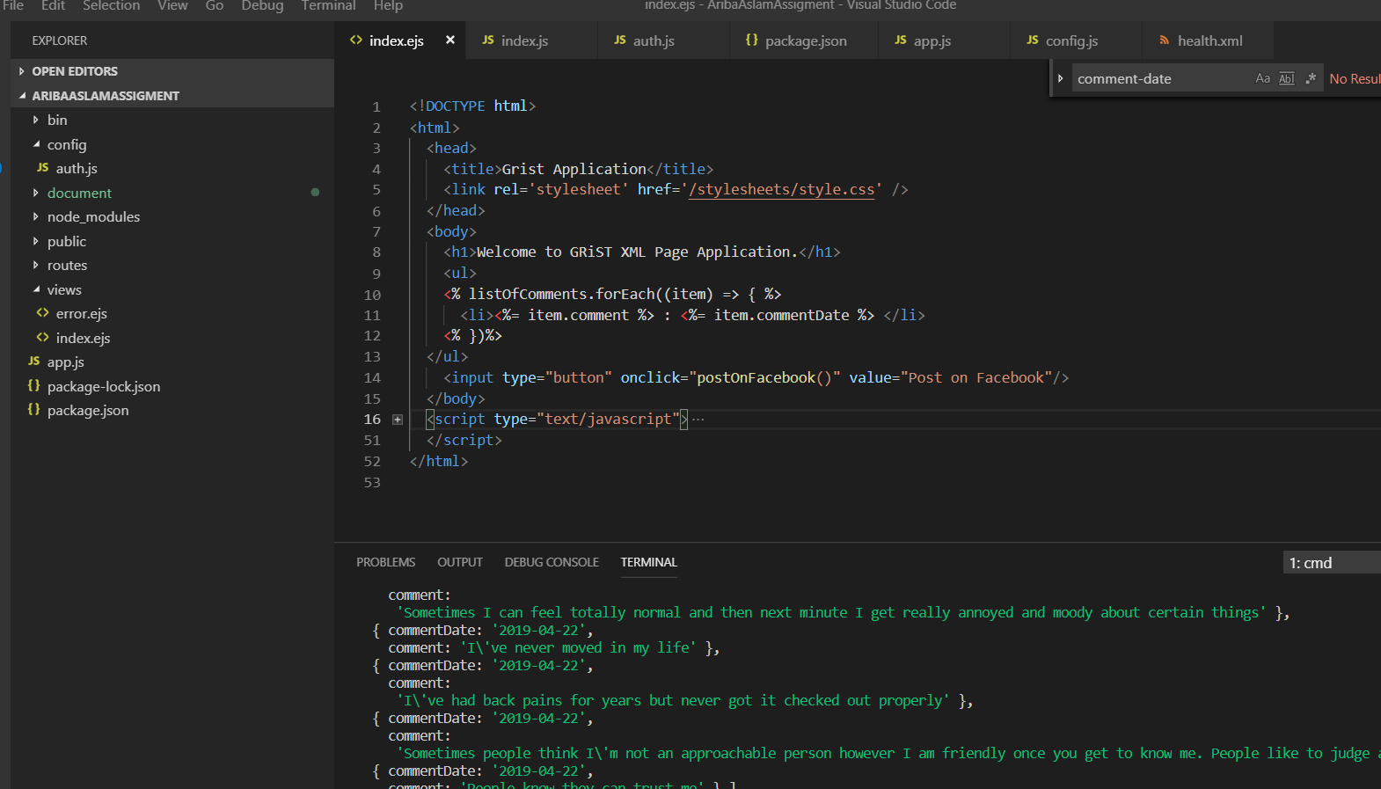

After that go into the view menu and select Terminal option from visual studio code. In bottom switch in to project directory where all project directories are showing and run the command.

Npm install.

That command will install all the required files for the project and its dependencies.

Once this command run successfully. After that run these commands as well

Npm install –g

Nodemon install –g

That command will install these packages golabally. Most of the time these packages are required for run the application.

Now you can run the application with the help of these commands.

Nodemon

Another command.

Npm start

You can find out difference between these two command on google.

# Node and Express:

Node is piece of software that run the javascript on server side. Normally we used the javascript for client side. But now we can used it on server side as well. Advantage is that we not need to learn new language for server side and client side. With the expertise of one language. We can used it on both end.

Express.js is frame work used to build web application. With the help of that we can easily create the web application.

I have used both of them to build this application.

How you create application on express. You can go through this part.

<https://expressjs.com/en/starter/installing.html>

<https://medium.com/@LindaVivah/the-beginners-guide-understanding-node-js-express-js-fundamentals-e15493462be1>

Above article explain each basic things related to the project.

# App.js:

Main file of the application. That exist in all node. Application. That file is the entry point of the application.

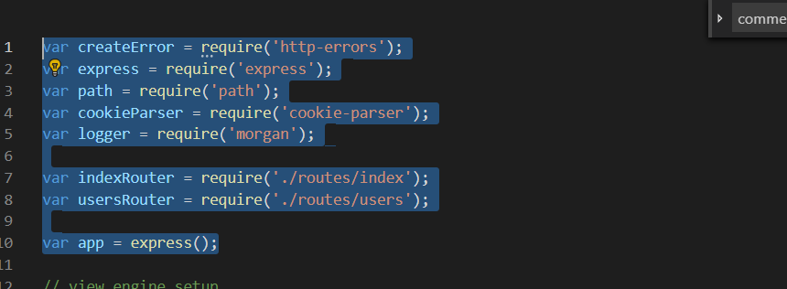

In that part of the application we mention the required packages of the application. IndexRouter and usersRouter are the files in which we required for the application and logic of the application.

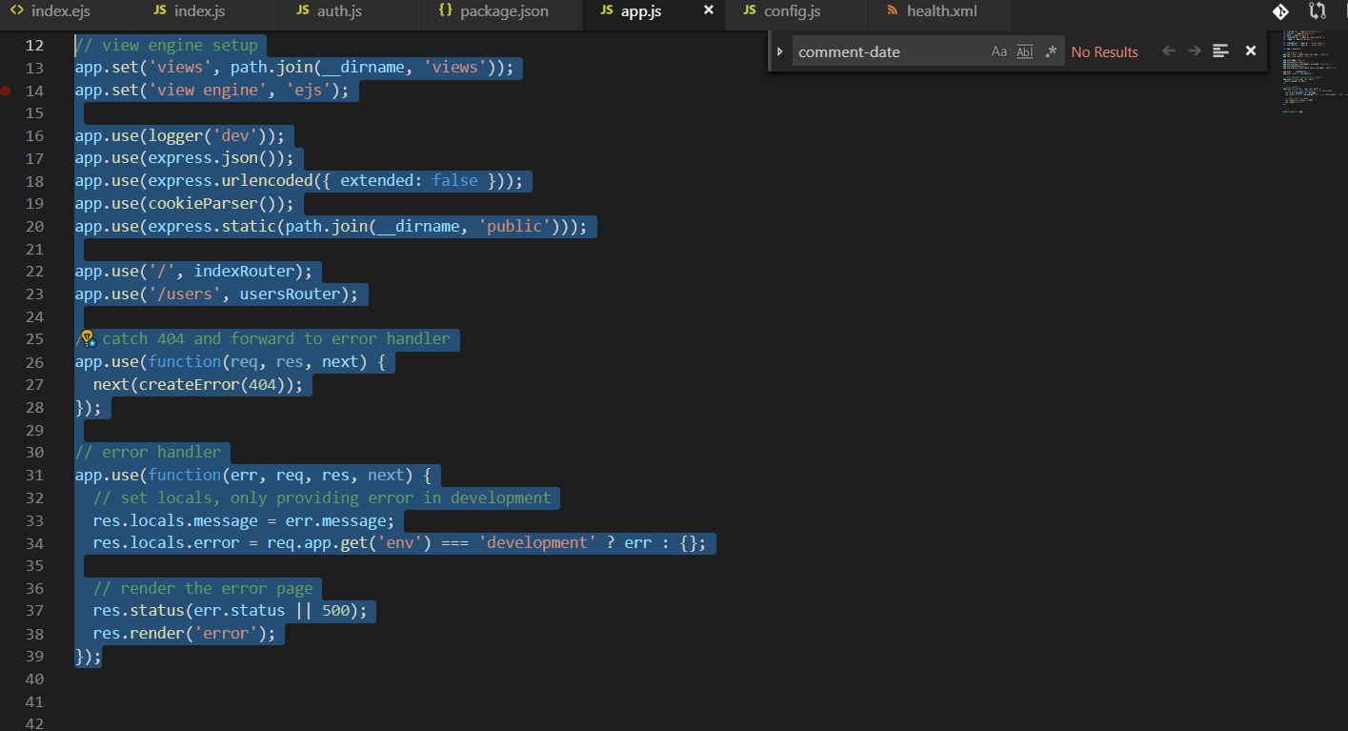

In that part of the application first two line tell about which view are going to use for the application. In next 5 line of the application from line number 16 to 20. App.use is the function that are used for each request. Like each request we check the cookies and url encoded etc.

Remaining lines of the code used like for each request of the application.

# Routes/index.js:

In this file first part of the code are used to include the list of required files for that file. See in screen shot below.

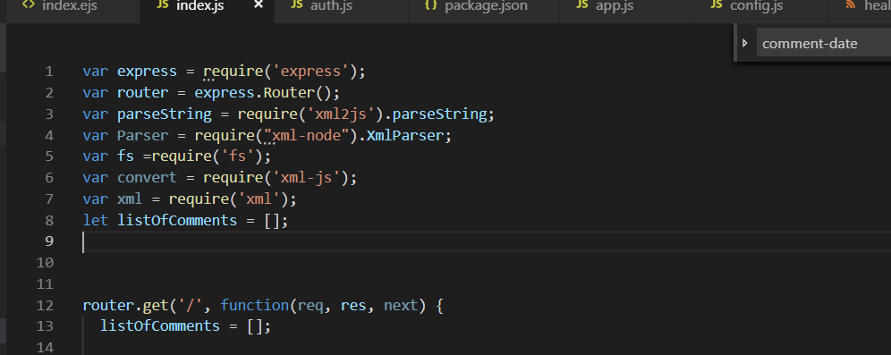

When we enter the url like localhost:3000. Request will come in this function.

Router.get(‘/’,function(req,res,next){

});

In this function I have writer down the code to read the xml and extract comment data.

In these two line. First line give the path of the file and second method read the file from location.

let filePath = './public/healthfiles/health.xml';

fs.readFile( filePath, 'utf8', function(err, data) {

fs.readFile function read the file and return its xml data in variable data.

parseString(data, function (err, result) {

above line are used to parse the data that read from file. Fs.readFile that function read the file from location and have in string format. ParseString convert that data in xml format.

for(let i=0; i<result.report.assessment[0].node.length; i++){

on this line result Is basically data in proper xml format. Result.report is the first node and assessment is the node in inside of report and that have list of nodes related to comment etc.

if(result.report.assessment[0].node[i].$.code == "generic"){

that line check the node inside of assessment tag one by one. Once the node come with attribute with generic. I get its all related nodes.

for(let j =0; j<result.report.assessment[0].node[i].node.length; j++){

another loop to check node one by one. That have comment-date and comment etc.

if(result.report.assessment[0].node[i].node[j].$['comment-date'])

above line check that node have comment-date or not.

if(result.report.assessment[0].node[i].node[j].node){

if node that have comment-date and inside another node. We used above line of code.

for(let k = 0; k<result.report.assessment[0].node[i].node[j].node.length; k++){

if node that have comment-date and inside have another nodes that have comment-date and comment etc. for that purpose I have written this loop.

if(result.report.assessment[0].node[i].node[j].node[k].$['comment-date'])

{

let commentData = {

commentDate : '',

comment : ''

}

commentData.commentDate = result.report.assessment[0].node[i].node[j].node[k].$['comment-date'];

commentData.comment = result.report.assessment[0].node[i].node[j].node[k].$.comment;

listOfComments.push(commentData)

}

In that part get comment date and store in string variable commentDate and comment etc.

res.render('index', { listOfComments: listOfComments });

that part return the get data of comments to the view.

# View/Index.ejs:

<!DOCTYPE html>

<html>

<head>

<title>Grist Application</title>

<link rel='stylesheet' href='/stylesheets/style.css' />

</head>

<body>

<h1>Welcome to GRiST XML Page Application.</h1>

<ul>

<% listOfComments.forEach((item) => { %>

<li><%= item.comment %> : <%= item.commentDate %> </li>

<% })%>

</ul>

<input type="button" onclick="postOnFacebook()" value="Post on Facebook"/>

</body>

That view are using to display the data of comment and comment-date. In this html I have writer the loop to show the comments and its dates.

Button are used to post data on facebook.

window.fbAsyncInit = function () {

FB.init({

appId: '593239947842894',

xfbml: true,

version: 'v2.5'

});

postOnFacebook();

};

(function (d, s, id) {

var js, fjs = d.getElementsByTagName(s)[0];

if (d.getElementById(id)) { return; }

js = d.createElement(s); js.id = id;

js.src = "//connect.facebook.net/en_US/sdk.js";

fjs.parentNode.insertBefore(js, fjs);

}(document, 'script', 'facebook-jssdk'));

Above line of code are used to include facebook sdk. With the help of that code. It will be posted on the facebook. App id is the app id of your application.

function postOnFacebook() {

//window.location.href = "/Account/PostOnFacebook";

FB.ui(

{

method: 'share',

href: 'https://health-assesment.herokuapp.com/',

},

// callback

function (response) {

if (response && !response.error_message) {

alert('Posting completed.');

} else {

alert('Error while posting.');

}

}

);

}

Above function are used to post data on facebook.