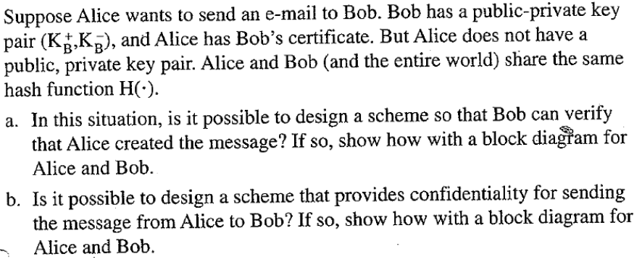

Answer:- a) No, It’s not possible to verify wheather Alice created the message without having the public-private key pair or pre shared secret key.

b) Yes, It’s possible to send message that provides confidentiality from Alice to Bob, by encrypting Alice message with Bob’s public key and sending it to Bob.

