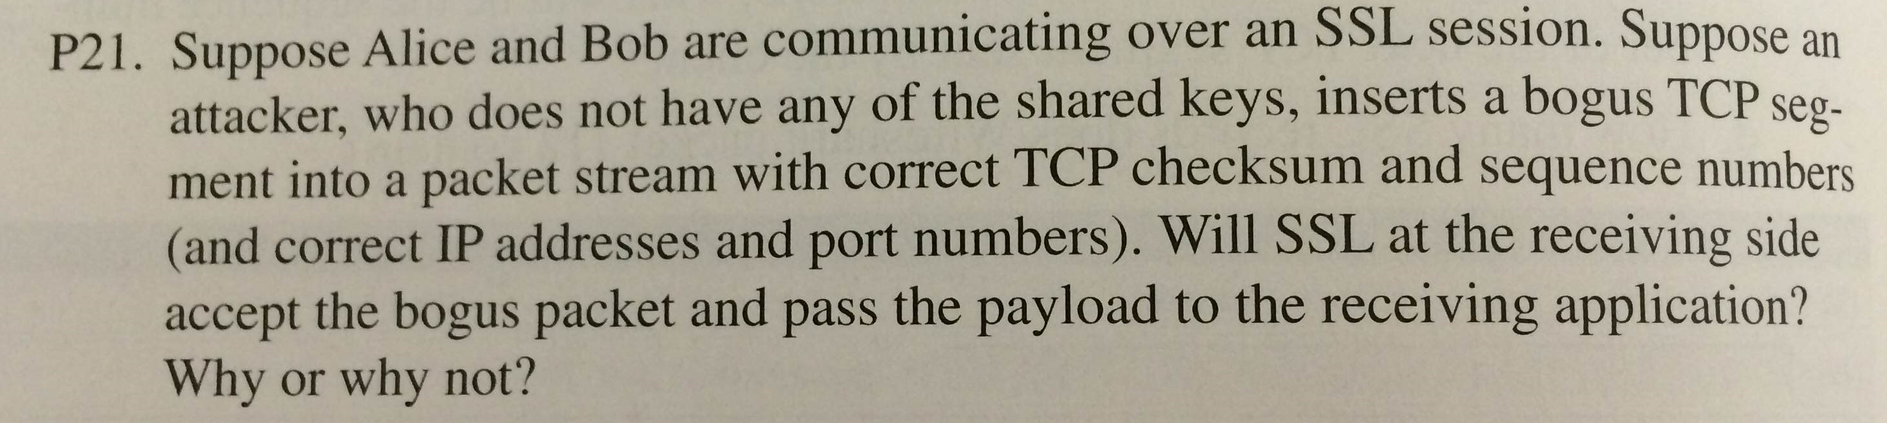

Ans- No, It won’t accept the bogus packet as packet will fail the integrity check which uses a shared MAC key and therefore, packet will be dropped at receiving end.

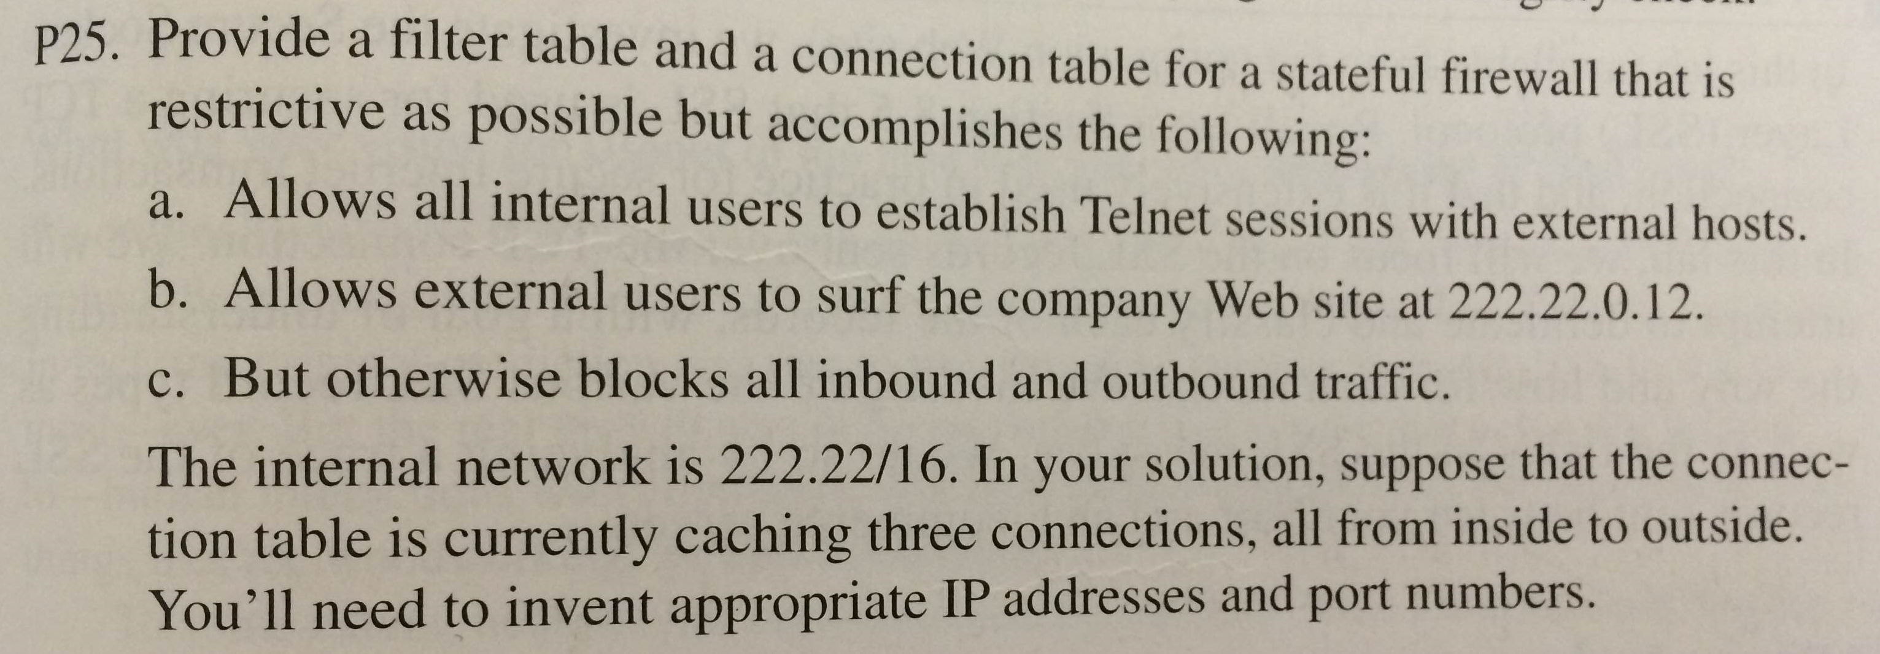

Filter Table

Action | Protocol | Source Address | Destination Address | Source Port | Dest Port | Flag Bit | Check  Connection
Allow | TCP | 222.22/16 | Outside of 222.22/16 | >1023 | 22 | Any
Allow | TCP | Outside of 222.22/16 | 222.22/16 | 22 | >1023 | ACK | X
Allow | TCP | Outside of 222.22/16 | 222.22.0.12 | >1023 | 80 | Any
Allow | TCP | 222.22.0.12 | Outside of 222.22/16 | 80 | >1023 | Any
Deny | All | All | All | All | All | All

