Visualization.pdf

library(readr)  
sp= read_csv("StudentsPerformance.csv")

##   
## -- Column specification --------------------------------------------------------  
## cols(  
## gender = col_character(),  
## `race/ethnicity` = col_character(),  
## `parental level of education` = col_character(),  
## lunch = col_character(),  
## `test preparation course` = col_character(),  
## `math score` = col_double(),  
## `reading score` = col_double(),  
## `writing score` = col_double()  
## )

View(sp)  
  
# creating data frame  
data1=data.frame(sp)  
View(data1)  
  
#Finding unique vales in each column  
for (i in seq(1,ncol(data1)-3,1)){  
 print(unique(data1[i]))  
}

## gender  
## 1 female  
## 4 male  
## race.ethnicity  
## 1 group B  
## 2 group C  
## 4 group A  
## 9 group D  
## 33 group E  
## parental.level.of.education  
## 1 bachelor's degree  
## 2 some college  
## 3 master's degree  
## 4 associate's degree  
## 9 high school  
## 16 some high school  
## lunch  
## 1 standard  
## 4 free/reduced  
## test.preparation.course  
## 1 none  
## 2 completed

# cleaning data/missing values  
clean_data=complete.cases(data1)  
a=data1[clean_data,]  
View(a)  
any(is.na(data1))

## [1] FALSE

# Summarizing all the columns  
summary(data1)

## gender race.ethnicity parental.level.of.education  
## Length:1000 Length:1000 Length:1000   
## Class :character Class :character Class :character   
## Mode :character Mode :character Mode :character   
##   
##   
##   
## lunch test.preparation.course math.score reading.score   
## Length:1000 Length:1000 Min. : 0.00 Min. : 17.00   
## Class :character Class :character 1st Qu.: 57.00 1st Qu.: 59.00   
## Mode :character Mode :character Median : 66.00 Median : 70.00   
## Mean : 66.09 Mean : 69.17   
## 3rd Qu.: 77.00 3rd Qu.: 79.00   
## Max. :100.00 Max. :100.00   
## writing.score   
## Min. : 10.00   
## 1st Qu.: 57.75   
## Median : 69.00   
## Mean : 68.05   
## 3rd Qu.: 79.00   
## Max. :100.00

#Data Visualization  
  
library(ggplot2)  
#Frequency of Reading score in terms of Gender  
ggplot(data=data1,aes(x=reading.score,fill=gender))+  
 geom_histogram(col="red",binwidth =1)+ylab("frequency")+  
 ggtitle(" Histogram of Reading score")+theme(text=element_text(size=11))+  
 xlab("Reading_score")

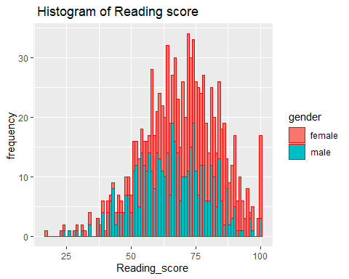

# Frequency of Writing score in terms of Gender  
ggplot(data=data1,aes(x=writing.score,fill=gender))+  
 geom_histogram(col="red",binwidth =1)+  
 ggtitle(" Histogram of Writing score")+  
 theme(text=element_text(size=11))+xlab("Wrting score")+  
 ylab("freqeuncy")

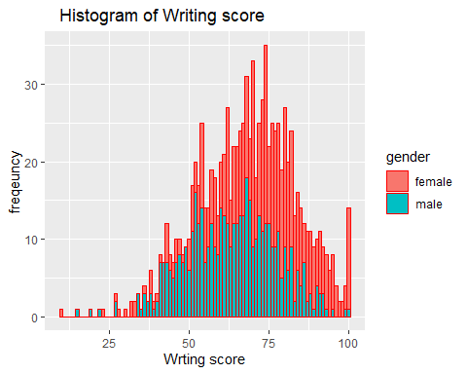

#Frequency of Maths Score in terms of Genders  
ggplot(data=data1,aes(x=math.score,fill=gender))+  
 geom_histogram(col="red",binwidth =1)+ ylab("Freqeuncy")+  
 ggtitle(" Histogram of Maths score")+  
 theme(text=element_text(size=11))+xlab("Maths_score")

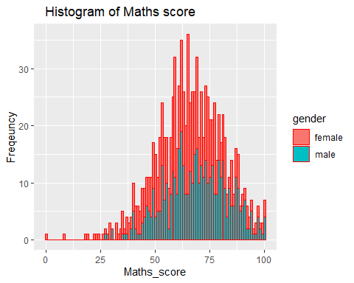

# Frequency of Genders Quantity in terms of Test Prep Course  
y1=ggplot(data=data1,aes(x=gender,fill=test.preparation.course))+  
 geom_bar()+ylab("Frequency")+ggtitle("test.preparation.course")+  
 theme(axis.text = element_text(size=8),axis.title = element_text(size=7))  
print(y1)

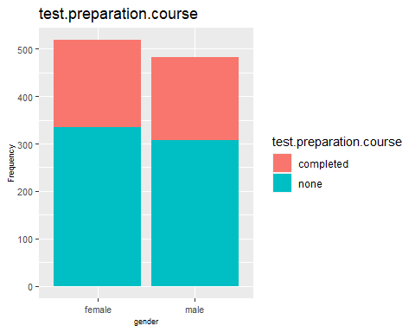

# Frequency Race/ethics in terms of Test Prep Course  
y2=ggplot(data=data1,aes(x=race.ethnicity,fill=test.preparation.course))+  
 geom_bar()+ylab("Frequency")+ggtitle("test.preparation.course")+  
 theme(axis.title = element_text(size=10),axis.text = element_text(size=7))  
print(y2)

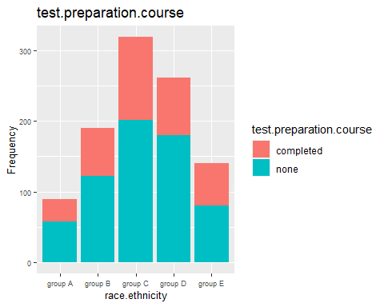

# Counting Prep level of education in terms of Test Prep Course  
y3=ggplot(data=data1,aes(x=parental.level.of.education,fill=test.preparation.course))+  
 geom_bar()+ggtitle("test.preparation.course")+  
 theme(axis.title = element_text(size = 8),axis.text = element_text(size = 7))+  
 ylab("Frequency")  
print(y3)

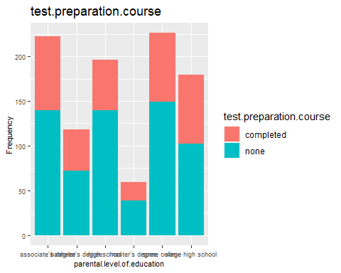

library(ggpubr)  
ggarrange(y1,y2,y3,ncol=1,nrow=3)

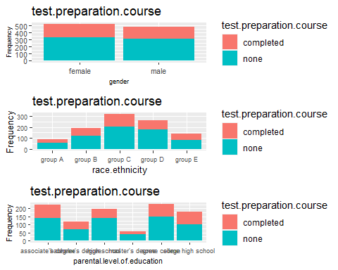

# Relationship between Reading Score and Maths Score in terms of Writing Score  
ggplot(data=data1,aes(x=reading.score,y=math.score,col=writing.score))+  
 geom_point()+ggtitle("Reading score vs math score")+  
 geom_smooth(method = 'lm',se=FALSE)

## `geom_smooth()` using formula 'y ~ x'

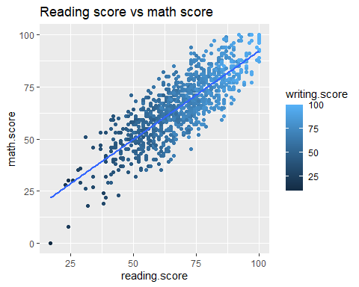

# Relationship between Reading Score and Maths Score in terms of Gender  
ggplot(data=data1,aes(x=reading.score,y=math.score,col=gender))+geom_point()+  
 geom_smooth(method='lm',se=FALSE)+ggtitle("Reading score vs math score")

## `geom_smooth()` using formula 'y ~ x'

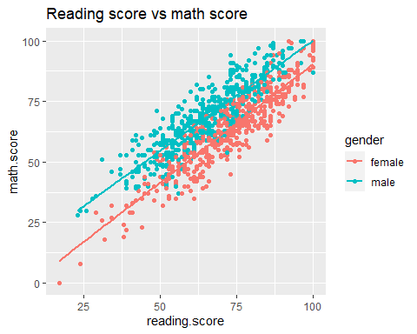

# Relationship between Reading Score and Maths Score in terms of Test prep  
ggplot(data=data1,aes(x=reading.score,y=math.score,col=test.preparation.course))+  
 geom_point()+ ggtitle("Reading score vs math score")+  
 geom_smooth(method='lm',se=FALSE)

## `geom_smooth()` using formula 'y ~ x'

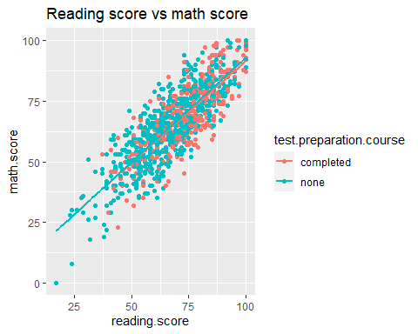

# Relationship between Reading Score and Maths Score in terms of Race/Ethics  
ggplot(data=data1,aes(x=reading.score,y=math.score,col=race.ethnicity))+  
 geom_point()+ ggtitle("Reading score vs math score")

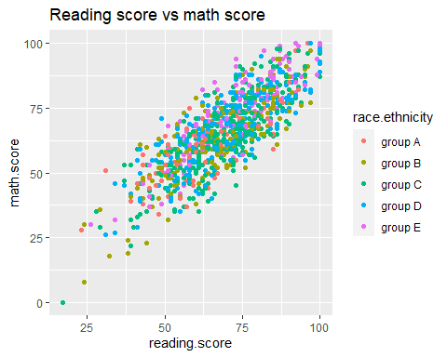

# Correlation between Maths Score and Reading Score  
cor.test(data1$math.score,data1$reading.score)

##   
## Pearson's product-moment correlation  
##   
## data: data1$math.score and data1$reading.score  
## t = 44.855, df = 998, p-value < 2.2e-16  
## alternative hypothesis: true correlation is not equal to 0  
## 95 percent confidence interval:  
## 0.7959276 0.8371428  
## sample estimates:  
## cor   
## 0.8175797

#boxplot  
#Summary of Maths score for Race/ethics in terms of Gender  
ggplot(data=data1,aes(x=race.ethnicity,y=math.score,fill=gender))+  
 geom_boxplot()+facet_grid(~gender)+  
 theme(text = element_text(size = 10),axis.text = element_text(size = 7) )

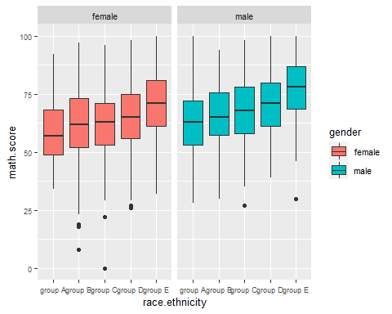

#Summary of Reading score for Race/ethics in terms of Gender  
#reading score;  
ggplot(data=data1,aes(x=race.ethnicity,y=reading.score,fill=gender))+  
 geom_boxplot()

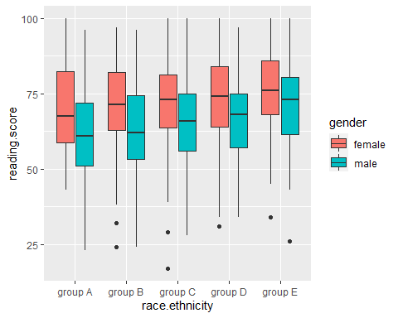

# Summary of writing score for Race/ethics in terms of Gender  
#writing score;  
ggplot(data=data1,aes(x=race.ethnicity,y=writing.score,fill=gender))+  
 geom_boxplot()+facet_grid(~gender)

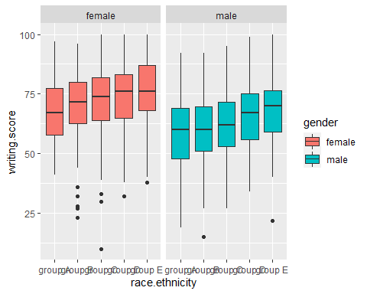

# Now applying hypothesis Test:  
  
i)   
Is there a difference in Maths mean score among students who's test   
preparation is "None" or "complete"  
  
#Null hypothesis: There is no difference in Maths mean score among students   
#who's test preparation is "None" or "complete"  
  
#Alternate hypothesis: There is difference in Maths mean score among students   
#who's test preparation is "None" or "complete"  
  
  
library(dplyr)

##   
## Attaching package: 'dplyr'

## The following objects are masked from 'package:stats':  
##   
## filter, lag

## The following objects are masked from 'package:base':  
##   
## intersect, setdiff, setequal, union

library(moments)  
# making Two separate data frames for maths score in terms of test preparation  
a=data1%>%select("test.preparation.course","math.score")%>%  
 filter(data1$test.preparation.course=="none")  
View(a)  
b=data1%>%select("test.preparation.course","math.score")%>%  
 filter(data1$test.preparation.course=="completed")  
View(b)  
  
  
#normality test to check Normal distribution;  
# i)visualization test for normality for maths score with complete Tests prep  
qqnorm(a$math.score)  
qqline(a$math.score, col = "steelblue",lwd = 2)

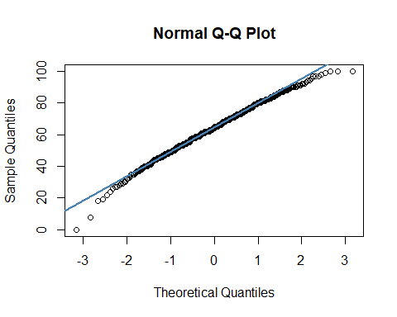

# taken alpha =5%   
  
# ii)Statistic test for normality  
shapiro.test(a$math.score)

##   
## Shapiro-Wilk normality test  
##   
## data: a$math.score  
## W = 0.99212, p-value = 0.001754

# since P-value < alpha value so it is not normal distribution  
  
agostino.test(a$math.score)

##   
## D'Agostino skewness test  
##   
## data: a$math.score  
## skew = -0.32796, z = -3.34757, p-value = 0.0008152  
## alternative hypothesis: data have a skewness

# since P-value < alpha value so it is not normal distribution  
  
#visualization test for normality for maths score with None Tests prep  
qqnorm(b$math.score) # qq-plot  
qqline(b$math.score, col = "steelblue",lwd = 2)

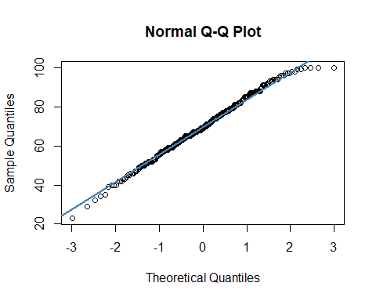

#Statistic test for normality  
shapiro.test(b$math.score)

##   
## Shapiro-Wilk normality test  
##   
## data: b$math.score  
## W = 0.99366, p-value = 0.1393

# since P-value > alpha value so it is normal distribution  
  
agostino.test(b$math.score)

##   
## D'Agostino skewness test  
##   
## data: b$math.score  
## skew = -0.1469, z = -1.1516, p-value = 0.2495  
## alternative hypothesis: data have a skewness

# since P-value > alpha value so it is normal distribution  
  
# checking the difference between the two data frames of maths score  
wilcox.test(a$math.score,b$math.score)

##   
## Wilcoxon rank sum test with continuity correction  
##   
## data: a$math.score and b$math.score  
## W = 91424, p-value = 8.015e-08  
## alternative hypothesis: true location shift is not equal to 0

# hence it is proves that mean of both data frames are different as   
#alternate hypothesis is seen as a result  
  
  
  
  
  
  
#ii)  
Is there a difference in Reading mean score among students who's test   
#preparation is "None" or "complete"  
  
Null hypothesis: There is no difference in Reading mean score among students   
who's test preparation is "None" or "complete"  
  
Alternate hypothesis: There is difference in Reading mean score among students   
who's test preparation is "None" or "complete"  
  
  
  
# making Two separate data frames for maths score in terms of test preparation  
a=data1%>%select("test.preparation.course","reading.score")%>%  
 filter(data1$test.preparation.course=="none")  
View(a)  
b=data1%>%select("test.preparation.course","reading.score")%>%  
 filter(data1$test.preparation.course=="completed")  
View(b)  
  
  
#normality test to check Normal distribution;  
# i)visualization test for normality for maths score with complete Tests prep  
qqnorm(a$reading.score)  
qqline(a$reading.score, col = "red",lwd = 2)

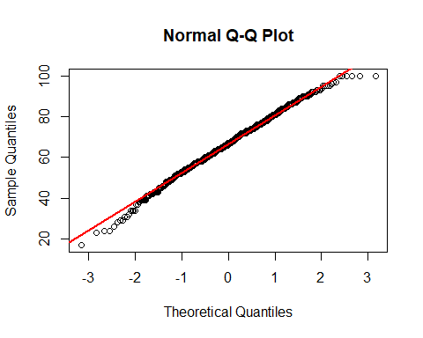

# taken alpha =5%   
  
# ii)Statistic test for normality  
shapiro.test(a$reading.score)

##   
## Shapiro-Wilk normality test  
##   
## data: a$reading.score  
## W = 0.99433, p-value = 0.017

# since P-value < alpha value so it is not normal distribution  
  
agostino.test(a$reading.score)

##   
## D'Agostino skewness test  
##   
## data: a$reading.score  
## skew = -0.2331, z = -2.4077, p-value = 0.01605  
## alternative hypothesis: data have a skewness

# since P-value < alpha value so it is not normal distribution  
  
#visualization test for normality for maths score with None Tests prep  
qqnorm(b$reading.score) # qq-plot  
qqline(b$reading.score, col = "steelblue",lwd = 2)

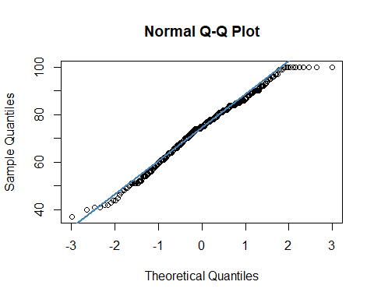

#Statistic test for normality  
shapiro.test(b$reading.score)

##   
## Shapiro-Wilk normality test  
##   
## data: b$reading.score  
## W = 0.98563, p-value = 0.001264

# since P-value < alpha value so it is not normal distribution  
  
agostino.test(b$reading.score)

##   
## D'Agostino skewness test  
##   
## data: b$reading.score  
## skew = -0.28696, z = -2.21927, p-value = 0.02647  
## alternative hypothesis: data have a skewness

# since P-value < alpha value so it is not normal distribution  
  
# checking the difference between the two data frames of maths score  
wilcox.test(a$reading.score,b$reading.score)

##   
## Wilcoxon rank sum test with continuity correction  
##   
## data: a$reading.score and b$reading.score  
## W = 81339, p-value = 1.712e-14  
## alternative hypothesis: true location shift is not equal to 0

# hence it is proves that mean of both data frames are different as   
#alternate hypothesis is seen as a result  
  
  
  
#iii)   
Is there a difference in Writing mean score among students who's test   
preparation is "None" or "complete"  
  
Null hypothesis: There is no difference in writing mean score among students   
who's test preparation is "None" or "complete"  
  
Alternate hypothesis: There is difference in writing mean score among students   
who's test preparation is "None" or "complete"  
  
  
  
# making Two separate data frames for maths score in terms of test preparation  
a=data1%>%select("test.preparation.course","writing.score")%>%  
 filter(data1$test.preparation.course=="none")  
View(a)  
b=data1%>%select("test.preparation.course","writing.score")%>%  
 filter(data1$test.preparation.course=="completed")  
View(b)  
  
  
#normality test to check Normal distribution;  
# i)visualization test for normality for maths score with complete Tests prep  
qqnorm(a$writing.score)  
qqline(a$writing.score, col = "red",lwd = 2)

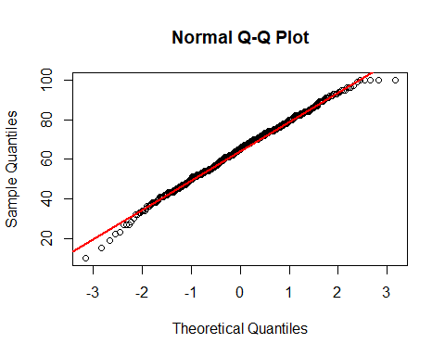

# taken alpha =5%   
  
# ii)Statistic test for normality  
shapiro.test(a$writing.score)

##   
## Shapiro-Wilk normality test  
##   
## data: a$writing.score  
## W = 0.99517, p-value = 0.04211

# since P-value < alpha value so it is not normal distribution  
  
agostino.test(a$writing.score)

##   
## D'Agostino skewness test  
##   
## data: a$writing.score  
## skew = -0.21476, z = -2.22243, p-value = 0.02625  
## alternative hypothesis: data have a skewness

# since P-value < alpha value so it is not normal distribution  
  
#visualization test for normality for maths score with None Tests prep  
qqnorm(b$writing.score) # qq-plot  
qqline(b$writing.score, col = "steelblue",lwd = 2)

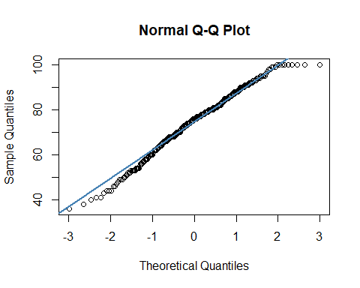

#Statistic test for normality  
shapiro.test(b$writing.score)

##   
## Shapiro-Wilk normality test  
##   
## data: b$writing.score  
## W = 0.98552, p-value = 0.001186

# since P-value < alpha value so it is not normal distribution  
  
agostino.test(b$writing.score)

##   
## D'Agostino skewness test  
##   
## data: b$writing.score  
## skew = -0.34683, z = -2.66064, p-value = 0.007799  
## alternative hypothesis: data have a skewness

# since P-value < alpha value so it is not normal distribution  
  
# checking the difference between the two data frames of maths score  
wilcox.test(a$writing.score,b$writing.score)

##   
## Wilcoxon rank sum test with continuity correction  
##   
## data: a$writing.score and b$writing.score  
## W = 71027, p-value < 2.2e-16  
## alternative hypothesis: true location shift is not equal to 0

# hence it is proves that mean of both data frames are different as   
#alternate hypothesis is seen as a result